STRATEGY MEMO
Optimizing Delivery ETAs with Graph-Based Network Intelligence
TO: | Head of Network Operations
FROM: | Network Analytics — Graph Intelligence Team
RE: | Where delay concentrates, and the three moves that recover it

BOTTOM LINE
Our routing engine (OSRM) under-predicts delivery time by about 2× network-wide — actual legs run roughly double the estimate, so ETAs are wrong and capacity planning slips. The delay is not spread evenly: it concentrates in a handful of mega-hubs. Just five facilities account for 31% of all delay in the network, and the top three account for 24%. We can (a) deploy a graph-based ETA model that is on-target 58% of the time vs 4% today, and (b) by upgrading the top three hubs, cut late deliveries on their corridors by ~28% and recover an estimated ₹1.5 crore/year of revenue-at-risk.

The problem in one chart
Delhivery promises ETAs from OSRM, a routing engine that assumes open roads and shortest paths. Reality includes congestion, dwell at facilities, and consolidation. The result: across 26,000 trip-legs, actual time is a median 2.0× the OSRM estimate, and 95% of legs run more than 20% over. This is not occasional noise — the estimate is structurally low, which is why downstream capacity planning keeps breaking.
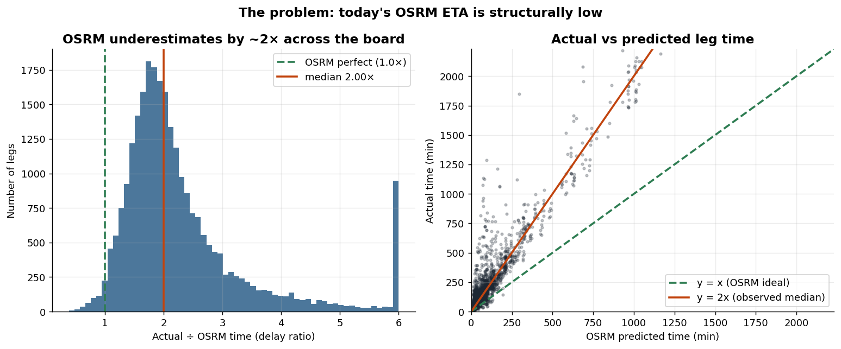
Figure 1 — Today's OSRM ETA is systematically ~2× too fast. The fix is not a tweak; it is a different model.

Where the delay actually is
Treating the network as a graph (facilities as nodes, corridors as edges) lets us see that delay is highly concentrated. Of the network's total excess delay, the top 5 hubs carry 30.8% and the top 3 carry 24.3%. These are the points where fixing one facility moves the whole network.
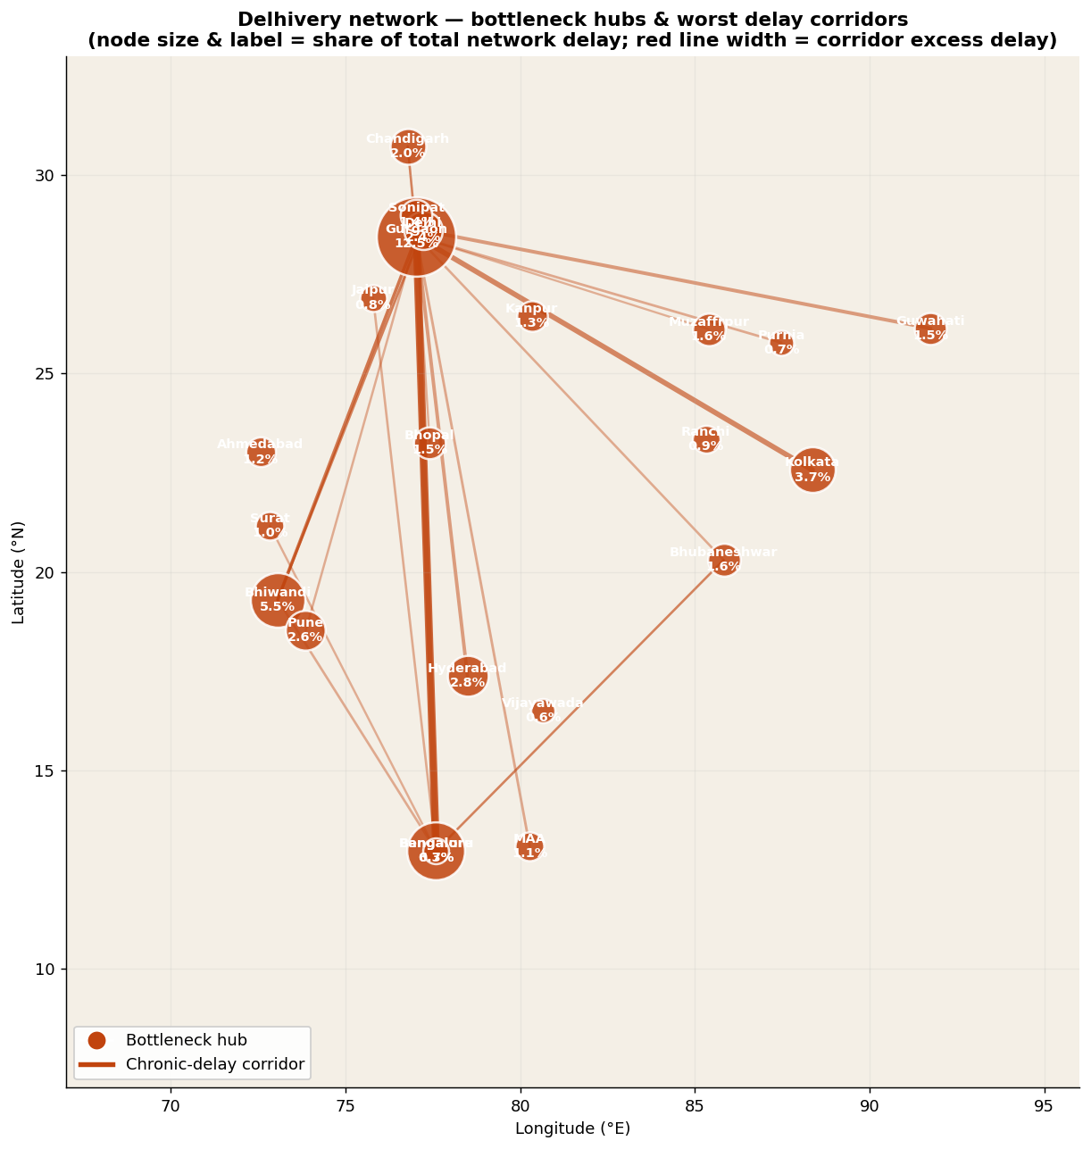
Figure 2 — The delay map. Circle size = a hub's share of total network delay; red lines = the most delayed corridors. The Gurgaon⇄Bangalore trunk dominates.

Top 5 bottleneck hubs — and what to do about each
Bottleneck hub | Share of network delay | Why it is a chokepoint | Recommended intervention
1. Gurgaon (Bilaspur HB), Haryana | 12.5% | Highest betweenness in the country (0.19); 49 outbound + 45 inbound corridors. The national gateway — almost every long-haul trunk routes through it. | Parallel sortation capacity + dedicated night-dispatch lanes to Bangalore, Kolkata, Hyderabad, Bhiwandi.
2. Bangalore (Nelamangla H), Karnataka | 6.3% | Southern anchor; 35 out / 36 in corridors. The Gurgaon⇄Bangalore trunk is the single worst lane in the network. | Add a parallel relay on the Gurgaon⇄Bangalore lane; balance inbound dock load.
3. Bhiwandi (Mankoli HB), Maharashtra | 5.5% | Mumbai gateway with high intrinsic delay (2.25× OSRM) — slow even for its volume, pointing to facility-side dwell. | Facility upgrade: dock automation + staffing to cut handling/dwell time.
4. Kolkata (Dankuni HB), West Bengal | 3.7% | Eastern gateway and the worst delay ratio of the top hubs (2.59× OSRM). | Facility upgrade + congestion-aware inbound scheduling.
5. Hyderabad (Shamshabad H), Telangana | 2.8% | Central-south chokepoint (betweenness 0.11) linking north and south flows. | Targeted throughput upgrade; monitor as volumes grow.

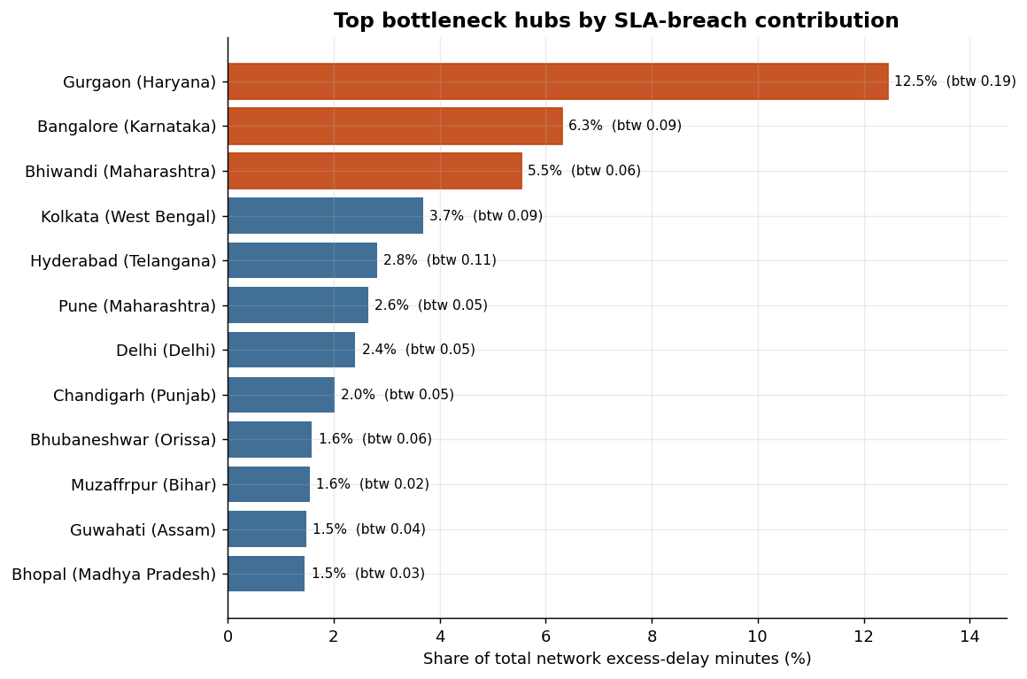
Figure 3 — Hub ranking by share of total network delay (top three in orange).

The corridors bleeding the most time
Three trunk lanes alone lose enormous time versus estimate and should be the first targets for parallel routing / relay points:
- Gurgaon ⇄ Bangalore — ~2,866 min actual vs 1,548 OSRM one way; the two directions together lose ~145,000 excess minutes in just three weeks. This single lane is the clearest case for a parallel relay.
- Gurgaon → Kolkata — 2.03× OSRM, ~55,600 excess minutes. Pair facility scheduling at Kolkata with a dedicated dispatch slot.
- Guwahati → Delhi & Gurgaon → Hyderabad / Bhiwandi — long, high-ratio lanes (2.1–2.5×) where reliability, not distance, is the issue.

Route type: stop deciding FTL vs Carting by habit
Route-type choice today does not account for a facility's position in the network. Our framework makes the trade-off explicit: full-truck (FTL) runs measurably more reliably (1.92× vs 2.15× OSRM) and its time advantage grows with distance, while Carting is cheaper on short feeders. The data-backed rule:
- Long-haul (>400 km): default to FTL — it is recommended on 100% of these lanes and is actually cheaper per leg once the truck is full, while saving 3–6 hours.
- Short feeders (<150 km): default to Carting — the FTL premium is not justified by the small time saving.
- 150–400 km: decide by graph position — shift to FTL when the source is a central hub feeding an SLA-critical trunk (≈31% of these lanes).

What the three moves are worth
If the top three hubs (Gurgaon, Bangalore, Bhiwandi) are upgraded so that 40% of their excess delay is removed — a conservative target that brings them toward network-median performance — the modelled impact is:
- ~28% fewer late deliveries on the corridors those hubs touch (≈5% across the entire network, from just three sites).
- ~110,000 hours of delay recovered per year — capacity that is currently lost to congestion and dwell.
- ≈ ₹1.5 crore/year of revenue-at-risk recovered (SLA penalties + churn avoided). Figures use explicit, finance-tunable assumptions; the leverage point — three hubs — is the robust finding.

A faster win available now: better ETAs
Independent of any facility spend, replacing the OSRM estimate with our graph-enhanced ETA model is a software change with immediate effect. On held-out data it is on-target (within 15% of actual) 58% of the time versus 4% today, and its average error falls from 108 minutes to 28. The single most powerful signal is corridor-level history — exactly what a point-to-point engine like OSRM ignores.
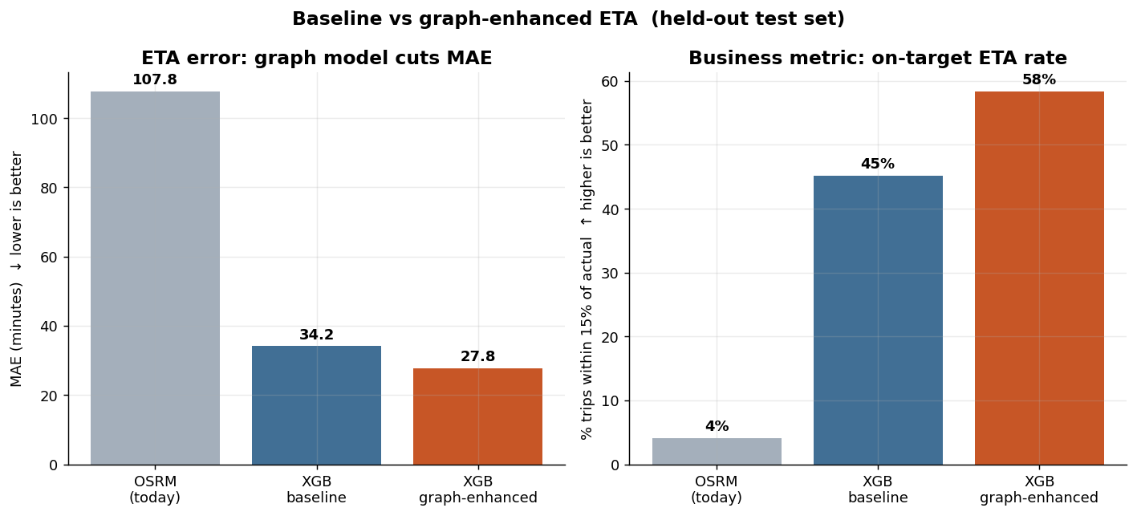
Figure 4 — The graph-enhanced model beats both today's OSRM and a trip-features-only baseline on accuracy and on the on-target-ETA business metric.

Recommended actions
- Deploy the graph-enhanced ETA model for promised-time generation and capacity planning (quick win, no capex).
- Upgrade Gurgaon first — it alone is 12.5% of network delay; add parallel sortation and dedicated night-dispatch lanes.
- Stand up a parallel relay on Gurgaon⇄Bangalore, the worst single corridor in the network.
- Adopt the FTL/Carting rule (FTL on long-haul and central-hub trunks; Carting on short feeders).
- Review Bhiwandi and Kolkata for facility-side dwell — their delay is high even for their volume, pointing to handling, not roads.
Method in brief: Directed weighted graph of 1,657 facilities and 2,775 corridors; edge weights = median actual÷OSRM delay ratio, stratified by route type and time of day. Hub ranking blends betweenness centrality, throughput and delay contribution. ETA model = gradient-boosted trees on trip features plus node2vec graph embeddings and corridor history, evaluated on a held-out 20% with leakage controls. All business constants are configurable. Data window ≈ 25 days, Sep–Oct 2018.

