Wazuh-Integration and Rules

27-Feb-2026

om

Wazuh Siem Implementation Report

Wazuh SIEM Deployment and Analysis Report

Abstract
This report presents the deployment, configuration, and validation of the Wazuh Security Information and Event Management (SIEM) platform in a controlled lab environment. The Wazuh Manager was deployed on an Ubuntu server, while Wazuh agents were installed on Kali Linux and Microsoft Windows endpoints. The objective was to achieve centralized log management, threat detection, and security monitoring across heterogeneous operating systems.

1. Overview of Wazuh
Wazuh is an open-source SIEM and XDR solution that provides capabilities such as log analysis, intrusion detection, file integrity monitoring (FIM), vulnerability detection, and compliance monitoring. It is widely used in SOC environments for real-time security visibility and incident response.

Table of content
Wazuh-Integration and Rules 1
27-Feb-2026 1
om 1
Wazuh SIEM Deployment and Analysis Report 2
Abstract 2
1. Overview of Wazuh 3
Table of content 4
2. Scope of the Project 5
3. Lab Architecture and Design 6
3.1 Components Used 6
3.2 Architecture Flow 6
4. Implementation Methodology 7
4.1 Wazuh Manager Setup (Ubuntu) 7
4.2 Agent Deployment 7
Kali Linux Agent 7
Windows Agent 7
5. Testing and Verification 8
6. Screenshot Evidence Section 9
Screenshot 1: Wazuh Dashboard Login Page 9
Screenshot 2: Wazuh Dashboard 10
Screenshot 3: Agent Status Page 11
Screenshot 5: File Integrity Monitoring (FIM) 13
Screenshot 6: Detecting Network Intrusion using Suricata IDS 17
Screenshot 7 : Detecting vulnerabilities 23
Screenshot 8 : Detecting and Blocking SSH Brute force attacks 28

2. Scope of the Project
- Deployment of Wazuh Manager on Ubuntu Linux
- Integration of Linux and Windows endpoints using Wazuh Agents
- Validation of log collection, alert generation, and dashboard visualization
- Demonstration of SIEM use cases in a cybersecurity lab environment

3. Lab Architecture and Design

3.1 Components Used
- Wazuh Manager: Ubuntu Linux (Central SIEM Server)
- Endpoints:
  - Kali Linux (Linux endpoint)
  - Microsoft Windows (Windows endpoint)
- Dashboard: Wazuh Web Dashboard

3.2 Architecture Flow
- Endpoints generate logs and security events.
- Wazuh Agents collect and forward logs securely.
- Wazuh Manager processes events using rules and decoders.
- Alerts and insights are visualized on the Wazuh Dashboard.

4. Implementation Methodology

4.1 Wazuh Manager Setup (Ubuntu)
- Installed Wazuh Manager, Indexer, and Dashboard on Ubuntu.
- Verified service status and dashboard accessibility.
- Configured firewall and network settings for agent communication.

4.2 Agent Deployment

Kali Linux Agent
- Installed Wazuh agent using Linux package manager.
- Configured manager IP address in agent configuration.
- Registered the agent and validated its active status.

Windows Agent
- Installed Wazuh agent using the official Windows installer.
- Imported authentication key and configured manager IP.
- Started the agent service and verified connectivity.

5. Testing and Verification
- Successful registration of Kali Linux and Windows agents.
- Continuous log ingestion observed on the dashboard.
- Alerts generated for authentication events and system activity.
- File Integrity Monitoring tested on monitored directories.

6. Screenshot Evidence Section

Screenshot 1: Wazuh Dashboard Login Page

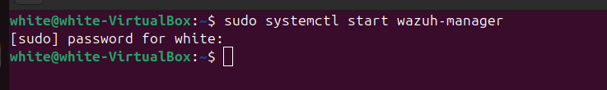
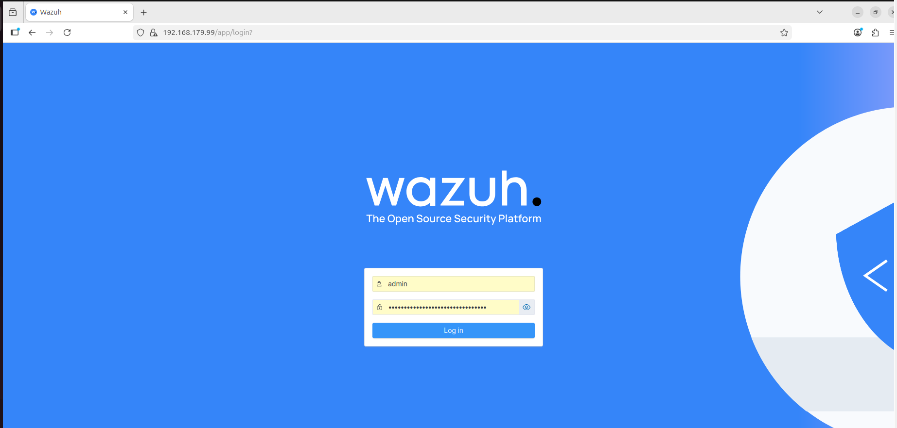

Screenshot 2: Wazuh Dashboard

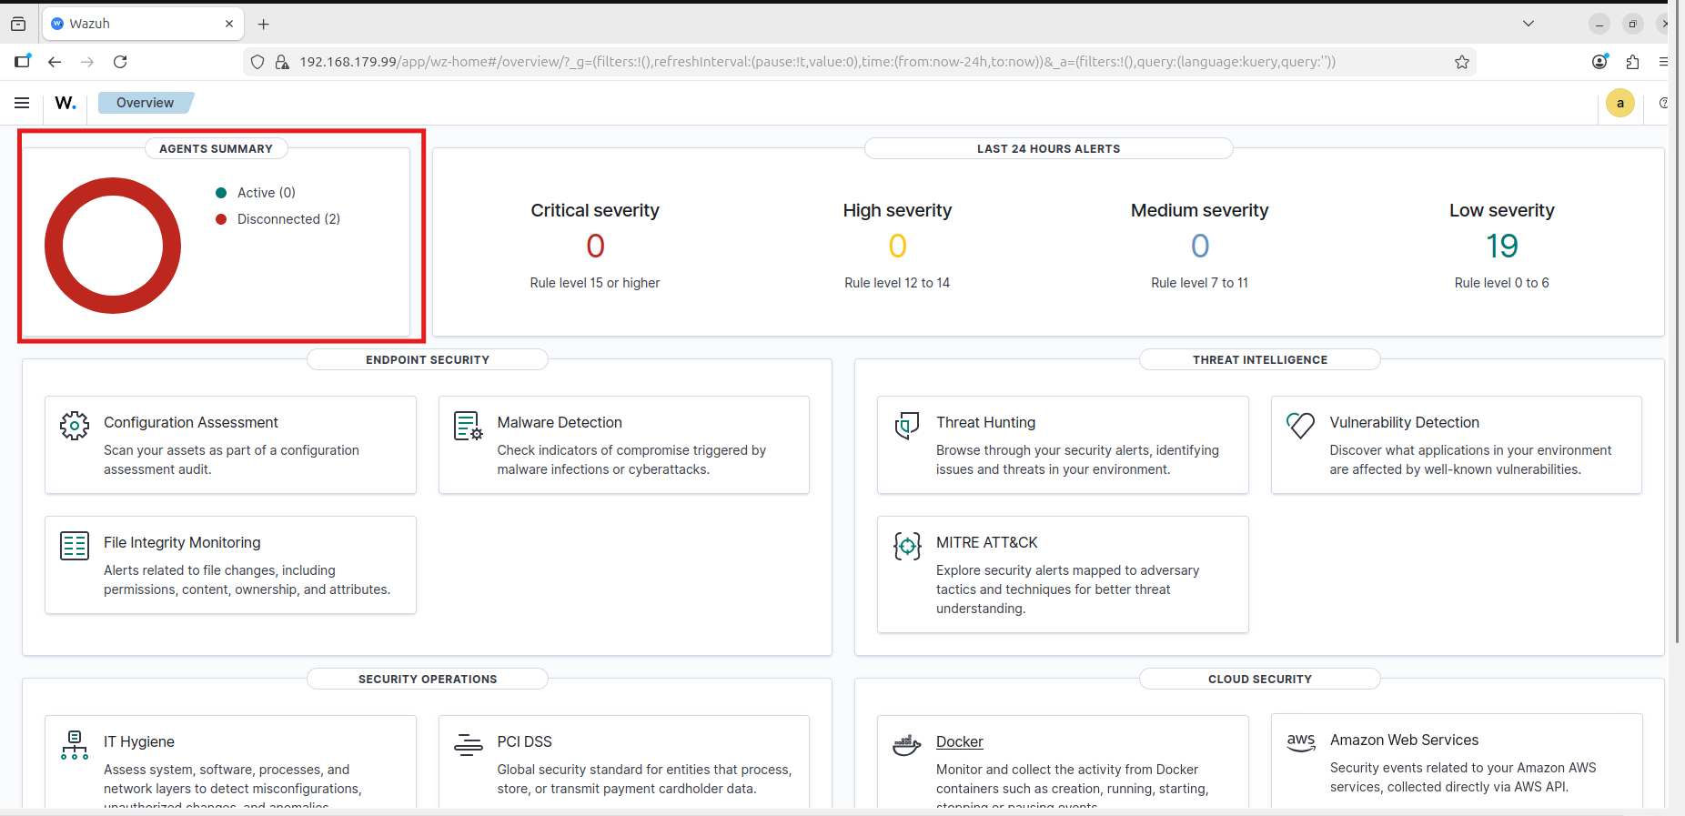

Screenshot 3: Agent Status Page
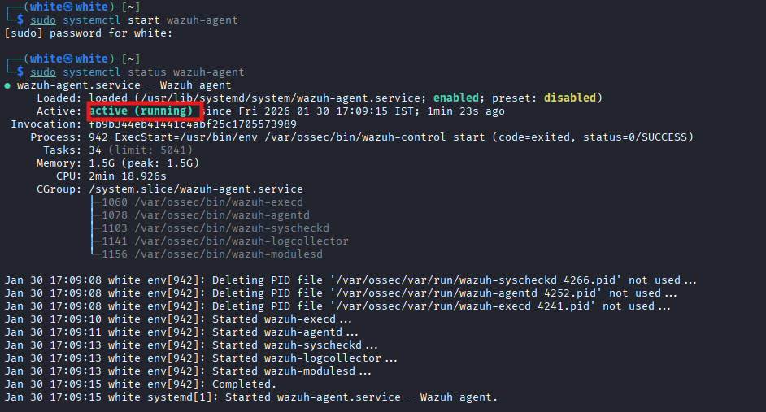
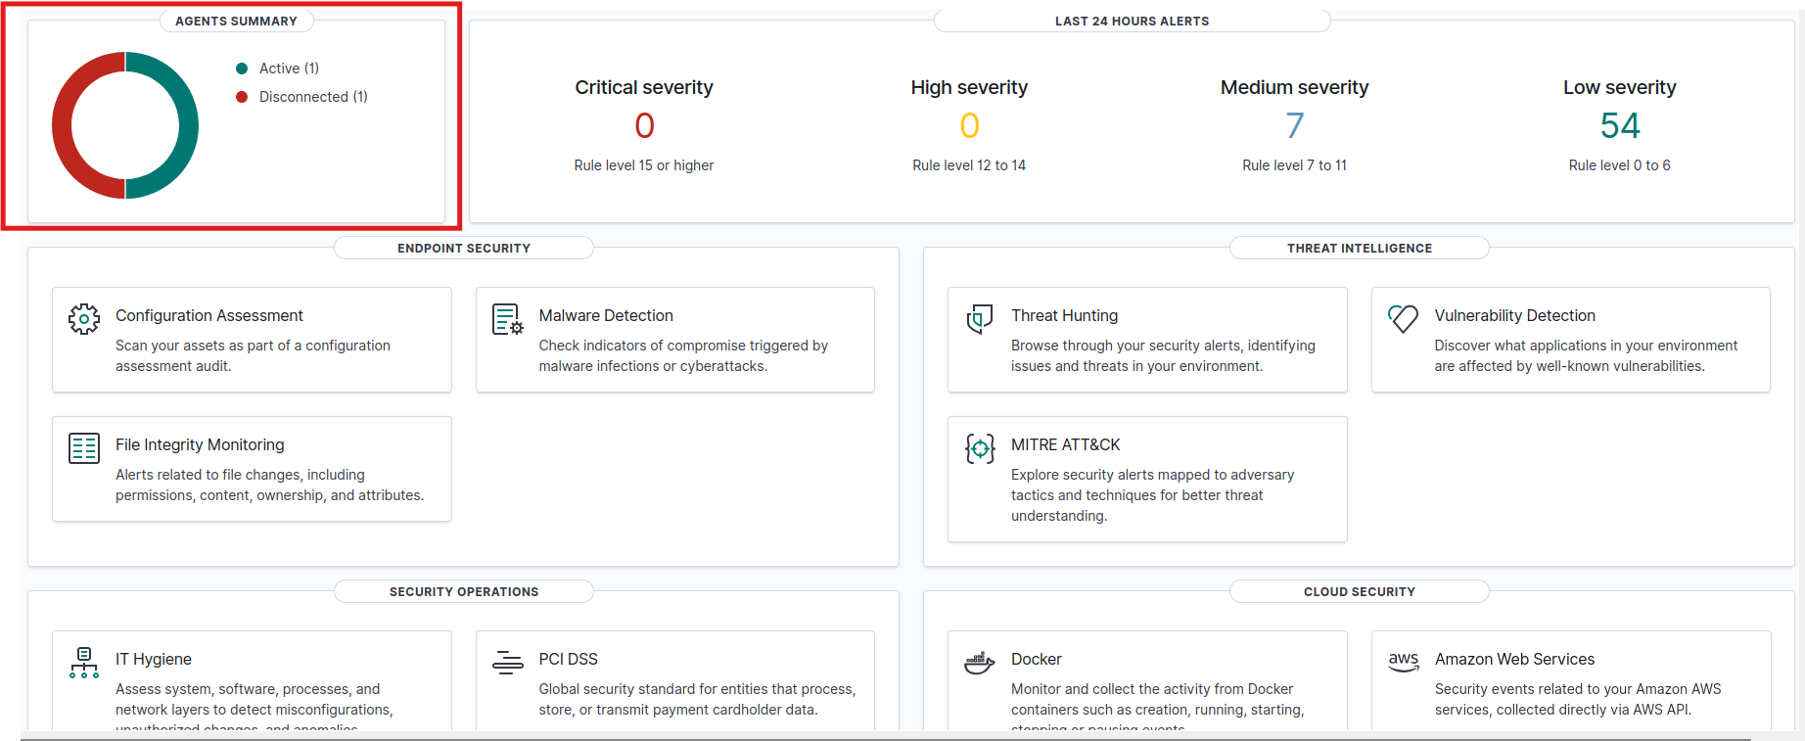

My linux agent is activated

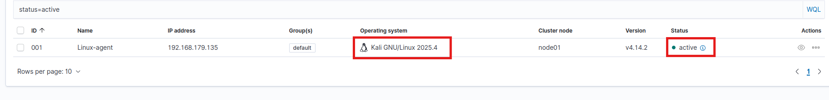

Screenshot 5: File Integrity Monitoring (FIM)

- This is my wazuh-manager

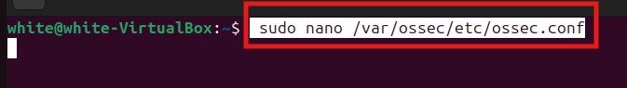

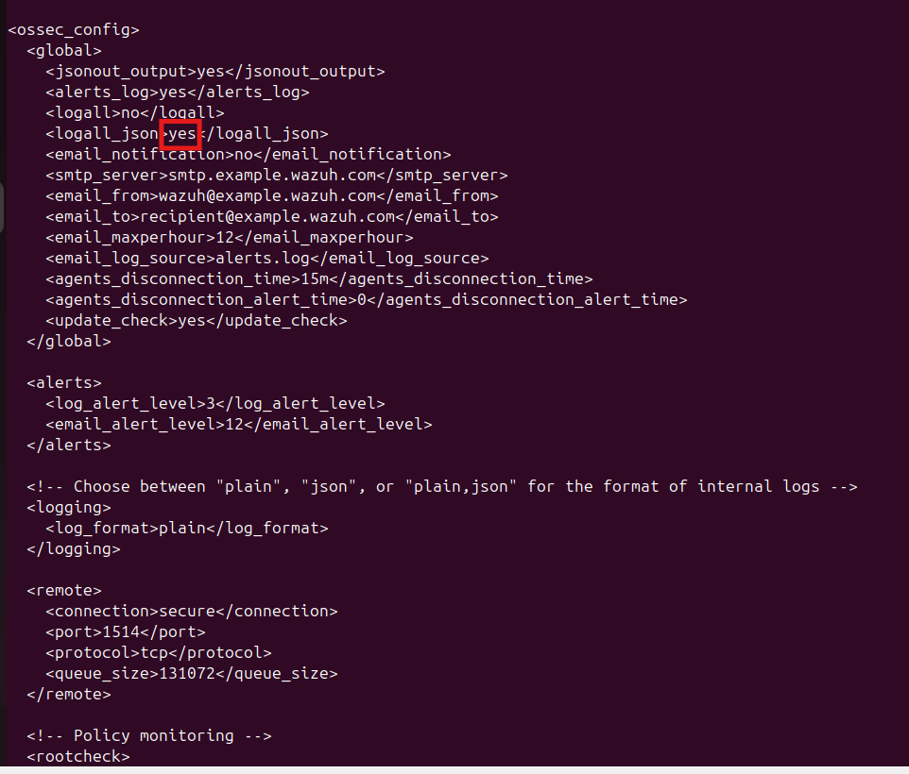

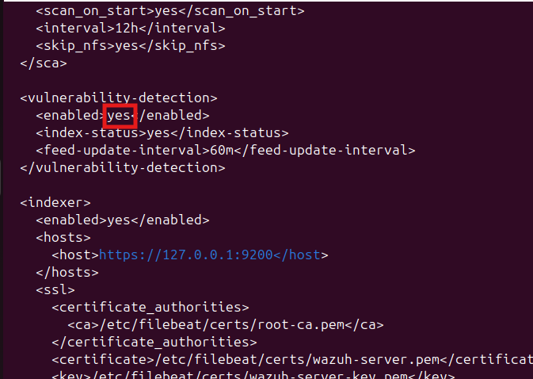
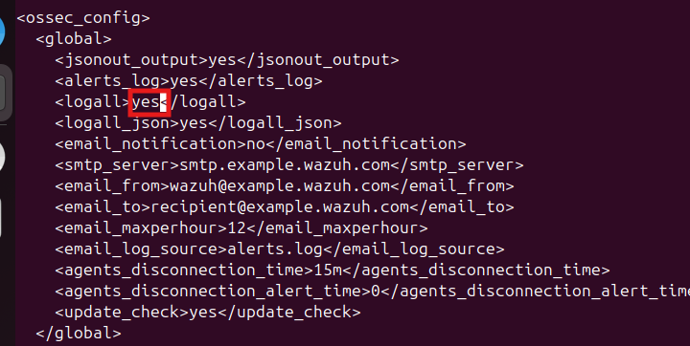

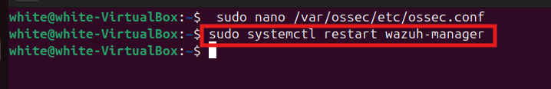

- This is my wazuh-agent

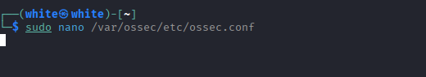
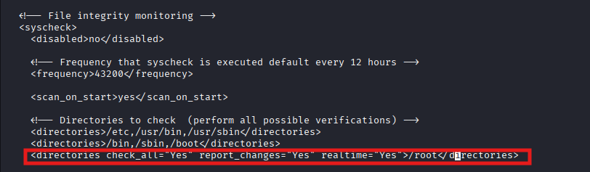

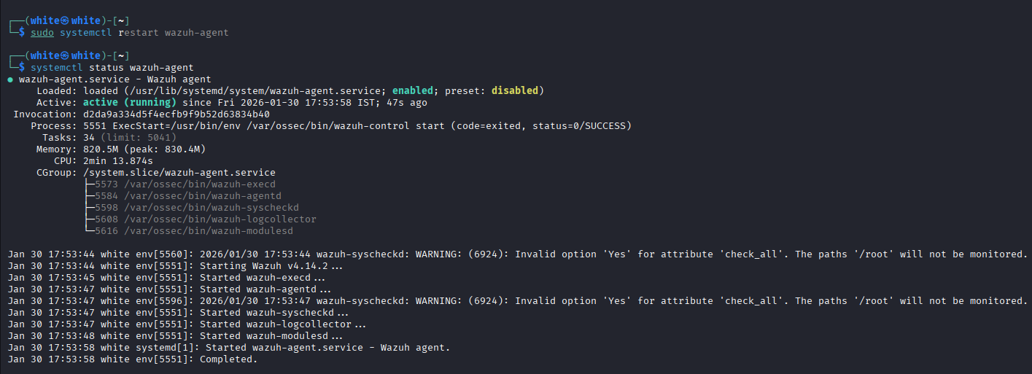

- Come to wazuh dashboard, then click on that active specific agent->Threat hunting->Events->Alerts generate automatically

Screenshot 6: Detecting Network Intrusion using Suricata IDS

- Installing Suricata on wazuh-agent

sudo apt install suricata –y

- We need to set our agent ip or ip-subnet on client/wazuh-agent

- I performed a simple syn scan to my agent ip from manager or you can you any other attackingg device.

- Then open wazuh-dashboard, suricata detect the attack

- You can also see the source ip
- Use can also check from wazuh-agent through suricata/fast.log

Screenshot 7 : Detecting vulnerabilities

- To detecting vulnerabilities, we need to make some changes on wazuh-manager

- If we click on vulnerablility.id

Screenshot 8 : Detecting and Blocking SSH Brute force attacks

- We need to add this rule in active response section.

- Open wazuh-dashboard -> server-management -> rules -> (search on search bar) ssh -> scroll pages till you find rule no. 5763

- Now we will lauch a ssh based bruteforce attack on wazuh-manager to check wazuh-dashboard logs generate or not and also blocking or not.

