**Project Report**

E-commerce Mobile App Testing with Sauce Labs

**1. Project Overview**

**1.1 Project Name**

E-commerce Mobile App Testing with Sauce Labs.

**1.2 Objective**

The objective of the "E-commerce Mobile App Testing with Sauce Labs" project is to automate the testing of an E-commerce mobile application using Sauce Labs. The primary goals and objectives include:

1. **Automated Testing:** Implement automated test scripts to validate the functionality of the E-commerce mobile app efficiently.
2. **Sauce Labs Integration:** Utilize Sauce Labs for mobile app testing, taking advantage of its features for cloud-based testing and virtual device environments.
3. **Comprehensive Test Coverage:** Design and execute test cases that cover critical aspects of the E-commerce app, including login functionality, cart management, and the online ordering flow.

**1.3 Technologies and Tools Used**

* **Mobile App:** Sauce Labs Sample App
* **Coding Platform:** IntelliJ Idea IDE
* **GUI Inspecting Tool:**  Appium Inspector
* **GUI Tool:** Android Emulator (Android Studio)
* **Test Automation Framework:** Appium
* **Test Execution Framework:** TestNG
* **Design Pattern:** Page Object Model (POM)
* **Version Control:** Git
* **Documentation:** Microsoft Word

**2. Test Cases**

**2.1 Test Case #1: Login with Valid Credentials**

* **Steps:**
  + Launch the app.
  + Enter a valid email and password.
  + Click the login button.
* **Expected Outcome:**
  + Successful login.

Status: Passed.

Execution time : 12 sec 400 ms .

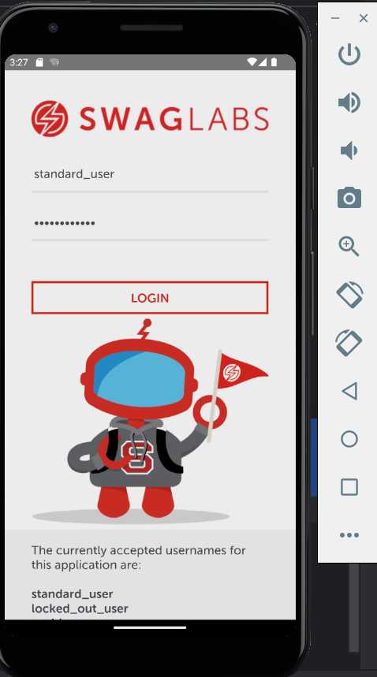 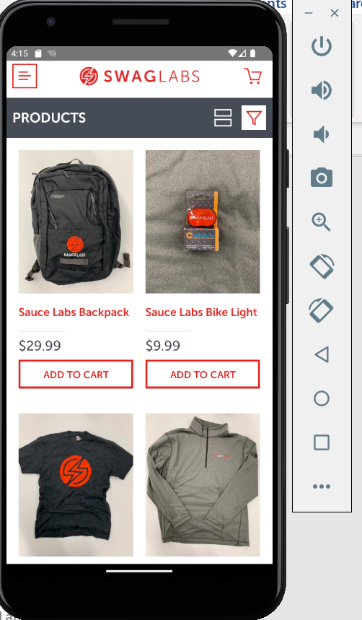

**2.2 Test Case #2: Login with Invalid Credentials**

* **Steps:**
  + Launch the app.
  + Enter an invalid email or password.
  + Click the login button.
* **Expected Outcome:**
  + Unsuccessful login.

Status: Passed.

Execution time : 12 sec 18ss ms .

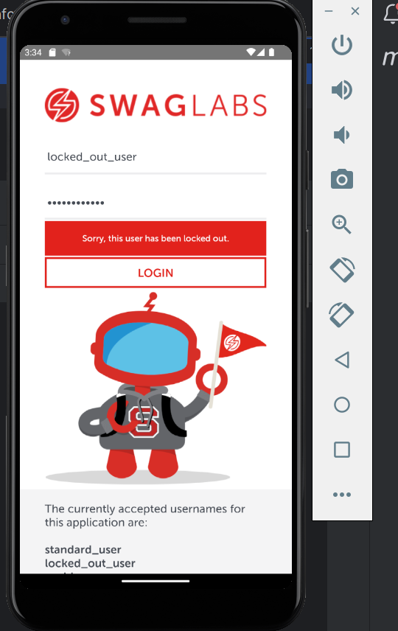

**2.3 Test Case #3: Add Item to Cart and Validate**

* **Steps:**
  + Login with valid credentials.
  + Add any item to the cart.
* **Expected Outcome:**
  + Title and price on the home page match the item and price in the cart.

Status: Passed

Execution Time: 10 sec 958 ms .

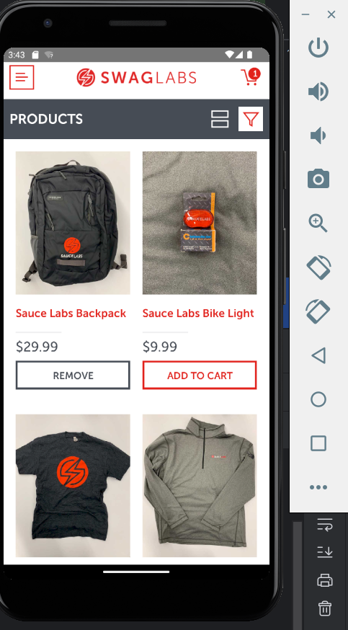 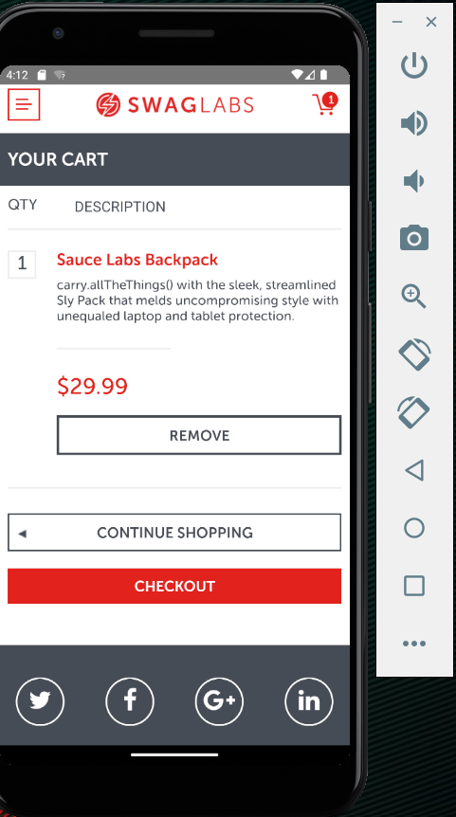

**2.4 Test Case #4: Remove Items from Cart and Validate Empty Cart**

* **Steps:**
  + Login with valid credentials.
  + Add any item to the cart.
  + Remove the item from the cart.
* **Expected Outcome:**
  + The cart is empty.

Status: Passed

Execution Time: 29 sec 92 ms .

 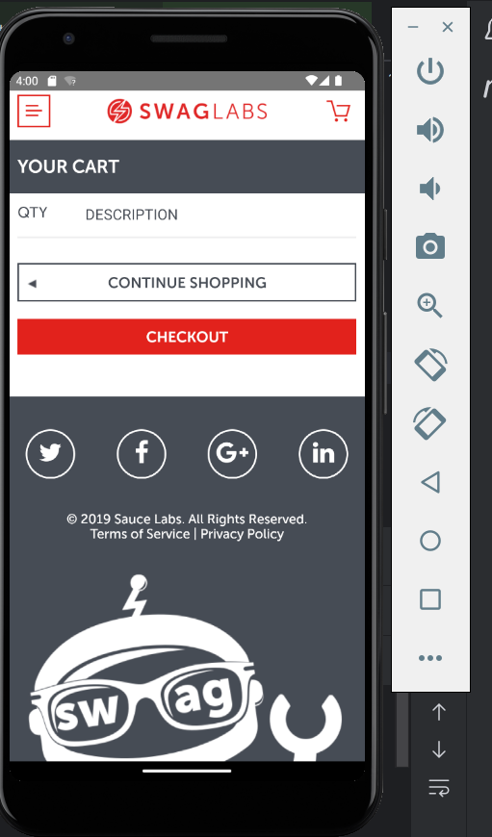

**2.5 Test Case #5: Online Ordering Flow**

* **Steps:**
  + Login with valid credentials.
  + Add item to cart.
  + Complete the flow until checkout.
* **Expected Outcome:**
  + Successful purchase and correct validation of price.

Status: Passed

Execution Time: 28 sec 436 ms .

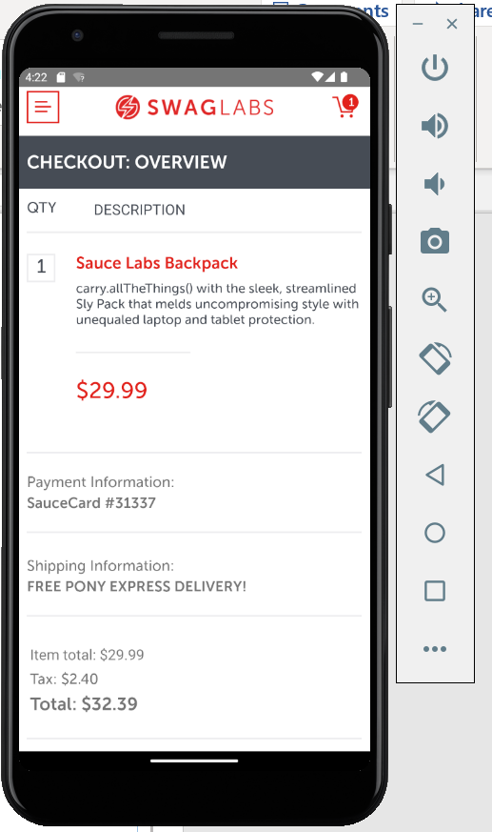 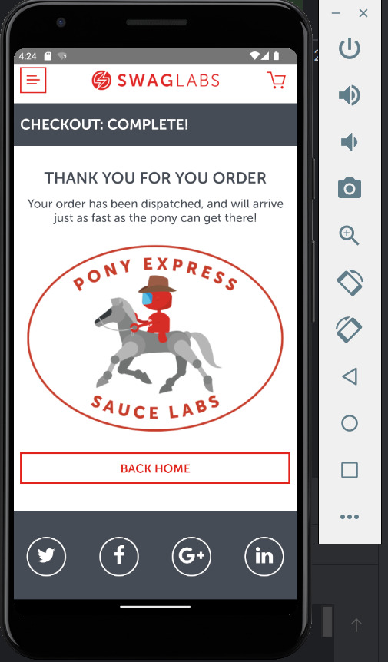

**3. Technical Implementation**

**3.1 Modular Design (Page Object Model)**

* Implemented Page Object Model (POM) for modular design.
* Separated page classes for login, home, cart, and checkout.

**3.2 GitHub Repository**

GitHub repository help us save and document the automated test and the data .

GitHub Repository Link – https://github.com/omshigwan/SauceLabsProject.git

**4. Conclusion**

The E-commerce mobile app testing project with Sauce Labs has been successfully implemented with a robust stack of technologies and tools. The use of Appium, TestNG, POM, Git, and Microsoft Word for documentation ensures efficient and reliable testing practices. The project is available on GitHub, and the report provides insights into the testing process.