Github link : https://github.com/omshinde-alt07/Week_2_Assignment

Q1: Conceptual — Explain virtual environments
Ans : A Python virtual environment is an isolated workspace that keeps a project’s dependencies separate from the system Python and other projects. Developers use virtual environments to avoid version conflicts and ensure each project runs with the exact libraries it needs. If you don’t use one, installing or upgrading a package for one project can break another project that depends on a different version.
It’s like having separate toolkits for different jobs instead of mixing all tools in one box and risking the wrong tool being used.

Q2: Coding — Fix and improve this code
Ans:
- Multiple imports on one line — Poor style (import os, sys, json).
- Unused imports — os and json are not used.
- Function naming style — checkVersion() should be check_version() (PEP 8).
- Unused variable — temp = 42.
- Missing main guard / script structure — Code runs on import; not ideal for Pylint.

Q3: Debug/Analyze
Ans:
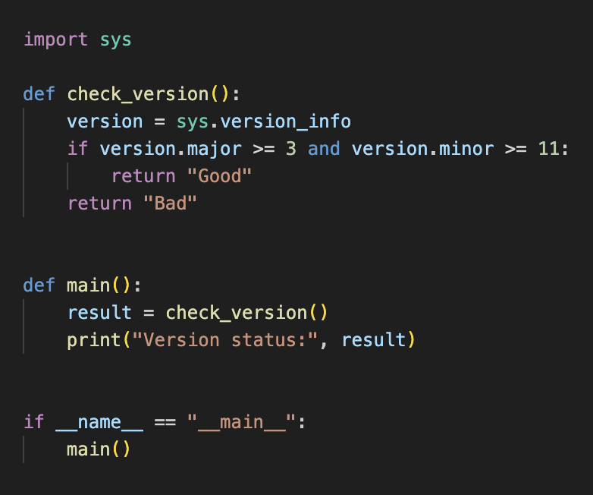

Q3: Debug / Analyze — numpy ModuleNotFoundError
Ans:

Cause 1: Installed in a different Python environment
Diagnostic :
python -c "import sys; print(sys.executable)"
pip --version

If paths differ → numpy installed in another environment.

Cause 2: Virtual environment not activated
Diagnostic :
which python
which pip
If they point to system Python instead of the virtual environment, activate it:
source venv/bin/activate

Cause 3: Installed for a different Python version
Diagnostic
python -m pip show numpy
If not found:
python -m pip install numpy

Q. 4 Use ChatGPT/Claude to generate a comprehensive .pylintrc configuration file
Ans :
Prompt : consider your self as engineer Task generate a comprehensive .pylintrc configuration file for project .

Q.5 What did the AI get right? What would you change? Did it includeany rules that are too strict or too lenient for beginners?
Ans : The AI generated a well-structured and professional .pylintrc file that follows industry best practices. It correctly included important configurations such as ignoring virtual environments and build folders, setting a maximum line length of 88 to match Black formatting, and enabling parallel jobs for faster linting. The naming conventions and complexity limits (like maximum arguments, branches, and statements) are useful for maintaining readable and maintainable code. Overall, the configuration is practical for real-world projects and helps developers maintain a good code quality standard.
However, a few changes could make it more beginner-friendly. The configuration disables missing docstring warnings, which might reduce the habit of writing proper documentation. For students or beginners, keeping at least function docstrings enabled would encourage better coding practices. Also, some design limits such as max-branches and max-statements may feel strict for learners who are still understanding code structure. On the other hand, ignoring duplicate-code warnings might be too lenient, as beginners should learn to avoid repetition early.
In conclusion, the configuration is strong for professional use, but for beginners, it should be slightly simpler with more emphasis on documentation and learning-oriented feedback.

