**Students’ Self Declaration for Open Source libraries and other source code usage in Minor Project**

We Mukund Madhav Goyal, Punit Jain and Shivam Singhal hereby declare the following usage of the open source code and prebuilt libraries in our minor project in V Semester with the consent of our supervisor. We also measure the similarity percentage of pre written source code and our source code and the same is mentioned below. This measurement is true with best of our knowledge and abilities.

1. List of pre build libraries:
   * Tesseract.js – This is a Javascript library which is works as an OCR to get text from the images automatically.

* + Speech to Text – This would be used to convert audio to text.

1. List of pre build features in libraries or in source code.
   1. Tesseract.js – We will used the text recognition feature of the library.
   2. Speech to Text – We might use the speech recognition feature.

1. Percentage of pre written source code and source written by us.

Source code written by us : near to 95%

Source code pre written : approx 5% (using libraries)

Signature (Supervisor):

Signature (Students):-

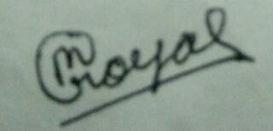

Mukund Madhav Goyal 181013138

Punit Jain 18103142

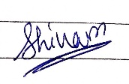

Shivam Singhal 18103149