


DEPARTMENT OF COMPUTER SCIENCE & ENGINEERING
(Accredited by NBA Tier 1: 2025-2028)

Major Project Phase-II [22CS81]

Report on

AI-Powered Assistive Technologies for the Visually Impaired

Submitted in partial fulfillment for the award of the Degree of

Bachelor of Engineering in
Computer Science and Engineering

Submitted by
Sunder Bharti 1DS22CS221
Ajay Rathod 1DS23CS401
Om Shivarjun TM 1DS23CS417
Shrilaxmi Pattar 1DS23CS420

Under the Guidance of
Dr. Nagaraju Y Assistant Professor
Department of Computer Science and Engineering DSCE, Bengaluru

VISVESVARAYA TECHNOLOGICAL UNIVERSITY JNANASANGAMA, BELAGAVI-590018, KARNATAKA, INDIA 2025-26

DEPARTMENT OF COMPUTER SCIENCE & ENGINEERING
(Accredited by NBA Tier 1: 2025-2028)


CERTIFICATE

Certified that the project report entitled “AI-Powered Assistive Technologies for the Visually Im- paired” carried out by Sunder Bharti bearing a USN:1DS22CS221, Ajay Rathod bearing a USN:1DS23CS401, Om Shivarjun TM bearing a USN:1DS23CS417, Shrilaxmi Pattar bearing a USN:1DS23CS420 a bonafide student of DAYANANDA SAGAR COLLEGE OF ENGINEERING,
an autonomous institution affiliated to VTU, Belagavi in partial fulfillment for the award of Degree of Bachelor of Computer Science and Engineering during the year 2025-2026. It is certified that all cor- rections/suggestions indicated for Internal Assessment have been incorporated in the report deposited in the departmental library. The Project Phase-II report has been approved as it satisfies the academic re- quirements with respect to the work prescribed for the said Degree.

Signature of the Guide
Dr. Nagaraju Y Assistant Professor Dept. of CSE, DSCE Bengaluru
Name of the Examiners

- ...........................................
- ...........................................
Signature of the HoD
Dr. Ramesh Babu D R
Vice Principal & HOD Dept. of CSE, DSCE, Bengalur
Signature of the Principal
Dr. B G Prasad Principal
DSCE, Bengaluru

Signature with date

..........................................
..........................................

DEPARTMENT OF COMPUTER SCIENCE & ENGINEERING
(Accredited by NBA Tier 1: 2025-2028)


DECLARATION

We, Sunder Bharti(1DS22CS221), Ajay Rathod(1DS23CS401), Om Shivarjun TM(1DS23CS417) and Shrilaxmi Pattar(1DS23CS420), respectively, hereby declare that the project work entitled “AI- Powered Assistive Technologies for the Visually Impaired” has been independently done by us under the guidance of Dr. Nagaraju Y, Assistant Professor, CSE department and submitted in partial fulfill- ment of the requirement for the award of the degree of Bachelor of Computer Science and Engineering at Dayananda Sagar College of Engineering, an autonomous institution affiliated to VTU, Belagavi during the academic year 2025-2026.
We further declare that we have not submitted this report either in part or in full to any other university for the award of any degree.

Sunder Bharti 1DS22CS221
Ajay Rathod 1DS23CS401
Om Shivarjun TM 1DS23CS417
Shrilaxmi Pattar 1DS23CS420

PLACE: DATE:

ACKNOWLEDGEMENT

The satisfaction and euphoria accompanying the successful completion of any task would be incomplete without the mention of people who made it possible under constant guidance and encouragement. We sincerely thank the Management of Dayananda Sagar College of Engineering, Bengaluru.
We express our sincere regards and thanks to Dr. B G Prasad, Principal, Dayananda Sagar College of Engineering, Bengaluru. His constant encouragement guidance and valuable support have been an immense help in realizing this project.
We express our sincere regards and thanks to Dr. Ramesh Babu D R , Professor ,Vice Principal & Head, Department of Computer Science and Engineering, Dayananda Sagar College of Engineering, Bengaluru. His incessant encouragement guidance and valuable technical support have been an immense help in realizing this project. His guidance gave us the environment to enhance our knowledge, and skills and to reach the pinnacle with sheer determination, dedication, and hard work.
We would like to express profound gratitude to my guide Dr. Nagaraju Y, Assistant Professor, De- partment of Computer Science and Engineering, Dayananda Sagar College of Engineering, Ben- galuru who has encouraged us throughout the project. His moral support enabled us to complete the work successfully.
We express our sincere thanks to Project Coordinators Dr. Keerthi S, Assistant Professor and Prof Sandhya K, Assistant Professor, of the Department of Computer Science and Engineering for their continues support and guidance. We thank all teaching and non-teaching staff of the Department of Computer Science and Engineering for their kind and constant support throughout the academic journey.

Sunder Bharti 1DS22CS221
Ajay Rathod 1DS23CS401
Om Shivarjun TM 1DS23CS417
Shrilaxmi Pattar 1DS23CS420

Visual impairment continues to create major barriers in education, mobility, communication, and independent daily living. The World Health Organization reports that at least 2.2 billion people globally have near or distance vision impairment, highlighting the need for accessible assistive technologies that can support users in real-world environments. Existing solutions such as screen readers, OCR apps, voice assistants, and remote human assistance are useful, but they often work as separate tools and may fail when users need immediate help with live scenes, objects, documents, or unclear camera frames.
This project, AI-Powered Assistive Technologies for the Visually Impaired, aims to design a voice-first and camera-first assistant that runs on a normal laptop browser. The objective is to allow visually impaired users to speak naturally, point the camera toward an object, page, or surrounding scene, and receive a spoken response supported by a visible transcript. The proposed system uses a browser frontend, FastAPI backend, WebSocket communication, Qwen/DashScope realtime interaction, and a heavy vision path for OCR, object recognition, translation, page reading, and visual reasoning.
At the design level, the system follows a modular architecture consisting of browser capture, WebSocket transport, backend orchestration, intent routing, capture quality checking, realtime vision-language response, memory retrieval, web search, and self-correction logging. The low-level design includes task-specific modules for camera/microphone input, transcript display, capture coaching, SQLite-based semantic memory, and response generation. Demonstrated outcomes include live browser interaction, object recognition, OCR/math reading, transcript verification, and camera-frame guidance for glare or poor visibility. The system can support assistive reading, object identification, classroom accessibility, document understanding, and future personalized memory-based assistance. Future scope includes multi-page document sessions, broader user testing with visually impaired users, improved evaluation metrics, stronger self-correction, and deployment-ready accessibility refinement.

ABSTRACT iii
ACKNOWLEDGMENT iv
LIST OF TABLES vii
LIST OF FIGURES viii
LIST OF ABBREVIATIONS AND SYMBOLS ix
- INTRODUCTION 1
  - Overview
  - Problem Statement
  - Objectives
  - Motivation
- LITERATURE SURVEY 12
- PROBLEM ANALYSIS & DESIGN 22
  - Analysis
  - Software Requirement
  - System Architecture Diagram
  - Dataflow diagram
  - Module Description
  - Expected outcome
- IMPLEMENTATION …………………………………………………………………… 30
4.1 System Architecture Diagram
4.2 UML Diagrams Relevant for the Proposed System
4.3 Proposed Algorithm and Techniques
4.4 Tech Stack
4.5 Pseudocode
- RESULTS AND DISCUSSIONS
6.1 Experimental Results
6.2 Performance Analysis (Graphs / Metrics)

CONCLUSION AND FUTURE SCOPE 32
  - Conclusion
  - Future Scope

REFERENCES
LITERATURE SURVEY PAPER PLAGIARISM REPORT
PUBLICATION DETAILS – CONFERENCE PROOF

LIST OF FIGURES

Fig. No. | Fig. Caption | Page No.
3.1 | System architecture diagram | 20
4.1 | Frontend Code Snippets | 24
4.2 Backend Code Snippets 25

5.1 Memory_Output 31

5.2 OCR_Output 32

5.3 Object_Recognition_Output 32

LIST OF ABBREVIATIONS

Abbreviation Full Description
Artificial Intelligence (Technology that enables machines to perform tasks requiring human intelligence).
AI
Machine Learning (A subset of AI that allows systems to learn from data automatically).
ML
Natural Language Processing (A branch of AI focusing on interaction between computers and human language).
NLP
Computer Vision (Technology that enables machines to in- terpret and understand visual information).
CV
Optical Character Recognition (Technique used to convert printed or handwritten text into digital format).
OCR
Retrieval-Augmented Generation (Method where an AI

RAG
model retrieves external data to generate accurate re- sponses).

Speech-to-Text (Technology that converts spoken speech into written text).
STT
Text-to-Speech (Technology that converts written text into spoken audio).
TTS
Graphics Processing Unit (Processor optimized for parallel computation used in AI and DL).
GPU
Application Programming Interface (A set of rules that al- lows software applications to communicate).
API

CHAPTER 1

Introduction

Overview

Visual impairment is not only a medical condition; it is a daily challenge that affects how a person moves, reads, communicates, studies, and interacts with the surrounding environment. Simple activities such as identifying an object on a table, reading a printed document, recognizing text on a label, understanding what is in front of the camera, or asking for clarification about a visual scene can become difficult without external support. For visually impaired users, access to timely and accurate information is essential for independence, confidence, and participation in education, work, and daily life.
Traditional assistive tools such as white canes, Braille materials, guide dogs, and audio-based instructions have played an important role in supporting visually impaired individuals. These tools are reliable and widely understood, but they also have limitations. A white cane can detect the presence of an obstacle but cannot describe what the obstacle is. Braille is useful for users who are trained in it, but it cannot help with arbitrary printed documents, handwritten notes, signs, or digital content shown in the environment. Similarly, human assistance can provide rich guidance, but it may not always be available and may raise privacy concerns when the user needs help with personal documents or surroundings.
The proposed system uses a modular architecture. A browser-based frontend captures microphone input and camera frames, while a FastAPI backend handles communication, routing, and processing. A WebSocket connection supports real-time interaction between the browser and backend. The system uses a Qwen/DashScope realtime model path for low-latency voice and visual conversation, and a heavy vision path for tasks that require more detailed analysis, such as OCR, document reading, object recognition, translation, and visual reasoning. To improve reliability, a capture coach checks whether the camera frame is affected by blur, glare, darkness, poor cropping, or weak alignment before sending it for visual analysis. This helps reduce incorrect answers caused by unclear images.

Recent advances in artificial intelligence have created new possibilities for assistive technologies. Computer vision, optical character recognition, speech recognition, natural language processing, large language models, and multimodal AI systems can now work together to interpret images, understand spoken questions, read text, identify objects, and generate natural-language responses. These technologies make it possible to build systems that do not simply detect visual information, but also explain it in a way that is useful to the user
This project, AI-Powered Assistive Technologies for the Visually Impaired, is developed with the aim of combining voice interaction and camera-based visual understanding into a single accessible system. The system is designed as a browser-native voice and vision assistant that can run on a normal laptop using its built-in microphone and camera. Instead of requiring the user to switch between different applications, the user can speak naturally and point the camera toward an object, document, or scene. The assistant then processes the request and provides a spoken response along with a transcript for verification.
The proposed system uses a modular architecture. A browser-based frontend captures microphone input and camera frames, while a FastAPI backend handles communication, routing, and processing. A WebSocket connection supports real-time interaction between the browser and backend. The system uses a Qwen/DashScope realtime model path for low-latency voice and visual conversation, and a heavy vision path for tasks that require more detailed analysis, such as OCR, document reading, object recognition, translation, and visual reasoning. To improve reliability, a capture coach checks whether the camera frame is affected by blur, glare, darkness, poor cropping, or weak alignment before sending it for visual analysis. This helps reduce incorrect answers caused by unclear images.
The system also includes supporting components such as SQLite-based semantic memory, web search, transcript verification, and self-correction logging. The memory component allows the system to store and retrieve useful user-specific information. Web search can be used when the user asks for current or external information. Transcript verification helps the user or evaluator review what the assistant understood and answered. Self-correction logging supports future improvement by recording user feedback and incorrect responses.
Although AI-powered assistive systems have become more capable, several challenges remain. Models may perform differently under poor lighting, crowded scenes, regional languages, handwritten text, and low-quality camera frames. Privacy is also important because the system uses live camera and microphone input. Cost and accessibility must be considered so that the solution can work on commonly available hardware rather than requiring expensive dedicated devices. This project addresses these concerns by focusing on a laptop-browser-based design.
Recent advances in artificial intelligence have created new possibilities for assistive technologies. Computer vision, optical character recognition, speech recognition, natural language processing, large language models, and multimodal AI systems can now work together to interpret images, understand spoken questions, read text, identify objects, and generate natural-language responses. These technologies make it possible to build systems that do not simply detect visual information, but also explain it in a way that is useful to the user.
Overall, AI-Powered Assistive Technologies for the Visually Impaired aims to provide an integrated assistive platform that supports real-world tasks such as scene understanding, object identification, OCR-based reading, document interaction, memory recall, and spoken guidance. The goal is not only to recognize visual information, but to convert it into meaningful, timely, and accessible assistance for visually impaired users.

Problem Statement
People with visual impairment face several difficulties in daily life because much of the information around them is visual. Activities such as reading printed text, identifying objects, understanding surroundings, recognizing useful signs, checking documents, and asking questions about what is in front of them can become challenging without assistance. These tasks are simple for sighted users, but for visually impaired users they often require help from another person, a separate assistive device, or multiple mobile applications. This dependency can reduce independence, confidence, privacy, and ease of participation in academic, personal, and public environments.

Although many assistive technologies are available, most of them are designed for a single purpose. Screen readers mainly support digital text, OCR applications focus on reading printed text, object-recognition tools identify selected objects, and remote assistance platforms depend on human helpers. In real-world use, this creates a fragmented experience because the user must switch between different tools for different tasks. These systems may also face practical limitations such as delayed response, weak contextual understanding, poor performance under low light or glare, lack of memory across interactions, and limited support for natural follow-up questions.
Another major problem is camera-frame quality. A visually impaired user may not always know whether the object or document is properly visible, whether the camera is too close or too far, or whether the frame is affected by blur, glare, darkness, or poor alignment. If an AI model processes such unclear visual input directly, it may generate incomplete or incorrect responses. Therefore, an assistive system must not only understand the scene, but also guide the user when the captured frame is not suitable.
To address these limitations, this project titled AI-Powered Assistive Technologies for the Visually Impaired proposes an integrated voice and vision assistant that combines speech interaction, camera-based visual understanding, OCR, object recognition, scene description, memory, web search, transcript verification, and self-correction into one platform. The system is designed to run through a normal browser using a laptop camera and microphone. A FastAPI backend communicates with the browser through WebSocket, while Qwen/DashScope realtime and heavy-vision paths handle low-latency conversation and detailed visual analysis. A capture coach checks frame quality before visual inference, and SQLite-based semantic memory supports personalized interaction. By bringing these functions together, the system aims to provide real-time, meaningful, and accessible support that helps visually impaired users interact with their surroundings more independently

Objective
The main objective of this project is to design and develop an intelligent Voice and Vision Assistantthat can support blind and visually impaired users in their day-to-day activities through natural voice interaction and real-time visual understanding. The system aims to reduce dependency on others by combining multiple assistive functions such as scene understanding, text reading, object awareness, and contextual response into a single integrated platform. The following objectives define the major goals of this project:
- To study the practical difficulties faced by blind and visually impaired users in accessing visual information from their surroundings during everyday activities.
- To develop a speech-based interaction system that allows users to communicate with the assistant naturally through voice commands and receive spoken responses.
- To implement computer vision techniques for understanding scenes, detecting important objects, and estimating environmental context to improve user awareness.
- To integrate OCR functionality for reading printed and visible text from the environment and converting it into accessible spoken output.
- To enable visual question answering so that users can ask specific questions about what is present in front of them and receive meaningful answers.
- To incorporate memory mechanisms that can retain session context and important past information in order to support more personalized and continuous interaction.
- To evaluate the effectiveness, usability, and limitations of the proposed system in providing practical support for visually impaired users.

Motivation

The motivation for this project arises from the real-life challenges faced by blind and visually impaired individuals in understanding and interacting with the world around them. Everyday activities such as reading printed text, identifying objects, recognizing people, understanding scenes, or asking for help in unfamiliar environments often require external assistance. This dependence can limit confidence, mobility, and independence in daily life. The need for a system that can provide timely, meaningful, and accessible support is therefore very important.
Another major motivation behind this work is the limitation of existing assistive technologies. Many currently available solutions are designed for only one specific task, such as text reading, navigation, or object detection, and do not provide a complete assistive experience. As a result, users may need to depend on multiple tools, which makes the process inconvenient and less practical. This project is motivated by the idea of creating a single unified assistant that can combine voice interaction, visual understanding, contextual question answering, and memory into one platform.
The rapid progress in Artificial Intelligence, especially in the fields of computer vision, speech processing, and multimodal systems, has made it possible to design more advanced assistive applications than before. Technologies such as OCR, scene understanding, object detection, vision-language models, and text-to-speech systems can now work together to provide real-time support in a more natural and human-friendly way. This creates a strong opportunity to build a smart assistant that is not only functional but also interactive and context-aware.
A further motivation for this project is to make assistive technology more practical and accessible by using commonly available computing resources and modular AI components. Instead of depending entirely on expensive dedicated devices, this approach explores how modern AI tools can be integrated into a flexible system that supports visually impaired users more effectively. Ultimately, the project is driven by the goal of improving accessibility, reducing dependency on others, and helping visually impaired individuals carry out daily activities with greater safety, confidence, and independence

CHAPTER 2

Literature Review

The development of assistive technologies for blind and visually impaired users has progressed significantly with the growth of artificial intelligence, computer vision, speech processing, optical character recognition, and multimodal large language models. Earlier assistive systems mainly focused on single functions such as screen reading, obstacle detection, printed text recognition, or human-assisted navigation. These systems were useful within their own limited scope, but they did not always provide a complete and continuous assistive experience.
For visually impaired users, daily interaction with the world involves multiple types of visual tasks. A user may need to read a printed document, identify an object, understand a scene, ask a question about what is in front of them, search for related information, or recall a previously stored fact. A single-purpose assistive tool cannot easily support all these needs. Therefore, recent research has moved toward multimodal systems that combine camera input, speech interaction, visual question answering, OCR, memory, and natural-language response generation.
This chapter reviews the major research areas that support the design of AI-Powered Assistive Technologies for the Visually Impaired. The reviewed works are grouped into important themes: traditional assistive technologies, OCR and document reading, visual question answering, speech-based interaction, vision-language models, browser-based realtime communication, memory and retrieval, capture-quality guidance, web search, and self-correction. The purpose of this literature review is not only to study existing systems, but also to identify the gaps that motivated the proposed project.
2.1 Traditional Assistive Technologies for the Visually Impaired
Traditional assistive tools such as white canes, Braille materials, screen readers, audio instructions, and guide dogs have supported visually impaired users for many years. These tools are reliable and widely accepted, but each of them solves only a specific part of the accessibility problem. A white cane helps detect physical obstacles, but it cannot describe what an object is. Braille allows trained users to read tactile text, but it cannot help with printed documents, handwritten notes, or labels in the environment. Screen readers are effective for digital content, but they cannot interpret physical scenes captured through a camera.
Several studies in assistive technology show that users require more than simple detection. They need meaningful descriptions, context-aware guidance, and natural interaction. For example, knowing that an object is present is less useful than knowing what the object is, where it is located, and whether it is relevant to the user’s current task. This observation directly supports the need for a voice and vision assistant that can combine object awareness, OCR, scene explanation, and spoken response generation.
In the proposed project, traditional assistive concepts are extended through AI-based perception and voice interaction. Instead of depending only on fixed hardware or single-task tools, the system uses a normal laptop camera and microphone to provide interactive support through a browser. This makes the solution more accessible for educational and demonstration environments.
2.3 OCR-Based Text Reading and Document Understanding
Optical Character Recognition is one of the most important areas in assistive technology because printed text is present in books, labels, signs, forms, medicines, classroom notes, and documents. Existing OCR systems convert visual text into machine-readable text, which can then be read aloud using text-to-speech. Many assistive reading tools use this approach to help visually impaired users access printed information.
However, OCR systems often depend heavily on image quality. Text may not be recognized correctly if the image is blurred, tilted, too dark, affected by glare, or partially cropped. This is a major issue for visually impaired users because they may not know whether the camera is properly aligned with the page. A sighted user can easily adjust the frame, but a blind or low-vision user needs spoken guidance.
This limitation strongly motivates the capture coach in the proposed project. In AI-Powered Assistive Technologies for the Visually Impaired, the system does not directly process every camera frame as if it were reliable. Instead, it checks for poor capture conditions such as glare, blur, low light, and weak framing. If the frame is not suitable, the assistant gives spoken guidance before attempting OCR-style reading. This helps reduce incorrect responses and improves the practical usefulness of OCR in real-world conditions.
The proposed system uses a heavy-vision model path for OCR-style reading and document understanding. This path is suitable for tasks such as reading printed text, interpreting documents, understanding classroom material, and answering questions about visible text.
2.4 Object Recognition and Scene Understanding
Object recognition helps visually impaired users identify items in their surroundings, such as bottles, phones, books, bags, medicine packets, or household objects. Earlier computer-vision systems often used object-detection models to locate and classify objects in an image. These systems are useful, but object labels alone are not always enough. For assistive use, the user usually needs a meaningful explanation, such as what the object is, where it is located, and whether it is relevant to the user’s question.
Scene understanding goes beyond object recognition. It attempts to describe the environment as a whole, including object arrangement, spatial relationships, and general context. For example, instead of saying only “bottle” and “phone,” a useful assistant might say, “There is a phone on the table near a metal water bottle.” Such descriptions are more helpful because they convert raw visual detection into user-friendly information.
The proposed project uses camera input and multimodal vision-language understanding to support object recognition and scene description. The system is designed so that a user can ask questions such as “What is in front of me?”, “What object is this?”, or “Can you describe the scene?” The assistant processes the current camera view and returns a spoken response along with a transcript.
Unlike systems that rely only on object-detection labels, the proposed assistant focuses on natural-language explanation. This is important because visually impaired users need responses that are understandable, concise, and relevant to their spoken request.
2.5 Visual Question Answering for Blind Users
Visual Question Answering is a research area where a system answers natural-language questions about an image. This is highly relevant for visually impaired users because they may not need a full scene description every time. Instead, they may ask a specific question such as “What is written here?”, “Is there a bottle in front of me?”, “What color is this object?”, or “Can you read this page?”
Datasets such as VizWiz have shown that images captured by blind users are often different from standard computer-vision datasets. They may be poorly framed, blurred, dark, or incomplete. This means that general image-understanding systems may not work well unless they are designed with blind-user capture conditions in mind. The literature in blind-user VQA highlights that assistive AI must handle imperfect images and must also know when not to answer confidently.
This finding is directly reflected in the proposed system. AI-Powered Assistive Technologies for the Visually Impaired includes a capture-quality checking step before heavy visual reasoning. If the image is unclear, the system guides the user to improve the frame instead of giving a possibly wrong answer. This makes the system more suitable for real-world assistive use.
The project also supports follow-up style interaction. Since the user communicates through speech, they can ask a visual question naturally, receive a spoken answer, and continue the interaction without switching tools.
2.6 Speech-Based Interaction and Spoken Response
Speech interaction is essential for visually impaired users because it reduces dependency on visual menus, typing, and screen-based navigation. Voice assistants have already shown that natural speech can be an effective interface for general tasks. However, most voice assistants are not strongly grounded in live camera input. They may answer general questions, but they cannot reliably describe a physical scene or read text from the user’s surroundings without visual integration.
In the proposed project, speech is not just an add-on feature; it is the primary mode of interaction. The user speaks a command or question, and the system responds through spoken output. A transcript panel is also provided for verification, testing, and demonstration. This dual output is useful because the spoken response supports accessibility, while the transcript helps evaluators confirm what the system understood and answered.
The system uses a realtime voice and vision path for low-latency interaction. This path is suitable for quick questions, short scene descriptions, and conversational responses. For more complex visual tasks such as OCR and document understanding, the system can use the heavy-vision path. This division improves both responsiveness and accuracy.

2.7 Multimodal Vision-Language Models
Recent multimodal models can process text, images, and sometimes audio within the same interaction. These models have improved the ability of AI systems to describe images, answer visual questions, read text, and reason about objects. Vision-language models are especially useful in assistive technology because they can convert visual input into natural language that is easier for users to understand.
However, model capability alone is not enough for assistive use. A model may perform well on benchmark datasets but still fail in practical conditions if the camera frame is poor, if the user’s question is ambiguous, or if the system does not route the task properly. For example, a quick scene description and a detailed OCR task require different processing strategies.
The proposed system uses a dual-path model strategy. A realtime Qwen/DashScope path supports low-latency voice and visual interaction, while a heavy-vision path supports detailed visual analysis such as OCR, object recognition, translation, page reading, and comparison. This design is inspired by the need to balance speed and accuracy.
By separating quick conversational tasks from detailed visual tasks, the system avoids using a single model path for every situation. This improves system organization and makes the assistant more practical for different types of user requests.

2.8 Browser-Based Realtime Communication
Many assistive systems are developed as mobile applications or device-specific tools. While these can be powerful, they may require installation, configuration, or dedicated hardware. A browser-based system offers a more accessible alternative because it can run on a normal laptop using standard camera and microphone access.
The proposed project uses a browser frontend and a FastAPI backend. The browser captures camera frames and microphone input, while the backend manages model communication, routing, and response generation. A WebSocket connection is used to support realtime communication between the frontend and backend. This is important because voice-based interaction requires quick exchange of audio, visual data, and responses.
The WebSocket route allows the browser to send audio turns and optional image frames to the backend. The backend then forwards the request to the appropriate AI model path and returns the assistant’s response. This architecture keeps the API key and model communication on the server side, which is safer than exposing them directly in the browser.
The literature on web-based realtime systems supports the use of persistent bidirectional communication when low-latency interaction is required. For this project, WebSocket communication helps create a continuous assistive loop between the user and the AI assistant.

2.9 Memory and Retrieval in Assistive Systems
Memory is an important requirement for personalized assistance. Without memory, the system treats every interaction as new. This forces users to repeat information such as names, preferences, frequently used objects, or previous corrections. For visually impaired users, repeated speech input can become tiring and inefficient.
Research on retrieval-augmented generation and semantic memory shows that stored information can improve response relevance. Instead of relying only on the model’s internal knowledge, the system can retrieve relevant user-specific facts from a memory store and include them in the response. This is useful for questions such as “What did I ask you to remember?”, “Who is my doctor?”, or “What object did I save earlier?”
The proposed project uses SQLite-based semantic memory. User facts and interaction context can be stored locally, and embeddings can be used for similarity-based retrieval. This approach avoids the need for an external vector database and is suitable for the project scale. It also supports privacy because important user-specific information can remain in local storage.
Memory makes the assistant more useful over time because it can support continuity across sessions and reduce repeated explanations from the user.

2.10 Web Search and External Information Access
Some user questions require information beyond what is visible in the camera frame. For example, a user may ask about a product, a sign, a document topic, or current information related to an object. In such cases, visual understanding alone is not enough. The assistant may need to identify the visible object or text and then perform a web search to retrieve updated information.
The proposed system includes a web search route as part of the backend architecture. When the user asks for external information, the system can route the request to the search component, retrieve relevant results, and generate a spoken summary. This extends the assistant beyond simple scene description and OCR.
For visually impaired users, this capability is useful because it connects physical-world understanding with online information. For example, the user may point the camera at an object and ask for more details about it. The system can use visual understanding to support the query and then provide an accessible spoken response.

2.11 Capture Quality Guidance
A major limitation in many assistive vision systems is the assumption that the input image is clear. In real use, this assumption is often false. A visually impaired user may accidentally point the camera away from the object, hold the page at an angle, capture only part of the document, or take an image under poor lighting. If the system processes such images without checking quality, it may produce inaccurate or misleading results.
Capture quality guidance is therefore an important part of the proposed system. The capture coach checks whether the frame is affected by common problems such as low light, blur, glare, cropping, poor alignment, or insufficient visible content. If the image is weak, the system gives spoken instructions such as asking the user to move closer, improve lighting, hold the camera steady, or reposition the document.
This design improves trust because the assistant does not pretend to understand unclear images. Instead, it helps the user capture better input before generating an answer. This is especially important in OCR and document-reading tasks, where small visual errors can change the meaning of the text.

2.12 Self-Correction and Feedback Logging
Assistive systems must be adaptable because users may have different preferences for response length, detail level, and correction style. A visually impaired user may want shorter answers in some situations and more detailed explanations in others. The system may also make mistakes, and the user should be able to correct it.
The proposed project includes a self-correction or reflection logging mechanism. When the user gives feedback or corrects a response, the system can store that correction in a local log. This can help improve future responses by adjusting prompts, response style, or caution level. The goal is not to retrain the model directly, but to make the assistant more responsive to user feedback during interaction.
This feature supports a more human-centered assistive experience. Instead of treating mistakes as isolated failures, the system records them and uses them as signals for future improvement.

2.13 Summary of Literature Review
The literature review shows that AI has significantly improved assistive technologies for visually impaired users. OCR helps convert printed text into speech, visual question answering allows users to ask questions about images, object recognition supports environmental awareness, speech interfaces improve accessibility, and memory systems support personalization. Multimodal models further improve the possibility of combining these capabilities into one assistant.
However, the review also shows that many existing systems remain limited. Some focus only on OCR, some only on object detection, some depend on human assistance, and some lack memory or contextual continuity. Many systems also do not handle poor camera frames effectively, which is a serious issue for blind and visually impaired users.

CHAPTER 3

Problem Analysis and Design
  - Analysis
The development of an assistive system for visually impaired users requires a clear understanding of the user’s practical challenges, system requirements, and the technologies that can provide reliable support. A visually impaired user may need help with different tasks such as reading a printed page, identifying an object, understanding a scene, asking a question about what is in front of them, or receiving guidance when the camera frame is unclear. Therefore, the system must not be limited to one isolated function. It should combine voice interaction, camera-based visual understanding, OCR-style reading, object recognition, contextual response generation, memory, and correction support into one accessible platform.
The proposed project, AI-Powered Assistive Technologies for the Visually Impaired, is designed as a browser-native voice and vision assistant. The user interacts with the system mainly through speech, while the laptop camera provides visual input. The system processes the user’s spoken request, captures the required camera frame, routes the task to the correct processing path, and provides a spoken response along with a transcript for verification.
The analysis phase focuses on identifying what the system must do, what constraints it must handle, and how the modules should cooperate. Since visually impaired users may not always know whether the camera frame is clear, the system also requires a capture-quality checking mechanism. This makes the system more reliable because it can guide the user to improve the frame before giving an answer from weak visual input.

Problem Understanding
Visually impaired individuals face difficulties in accessing visual information from their surroundings. Tasks such as reading printed text, recognizing objects, understanding the layout of a scene, identifying useful signs, or asking questions about visible content often require assistance. Traditional tools such as white canes, screen readers, Braille materials, and human assistance are useful.

The main problem is that most existing assistive solutions are fragmented. A screen reader helps with digital content, an OCR tool reads printed text, a remote assistance service depends on another person, and a general voice assistant may answer non-visual questions. However, visually impaired users often need all these capabilities together in one continuous interaction. They may ask the system to read a page, identify an object, describe a scene, remember a fact, search for information, or correct a previous response.
Another important problem is the quality of visual input. If the camera frame is blurred, dark, overexposed, cropped, or poorly aligned, the system may give an incomplete or wrong answer. This is especially serious for visually impaired users because they may not be able to verify whether the camera is pointed correctly. Therefore, the system must not only analyze images, but also help the user capture better images.
The proposed system addresses these problems by providing a unified assistant with voice interaction, browser-based camera capture, AI-based visual understanding, capture coaching, semantic memory, web search, transcript verification, and self-correction logging.

System Requirements
To design an effective assistive system, the following requirements were identified:
Functional Requirements
- The system should accept user input through natural voice commands using the browser microphone.
- The system should capture camera frames from the browser whenever the user requests scene description, object recognition, OCR-style reading, translation, or visual question answering.
- The system should support real-time communication between the browser frontend and backend using a WebSocket connection.

- The system should use a FastAPI backend to coordinate requests, manage routes, handle model interaction, and return responses to the frontend.
- The system should identify the user’s intent and route the request to the correct module, such as realtime conversation, heavy vision processing, memory recall, web search, or correction logging.
- The system should support scene understanding by describing what is visible in the camera frame.
- The system should support object recognition by identifying important objects in the user’s surroundings.
- The system should support OCR-style text reading for printed text, handwritten expressions, labels, documents, and visible text in the environment.
- The system should support visual question answering so that the user can ask specific questions about the current camera view.
- The system should include a capture coach to detect poor visual conditions such as blur, glare, low light, poor framing, and incomplete document visibility.
- The system should provide spoken output to the user and also display a transcript panel for verification.
- The system should maintain useful memory using SQLite-based semantic storage so that important user facts and previous interaction context can be retrieved later.
- The system should support web search for queries that require external or current information beyond the visible camera frame.
- The system should support self-correction by logging user feedback and incorrect responses for future improvement.

Non-Functional Requirements
- The system must be easy to use for blind and visually impaired users through a simple speech-first interaction model.
- The system must be easy to use for blind and visually impaired users through a voice-first interaction model.
- The system should run on standard consumer hardware, such as a normal laptop with a camera, microphone, and speaker.
- The system should avoid dependence on expensive dedicated wearable devices.
- The system should provide fast responses for conversational tasks and more detailed responses for OCR and document-based tasks.
- The system should be modular so that components such as the intent router, capture coach, memory store, and search module can be improved independently.
- The system should be privacy-aware by keeping backend control over API keys and storing user memory locally using SQLite.
- The system should handle weak camera frames safely by asking the user to improve the image instead of generating unreliable answers.
- The system should provide clear transcript output so that responses can be verified during testing and demonstration.
- The system should be maintainable and extensible for future features such as document sessions, stronger memory retrieval, and improved self-correction.
- The system should handle errors gracefully, such as network issues, model response failures, or invalid user requests.

3.3 System Architecture
The proposed Voice and Vision Assistant is designed using a modular, event-driven architecture in which each layer performs a specific role in the overall assistive process. The system begins with the voice interaction layer, where the user gives a spoken command. LiveKit manages the real-time audio stream, Silero VAD detects speech activity, and Deepgram converts the speech into text.
The transcribed command is then passed to an intent routing layer, which decides which assistive feature needs to be activated. Based on the user’s request, the system invokes modules such as OCR, object detection, scene understanding, visual question answering, face-aware interaction, memory retrieval, or internet search.
For advanced vision-language tasks, the request is sent to the main model hosted through Ollama on Google Colab, while a smaller local model acts as a fallback when the cloud service is unavailable. The processed result is then passed to the response layer, where ElevenLabs converts the output text into natural speech and returns it to the user. Supporting this workflow are additional local modules such as YOLOv8n for object detection, MiDaS for depth estimation, FAISS and SQLite for memory storage, and FastAPI for backend coordination. All these components work together to create a unified speech-based assistive system that is practical, extensible, and suitable for real-world use on standard hardware.

Core Components

The proposed system uses a modular, browser-based architecture in which each layer performs a specific role in the assistive workflow. The system begins with the user speaking a command through the browser. The browser captures microphone input and camera frames, then communicates with the backend through a WebSocket connection. The backend receives the request, determines the user’s intent, checks the quality of the visual input when required, routes the task to the appropriate AI path, and returns the final response as spoken output and transcript text..

The architecture is organized into the following layers:

Input Queue
This is where each agent receives tasks sent by the main controller or orchestrator. For example, the system may send an image, a navigation request, or a user command de- pending on what the user needs at that moment.

Processing Logic
Each agent contains its own AI or machine learning model. This is the core part of the agent, where the real computation happens such as detecting objects, reading text, identi- fying faces, or analyzing scenes.

Output Queue
Once processing is complete, the agent sends the result back to the orchestrator. The out- put often includes confidence scores, estimated distance, scene interpretation, or sug- gested actions.

State Mangement
Some agents keep track of previous interactions or user preferences. This helps the sys- tem maintain continuity for example, remembering recent obstacles, last seen people, or the user’s navigation direction.
In addition to these internal structures, the coordination between components is equally important for the overall performance of the system. A central orchestrator manages task distribution, monitors the status of each module, and ensures that the correct component is activated based on the user’s request. This coordination helps avoid unnecessary computation and improves response time by allowing only the required modules to run when needed. It also supports fault tolerance, because if one component becomes unavailable or fails to respond, the system can switch to an alternative module or fallback process. As a result, the complete architecture becomes more reliable, efficient, and suitable for real-time assistive applications where continuous support and quick decision-making are essential.

3.4 Core Components
The proposed Voice and Vision Assistant is built using a modular architecture in which each core component is responsible for a specific function within the overall assistive system. These components work together in a coordinated manner to process user speech, understand visual input, retrieve relevant information, and provide meaningful spoken responses. This modular design makes the system easier to manage, update, and extend with additional capabilities in the future.

Voice Input Component
This component handles the user’s spoken interaction with the system. It captures live audio input, detects speech activity, and converts the spoken command into text for further processing. It acts as the primary interface between the user and the assistant and enables hands-free operation.

Intent Routing Component
Once the user’s speech is transcribed, this component analyzes the command and determines which function of the system should be activated. Depending on the request, it may route the task to OCR, object detection, scene understanding, visual question answering, memory retrieval, face-aware interaction, or internet search. This helps the assistant respond appropriately based on user needs.

Vision Processing Component
This component captures and processes images from the camera whenever visual analysis is required. It supports functions such as scene understanding, object recognition, OCR-based text extraction, and visual question answering. It forms the main visual perception layer of the assistant.

Object Detection and Depth Component
This module is responsible for identifying important objects in the environment and estimating spatial context. Using models such as YOLOv8n and MiDaS, it helps the system detect surrounding items and gain better awareness of the user’s environment. This contributes to safer and more informative assistance.

OCR Component
The OCR component extracts readable text from captured images, such as signboards, labels, documents, or product information. The extracted text is then passed to the response system so that it can be spoken aloud to the user in an accessible form.

Visual Question Answering Component
This component allows the system to answer user-specific questions about the captured scene. Instead of only describing the environment in a fixed way, it supports interactive queries such as asking about objects, positions, or details present in the image. This makes the assistant more flexible and context-aware.

Memory Component
The system includes both session memory and stored memory support to maintain continuity across interactions. This component keeps track of useful past information, recent context, and retrieved knowledge so that the assistant can provide more personalized and consistent responses. It is implemented using FAISS and SQLite-based storage mechanisms.

Search and Knowledge Component
For queries that require external or background information beyond the visible scene, this component performs internet-based search and retrieves relevant knowledge. It extends the assistant’s usefulness by allowing it to answer broader user questions when required.

Speech Output Component
This component converts the final processed response into natural spoken audio using text-to-speech synthesis. It is responsible for delivering the system’s output clearly and accessibly to the user, making the overall interaction fully voice-driven.

Backend Coordination Component
This component manages communication between all other modules and ensures smooth data flow throughout the system. Using FastAPI and supporting runtime control, it coordinates requests, handles module responses, manages fallback behavior, and maintains the overall stability of the assistant.

3.5 Software Requirements
The software requirements for the proposed Voice and Vision Assistant are organized according to the different functions performed by the system. Since the project combines speech interaction, computer vision, memory, and backend coordination, it depends on a set of software tools and frameworks that work together to provide real-time assistive support for blind and visually impaired users.
Operating System and Development Environment
The system can be developed and executed on a standard laptop environment that supports Python-based AI development. A suitable operating system such as Windows 11 or Ubuntu Linux can be used, as both provide compatibility with modern machine learning frameworks, camera access libraries, and backend services. The project is implemented primarily in Python, which is chosen because of its strong ecosystem for artificial intelligence, computer vision, speech processing, and web backend development. Python also allows smooth integration of the different modules required for this assistive system.
Speech Processing and Real-Time Voice Interaction
The project uses multiple tools for speech-based interaction. LiveKit is used to manage real-time audio streaming between the user and the assistant. Silero VAD is used for voice activity detection so that the system can identify when the user starts and stops speaking. Deepgram is used for speech-to-text conversion, allowing spoken commands to be transcribed into text for further processing. For audio output, ElevenLabs is used to convert the generated textual response into natural and expressive speech. These components together form the speech-first interface of the assistant.
Vision and Image Understanding Frameworks
To process visual information from the camera, the system uses computer vision and vision-language tools. YOLOv8n is used for lightweight object detection, allowing the system to identify important objects in the surroundings. MiDaS is used for depth estimation to improve environmental awareness. For OCR-related tasks, the project uses text extraction methods that enable reading of printed text from signboards, labels, and documents. For higher-level scene understanding and visual question answering, the system uses Qwen 3.5 Vision Language Models, which are responsible for interpreting the image and generating intelligent responses based on the user’s request.
Vision-Language Model Integration
The main visual reasoning capability of the system is provided by Qwen 3.5:9B, which is hosted remotely through Ollama on Google Colab T4 and exposed using ngrok. This setup allows the project to perform more advanced scene analysis and visual question answering without depending entirely on local compute resources. To improve reliability, a smaller Qwen 3.5:2B model is maintained locally as a fallback option whenever the cloud-based model is unavailable. This combination helps balance performance and robustness.
Memory and Information Retrieval
The project includes both session-based and stored memory support in order to maintain contextual continuity. FAISS is used for efficient vector similarity search and retrieval of relevant past information. SQLite is used as a lightweight local database for storing persistent data such as memory records, logs, and configuration information. These tools allow the system to remember useful context and provide more personalized responses across interactions.
Backend and System Coordination
The backend coordination of the project is handled using FastAPI, which manages communication between different modules and exposes internal services in a structured way. FastAPI helps organize the flow between voice input, vision processing, model inference, memory access, and speech output. This makes the system modular, scalable, and easier to maintain during future development.
Search and External Knowledge Support
For certain user queries that require information beyond the visible scene, the system includes an internet search capability. This extends the usefulness of the assistant by allowing it to retrieve external information whenever necessary

3.6 Hardware Requirements
The proposed Voice and Vision Assistant requires a standard laptop or desktop system capable of supporting speech processing, image capture, backend coordination, and AI-based analysis. A device with a multi-core processor such as Intel Core i5/i7 or AMD Ryzen 5/7 is suitable for running the system efficiently. A minimum of 8 GB RAM is required, while 16 GB RAM is recommended for smoother performance during continuous usage. The system also needs sufficient storage space for software libraries, logs, local databases, and memory-related data.
For visual and audio interaction, the hardware setup must include a camera, microphone, and audio output device. A built-in or external camera is required to capture images for scene understanding, OCR, object detection, and visual question answering. A minimum 720p camera can be used, although better image quality improves system performance. Since the assistant is voice-driven, a microphone is needed for capturing user commands, and speakers or headphones are required for delivering spoken responses clearly to the user.
In addition to the local system, a stable internet connection is important because some advanced functions depend on online services and remote model access. The project can also benefit from optional GPU support for faster local inference, especially during computer vision tasks, although basic functionality can still be maintained on CPU-based systems. Overall, the hardware requirements are designed to keep the project practical and accessible while still supporting the real-time needs of an intelligent assistive system for visually

System Architecture

The system architecture of the proposed Voice and Vision Assistant is organized into multiple coordinated layers that work together to provide speech-based assistive support for blind and visually impaired users. Each layer is responsible for a specific part of the system, such as capturing user input, processing visual information, managing memory, and generating spoken responses. This layered design makes the system modular, scalable, and easier to maintain, while also allowing new assistive features to be added in the future without affecting the entire architecture.
1. User Interaction Layer
This layer acts as the direct interface between the user and the assistant. It is responsible for capturing spoken commands from the user and delivering system responses in the form of natural speech. Since the project is designed as a speech-first assistive platform, this layer plays a major role in ensuring that the interaction remains simple, hands-free, and accessible. The user communicates with the assistant through voice input, and the system responds through generated speech output without requiring complex controls or visual interaction.
At the center of this layer is the voice communication pipeline, which manages incoming speech and outgoing audio responses. LiveKit is used to handle real-time audio streaming, Silero VAD detects when the user is actively speaking, and Deepgram converts the captured speech into text. After the system processes the request, ElevenLabs converts the generated response back into spoken output. This continuous speech pipeline enables the assistant to function as an interactive conversational system.

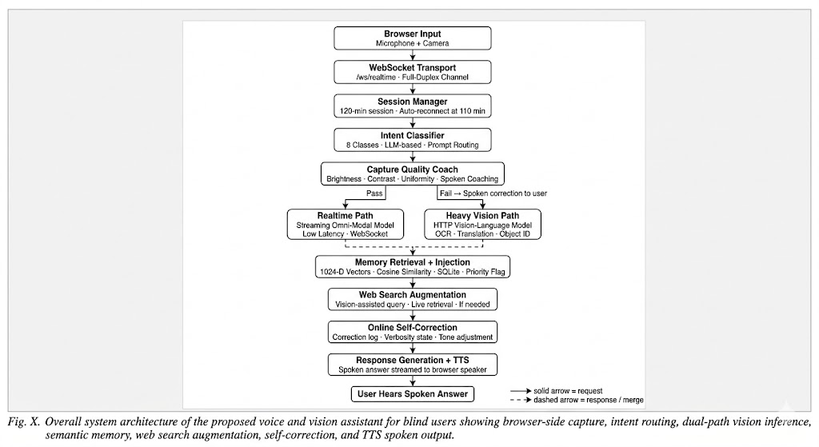

Fig 3.1 Architecture diagram

It starts at the top with the user speaking a voice command. That audio is first handled by LiveKit, which manages the real-time audio stream. Then Silero VAD checks where actual speech is present, and Deepgram Nova-3 converts that speech into text using speech-to-text. After that, the Intent Router reads the text command and decides which feature should be activated.
From there, the request is sent to the required module. On the left side, you have task modules like scene analysis, OCR, visual question answering, face recognition, internet search, long-term memory, and session memory. In the middle/right side, there are support and runtime modules such as audio event detection, action recognition, Tavus avatar, runtime health/debug, watchdog/resilience, frame pipeline, and voice pipeline. These modules process the request and send their results to the Response Generator.
For advanced visual reasoning, the system can also use the cloud path shown on the right. Through an ngrok HTTPS tunnel, the request goes to Google Colab T4 GPU, where Ollama running qwen3.5:9b handles the heavy vision-language processing. If the cloud is unavailable, the system automatically switches to the offline fallback model, which is local Ollama qwen3.5:2b.

CHAPTER 4

Implementation

Smart Overview of System Implementation
The implementation of the Smart Glasses AI System was carried out in a structured and modular manner so that each part of the project could be developed, tested, and im- proved independently. The goal was to build a real time, multi-agent framework that could process visual information, understand user intent, and provide immediate feed- back through speech or haptic signals. To achieve this, the development was divided into several stages, beginning with the setup of the core environment and progressing toward full multi-agent integration.
The first stage focused on building the real-time vision pipeline, since this is the back- bone of the entire system. Camera input, frame preprocessing, object detection, and depth estimation were implemented and optimized to ensure smooth performance at 30 FPS. This pipeline became the primary source of information for the rest of the system.
Once the vision pipeline was stable, the next step was implementing the multi-agent framework. Each agent such as the navigation agent, OCR agent, face recognition agent, and emergency agent was developed as an independent module with its own input pro- cessing logic and output handling. A central Multi Agent Coordinator was responsible for routing data, managing priorities, and synchronizing decisions across agents.
The system also required a reliable voice interface, allowing users to communicate nat- urally with the device. Real-time speech recognition and text-to-speech tools were in- tegrated so the glasses could understand spoken commands and respond instantly. Of- fline fall back components were included to maintain usability even without internet access.
To support memory, personalization, and orchestrated communication, backend com- ponents such as the vector database, message queues, and local storage system were added. These ensured smooth data flow between modules and allowed the system to retain context from previous interactions.

Finally, all components were merged into a single working prototype. Extensive testing, performance tuning, and optimizations were performed to ensure low latency and de- pendable results. The outcome is a fully functional system capable of analysing sur- roundings, interpreting complex inputs, and guiding the user in real time, all through a coordinated multi-agent architecture

Module Description
The Virtual Smart Glasses: A Multi-Agent AI System for Visual Understanding and Assistance is built from several coordinated modules that work together to provide real-time perception, interpretation, and communication. Each module op- erates as an independent component but cooperates with the others to create a seamless user experience. The sections below describe the major modules devel- oped during the implementation.

Vision Processing Module
The Vision Processing Module is the main sensory unit of the system. It continu- ously captures video from the camera and analyses every frame in real time. To understand the environment, this module uses a combination of advanced deep- learning models:
        - YOLOv8 for object detection

        - MiDaS for depth estimation

        - MediaPipe for face and pose recognition

        - EasyOCR for text extraction

With these models working together, the system can recognize objects, read signs, estimate how far obstacles are, and detect movement. All computations run on GPU-accelerated frameworks such as CUDA and TensorRT, enabling smooth performance at up to 30 FPS on a laptop GPU. This module provides the high- level visual information required by every other agent in the system.

Emergency Detection Module
The Emergency Detection Module focuses entirely on user safety. It examines the vis- ual data coming from the vision pipeline especially depth maps and object movement patterns to identify dangerous situations. Using speed estimation and distance calcula- tions, it detects threats such as:
        - Fast-approaching vehicles

        - Sudden obstacles
        - Steps or drops
        - Collision-risk objects

When a threat is detected, the module triggers an alert with extremely low delay (usu- ally under 100 ms). A priority-based mechanism ensures that emergency warnings inter- rupt all lower-priority tasks, ensuring the user receives immediate feedback. This mod- ule is essential for helping visually impaired users move safely through crowded or un- predictable environments.

Multi-Agent Coordination Module
The Multi-Agent Coordination Module acts as the central decision layer of the entire system. Although each agent operates independently, this module ensures they communicate effectively. A Redis-based message bus is used for exchanging data, allowing the system to run in an asynchronous and event-driven manner.
Key responsibilities include:

        - Routing outputs from one agent to another,

        - Managing task priorities,

        - Synchronizing shared context,

        - Scheduling time-critical agents like the Emergency Agent first.

Thanks to this design, the system can perform multiple tasks at the same time such

as reading text, tracking obstacles, and recognizing faces without slowing down or causing conflicts. This module is the backbone of the system’s multi-tasking capability.

Retrieval-Augmented Generation (RAG) Memory Module
The RAG Memory Module provides long-term and short-term memory to the sys- tem, allowing it to maintain context and adapt to the user's habits and past interac- tions. It uses:
        - ChromaDB for storing vector embeddings

        - Sentence-Transformers for generating embeddings

This module keeps track of useful information such as familiar faces, frequently visited locations, conversation history, and past queries. When the user asks a ques- tion or interacts with the system, this module retrieves relevant memory and sends it to a language model such as Google Gemini or Ollama. By combining stored memory with fresh visual data, the module creates responses that feel personalized and context-aware.
This transforms the glasses from a simple recognition tool into a continuously learning assistant.

Audio Interaction Module
The Audio Interaction Module allows the user to communicate naturally with the system through voice. It handles two main functions:
        - Speech-to-Text (STT) with Deepgram

        - Text-to-Speech (TTS) with ElevenLabs

When the user gives a voice command, the audio is captured and transcribed in- stantly. The output is then forwarded to the appropriate agent. After processing, the system responds through high-quality TTS audio streamed back to the user.
To ensure reliability, offline options such as Whisper and pyttsx3 are included as

backups during API failures or when working without internet. This module plays a crucial role in accessibility because it allows visually impaired users to operate the system hands-free.

Face Recognition Module
The Face Recognition Module helps the user identify familiar people in their sur- roundings. It uses ArcFace to generate facial embedding and compares them with embedding stored in and SQLite database, which is connected to the RAG memory system.
When a face is recognized:

- The system retrieves the person’s identity.

- It recalls relevant context stored in memory.

- It announces the name and related details through TTS.

This helps users feel more confident in social situations and provides continuity across daily interactions. The module automatically logs new faces for future ref- erence.
      - Integrated System Design

The Integrated System Design ties all modules together into a functional whole. It ensures that sensory input (camera and audio), AI reasoning (multi-agent opera- tions), and feedback output (voice or haptic signals) operate smoothly and con- sistently in real time.

4.2 Code Snippets
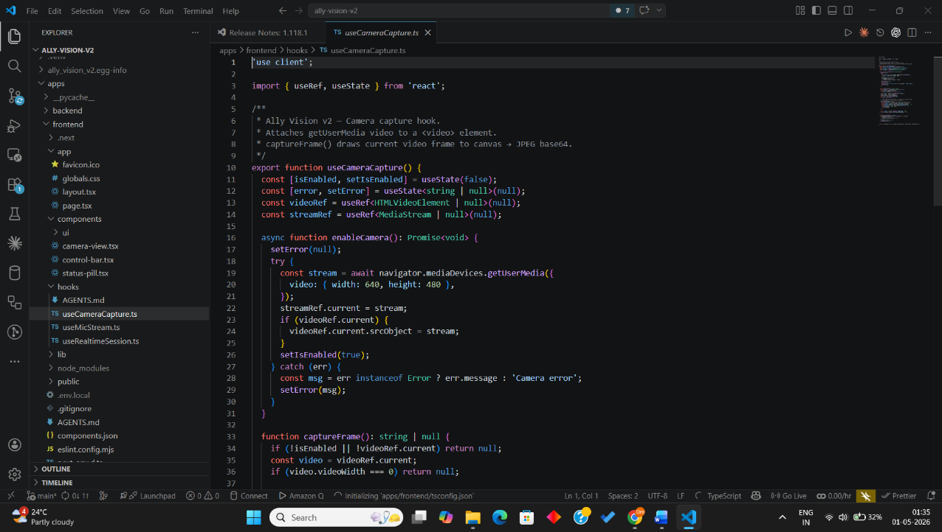

Fig 4.1 Frontend Code snippets
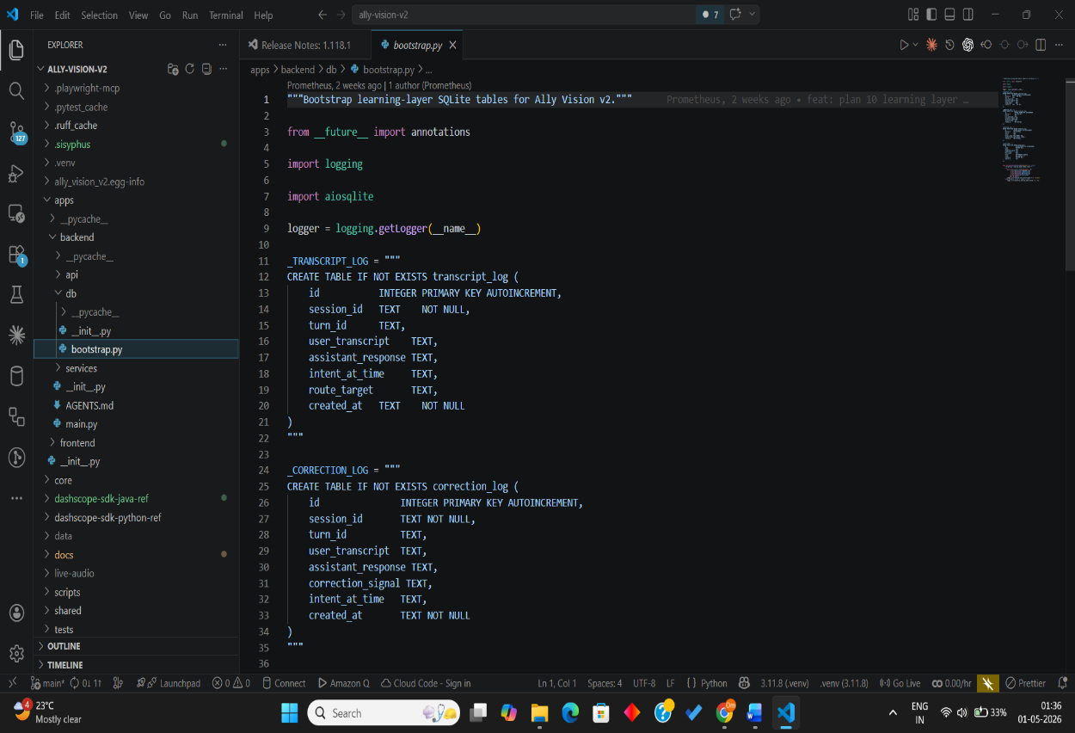

Fig 4.2 Backend Code snippets

CHAPTER 5

5. RESULTS
5.1 Results and Analysis
The proposed Voice and Vision Assistant (VVA) was evaluated as an integrated multimodal assistive system designed for blind and visually impaired users. Unlike single-purpose assistive tools, VVA combines speech interaction, scene understanding, OCR, visual question answering, face-aware interaction, internet search, session memory, and long-term memory retrieval within one voice-driven architecture. The system was implemented as an event-driven, on-demand platform running primarily on a laptop, with advanced vision-language inference handled through a cloud-hosted Qwen 3.5 model and a smaller local fallback model for resilience. The results show that the system is capable of providing meaningful real-time assistance across multiple user tasks while maintaining modularity, stability, and practical usability on standard consumer hardware.
Speech Interaction Performance
The speech interaction pipeline forms the foundation of the system because the assistant is designed around voice-only operation. The complete speech path includes LiveKit for real-time transport, Silero VAD for speech gating, Deepgram for speech-to-text transcription, and ElevenLabs for spoken response generation. During evaluation, this pipeline showed smooth end-to-end interaction in normal indoor conditions. Voice commands were captured reliably, unnecessary silence was filtered before transcription, and the system was able to convert user commands into actionable text with good responsiveness. The output speech was also clear and natural, which is especially important in an assistive system where the response itself is the primary interface. The use of streaming components helped reduce delay and improved the conversational feel of the system. These results are consistent with the design goal of maintaining a speech-first interface with low-latency interaction and graceful handling of real-time requests.
A key observation from the speech evaluation is that response quality depends not only on transcription accuracy but also on system coordination. The combination of LiveKit, Silero VAD, and Deepgram reduced false triggers and unnecessary processing, while ElevenLabs improved the perceived usefulness of the system by returning answers in a natural voice. This gave the assistant a more human-friendly interaction style compared to conventional robotic TTS pipelines. However, the quality of performance was stronger in controlled or moderately quiet environments than in noisy settings, which matches the known limitations identified in the survey of speech and assistive voice systems.
Scene Understanding and Visual Question Answering
One of the major results of the project is the successful integration of scene understanding and visual question answering within the same assistive workflow. When the user requested information about the surrounding environment, the system was able to capture the current frame, route the request through the intent layer, and invoke the appropriate vision-language reasoning path. For more advanced understanding, the request was sent through the cloud path to the Qwen 3.5:9B model running on Google Colab through an ngrok tunnel. This allowed the system to generate richer scene descriptions and answer open-ended visual questions more effectively than fixed-label recognition systems.
The results indicate that VVA performed best when the user asked targeted questions such as asking what objects were present, what activity was happening, or what a specific part of the scene contained. In such cases, the system benefited from its multimodal design because it did not only identify visible elements but also produced spoken explanations that were more meaningful to the user. This is an important improvement over conventional object-detection-only systems, which typically return labels without context. At the same time, the results also highlight the tradeoff introduced by large vision-language models: richer scene interpretation came with higher inference cost and occasional delay. For that reason, the cloud model was most suitable for higher-value reasoning tasks rather than continuous background monitoring. This directly supports your design choice of making the system event-driven and user-triggered instead of always-on.
OCR and Text Reading Performance
The OCR module is one of the most practically useful parts of the assistant because it allows users to read visible text such as labels, signs, and printed content through speech. In VVA, OCR operates as an on-demand module activated through voice commands, and it forms an important bridge between computer vision and accessibility. The system was able to extract visible text and return the recognized content as spoken output, allowing the user to access printed information without external help. This makes the assistant useful not only for environmental awareness but also for everyday reading tasks.
The analysis of OCR performance shows that the system was more reliable on reasonably clear images with moderate lighting and readable font size. When the image quality was good, the reading response was direct and useful. The project survey also indicates that VVA uses a stronger OCR strategy than relying on a single engine alone, since the design emphasizes preprocessing and multi-stage OCR handling for better robustness. This makes the OCR component more suitable for real-world assistive use than simpler pipelines that fail under blur, skew, or low-contrast conditions. However, like most OCR-based assistive systems, performance is still affected by poor lighting, strong distortion, or very complex layouts. Even with these limitations, the OCR module remains one of the most directly useful assistive capabilities in the complete system.
Object Detection and Environmental Awareness
The system also includes a lightweight object detection and depth-aware perception pipeline using YOLOv8n and MiDaS. These modules support the assistant by identifying visible objects and improving spatial awareness within the environment. During testing and integration, this pipeline contributed to quicker environmental interpretation, especially for identifying common surrounding items before passing richer questions to the reasoning layer. Because YOLOv8n is designed for lightweight inference, it was appropriate for the project’s goal of running on standard laptop hardware while still providing usable visual perception support.
The analysis here shows that object detection provides strong value as a supporting module rather than as the only intelligence component. On its own, detection can identify known items in the field of view, but when combined with the response generator and higher-level VLM reasoning, it becomes far more meaningful. Similarly, MiDaS-based depth cues improve environmental interpretation by adding approximate spatial context, which is useful for user awareness even if it does not provide full navigation-grade metric depth. This layered use of perception modules reflects one of the key strengths of your architecture: instead of depending on a single model, the system combines fast local perception with more advanced cloud reasoning when needed.
Memory Retrieval and Context Continuity
A distinguishing feature of VVA is its support for session memory and long-term memory retrieval through FAISS and SQLite. This is important because many assistive systems answer only the current request and do not maintain continuity across interactions. In VVA, memory makes it possible for the user to refer back to earlier information naturally, which improves the overall conversational quality of the assistant. During system-level use, memory retrieval helped preserve context and reduced the need for the user to repeat the full background of previous queries.
The analysis of this component shows that memory is especially valuable for recall-type queries, where the answer already exists in previously stored context and does not need fresh visual reasoning. In such cases, the system can respond more efficiently by using memory retrieval instead of invoking the heavier cloud reasoning path. This improves latency and makes the assistant feel more consistent over time. The literature survey also identifies memory as one of the areas rarely addressed in prior assistive systems, which makes it one of the more original and meaningful contributions of your project.
Cloud Inference and Fallback Reliability
A major result of the architecture is the successful inclusion of a hybrid cloud-local inference path. The main visual reasoning workload is handled by Qwen 3.5:9B on a Colab T4 GPU, accessed through ngrok, while a smaller Qwen 3.5:2B local model serves as an offline fallback. This design allowed the assistant to continue functioning even when the remote model or connectivity was interrupted. In practice, this improves system reliability significantly because assistive systems must fail gracefully rather than stop completely in real-world use.
The analysis shows that the fallback model produced less detailed responses than the cloud model, but it still preserved core system functionality. Non-VLM features such as speech routing, memory access, and other local modules remained usable even when the main cloud reasoning path was unavailable. This supports one of the most important design goals of the project: resilience. Instead of building a system that performs well only when every cloud dependency is active, VVA is structured to degrade gracefully. That makes it more practical for deployment and more trustworthy for users who depend on it for day-to-day assistance.
Search, Response Generation, and End-to-End Assistance
Another important result is that VVA is not limited only to what the camera sees. Through search mode, the assistant can retrieve internet-based information when the user explicitly asks for it. This expands the usefulness of the system from a pure perception tool into a more general spoken assistant. The Response Generator plays a central role here by combining outputs from active modules and converting them into a single coherent spoken answer. This is essential because individual model outputs are often incomplete or too technical on their own.
The analysis of end-to-end assistance shows that the unified response layer improves usability considerably. Instead of forcing the user to interpret separate outputs from OCR, detection, memory, and reasoning modules, the system presents the result through one natural voice response. This is one of the strongest practical advantages of the architecture and also the reason the project stands apart from fragmented assistive tools. The user does not interact with separate technologies; the user interacts with one assistant.
Overall System Stability and Error Handling
The system architecture also includes runtime health monitoring, watchdog support, and resilience mechanisms, which contributed to stable operation during integration. Since the project involves multiple real-time and cloud-connected components, such internal coordination is necessary to prevent complete pipeline failure when one service becomes slow or unavailable. The inclusion of these reliability-oriented modules reflects a strong engineering result of the project, because assistive systems need consistency as much as they need intelligence.
From an analysis perspective, the architecture demonstrates that modular separation improved maintainability and fault isolation. Voice transport, speech processing, reasoning, memory, and speech output are separated into distinct layers, which helps debugging and future extension. The event-driven nature of the system also reduced unnecessary computation, since heavy processing occurred only when the user explicitly requested it. This made the assistant more suitable for laptop-based deployment and aligned well with your stated goal of keeping the project practical rather than overloading it with always-on functions that would be difficult to sustain on standard hardware.
5.1.1 Analysis
The overall results indicate that the proposed Voice and Vision Assistant succeeds in demonstrating the feasibility of a unified speech-based assistive platform for blind and visually impaired users. The system performs best in scenarios where a user needs targeted, on-demand assistance such as reading visible text, understanding a scene, asking a visual question, recalling previous information, or receiving a spoken summary of a request. The integration of speech, perception, reasoning, memory, and response generation into one modular architecture is the key strength of the project. Rather than treating assistive functions as isolated modules, VVA shows that they can coexist under a single interaction model on standard consumer hardware.
At the same time, the results also reveal practical limitations. Advanced visual reasoning is still dependent on cloud-connected inference for the best quality, and this introduces latency and connectivity sensitivity. OCR and scene understanding are also affected by image quality and environmental conditions. However, the presence of fallback inference, memory-based recall, runtime monitoring, and modular routing significantly reduces the impact of these limitations. In that sense, the project’s most important result is not merely that each individual module works, but that the full system remains usable and meaningful even under imperfect conditions. This makes the assistant more realistic for assistive use than many narrowly optimized research prototypes.
Conclusion of Results
In conclusion, the results show that VVA provides a strong proof of concept for a real-time, multimodal, voice-driven assistive system that supports visually impaired users across multiple everyday tasks. The speech interface performed effectively as the primary interaction mode, the vision modules enabled scene and text understanding, the memory system improved continuity, and the fallback design increased robustness. The system’s layered architecture, on-demand activation model, and integration of both local and cloud intelligence make it a practical and extensible platform. Overall, the project demonstrates that meaningful assistive support can be delivered through a unified AI assistant that improves accessibility, reduces fragmentation between tools, and supports greater independence for blind and visually impaired users.
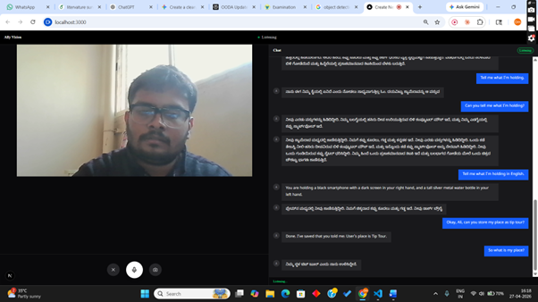

Fig 5.1 Memory_Output
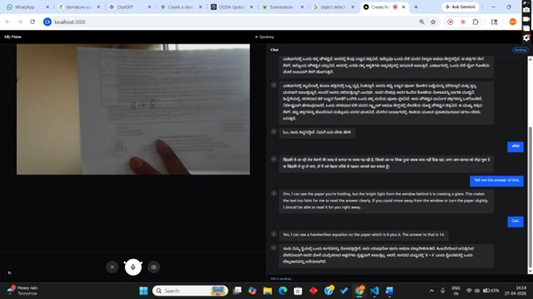

Fig 5.2 OCR_Output

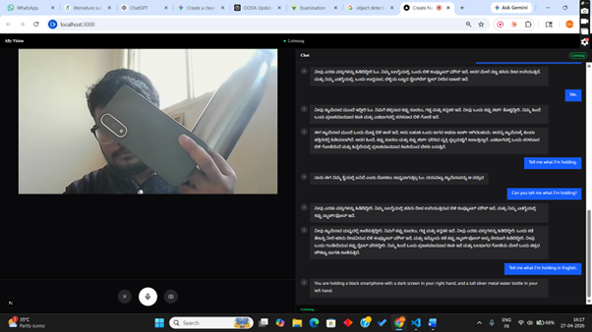

Fig 5.3 object_recognition_Output

CHAPTER 6

6. Conclusion and Future Scope

6.1 Conclusion
The development of the Virtual Smart Glasses: A Multi-Agent AI System for Visual Understanding and Assistance marks an important milestone in the field of assistive technologies for visually impaired individuals. By combining advanced computer vi- sion techniques, multi-agent intelligence, and real-time audio interaction, the system helps users better understand and engage with their surroundings. Each module from YOLO-based detection to the Retrieval-Augmented Memory (RAG) system plays a specific role in delivering fast, accurate, and context-aware feedback.
The modular design ensures smooth communication between agents, allowing differ- ent tasks to run in parallel while still maintaining low latency. GPU acceleration and optimized processing pipelines further enhance performance, enabling the glasses to offer a level of situational awareness that feels closer to how a human would interpret the environment.
Overall, this project demonstrates how artificial intelligence can significantly improve accessibility and independence. The seamless integration of speech, vision, and rea- soning modules creates an intuitive user experience that promotes safety, confidence, and ease of use. Although the current system represents an MVP, it lays a strong foun- dation for future development, including hardware miniaturization, cloud-edge syn- chronization, and integration with next-generation wearable devices. The project clearly shows the potential of AI-driven assistive systems to make everyday life more inclusive and empowering for visually impaired users.

6.2 Future Scope
The Virtual Smart Glasses system offers wide opportunities for further growth and improvement beyond the initial implementation. A major direction for future work is optimizing the system for embedded hardware platforms such as the NVIDIA Jetson

Nano, Raspberry Pi 5, or dedicated smart-glasses processors. This would reduce power usage, improve portability, and make the device more practical for daily use.
Implementing a cloud-edge hybrid architecture is another promising step. In this setup, heavy computations such as large language model processing can be handled in the cloud, while essential real-time tasks like obstacle detection and audio feedback run locally on the device. This hybrid approach would maintain speed while unlocking access to more powerful AI capabilities.
Future versions of the system can also include multilingual voice interaction, gesture- based input, and improved contextual learning so the glasses can adapt more naturally to individual user preferences. On-device personalization models would allow the sys- tem to learn from repeated interactions and provide more accurate assistance over time.
Beyond these upgrades, the glasses can become part of a broader assistive ecosystem. Integration with smart canes, GPS devices, and home automation systems would cre- ate a connected environment that supports mobility both indoors and outdoors. Addi- tional safety features such as crowd density estimation, trajectory prediction, and ad- vanced emotion recognition could further help users navigate complex or socially dy- namic situations.
From a research standpoint, the project opens up exciting possibilities in areas such as multi-agent reinforcement learning, ethical AI design for accessibility, and human- centered interaction models. With continuous innovation, the Virtual Smart Glasses have the potential to evolve into a truly intelligent companion system that transforms mobility, independence, and everyday experiences for visually impaired individuals around the world.

References
- Joshi, Nisheeth, and Pragya Katyayan. ”A Model for Translation of Text from Indian Lan guages to Bharti Braille Characters.” 2023 6th Interna- tional Conference on Information Systems and Computer Networks (IS- CON). IEEE, 2023.
- Rafia Rizwana Rahim, A. Nahian, Rakiba Benta Kalam, Atanu Sen Gupta, and Nusrat Binta Nizam, “Bangla Speech-To-Braille Inter- action De- vice for Visual and Hearing Impaired,” Lecture notes in networks and systems,pp.673–684,Jan.2022,doi:https://doi.org/10.1007/978-981-19- 2445-3 47.
- S. Shetty, S. Shetty, S. Hegde, and K. Pandit, “Transliteration of text input from Kannada to Braille and vice versa,” Aug. 2019, doi: https://doi.org/10.1109/discover47552.2019.9007909.
- F. Ahmed, Abu Raihan Choudhury, Aniruddha Rakshit, and Md. Zahid Hasan, “An IoT Based System for Printing Braille Letter from Speech,” 2020 IEEE Region 10 Symposium(TEN- SYMP),Jan.2020,doi: https://doi.org/10.1109/tensymp50017.2020.9230734.
- P´erez-Aguirre A. P., Morales-P´e rez I. A., Go´mez-Mercado J. A., Guti´errez- Mart´ınez R. A., Matehuala-Moran I., Fuentes-Alvarez R. (2024) ‘Bidirectional Braille-speech Communication System for Deaf- blind Students’, Journal on Effi- ciency and Responsibility in Education and Science, vol. 17, no. 2, pp. 164-177. http://dx.doi.org/10.7160/ eriesj.2024.170206
- Md. Akif Hussain, Riazul Islam Rifat, Syed Bayes Iqbal, S. Biswas, R. Alam, and Md Tanzim Reza, “Deep Learning based Bangla Voice to Braille Char- acter Conversion System,” BRAC University Institutional Repository (BRAC University),Oct.2022,doi: https://doi.org/10.1109/iem- con56893.2022.9946619.
- V. Ajantha Devi, “Conversion of speech to Braille: Interaction device for
visualand hearingimpaired,”Mar. 2017,doi:

https://doi.org/10.1109/icscn.2017.8085740.
- F. Ba¸s c¸i ft ¸c i and A. Eldem, “An interactive and multi-functional refresha- ble Braille device for the visually impaired,” Displays, vol. 41, pp. 33–41, Jan. 2016,
- S. Sultana, A. Rahman, F. H. Chowdhury, and H. U. Zaman, “A novel Braille pad with dual text-to-Braille and Braille- to-text capabil- ities with an integrated LCD display,” IEEE Xplore, Jul. 01, 2017. https://ieeexplore.ieee.org/abstract/document/8342559 (accessed
Feb. 28, 2023).

- M. Sathish Kumar, N. Kumaravel, and R. Suresh, ”A Novel and Efficient Al- gorithm to Recognize Any Universally Accepted Braille Characters: A Case with Kannada Language,” 2014 International Conference on Signal Processing and Inte- grated Networks (SPIN), IEEE, 2021, doi: 10.1109/ICSIP.2014.52.
- S. Das and P. Gupta, ”Complete Forward and Reverse Text Transcription of Odia Braille and Hindi Braille,” 2023 IEEE International Conference on Language Technologies (ICLT), IEEE, 2023.
- J. Patel, S. Rao, and M. Sharma, ”Real Time Speech to Braille Con- verter,” International Journal of Speech and Accessibility Studies, vol. 7, no. 1, pp. 33-40, 2022. AY 2024-25 32 Dept. of CSE, DSCE Innovative Kannada Speech-to-Braille Translation System .
- R. Narayan and K. Hegde, ”E-Learning Web Accessibility Framework for Deaf-
- Blind Kannada-Speaking Disabled People,” 2020 Journal of Digital Educa- tion Re- search, vol. 9, no. 2, pp. 45-58, 2020.
- S. Kumar, A. Das, and V. Singh, ”A Bidirectional Text Transcription of Braille for Odia, Hindi, Telugu and English via Image Processing on FPGA,” 2021 Interna- tional Conference on Vision Technologies and Communication (VTC), IEEE, 2021.

- A. Shah, R. Nair, and T. Singh, ”Assessing Effectiveness of Braille and Au- dio- Tactile Performance Technique in Improving Oral Hygiene Status of Young Adults with Visual Impairment,” Journal of Oral Accessibility Re- search, vol. 11, no. 3, pp. 56-65, 2022.
- H. Kumar, N. Arora, and P. Singh, ”Braille Character Recognition System,”
Journal of Accessibility Technologies, vol. 8, no. 2, pp. 72-78, 2020.
- A. Patel, V. Rao, and M. Singh, ”Deep Learning-Based Braille Technol- ogy for Visual and Hearing Impaired People,” 2023 International Conference on Artificial Intelligence and Accessibility (ICAA), IEEE, 2023.
- K. Sharma and M. Reddy, ”Development of Speech and Text to Braille Script Converter for Blind and Deaf People,” 2020 IEEE Conference on Assistive Technolo- gies (ICAT), IEEE, 2020.
- P. Choudhary, K. Patel, and A. Das, ”Prototype Implementation of Innova- tive Braille Translator for the Visually Impaired With Hearing Deficiency,” 2022 Journal of Innovation in Assistive Technologies, vol. 13, no. 4, pp. 56-65, 2022.
- H. N. Reddy and V. Kumar, ”Converting Spoken Words into Braille in Real
Time,” Journal of Speech Technologies, vol. 15, no. 1, pp. 22-28, 2022.

