**Question 1 Euro Cup 2016**

Design a GUI based user-interface to provide user the Euro Cup 2016 venue details. The comboBox should have all the venue stadiums location used for **Euro Cup 2016** football match.

<https://en.wikipedia.org/wiki/UEFA_Euro_2016>

When the user selects a venue, the corresponding stadium picture should be displayed and the capacity of the stadium should be displayed in label as shown in the figure.

The stadium capacity and images are as per the below URL.

<https://en.wikipedia.org/wiki/UEFA_Euro_2016#Venues>

e.g. Saint-Denis has a Capacity of 81,338

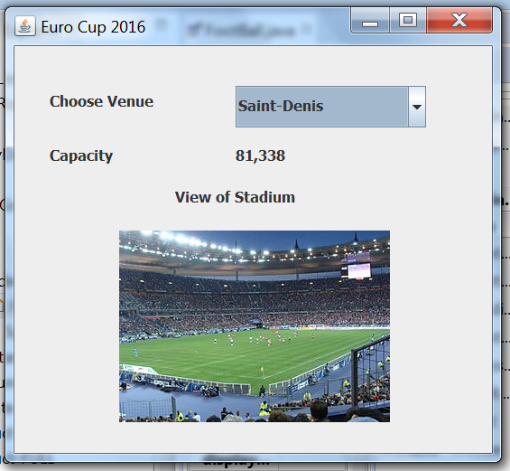

**Question 2**

Design a simple calculator using Java GUI. There should be buttons to represent the numbers 0 to 9, including decimal point. Arithmetic operations addition, subtraction, multiplication and division should be possible using 4 buttons as shown below. A Text Field at the top keeps track of the numbers being pressed and the result of the arithmetic operations. When ‘=’ is clicked the result is displayed.

Implement the required Action Listeners interface for handling button event clicks and the results.

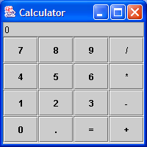

**Question 3 – Customer Login Form**

**Create a single dimension array for the following data**

* String CustomerName
* String EmailID
* String Password
* Boolean active

**Initialize** the array with the following values e.g.

Table 1: Data

|  |  |  |  |
| --- | --- | --- | --- |
| Customer Name | Email ID | Password | Status |
| AAAA | [aa@hotmail.com](mailto:aa@hotmail.com) | a12345678 | True |
| BBBB | [bb@hotmail.com](mailto:bb@hotmail.com) | b12345678 | True |
| CCCC | [cc@hotmail.com](mailto:cc@hotmail.com) | c12345678 | True |
| DDDD | [dd@hotmail.com](mailto:dd@hotmail.com) | d12345678 | True |
| EEEE | [ee@hotmail.com](mailto:ee@hotmail.com) | e12345678 | True |

* Design a **GUI** as shown below for customer login check

Perform validation

* Email ID can’t be empty, it should have ‘@’, ‘.’
* Password should be **JPasswordField,** Can’t be empty
* Display related messages in **JLabel** as required
* On click of “Signin” the login information already initialized is checked. If successful display a dialog box “Login Successful” and display welcome message using **JLabel** as shown in figure.
* On click of “Clear” all **textFields** are cleared.
* If login is unsuccessful with wrong password for 3 times, disable the account using **Boolean** active and future login should give a message “Account Locked”

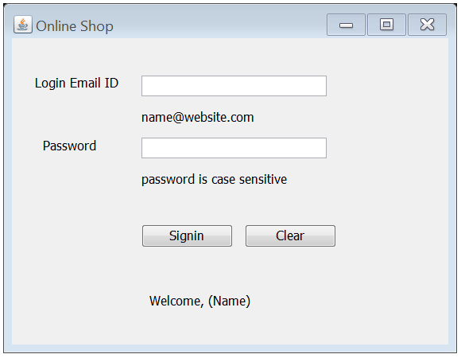

**Question 4:**

Design the JFrame using **JPanel** and **JTextArea**.

* Two **JPanels** should be used as shown below
* On Click of Check button

Display the number of words (count it based on the number of spaces)

Display number of letters (include numbers, space, special characters etc.)

