Computer Engineering Department Kuwait University

CpE 201
Object Oriented Paradigm
HW#9
Due: Saturday 2nd December 23:55

Important Notes:
- All files should be in one folder hw9YOURNAME (hw9Sara)
- All files should be .java files (q1sara.java, q2sara.java, ...) with your Name & ID as comment in the top of the programs
- Don't forget to change class name to match file name (q1sara.java --> class name should be q1sara)
- Compress your folder and upload
- Don't wait for the last minute, the upload my take sometime and if the submission is closed it will not be reopened
- The files should also contain the output as a comment at the end of the program between /**/
- You have two jokers to be used for the homework. Each joker will give you a 24 hours delay. Once the homework is discussed in class no joker is accepted

Question 1:

Implement the classes based on the following hierarchy:

Drug

PainRelievers

Antibiotics

Class Drug should have the following instance variables:
- A variable to store the drug name of type String
- A variable to store the date of manufacture of type Date (you need to implement class date to manage the date)
- A variable to store the expiration date of type Date (you need to implement class date to manage the date)

- A variable to store company name of type String
- A variable category to store whether the drug is a pain reliever or an antibiotic of type String
- A variable to store the dosage of type String
- A variable to store the side effect of type String

Class Drug should have the following methods:
- A construction to set the instance variables with given parameters
- A set method to set the instance variable
- A get method to retrieve the value of the instance variable
- A toString method to print the values of the instance variable

Class PainRelievers should have the following instance variables:
- A variable to store the conflicting material to be consumed with this drug of type String
Class PainRelievers should have the following methods:
- A construction to set the instance variables with given parameters
- Set methods to set each instance variable
- Get methods to retrieve the value of each instance variable
- A toString method to print the values of the instance variables

Class Antibiotics should have the following instance variables:
- A variable to store the time between each dosage of type int
Class Antibiotics should have the following methods:
- A construction to set the instance variables with given parameters
- A Set methods to set each instance variable
- A Get methods to retrieve the value of each instance variable
- A toString method to print the values of the instance variables
Create a test class to test all the above classes. Print all content of the variables using the toString methods

Sample Output:

Advil is a pain reliever. It is made by Pfizer on the 23/3/2012 and it expires on the 23/3/2019. The dosage is 2tablets. Side effects include: upset stomach, mild heartburn, nausea and vomiting

TYLENOL is a pain reliever. It is made by McNeil Consumer Healthcare, on the 3/1/2015 and it expires on the 3/11/2020. The dosage is 1tablet. Side effects include: loss of appetite, Itching and rash

Amoxicillin is an antibiotic. It is made by ABIOLEX, on the 12/5/2013 and it expires on the 12/5/2018. The dosage is 1tablet/12hours. Side effects include: nausea, vomiting and diarrhea

Question 2:

Given the following information:
- 13-inch MacBook Air, 1.6GHz dual-core Intel Core i5 processor, Turbo Boost up to 2.7GHz, Intel HD Graphics 6000, 8GB memory, 128GB PCIe-based flash storage
- 13-inch MacBook Air, 1.6GHz dual-core Intel Core i5 processor, Turbo Boost up to 2.7GHz, Intel HD Graphics 6000, 8GB memory, 256GB PCIe-based flash storage
- 15.6-inch Dell i3552, 1.6GHz Processor, Intel Pentium N3700, HD Laptop, 4 GB memory, DDR3L SDRAM, Windows 10, Black

Drive 3 classes; class Computer (a super class), class Apple and class Others (subclasses). Your classes should have whatever variables you think needed to reflect the given information, think carefully what is needed to be assigned to the super class and what should be assigned to the sub classes.

Question 3:
Implement a program to store the information’s of peoples residences. You need to implement the following:
A super class called Residence, which has the following instance variables:
- A variable area of type String the store the area where the residences is located
- A variable street of type int that stores the street number where the residences is located
- A variable block of type int that stores the block number where the residences is located
- A variable phoneNum of type long that stores the phone number of the residences
- A variable floors of type int that stores the number of floors of the residences
The class should have the following methods:
- A constructor that sets the instance variables
- A set method for each instance variable
- A get method for each instance variable
- A toString to display class information
A sub class House that inherits from the super class and has the following instance variables:
- A variable location of type String that stores a description of the house location (corner, one street, two streets)
The class should have the following methods:
- A constructor that sets the instance variables
- A set method for each instance variable
- A get method for each instance variable
- A toString to display class information

A sub class Flat that inherits from the super class and has the following instance variables:
- A variable floor of type int that stores in which floor the flat is
- A variable extension of type int that stores the phone extension number
- A variable parking of type int that stores the flats parking number
The class should have the following methods:
- A constructor that sets the instance variables
- A set method for each instance variable
- A get method for each instance variable
- A toString to display class information

Question 4:

Implement an application that will display a number of ball pictures and ask the user to count how many balls are there. The JFrame should show a random number of balls each time and the user should guess it using JOptionPane. The JFrame should also display a text asking the user for the number of balls shown. You need to generate an application based on the given picture (note that the picture is a guideline to show you what information need to be added in your frame). The size of your frame should be correct so that the user needs no resizing of the frame. Here is a diagram of what to implement:


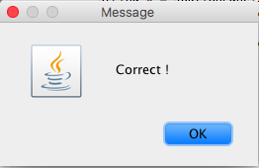
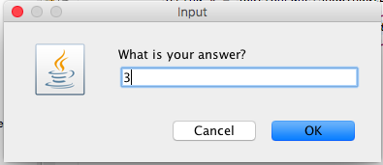
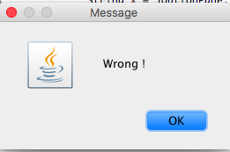
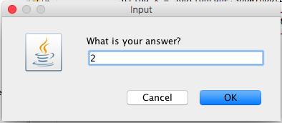
How many balls are shown?

