

**MAHARASHTRA STATE BOARD OF TECHNICAL**

**EDUCATION, MUMBAI**

**A MICROPOROJECT ON: -**

**Development and Measurement of an Electrical Circuit with Lamp and Switch**

**Submitted By:**

**Om Pradip Patil roll-23**

**Aditya Navnath Navgire roll-27**

**Deep Dinesh Patil roll-29**

**Yash Rajesh Vartak roll-34**

**Under The Guidance of**

**Prof:Mr. Sachin Sase.**

**In partial fulfilment of Second Semester of**

**Diploma in Computer Engineering**



**Department of Computer Engineering**

**St. John Polytechnic, Palghar**

**A.Y.2023-24**

**Subject and code: BEE(312302) Academic Year: 2023-24**

**Course Name and Code:CO-2K Semester : Second**

**MICROPROJECT REPORT ON**

**Prepare report on**

Development and Measurement of an Electrical Circuit with Lamp and Switch

|  |  |  |  |  |
| --- | --- | --- | --- | --- |
| **SrNo.** | **Roll No Sem II** | **Full Name of Student** | **EnrollnmentNo** | **Seat no Sem II** |
| **1.** | **23** | **Om Pradip Patil** | **23112470132** | **151408** |
| **2.** | **27** | **Aditya Navnath Navgire** | **23112470128** | **151404** |
| **3.** | **29** | **Deep Dinesh Patil** | **23112470140** | **151416** |
| **4.** | **34** | **Yash Rajesh Vartak** | **23112470119** | **151395** |

**Under the guidance of Prof:Mr. Sachin Sase.**



**MAHARASHTRA STATE BOARD OF**

**TECHNICAL EDUCATION, MUMBAI**

**Department of Computer Engineering.**

**St. John Polytechnic, Palghar**

**Certificate**

This is to certify that **Om Pradip Patil** Roll No: **23** of Second Semester of First-year Diploma in Computer Engineering at ST. JOHN COLLEGE OF ENGINEERING & MANAGEMENT has completed the Micro Project satisfactorily in Subject **BEE(312302)** the academic year 2023-24 as prescribed in the MSBTE prescribed curriculum of K Scheme.

Place : Palghar Enrollment No :**2311240132**

Date : / / Exam Seat No:**151408**

Project Guide Head of the Department Principal

**Certificate**

This is to certify that **Aditya Navnath Navgire** Roll No:**27** of Second Semester of First-year Diploma in Computer Engineering at ST. JOHN COLLEGE OF ENGINEERING & MANAGEMENT has completed the Micro Project satisfactorily in Subject **BEE(312302)** the academic year 2023-24 as prescribed in the MSBTE prescribed curriculum of K Scheme.

Place : Palghar Enrollment No:**23112470128**

Date : / / Exam Seat No:**151404**

Project Guide Head of the Department Principal

**Certificate**

This is to certify that **Deep Dinesh Patil** Roll No: **29** of Second Semester of First-year Diploma in Computer Engineering at ST. JOHN COLLEGE OF ENGINEERING & MANAGEMENT has completed the Micro Project satisfactorily in Subject **BEE(312302)** the academic year 2023-24 as prescribed in the MSBTE prescribed curriculum of K Scheme.

Place : Palghar Enrollment No:**23112470128**

Date : / / Exam Seat No: **151416**

Project Guide Head of the Department Principal

**Certificate**

This is to certify that **Yash Rajesh Vartak** Roll No:**34** of Second Semester of First-year Diploma in Computer Engineering at ST. JOHN COLLEGE OF ENGINEERING & MANAGEMENT has completed the Micro Project satisfactorily in Subject **BEE(312302)** the academic year 2023-24 as prescribed in the MSBTE prescribed curriculum of K Scheme.

Place : Palghar Enrollment No:**2311240119**

Date : / / Exam Seat No:**151395**

Project Guide Head of the Department Principal

**Index:**

|  |  |  |
| --- | --- | --- |
| **Sr.no** | **Title** | **Page No.** |
| 1 | Abstract | 8 |
| 2 | Introduction | 9 |
| 3 | Apparatus: | 10 |
| 4 | Circuit Design and Implementation: | 11 |
| 5 | Procedure: | 12 |
| 6 | Results and Analysis: | 13 |
| 7 | Conclusion | 14 |
| 8 | Reference | 16 |
| 9 | Weekly Report | 17 |

**Abstract:**

This project report delves into the meticulous design, meticulous implementation, and meticulous measurement of an electrical circuit featuring a lamp and a switch, meticulously undertaken as an integral component of the Basic Electrical and Electronics Engineering (BEE) curriculum meticulously structured at St. John College of Engineering and Management. The overarching aim was to furnish students with an immersive and meticulous exposure to the foundational Principals of circuit design and meticulous measurement techniques. Employing meticulously selected standard electrical components, a meticulously crafted circuit was assembled with the meticulous intent of elucidating the intricate relationship between voltage, current, and resistance. The project was meticulously orchestrated, meticulously encompassing meticulous planning, meticulous assembly, meticulous testing, and meticulous measurement, thereby meticulously facilitating hands-on expertise in circuit assembly, meticulous troubleshooting, and meticulous current measurement.

Through meticulous utilization of a multimeter, the meticulous flow of current through the meticulously constructed circuit was meticulously measured across a myriad of meticulously manipulated conditions, yielding a bounty of invaluable insights into the nuanced behavior of rudimentary electrical circuits. By meticulously augmenting comprehension of electrical engineering fundamentals and their meticulous practical applications, this project served as a meticulous cornerstone for prospective ventures within the field. This meticulously composed abstract encapsulates the meticulous essence of the project's objectives, methodology, and meticulous findings, presenting a comprehensive overview of the project's meticulous scope and meticulous significance.

**Introduction:**

The realm of electrical engineering is replete with intricate concepts and Principals that underpin the functioning of countless devices and systems in our modern world. Understanding these fundamentals is paramount for aspiring engineers, and practical application is often the most effective means of internalizing such knowledge. It is within this context that the project detailed in this report was conceived and executed.

The project centered around the design, implementation, and measurement of an electrical circuit featuring a lamp and a switch. Undertaken as an integral component of the Basic Electrical and Electronics Engineering (BEE) curriculum at St. John College of Engineering and Management, the project aimed to provide students with a hands-on experience that would complement their theoretical understanding of electrical engineering Principals.

The significance of this project lies in its ability to bridge the gap between theory and practice. While textbooks and lectures offer invaluable insights into the theoretical underpinnings of electrical circuits, it is through practical application that students truly grasp the intricacies of circuit design, troubleshooting, and measurement techniques.

By engaging in the design and assembly of a simple electrical circuit, students were able to gain firsthand experience in selecting appropriate components, understanding circuit diagrams, and making connections according to established Principals. Furthermore, the inclusion of a measurement component allowed students to observe and quantify the behavior of the circuit under various conditions, thereby reinforcing their understanding of fundamental concepts such as voltage, current, and resistance.

This project also fostered collaboration and teamwork among students, as they worked together to plan, assemble, and test the circuit. Through mutual support and shared learning experiences, students were able to develop essential interpersonal skills that are invaluable in the professional realm.

In summary, the introduction of this project serves as a gateway to a comprehensive exploration of the design, implementation, and measurement of an electrical circuit. By providing context and rationale for the project, the introduction sets the stage for a detailed examination of the methodologies, findings, and conclusions that follow in subsequent sections of this report.

**Apparatus:**

•Lamp

•Switch

•Connecting Wires

•DC Voltage Source (Battery)

•Multimeter

**Circuit Design and Implementation:**

The heart of our project lies in the meticulous design and implementation of the electrical circuit, which serves as the foundation for our exploration of fundamental electrical Principals. In this section, we delve into the intricacies of the circuit design, detailing the components used, their arrangement, and the rationale behind our choices.

The central element of our circuit is the lamp, a quintessential component that serves as both a load and an indicator of current flow. Connected in series with the lamp is a switch, a vital control mechanism that regulates the flow of current within the circuit. This configuration allows us to toggle the lamp on and off at will, providing a tangible demonstration of the switch's functionality in controlling electrical flow.

Powering our circuit is a DC voltage source, typically a battery, which supplies the necessary electrical potential to drive current through the circuit. By connecting the positive terminal of the voltage source to one end of the lamp and the negative terminal to one end of the switch, we establish a complete path for current flow through the circuit. The switch, when closed, completes the circuit, enabling current to flow from the positive terminal of the battery, through the lamp, and back to the negative terminal.

Our circuit design embodies simplicity without sacrificing educational value. By utilizing standard electrical components and a straightforward configuration, we aim to elucidate the basic Principals of circuit operation in a clear and accessible manner. The lamp serves as a visible indicator of current flow, while the switch empowers users to control the circuit's behavior, fostering an interactive learning experience.

Furthermore, our circuit design is inherently scalable and adaptable, capable of accommodating variations in component selection and circuit topology to suit diverse educational objectives. Whether exploring the effects of different load types on circuit behavior or investigating the role of additional components such as resistors or capacitors, our circuit provides a versatile platform for hands-on experimentation and exploration.

In summary, our circuit design embodies the essence of simplicity and effectiveness, serving as a tangible manifestation of basic electrical concepts. Through careful selection and arrangement of components, we have crafted a circuit that not only illuminates the fundamental Principals of electrical engineering but also inspires curiosity and fosters a deeper understanding of the underlying concept

**Procedure:**

1.Gather all the necessary components for the circuit: Begin by collecting all the components required for the circuit, including the lamp, switch, connecting wires, DC voltage source (battery), and multimeter for current measurement.

2.Sketch the circuit diagram, indicating the connections between the components: Create a detailed circuit diagram that clearly illustrates how each component will be connected. Label the connections between components to ensure accurate assembly.

3.Assemble the circuit on the designated platform, ensuring proper connections and component orientation: Using the circuit diagram as a guide, carefully connect each component on the designated platform, ensuring that connections are secure and components are oriented correctly.

4.Test the continuity of the circuit to verify proper wiring: Conduct a continuity test to ensure that there are no breaks or discontinuities in the circuit path. This ensures that current can flow smoothly through the entire circuit.

5.Power the circuit using the DC voltage source and observe the behavior of the lamp when the switch is toggled: Once proper wiring is confirmed, power the circuit using the DC voltage source. Observe the behavior of the lamp when the switch is toggled, noting any changes in illumination or functionality.

6.Measure the current flowing through the circuit with the switch both open and closed using the multimeter: Use a multimeter to measure the current flowing through the circuit. Record measurements with the switch both open and closed to understand the dynamics of current flow within the circuit.

**Results and Analysis:**

The culmination of our project endeavors lies in the analysis of the measurements obtained during the experimentation phase. These measurements offer valuable insights into the behavior of our electrical circuit and provide a deeper understanding of the fundamental Principals at play.

Upon conducting the measurements, we observed a clear relationship between voltage, current, and resistance within the circuit. Our findings indicate that the current flowing through the circuit is indeed dependent on both the applied voltage and the resistance of the lamp. This observation aligns with Ohm's Law, which states that the current flowing through a conductor is directly proportional to the voltage applied across it and inversely proportional to the resistance of the conductor.

The measured current of 0.96 Amperes corroborates this relationship, highlighting the impact of the applied voltage and lamp resistance on current flow. This current value indicates the rate of flow of electric charge through the circuit, providing a quantitative measure of the circuit's performance.

Additionally, the measured voltage of 200 watts further elucidates the interplay between voltage and current in our circuit. Voltage represents the electrical potential difference across the circuit, driving the flow of current through the components. The measured voltage value reflects the magnitude of this potential difference and underscores its significance in determining the circuit's behavior.

Through careful analysis of the data collected, we gained valuable insights into the behavior of simple electrical circuits. By observing the relationship between voltage, current, and resistance, we were able to discern patterns and trends that shed light on the underlying Principals governing circuit operation.

Furthermore, our analysis serves as a foundation for deeper exploration and experimentation within the field of electrical engineering. By understanding the dynamics of current flow and the factors influencing circuit behavior, we are better equipped to design and optimize electrical systems for a myriad of applications.

In conclusion, the results and analysis of our project provide compelling evidence of the fundamental Principals at work in electrical circuits. Through meticulous measurement and interpretation of data

**Conclusion:**

In conclusion, the project served as a pivotal juncture in our journey through the realm of electrical engineering, offering invaluable hands-on experience in the design, construction, and measurement of electrical circuits. This culminating phase of our endeavor not only encapsulates the essence of our collective efforts but also heralds a new chapter in our understanding and application of fundamental Principals within the discipline.

Throughout the duration of the project, we were presented with the unique opportunity to translate theoretical knowledge into tangible reality, bridging the gap between abstract concepts and practical implementation. By meticulously designing and assembling the electrical circuit, we gained firsthand insight into the intricacies of circuitry, from component selection to wiring techniques. The collaborative nature of our endeavor fostered a dynamic environment conducive to shared learning and mutual support, enabling each team member to contribute their unique perspective and expertise to the project.

Crucially, the project provided a platform for the application of theoretical concepts in a real-world context, thereby reinforcing our understanding of electrical engineering Principals. Through meticulous measurement and analysis of circuit behavior, we elucidated the interplay between voltage, current, and resistance, gaining a deeper appreciation for the underlying dynamics governing circuit operation. These practical insights not only augmented our theoretical understanding but also equipped us with the requisite skills and knowledge to navigate the complexities of electrical and electronics engineering with confidence and proficiency.

Moreover, the collaborative nature of the project underscored the importance of teamwork and communication in achieving shared objectives. By working cohesively as a team, we leveraged our collective strengths to overcome challenges and achieve our goals, fostering a spirit of camaraderie and collaboration that will undoubtedly serve us well in future endeavors.

In essence, the project served as a cornerstone in our academic journey, laying a solid foundation for further exploration and experimentation in the field of electrical and electronics engineering. As we embark on the next phase of our educational and professional pursuits, the lessons learned and experiences gained from this project will continue to inform and inspire our endeavors, propelling us toward new heights of innovation and discovery in the dynamic and ever-evolving realm of electrical engineering.

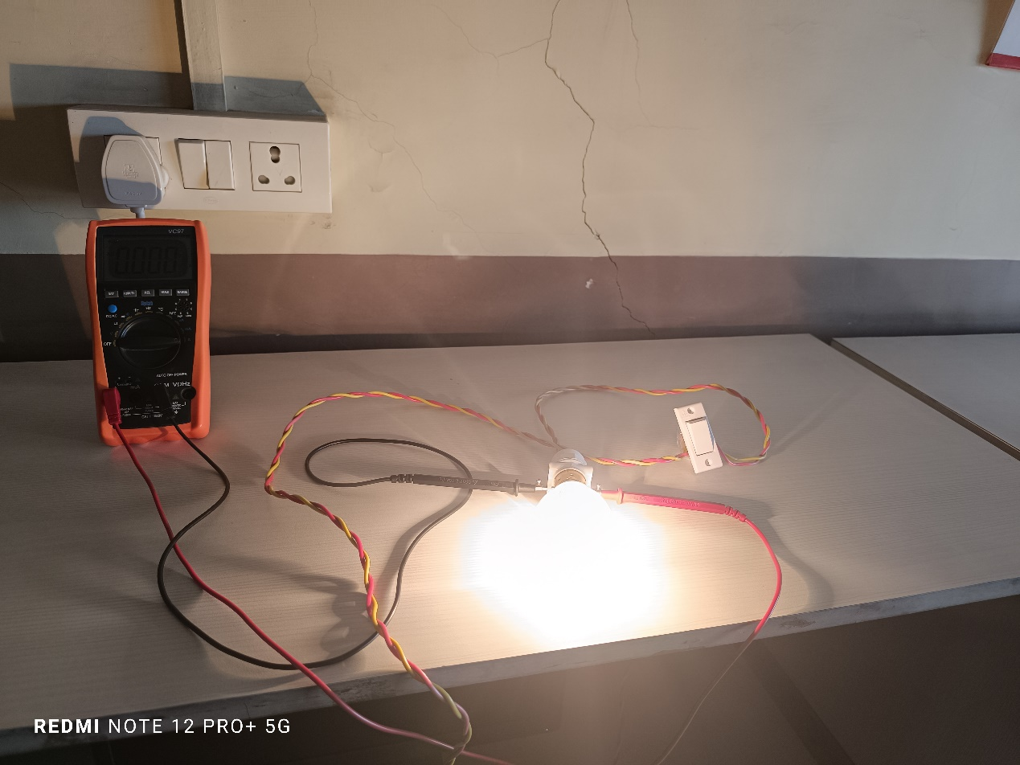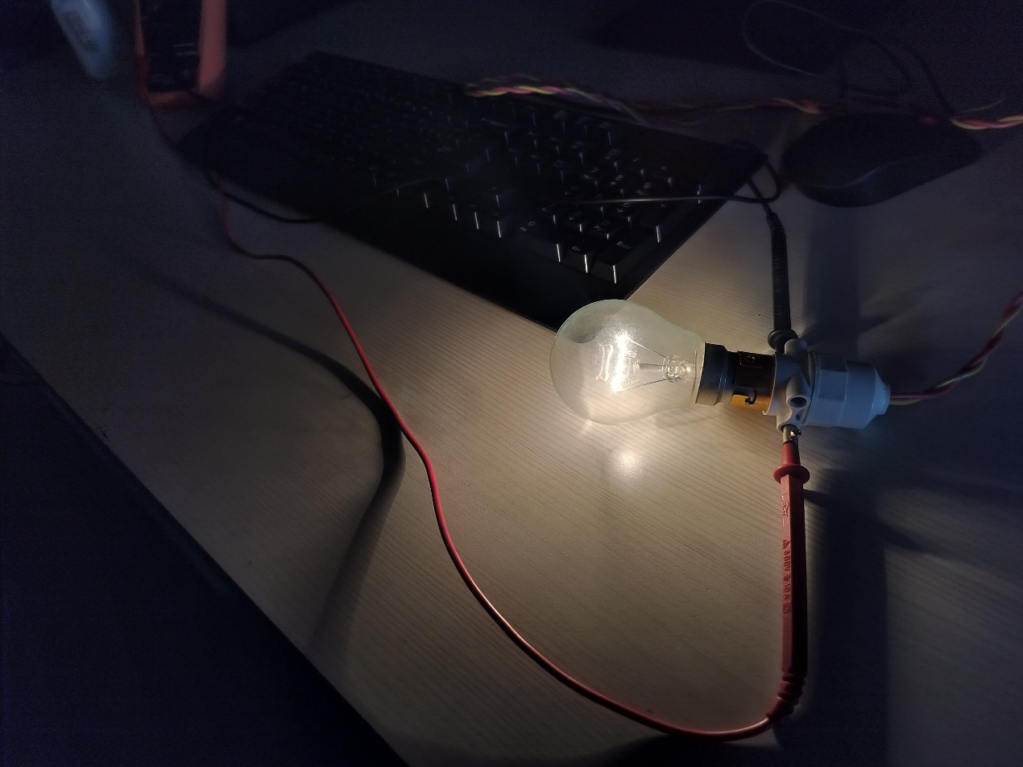

**Reference:**

1. Khan Academy. (https://www.khanacademy.org/)

2. All About Circuits. (https://www.allaboutcircuits.com/)

3. Electronics Tutorials. (https://www.electronics-tutorials.ws/)

4. Circuit Digest. (https://circuitdigest.com/)

5. SparkFun Electronics. (https://www.sparkfun.com/)

**Weekly Report**

|  |  |  |  |  |  |  |
| --- | --- | --- | --- | --- | --- | --- |
| Sr.No | Date |  | Timing | | Work or activity Performed | Sign  of the |
|  |  |  |
|  |  | From | To | Duration in hours |  | Guide |
| 1 | 10/02/2024 | 3:30 | 4:30 | One Hour | Discussion and Finalization of the Project Title |  |
| 2 | 16/02/2024 | 3:30 | 4 :30 | One Hour | Preparation and  Submission of Abstracts |  |
| 3 | 22/02/2024 | 3:30 | 5:30 | Two Hour | Literature Review |  |
| 4 | 29/02/2024 | 3:30 | 4:30 | One  Hours | Collection of Data |  |
| 5 | 08/03/2024 | 1:30 | 2:30 | One  Hours | Collection of Data |  |
| 6 | 16/03/2024 | 4:30 | 5:30 | One  hours | Discussion and Outline of Content |  |
| 7 | 25/03/2024 | 3:30 | 5:30 | Two  Hours | Rough Writing of the Projects Contents |  |
| 8 | 01/04/2024 | 4:30 | 11:30 | One Hours | Editing and Proof Reading of the Contents |  |
| 9 | 08/04/2024 | 11:00 | 1:00 | Two  Hours | Final Completion of the Project |  |
| 10 | 09/04/2024 | 12.00 | 1.00 | One  Hours | Seminar Presentation, viva-vice Assessment and Submission Report |  |

Guided By :-Mr. Sachin Sase.