PRACTICAL - 06
Part A — Practice Programs (Hour 1)

PROBLEM1 | 1. Remote control: an interface Switchable with on()/off() and a default toggle(); Fan and  Light implement it. Loop over a Switchable[] toggling each. Then add a functional  interface that decides, given a device and an hour, whether it may switch on, and supply it  once as an anonymous class and once as a lambda.
CODE | interface Switchable {  void on();  void off();  default void toggle() {  on();  off();  }  }  class Fan implements Switchable {  public void on() {  System.out.println("Fan is ON");  }  public void off() {  System.out.println("Fan is OFF");  }  }  class Light implements Switchable {  public void on() {  System.out.println("Light is ON");  }  public void off() {  System.out.println("Light is OFF");  }  }  @FunctionalInterface  interface Permission {  boolean maySwitchOn(String device, int hour);  }  public class RemoteControl {  public static void main(String[] args) {  Fan fan = new Fan();  Light light = new Light();  Switchable[] devices = {fan, light};  System.out.println("Toggling devices:");  for (Switchable device : devices) {  device.toggle();  }  Permission p1 = new Permission() {  public boolean maySwitchOn(String device, int hour) {  return hour >= 6 && hour <= 22;  }  };  System.out.println("Fan at 10: " + p1.maySwitchOn("Fan", 10));  System.out.println("Light at 2: " + p1.maySwitchOn("Light", 2));  Permission p2 = (device, hour) -> hour >= 6 && hour <= 22;  System.out.println("\nUsing lambda:");  System.out.println("Fan at 8: " + p2.maySwitchOn("Fan", 8));  System.out.println("Light at 3: " + p2.maySwitchOn("Light", 3));  }  }
OUTPUT | 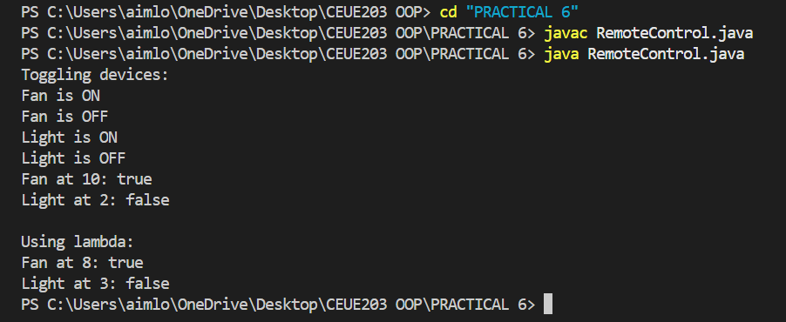
PROBLEM2 | 2. Notification senders: a functional interface Notifier with send (String); make email and  SMS senders as lambdas, hold them in an array, and broadcast one message through all.  Add a marker interface Urgent and send twice for senders marked urgent.
CODE | @FunctionalInterface  interface Notifier {  void send(String message);  }  interface Urgent {  }  class Email implements Urgent {  String name;  Email(String name) {  this.name = name;  }  }  class SMS {  String name;  SMS(String name) {  this.name = name;  }  }  public class NotificationSender {  public static void main(String[] args) {  Email email = new Email("Email");  SMS sms = new SMS("SMS");  Notifier email_sender = message ->  System.out.println("Email: " + message);  Notifier sms_sender = message ->  System.out.println("SMS: " + message);  Notifier[] senders = {email_sender, sms_sender};  String message = "Meeting at 5 PM";  for (Notifier sender : senders) {  sender.send(message);  if (sender == email_sender && email instanceof Urgent) {  sender.send(message);  }  }  }  }
OUTPUT | 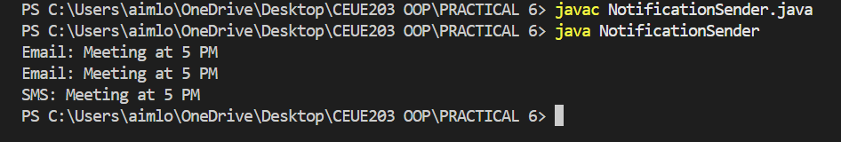
PROBLEM3 | 3. (For Advanced Learners – home) Build a small discount engine where each rule is a  lambda the user picks at runtime and applies to a list of prices; organise it into packages  and ship it as a runnable JAR.
CODE | DiscountApp.java  package discount;  import java.util.Scanner;  public class DiscountApp {  public static void main(String[] args) {  Scanner sc = new Scanner(System.in);  double[] prices = {500, 1000, 1500, 2000};  System.out.println("Choose discount:");  System.out.println("1. 10% discount");  System.out.println("2. 20% discount");  System.out.println("3. 50% discount");  System.out.print("Enter choice: ");  int choice = sc.nextInt();  DiscountRule rule;  if (choice == 1) {  rule = price -> price - (price * 0.10);  }  else if (choice == 2) {  rule = price -> price - (price * 0.20);  }  else if (choice == 3) {  rule = price -> price - (price * 0.50);  }  else {  System.out.println("Invalid choice");  sc.close();  return;  }  System.out.println("\nPrices after discount:");  for (double price : prices) {  double final_price = rule.apply(price);  System.out.println(price + " -> " + final_price);  }  sc.close();  }  }  DiscountRule.java  package discount;  @FunctionalInterface  public interface DiscountRule {  double apply(double price);  }
OUTPUT | 