PRACTICAL - 04
Part A — Practice Programs (Hour 1)

PROBLEM1 | - Password Strength (PasswordChecker.java + Driver.java)  - In PasswordChecker, check four rules - length >= 8, contains an uppercase letter, contains a digit, contains a special character - using regex (e.g. .[A-Z].) or String methods.  - Write strength(String pw) that counts how many rules pass and returns "Weak" (0-1), "Medium" (2-3) or "Strong" (4).  - In Driver.main, test several passwords. For each, print which rules passed and the final label.  Expected Output: "abc" -> Weak; "Abcd1234!" -> Strong.
CODE | public class PasswordChecker {  public static boolean hasLength(String pw) {  return pw.length() >= 8;  }  public static boolean hasUppercase(String pw) {  return pw.matches(".*[A-Z].*");  }  public static boolean hasDigit(String pw) {  return pw.matches(".*[0-9].*");  }  public static boolean hasSpecial(String pw) {  return pw.matches(".*[^a-zA-Z0-9].*");  }  public static String strength(String pw) {  int count = 0;  if (hasLength(pw))  count++;  if (hasUppercase(pw))  count++;  if (hasDigit(pw))  count++;  if (hasSpecial(pw))  count++;  if (count <= 1)  return "Weak";  else if (count <= 3)  return "Medium";  else  return "Strong";  }  }  DRIVER CLASS  public class Driver {  public static void main(String[] args) {  String[] passwords = {  "abc",  "Password",  "Pass1234",  "Abcd1234!",  "hello@12",  "WELCOME1"  };  for (String pw : passwords) {  System.out.println("Password: " + pw);  System.out.println("Length >= 8 : " + PasswordChecker.hasLength(pw));  System.out.println("Uppercase : " + PasswordChecker.hasUppercase(pw));  System.out.println("Digit : " + PasswordChecker.hasDigit(pw));  System.out.println("Special Char: " + PasswordChecker.hasSpecial(pw));  System.out.println("Strength : " + PasswordChecker.strength(pw));  System.out.println("---------------------------");  }  }  }
OUTPUT | 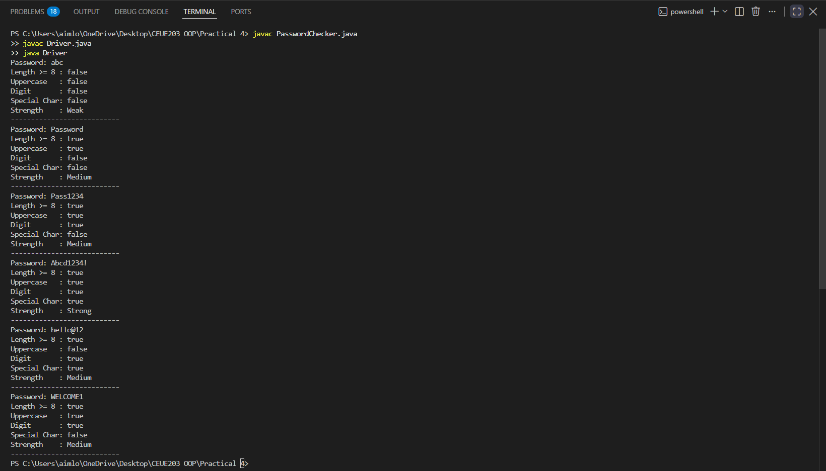
PROBLEM2 | - Chat-log Filter (ChatFilter.java + Driver.java)  - In Driver.main, define a String[] of log lines like "10:05 alice Hello there" (include one malformed line with fewer than 3 parts).  - Read a keyword from the user.  - For each line, split into time/user/message with split(" ", 3); skip lines that do not have 3 parts.  - If the message contains the keyword (case-insensitive), increment a counter and append "time user: message" to a StringBuilder.  - Print "Matches: N" and the built report.  Expected Output: Keyword "hello" over 3 lines (1 malformed) -> "Matches: 1" and the matching line.
CODE | public class ChatFilter {  public static String filterChats(String[] logs, String keyword) {  StringBuilder result = new StringBuilder();  int count = 0;  for (String line : logs) {  String[] parts = line.split(" ", 3);  if (parts.length < 3) {  continue;  }  String time = parts[0];  String user = parts[1];  String message = parts[2];  if (message.toLowerCase().contains(keyword.toLowerCase())) {  count++;  result.append(time)  .append(" ")  .append(user)  .append(": ")  .append(message)  .append("\n");  }  }  return "Matches: " + count + "\n" + result.toString();  }  }  DRIVER CLASS  import java.util.Scanner;  public class Driver1 {  public static void main(String[] args) {  String[] logs = {  "10:05 om Hello there",  "10:10 bhavy How are you?",  "10:15",  "10:20 manthan Good morning"  };  Scanner sc = new Scanner(System.in);  System.out.print("Enter keyword: ");  String keyword = sc.nextLine();  String output = ChatFilter.filterChats(logs, keyword);  System.out.println(output);  sc.close();  }  }
OUTPUT | 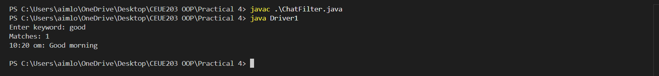
PROBLEM3 | - Template Filler (TemplateFiller.java + Driver.java)  (a) In Driver.main, define a template like "Dear {name}, order {id} ships {date}." and two parallel arrays: names {"name", "id"} and values {"Riya", "A07"} (note {date} is not supplied).  (b) Compile a Pattern for {(\w+)} and get a Matcher on the template.  (c) Walk the matches with a StringBuilder. For each {placeholder}, look up its value in the names array and replace it with the value, or with "[?]" if not found.  (d) Print the filled template.  Expected Output: The unsupplied {date} becomes [?].
CODE | import java.util.regex.*;  public class TemplateFiller {  public static String fillTemplate(String template, String[] names, String[] values) {  Pattern p = Pattern.compile("\\{(\\w+)\\}");  Matcher m = p.matcher(template);  StringBuilder result = new StringBuilder();  int last = 0;  while (m.find()) {  result.append(template.substring(last, m.start()));  String key = m.group(1);  String value = "[?]";  for (int i = 0; i < names.length; i++) {  if (names[i].equals(key)) {  value = values[i];  break;  }  }  result.append(value);  last = m.end();  }  result.append(template.substring(last));  return result.toString();  }  }  DRIVER CLASS  public class Driver2 {  public static void main(String[] args) {  String template = "Dear {name}, order {id} ships {date}.";  String[] names = {"name", "id"};  String[] values = {"OM", "72"};  String output = TemplateFiller.fillTemplate(template, names, values);  System.out.println(output);  }  }
OUTPUT | 