PRACTICAL - 11
Part A — Practice Programs (Hour 1)

PROBLEM1 | 1. Save/load: make a small class Serializable, save an array of its objects to a file with Object Output Stream, then read it back into fresh objects and confirm the values survived. Mark one field transient and show it is not saved.
CODE | import java.io.*;  class Student implements Serializable {  private static final long serialVersionUID = 1L;  int rollNo;  String name;  // This field will NOT be saved  transient String password;  Student(int rollNo, String name, String password) {  this.rollNo = rollNo;  this.name = name;  this.password = password;  }  void display() {  System.out.println(  "Roll No: " + rollNo +  ", Name: " + name +  ", Password: " + password  );  }  }  public class SaveLoad {  public static void main(String[] args) {  Student[] students = {  new Student(1, "Om", "om123"),  new Student(2, "Rahul", "rahul123"),  new Student(3, "Amit", "amit123")  };  // Save objects  try (ObjectOutputStream out =  new ObjectOutputStream(  new FileOutputStream("students.dat"))) {  out.writeObject(students);  System.out.println("Students saved successfully.");  } catch (IOException e) {  e.printStackTrace();  }  // Load objects  try (ObjectInputStream in =  new ObjectInputStream(  new FileInputStream("students.dat"))) {  Student[] loadedStudents = (Student[]) in.readObject();  System.out.println("\nStudents loaded from file:");  for (Student s : loadedStudents) {  s.display();  }  } catch (IOException | ClassNotFoundException e) {  e.printStackTrace();  }  }  }
OUTPUT | 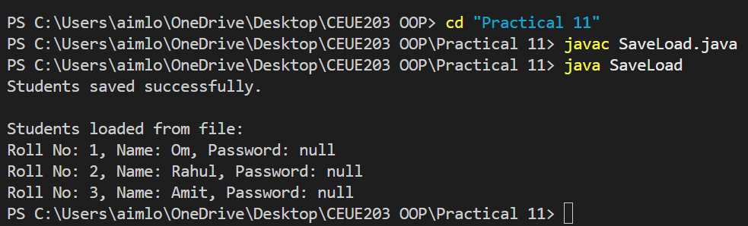
PROBLEM2 | 2. Log analyzer: create a few text files, then use Path/Files to read each line by line and count the total lines and how many contain a keyword across all files; also print each file’s size from its attributes.
CODE | import java.io.IOException;  import java.nio.file.*;  import java.util.List;  public class LogAnalyzer {  public static void main(String[] args) {  String keyword = "ERROR";  Path[] files = {  Paths.get("log1.txt"),  Paths.get("log2.txt"),  Paths.get("log3.txt")  };  int totalLines = 0;  int keywordLines = 0;  try {  for (Path file : files) {  // Get file size  long size = Files.size(file);  System.out.println("\nFile: " + file.getFileName());  System.out.println("Size: " + size + " bytes");  // Read file line by line  List<String> lines = Files.readAllLines(file);  for (String line : lines) {  totalLines++;  if (line.contains(keyword)) {  keywordLines++;  }  }  }  System.out.println("\n----- SUMMARY -----");  System.out.println("Total lines: " + totalLines);  System.out.println(  "Lines containing '" + keyword + "': "  + keywordLines  );  } catch (IOException e) {  e.printStackTrace();  }  }  }
OUTPUT | 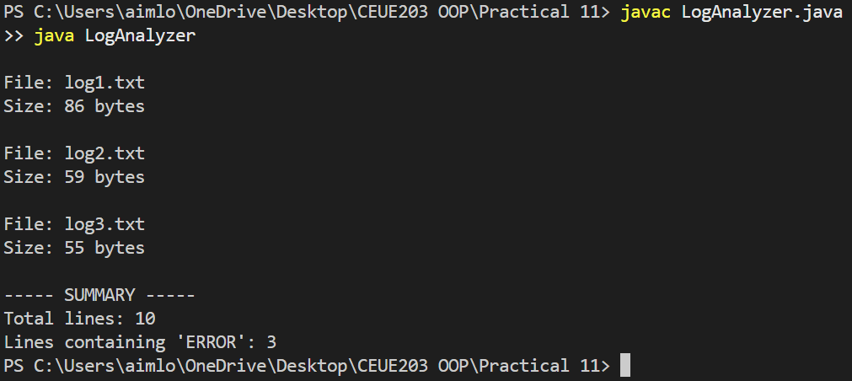
PROBLEM3 | 3. (For Advanced Learners – home) Walk a folder tree with NIO and produce a report of the files it contains (name, size, modified time), writing the summary to a file; decide what to include.
CODE | import java.io.IOException;  import java.nio.file.*;  import java.nio.file.attribute.BasicFileAttributes;  import java.util.stream.Stream;  public class FolderReport {  public static void main(String[] args) {  Path folder = Paths.get("myfolder");  Path report = Paths.get("folder_report.txt");  try {  try (Stream<Path> paths = Files.walk(folder)) {  StringBuilder result = new StringBuilder();  result.append("FOLDER REPORT\n");  result.append("====================\n\n");  paths.filter(Files::isRegularFile)  .forEach(path -> {  try {  BasicFileAttributes attributes =  Files.readAttributes(  path,  BasicFileAttributes.class  );  result.append(  "File Name: "  + path.getFileName()  + "\n"  );  result.append(  "Path: "  + path  + "\n"  );  result.append(  "Size: "  + attributes.size()  + " bytes\n"  );  result.append(  "Modified: "  + attributes.lastModifiedTime()  + "\n"  );  result.append(  "--------------------\n"  );  } catch (IOException e) {  System.out.println(  "Could not read: " + path  );  }  });  Files.writeString(report, result.toString());  }  System.out.println(  "Folder report created successfully."  );  } catch (IOException e) {  e.printStackTrace();  }  }  }
OUTPUT | 