PRACTICAL - 05
Part A — Practice Programs (Hour 1)

PROBLEM1 | Shape areas: an abstract Shape with abstract area(); subclasses Circle, Rectangle, Triangle. Put a mix in a Shape[] and loop once to print each area and the running total, tracking the largest — one loop handling every shape through polymorphism.
CODE | abstract class Shape {  public abstract double area();  }  class Circle extends Shape {  private double radius;  public Circle(double radius) {  this.radius = radius;  }  public double area() {  return Math.PI * radius * radius;  }  }  class Rectangle extends Shape {  private double width, height;  public Rectangle(double width, double height) {  this.width = width;  this.height = height;  }  public double area() {  return width * height;  }  }  class Triangle extends Shape {  private double base, height;  public Triangle(double base, double height) {  this.base = base;  this.height = height;  }  public double area() {  return 0.5 * base * height;  }  }  public class ShapeTest {  public static void main(String[] args) {  Shape[] shapes = {  new Circle(5),  new Rectangle(3, 5),  new Triangle(4, 6),};  double totalArea = 0;  double largestArea = Double.MIN_VALUE;  Shape largestShape = null;  for (Shape s : shapes) {  double area = s.area();  System.out.println("Area: " + area);  totalArea += area;  if (area > largestArea) {  largestArea = area;  largestShape = s;  }  }  System.out.println("Total area = " + totalArea);  System.out.println("Largest area = " + largestArea + " (from " + largestShape.getClass().getSimpleName() + ")");  }  }
OUTPUT | 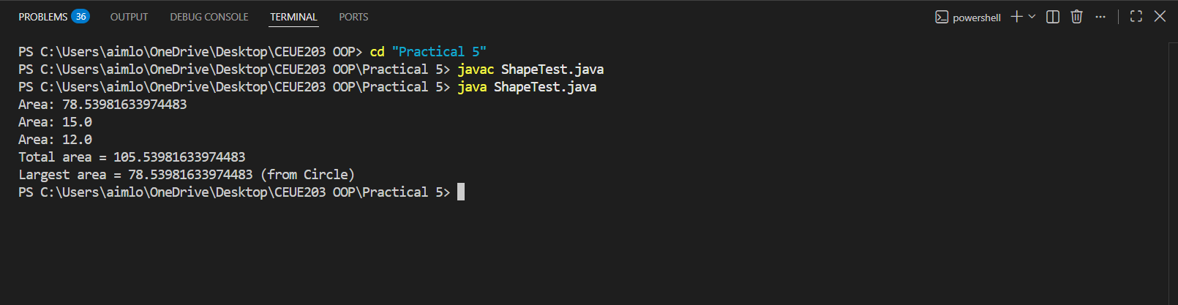
PROBLEM2 | Payroll: an abstract Employee with abstract monthlySalary(); FullTime (fixed), PartTime (hours × rate) and Intern (stipend), each calling super for the shared name/id. Loop a mixed array to print each salary and the total; use instanceof to add a note only for interns.
CODE | abstract class Employee {  private String name;  private int id;  public Employee(String name, int id) {  this.name = name;  this.id = id;  }  public String getName() {  return name;  }  public int getId() {  return id;  }  public abstract double monthlySalary();  }  class FullTime extends Employee {  private double salary;  public FullTime(String name, int id, double salary) {  super(name, id);  this.salary = salary;  }  public double monthlySalary() {  return salary;  }  }  class PartTime extends Employee {  private int hours;  private double rate;  public PartTime(String name, int id, int hours, double rate) {  super(name, id);  this.hours = hours;  this.rate = rate;  }  public double monthlySalary() {  return hours * rate;  }  }  class Intern extends Employee {  private double stipend;  public Intern(String name, int id, double stipend) {  super(name, id);  this.stipend = stipend;  }  public double monthlySalary() {  return stipend;  }  }  public class PayrollTest {  public static void main(String[] args) {  Employee[] employees = {  new FullTime("Om", 72, 500000),  new PartTime("Jugal", 65, 80, 200),  new Intern("Yug R", 62, 5000),  new FullTime("Yug T", 75, 60000),};  double total = 0;  for (Employee e : employees) {  double salary = e.monthlySalary();  System.out.print(e.getName() + " (ID " + e.getId() + ") salary is " + salary);  if (e instanceof Intern) {  System.out.print(" [Internship]");  }  System.out.println();  total += salary;  }  System.out.println("Total payroll = " + total);  }  }
OUTPUT | 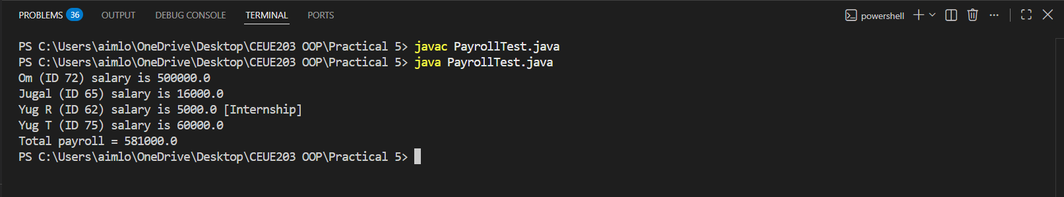
PROBLEM3 | (For Advanced Learners – home) Model a few media types that each compute a late fee differently and total the fees for a returned batch. Design the hierarchy and rules yourself.
CODE | abstract class Media {  private String title;  private int id;  public Media(String title, int id) {  this.title = title;  this.id = id;  }  public String getTitle() { return title; }  public int getId() { return id; }  public abstract double lateFee(int daysLate);  }  class Book extends Media {  public Book(String title, int id) {  super(title, id);  }  @Override  public double lateFee(int daysLate) {  return daysLate * 2.0;  }  }  class DVD extends Media {  public DVD(String title, int id) {  super(title, id);  }  public double lateFee(int daysLate) {  return daysLate * 5.0;  }  }  class Magazine extends Media {  public Magazine(String title, int id) {  super(title, id);  }  public double lateFee(int daysLate) {  return daysLate > 0 ? 10.0 : 0.0;  }  }  public class MediaTest {  public static void main(String[] args) {  Media[] items = {  new Book("Java", 1),  new DVD("Inception", 2),  new Magazine("Weekly Magazine", 3),  new Book("DSA in C++", 4),  new DVD("Interstellar", 5)  };  int[] daysLate = {3, 1, 0, 5, 2};  double totalFee = 0;  for (int i = 0; i < items.length; i++) {  double fee = items[i].lateFee(daysLate[i]);  System.out.println(items[i].getTitle() + " (ID " + items[i].getId() +  ") late fee = " + fee);  totalFee += fee;  }  System.out.println("Total late fees = " + totalFee);  }  }
OUTPUT | 