PRACTICAL – 02

Project Overview
Semantic HTML5 Pages with Accessibility-Ready Structure
Problem Definition Develop static HTML5 skeletons for at least 10 Student Hub pages such as Home, About, Register, Login, Dashboard, Events, Profile, Contact, Admin, FAQ, and Feedback. Use semantic tags and accessibility-friendly structure.

CODES AND PAGES

Home.html | <!DOCTYPE html>  <html lang="en">  <head>  <meta charset="UTF-8">  <meta name="viewport" content="width=device-width, initial-scale=1.0">  <title>Home | CHARUSAT Student Hub</title>  </head>  <body>  <a href="#main-content" class="skip-link">Skip to main content</a>  <header>  <img src="CHARUSAT.jpg" alt="UNIVERSITY BANNER">  <h1>CHARUSAT Student Hub</h1>  <nav aria-label="Primary">  <ul>  <li><a href="index.html" aria-current="page">Home</a></li>  <li><a href="about.html">About</a></li>  <li><a href="register.html">Register</a></li>  <li><a href="login.html">Login</a></li>  <li><a href="dashboard.html">Dashboard</a></li>  <li><a href="events.html">Events</a></li>  <li><a href="profile.html">Profile</a></li>  <li><a href="contact.html">Contact</a></li>  <li><a href="admin.html">Admin</a></li>  <li><a href="faq.html">FAQ</a></li>  <li><a href="feedback.html">Feedback</a></li>  </ul>  </nav>  </header>  <main id="main-content">  <h2>Welcome to the Student Hub</h2>  <p>  The Student Hub is the single place to check your courses, attendance,  results, notices and campus events. Use the navigation menu above,  or the shortcuts below, to get started.  </p>  <section aria-labelledby="quick-links-heading">  <h3 id="quick-links-heading">Quick links</h3>  <ul>  <li><a href="login.html">Log in to your account</a></li>  <li><a href="register.html">Create a new account</a></li>  <li><a href="events.html">See upcoming events</a></li>  <li><a href="faq.html">Read frequently asked questions</a></li>  </ul>  </section>  <section aria-labelledby="announcements-heading">  <h3 id="announcements-heading">Latest announcements</h3>  <article>  <h4>Semester registration now open</h4>  <p>Students can register for next semester's courses from the Register page.</p>  </article>  <article>  <h4>Library timings extended</h4>  <p>The central library will remain open until 9 PM on weekdays.</p>  </article>  </section>  </main>  <footer>  <nav aria-label="Footer">  <ul>  <li><a href="about.html">About</a></li>  <li><a href="contact.html">Contact us</a></li>  <li><a href="faq.html">FAQ</a></li>  <li><a href="feedback.html">Feedback</a></li>  </ul>  </nav>  <p>&copy; 2026 CHARUSAT Student Hub. All rights reserved.</p>  </footer>  </body>  </html>
Page | 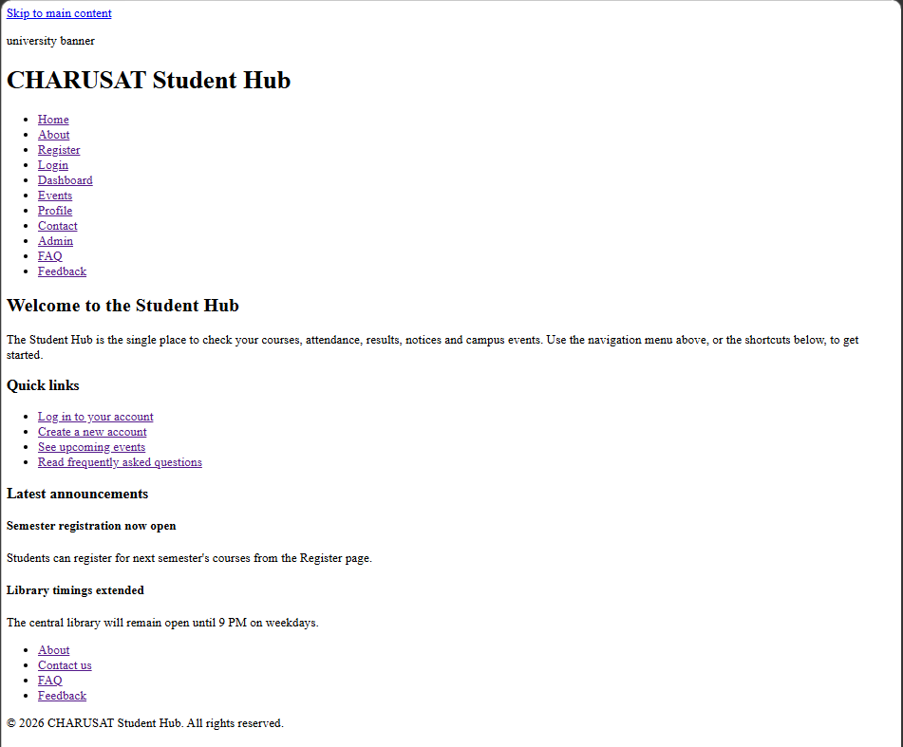
About.html | <!DOCTYPE html>  <html lang="en">  <head>  <meta charset="UTF-8">  <meta name="viewport" content="width=device-width, initial-scale=1.0">  <title>About | CHARUSAT Student Hub</title>  </head>  <body>  <a href="#main-content" class="skip-link">Skip to main content</a>  <header>  <img src="CHARUSAT.jpg" alt="UNIVERSITY BANNER">  <h1>CHARUSAT Student Hub</h1>  <nav aria-label="Primary">  <ul>  <li><a href="index.html">Home</a></li>  <li><a href="about.html" aria-current="page">About</a></li>  <li><a href="register.html">Register</a></li>  <li><a href="login.html">Login</a></li>  <li><a href="dashboard.html">Dashboard</a></li>  <li><a href="events.html">Events</a></li>  <li><a href="profile.html">Profile</a></li>  <li><a href="contact.html">Contact</a></li>  <li><a href="admin.html">Admin</a></li>  <li><a href="faq.html">FAQ</a></li>  <li><a href="feedback.html">Feedback</a></li>  </ul>  </nav>  </header>  <nav aria-label="Breadcrumb">  <ol>  <li><a href="index.html">Home</a></li>  <li aria-current="page">About</li>  </ol>  </nav>  <main id="main-content">  <h2>About Student Hub</h2>  <section aria-labelledby="mission-heading">  <h3 id="mission-heading">Our mission</h3>  <p>  Student Hub brings together course information, attendance, results,  notices and events in one accessible portal for students, faculty  and administrators of CHARUSAT.  </p>  </section>  <section aria-labelledby="roles-heading">  <h3 id="roles-heading">Who uses this portal</h3>  <article>  <h4>Students</h4>  <p>View courses, attendance, results and campus notices.</p>  </article>  <article>  <h4>Faculty</h4>  <p>Post notices, record attendance and publish results.</p>  </article>  <article>  <h4>Administrators</h4>  <p>Manage user accounts, courses and site-wide content.</p>  </article>  </section>  <aside aria-labelledby="contact-aside-heading">  <h3 id="contact-aside-heading">Need help?</h3>  <p>Visit the <a href="contact.html">Contact us</a> page or check the <a href="faq.html">FAQ</a>.</p>  </aside>  </main>  <footer>  <nav aria-label="Footer">  <ul>  <li><a href="about.html">About</a></li>  <li><a href="contact.html">Contact us</a></li>  <li><a href="faq.html">FAQ</a></li>  <li><a href="feedback.html">Feedback</a></li>  </ul>  </nav>  <p>&copy; 2026 CHARUSAT Student Hub. All rights reserved.</p>  </footer>  </body>  </html>
Page | 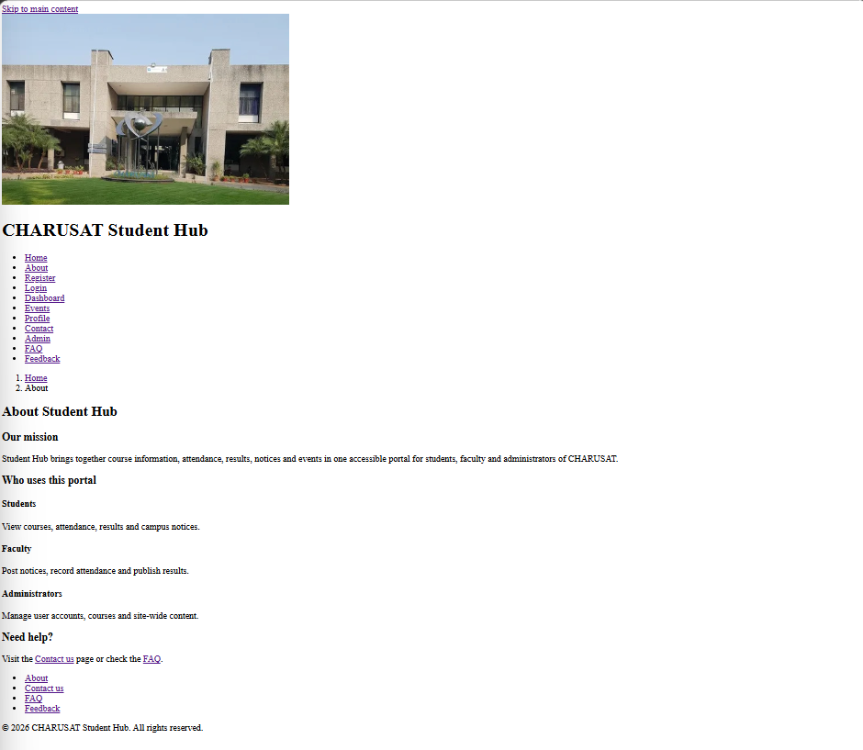
Register.html | <!DOCTYPE html>  <html lang="en">  <head>  <meta charset="UTF-8">  <meta name="viewport" content="width=device-width, initial-scale=1.0">  <title>Register | CHARUSAT Student Hub</title>  </head>  <body>  <a href="#main-content" class="skip-link">Skip to main content</a>  <header>  <h1>CHARUSAT Student Hub</h1>  <nav aria-label="Primary">  <ul>  <li><a href="index.html">Home</a></li>  <li><a href="about.html">About</a></li>  <li><a href="register.html" aria-current="page">Register</a></li>  <li><a href="login.html">Login</a></li>  <li><a href="dashboard.html">Dashboard</a></li>  <li><a href="events.html">Events</a></li>  <li><a href="profile.html">Profile</a></li>  <li><a href="contact.html">Contact</a></li>  <li><a href="admin.html">Admin</a></li>  <li><a href="faq.html">FAQ</a></li>  <li><a href="feedback.html">Feedback</a></li>  </ul>  </nav>  </header>  <nav aria-label="Breadcrumb">  <ol>  <li><a href="index.html">Home</a></li>  <li aria-current="page">Register</li>  </ol>  </nav>  <main id="main-content">  <h2>Create an account</h2>  <section aria-labelledby="register-form-heading">  <h3 id="register-form-heading" class="visually-hidden">Registration form</h3>  <form action="#" method="post">  <fieldset>  <legend>Personal details</legend>  <div>  <label for="full-name">Full name</label>  <input type="text" id="full-name" name="full-name" autocomplete="name" required>  </div>  <div>  <label for="reg-email">Email address</label>  <input type="email" id="reg-email" name="email" autocomplete="email" required>  </div>  <div>  <label for="reg-role">I am registering as</label>  <select id="reg-role" name="role" required>  <option value="">Select a role</option>  <option value="student">Student</option>  <option value="faculty">Faculty</option>  </select>  </div>  </fieldset>  <fieldset>  <legend>Account security</legend>  <div>  <label for="reg-password">Password</label>  <input type="password" id="reg-password" name="password" autocomplete="new-password" required aria-describedby="password-hint">  <p id="password-hint">Use at least 8 characters, including a number.</p>  </div>  <div>  <label for="reg-confirm">Confirm password</label>  <input type="password" id="reg-confirm" name="confirm-password" autocomplete="new-password" required>  </div>  </fieldset>  <button type="submit">Create account</button>  </form>  <p>Already have an account? <a href="login.html">Log in here</a>.</p>  </section>  </main>  <footer>  <nav aria-label="Footer">  <ul>  <li><a href="about.html">About</a></li>  <li><a href="contact.html">Contact us</a></li>  <li><a href="faq.html">FAQ</a></li>  <li><a href="feedback.html">Feedback</a></li>  </ul>  </nav>  <p>&copy; 2026 CHARUSAT Student Hub. All rights reserved.</p>  </footer>  </body>  </html>
Page | 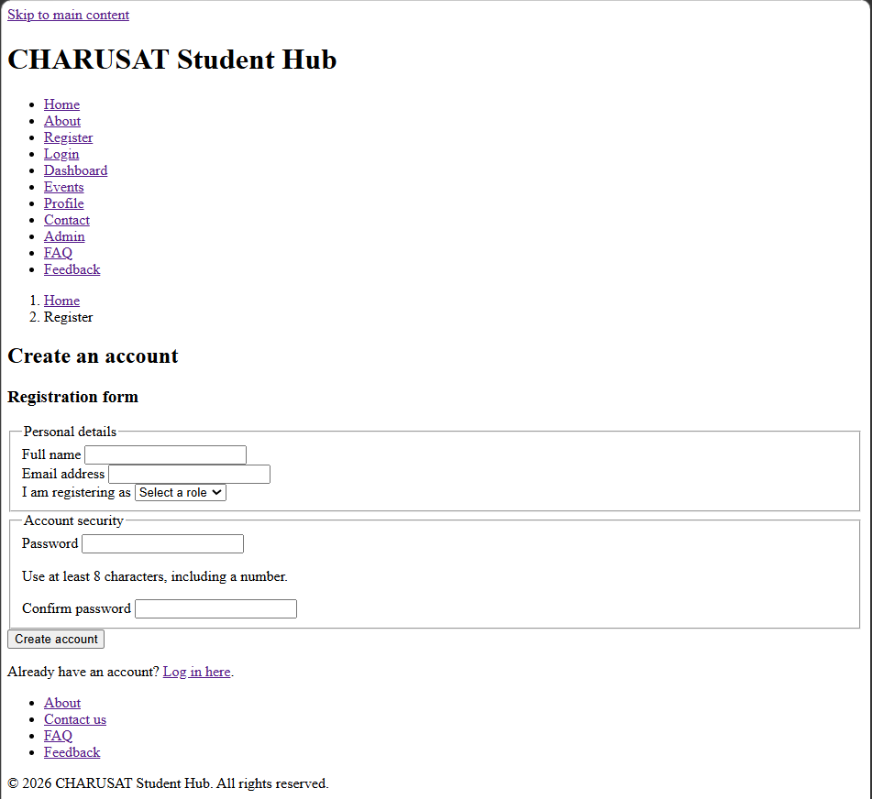
Login.html | <!DOCTYPE html>  <html lang="en">  <head>  <meta charset="UTF-8">  <meta name="viewport" content="width=device-width, initial-scale=1.0">  <title>Login | CHARUSAT Student Hub</title>  </head>  <body>  <a href="#main-content" class="skip-link">Skip to main content</a>  <header>  <h1>CHARUSAT Student Hub</h1>  <nav aria-label="Primary">  <ul>  <li><a href="index.html">Home</a></li>  <li><a href="about.html">About</a></li>  <li><a href="register.html">Register</a></li>  <li><a href="login.html" aria-current="page">Login</a></li>  <li><a href="dashboard.html">Dashboard</a></li>  <li><a href="events.html">Events</a></li>  <li><a href="profile.html">Profile</a></li>  <li><a href="contact.html">Contact</a></li>  <li><a href="admin.html">Admin</a></li>  <li><a href="faq.html">FAQ</a></li>  <li><a href="feedback.html">Feedback</a></li>  </ul>  </nav>  </header>  <nav aria-label="Breadcrumb">  <ol>  <li><a href="index.html">Home</a></li>  <li aria-current="page">Login</li>  </ol>  </nav>  <main id="main-content">  <h2>Log in</h2>  <section aria-labelledby="login-form-heading">  <h3 id="login-form-heading" class="visually-hidden">Login form</h3>  <form action="#" method="post">  <div>  <label for="login-email">Email address</label>  <input type="email" id="login-email" name="email" autocomplete="email" required>  </div>  <div>  <label for="login-password">Password</label>  <input type="password" id="login-password" name="password" autocomplete="current-password" required>  </div>  <fieldset>  <legend>Log in as</legend>  <div>  <input type="radio" id="role-student" name="role" value="student" checked>  <label for="role-student">Student</label>  </div>  <div>  <input type="radio" id="role-faculty" name="role" value="faculty">  <label for="role-faculty">Faculty</label>  </div>  <div>  <input type="radio" id="role-admin" name="role" value="admin">  <label for="role-admin">Admin</label>  </div>  </fieldset>  <button type="submit">Log in</button>  </form>  <p>Don't have an account? <a href="register.html">Register here</a>.</p>  </section>  </main>  <footer>  <nav aria-label="Footer">  <ul>  <li><a href="about.html">About</a></li>  <li><a href="contact.html">Contact us</a></li>  <li><a href="faq.html">FAQ</a></li>  <li><a href="feedback.html">Feedback</a></li>  </ul>  </nav>  <p>&copy; 2026 CHARUSAT Student Hub. All rights reserved.</p>  </footer>  </body>  </html>
Page | 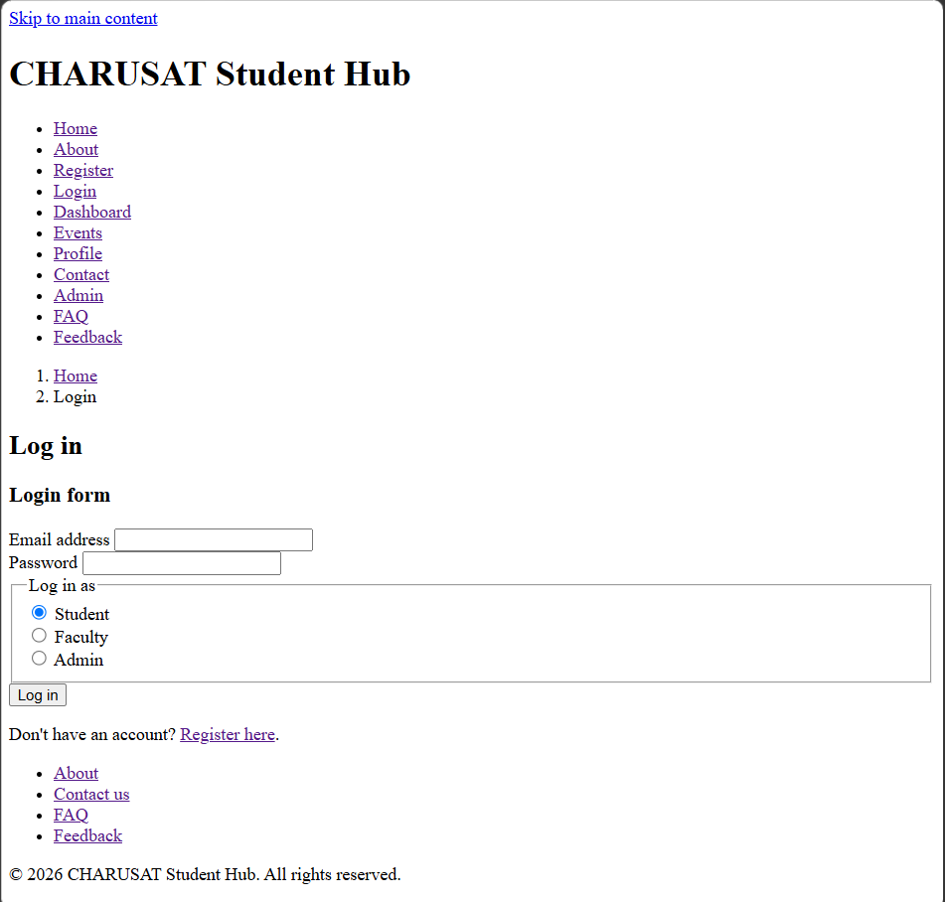
Dashboard.html | <!DOCTYPE html>  <html lang="en">  <head>  <meta charset="UTF-8">  <meta name="viewport" content="width=device-width, initial-scale=1.0">  <title>Dashboard | CHARUSAT Student Hub</title>  </head>  <body>  <a href="#main-content" class="skip-link">Skip to main content</a>  <header>  <h1>CHARUSAT Student Hub</h1>  <nav aria-label="Primary">  <ul>  <li><a href="index.html">Home</a></li>  <li><a href="about.html">About</a></li>  <li><a href="register.html">Register</a></li>  <li><a href="login.html">Login</a></li>  <li><a href="dashboard.html" aria-current="page">Dashboard</a></li>  <li><a href="events.html">Events</a></li>  <li><a href="profile.html">Profile</a></li>  <li><a href="contact.html">Contact</a></li>  <li><a href="admin.html">Admin</a></li>  <li><a href="faq.html">FAQ</a></li>  <li><a href="feedback.html">Feedback</a></li>  </ul>  </nav>  </header>  <nav aria-label="Breadcrumb">  <ol>  <li><a href="index.html">Home</a></li>  <li aria-current="page">Dashboard</li>  </ol>  </nav>  <main id="main-content">  <h2>Dashboard</h2>  <p>Welcome back. Here is a summary of your academic activity.</p>  <section aria-labelledby="summary-heading">  <h3 id="summary-heading">Summary</h3>  <ul>  <li>Attendance: 87%</li>  <li>Pending assignments: 3</li>  <li>Latest result: Semester 4 published</li>  </ul>  </section>  <section aria-labelledby="notices-heading">  <h3 id="notices-heading">Recent notices</h3>  <table>  <caption class="visually-hidden">Recent notices with dates</caption>  <thead>  <tr>  <th scope="col">Date</th>  <th scope="col">Notice</th>  </tr>  </thead>  <tbody>  <tr>  <td>02 Aug 2026</td>  <td>Mid-semester exam schedule released</td>  </tr>  <tr>  <td>28 Jul 2026</td>  <td>Library timings extended</td>  </tr>  </tbody>  </table>  </section>  <aside aria-labelledby="shortcuts-heading">  <h3 id="shortcuts-heading">Shortcuts</h3>  <ul>  <li><a href="profile.html">Edit profile</a></li>  <li><a href="events.html">Upcoming events</a></li>  </ul>  </aside>  </main>  <footer>  <nav aria-label="Footer">  <ul>  <li><a href="about.html">About</a></li>  <li><a href="contact.html">Contact us</a></li>  <li><a href="faq.html">FAQ</a></li>  <li><a href="feedback.html">Feedback</a></li>  </ul>  </nav>  <p>&copy; 2026 CHARUSAT Student Hub. All rights reserved.</p>  </footer>  </body>  </html>
Page | 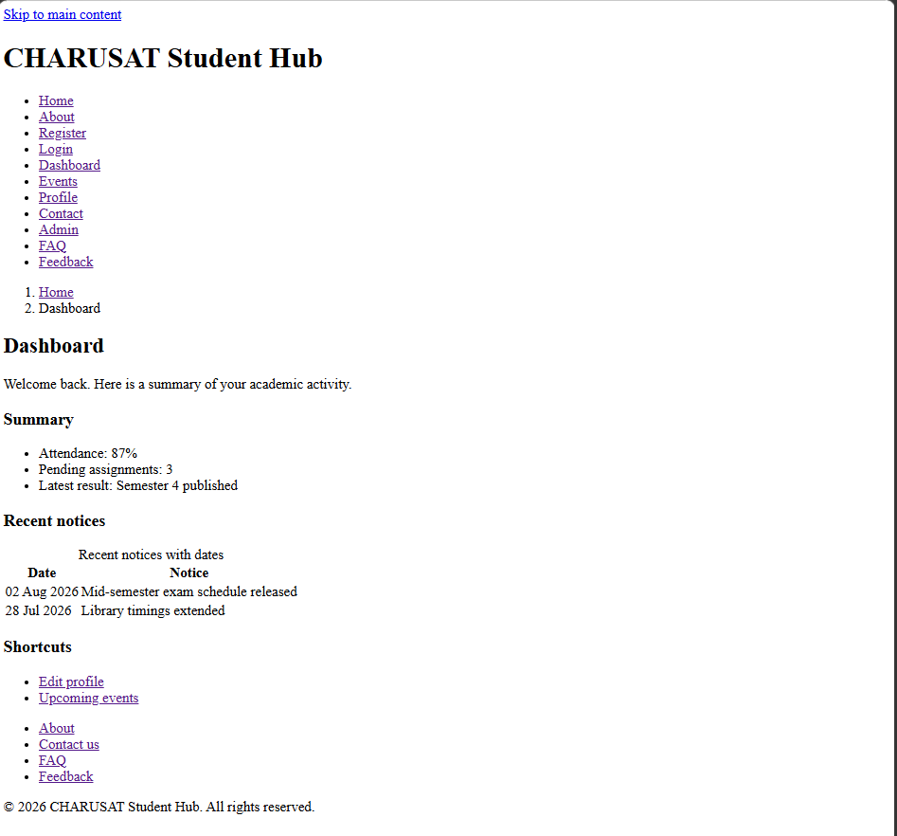
Events.html | <!DOCTYPE html>  <html lang="en">  <head>  <meta charset="UTF-8">  <meta name="viewport" content="width=device-width, initial-scale=1.0">  <title>Events | CHARUSAT Student Hub</title>  </head>  <body>  <a href="#main-content" class="skip-link">Skip to main content</a>  <header>  <h1>CHARUSAT Student Hub</h1>  <nav aria-label="Primary">  <ul>  <li><a href="index.html">Home</a></li>  <li><a href="about.html">About</a></li>  <li><a href="register.html">Register</a></li>  <li><a href="login.html">Login</a></li>  <li><a href="dashboard.html">Dashboard</a></li>  <li><a href="events.html" aria-current="page">Events</a></li>  <li><a href="profile.html">Profile</a></li>  <li><a href="contact.html">Contact</a></li>  <li><a href="admin.html">Admin</a></li>  <li><a href="faq.html">FAQ</a></li>  <li><a href="feedback.html">Feedback</a></li>  </ul>  </nav>  </header>  <nav aria-label="Breadcrumb">  <ol>  <li><a href="index.html">Home</a></li>  <li aria-current="page">Events</li>  </ol>  </nav>  <main id="main-content">  <h2>Campus events</h2>  <img src="SPOURAL.jpg" alt="Students participating in the campus Spoural event">  <section aria-labelledby="upcoming-heading">  <h3 id="upcoming-heading">Upcoming events</h3>  <article aria-labelledby="event1-heading">  <h4 id="event1-heading">Annual Tech Fest</h4>  <p>15 Sept 2026, Main Auditorium. Open to all students.</p>  </article>  <article aria-labelledby="event2-heading">  <h4 id="event2-heading">Career Guidance Workshop</h4>  <p>22 Sept 2026, Seminar Hall B. Registration required.</p>  </article>  <article aria-labelledby="event3-heading">  <h4 id="event3-heading">Sports Meet</h4>  <p>30 Sept 2026, University Ground. All departments welcome.</p>  </article>  </section>  </main>  <footer>  <nav aria-label="Footer">  <ul>  <li><a href="about.html">About</a></li>  <li><a href="contact.html">Contact us</a></li>  <li><a href="faq.html">FAQ</a></li>  <li><a href="feedback.html">Feedback</a></li>  </ul>  </nav>  <p>&copy; 2026 CHARUSAT Student Hub. All rights reserved.</p>  </footer>  </body>  </html>
Page | 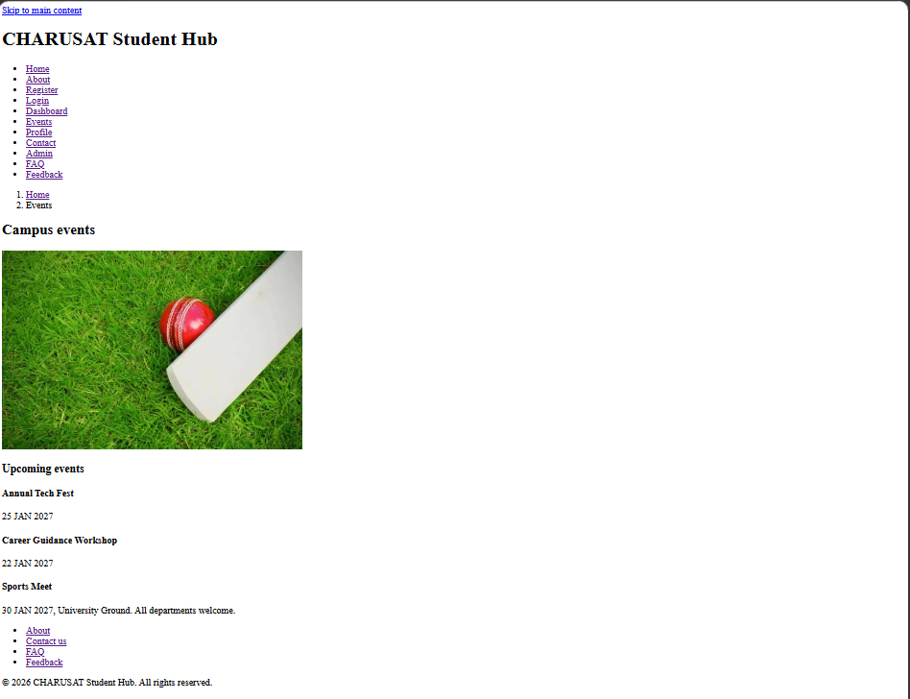
Profile.html | <!DOCTYPE html>  <html lang="en">  <head>  <meta charset="UTF-8">  <meta name="viewport" content="width=device-width, initial-scale=1.0">  <title>Profile | CHARUSAT Student Hub</title>  </head>  <body>  <a href="#main-content" class="skip-link">Skip to main content</a>  <header>  <h1>CHARUSAT Student Hub</h1>  <nav aria-label="Primary">  <ul>  <li><a href="index.html">Home</a></li>  <li><a href="about.html">About</a></li>  <li><a href="register.html">Register</a></li>  <li><a href="login.html">Login</a></li>  <li><a href="dashboard.html">Dashboard</a></li>  <li><a href="events.html">Events</a></li>  <li><a href="profile.html" aria-current="page">Profile</a></li>  <li><a href="contact.html">Contact</a></li>  <li><a href="admin.html">Admin</a></li>  <li><a href="faq.html">FAQ</a></li>  <li><a href="feedback.html">Feedback</a></li>  </ul>  </nav>  </header>  <nav aria-label="Breadcrumb">  <ol>  <li><a href="index.html">Home</a></li>  <li aria-current="page">Profile</li>  </ol>  </nav>  <main id="main-content">  <h2>My profile</h2>  <section aria-labelledby="profile-details-heading">  <h3 id="profile-details-heading">Profile details</h3>  <dl>  <dt>Name</dt>  <dd>Student Name</dd>  <dt>Enrollment number</dt>  <dd>21CE001</dd>  <dt>Department</dt>  <dd>Computer Engineering</dd>  <dt>Email</dt>  <dd>student@charusat.edu.in</dd>  </dl>  </section>  <section aria-labelledby="edit-profile-heading">  <h3 id="edit-profile-heading">Update details</h3>  <form action="#" method="post">  <div>  <label for="profile-phone">Phone number</label>  <input type="tel" id="profile-phone" name="phone" autocomplete="tel">  </div>  <div>  <label for="profile-photo">Profile photo</label>  <input type="file" id="profile-photo" name="photo" accept="image/*">  </div>  <button type="submit">Save changes</button>  </form>  </section>  </main>  <footer>  <nav aria-label="Footer">  <ul>  <li><a href="about.html">About</a></li>  <li><a href="contact.html">Contact us</a></li>  <li><a href="faq.html">FAQ</a></li>  <li><a href="feedback.html">Feedback</a></li>  </ul>  </nav>  <p>&copy; 2026 CHARUSAT Student Hub. All rights reserved.</p>  </footer>  </body>  </html>
Page | 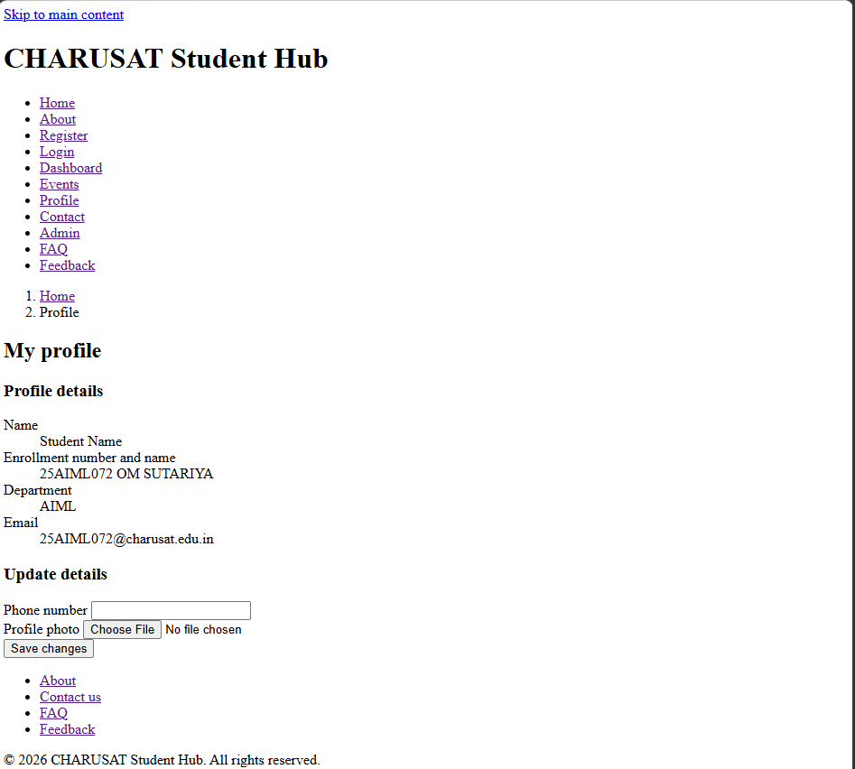
Contact.html | <!DOCTYPE html>  <html lang="en">  <head>  <meta charset="UTF-8">  <meta name="viewport" content="width=device-width, initial-scale=1.0">  <title>Contact | CHARUSAT Student Hub</title>  </head>  <body>  <a href="#main-content" class="skip-link">Skip to main content</a>  <header>  <h1>CHARUSAT Student Hub</h1>  <nav aria-label="Primary">  <ul>  <li><a href="index.html">Home</a></li>  <li><a href="about.html">About</a></li>  <li><a href="register.html">Register</a></li>  <li><a href="login.html">Login</a></li>  <li><a href="dashboard.html">Dashboard</a></li>  <li><a href="events.html">Events</a></li>  <li><a href="profile.html">Profile</a></li>  <li><a href="contact.html" aria-current="page">Contact</a></li>  <li><a href="admin.html">Admin</a></li>  <li><a href="faq.html">FAQ</a></li>  <li><a href="feedback.html">Feedback</a></li>  </ul>  </nav>  </header>  <nav aria-label="Breadcrumb">  <ol>  <li><a href="index.html">Home</a></li>  <li aria-current="page">Contact</li>  </ol>  </nav>  <main id="main-content">  <h2>Contact us</h2>  <section aria-labelledby="contact-form-heading">  <h3 id="contact-form-heading" class="visually-hidden">Contact form</h3>  <form action="#" method="post">  <div>  <label for="contact-name">Your name</label>  <input type="text" id="contact-name" name="name" autocomplete="name" required>  </div>  <div>  <label for="contact-email">Your email</label>  <input type="email" id="contact-email" name="email" autocomplete="email" required>  </div>  <div>  <label for="contact-subject">Subject</label>  <input type="text" id="contact-subject" name="subject" required>  </div>  <div>  <label for="contact-message">Message</label>  <textarea id="contact-message" name="message" rows="5" required></textarea>  </div>  <button type="submit">Send message</button>  </form>  </section>  <aside aria-labelledby="contact-info-heading">  <h3 id="contact-info-heading">Campus address</h3>  <address>  CHARUSAT Campus, Changa,<br>  Anand, Gujarat, India  </address>  </aside>  </main>  <footer>  <nav aria-label="Footer">  <ul>  <li><a href="about.html">About</a></li>  <li><a href="contact.html">Contact us</a></li>  <li><a href="faq.html">FAQ</a></li>  <li><a href="feedback.html">Feedback</a></li>  </ul>  </nav>  <p>&copy; 2026 CHARUSAT Student Hub. All rights reserved.</p>  </footer>  </body>  </html>
Page | 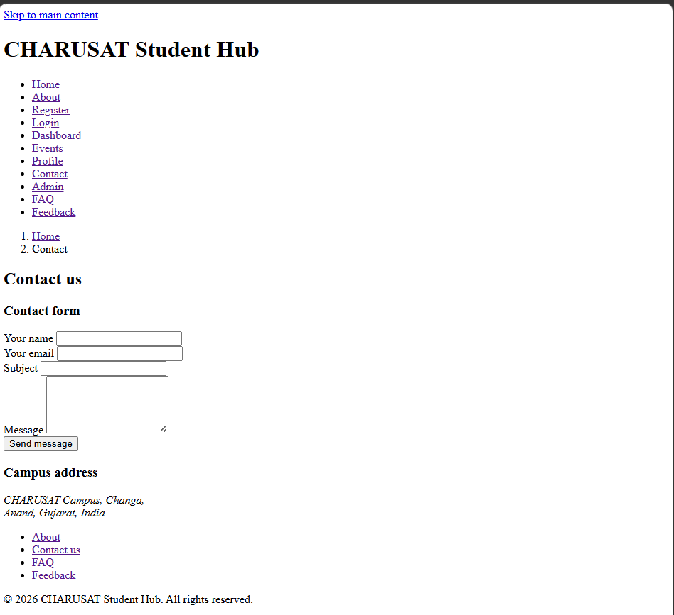
Admin.html | <!DOCTYPE html>  <html lang="en">  <head>  <meta charset="UTF-8">  <meta name="viewport" content="width=device-width, initial-scale=1.0">  <title>Admin | CHARUSAT Student Hub</title>  </head>  <body>  <a href="#main-content" class="skip-link">Skip to main content</a>  <header>  <h1>CHARUSAT Student Hub</h1>  <nav aria-label="Primary">  <ul>  <li><a href="index.html">Home</a></li>  <li><a href="about.html">About</a></li>  <li><a href="register.html">Register</a></li>  <li><a href="login.html">Login</a></li>  <li><a href="dashboard.html">Dashboard</a></li>  <li><a href="events.html">Events</a></li>  <li><a href="profile.html">Profile</a></li>  <li><a href="contact.html">Contact</a></li>  <li><a href="admin.html" aria-current="page">Admin</a></li>  <li><a href="faq.html">FAQ</a></li>  <li><a href="feedback.html">Feedback</a></li>  </ul>  </nav>  </header>  <nav aria-label="Breadcrumb">  <ol>  <li><a href="index.html">Home</a></li>  <li aria-current="page">Admin</li>  </ol>  </nav>  <main id="main-content">  <h2>Admin panel</h2>  <p>Restricted area. Manage users, courses and site-wide notices.</p>  <section aria-labelledby="admin-users-heading">  <h3 id="admin-users-heading">User management</h3>  <table>  <caption class="visually-hidden">List of registered users and their roles</caption>  <thead>  <tr>  <th scope="col">Name</th>  <th scope="col">Role</th>  <th scope="col">Status</th>  </tr>  </thead>  <tbody>  <tr>  <td>Aarav Patel</td>  <td>Student</td>  <td>Active</td>  </tr>  <tr>  <td>Dr. Neha Shah</td>  <td>Faculty</td>  <td>Active</td>  </tr>  </tbody>  </table>  </section>  <aside aria-labelledby="admin-actions-heading">  <h3 id="admin-actions-heading">Quick actions</h3>  <ul>  <li><a href="#">Add new course</a></li>  <li><a href="#">Post a site-wide notice</a></li>  </ul>  </aside>  </main>  <footer>  <nav aria-label="Footer">  <ul>  <li><a href="about.html">About</a></li>  <li><a href="contact.html">Contact us</a></li>  <li><a href="faq.html">FAQ</a></li>  <li><a href="feedback.html">Feedback</a></li>  </ul>  </nav>  <p>&copy; 2026 CHARUSAT Student Hub. All rights reserved.</p>  </footer>  </body>  </html>
Page | 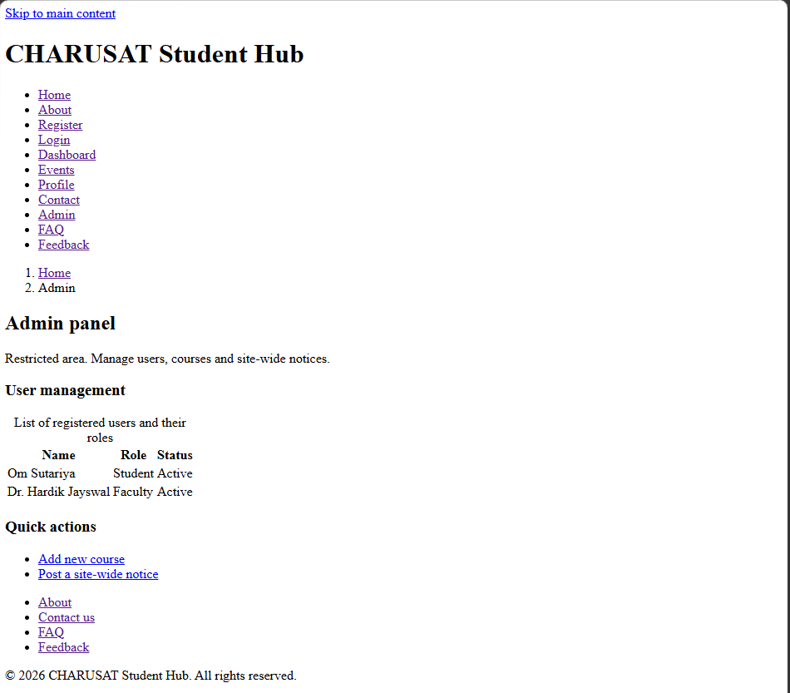
FAQ.html | <!DOCTYPE html>  <html lang="en">  <head>  <meta charset="UTF-8">  <meta name="viewport" content="width=device-width, initial-scale=1.0">  <title>FAQ | CHARUSAT Student Hub</title>  </head>  <body>  <a href="#main-content" class="skip-link">Skip to main content</a>  <header>  <h1>CHARUSAT Student Hub</h1>  <nav aria-label="Primary">  <ul>  <li><a href="index.html">Home</a></li>  <li><a href="about.html">About</a></li>  <li><a href="register.html">Register</a></li>  <li><a href="login.html">Login</a></li>  <li><a href="dashboard.html">Dashboard</a></li>  <li><a href="events.html">Events</a></li>  <li><a href="profile.html">Profile</a></li>  <li><a href="contact.html">Contact</a></li>  <li><a href="admin.html">Admin</a></li>  <li><a href="faq.html" aria-current="page">FAQ</a></li>  <li><a href="feedback.html">Feedback</a></li>  </ul>  </nav>  </header>  <nav aria-label="Breadcrumb">  <ol>  <li><a href="index.html">Home</a></li>  <li aria-current="page">FAQ</li>  </ol>  </nav>  <main id="main-content">  <h2>Frequently asked questions</h2>  <section aria-labelledby="faq-account-heading">  <h3 id="faq-account-heading">Account</h3>  <article>  <h4>How do I reset my password?</h4>  <p>Go to the Login page and select "Forgot password" to receive a reset link by email.</p>  </article>  <article>  <h4>Can faculty and students share one account?</h4>  <p>No, each person must register separately with the correct role.</p>  </article>  </section>  <section aria-labelledby="faq-academics-heading">  <h3 id="faq-academics-heading">Academics</h3>  <article>  <h4>Where can I check my attendance?</h4>  <p>Attendance is available on your Dashboard once you log in.</p>  </article>  <article>  <h4>When are results published?</h4>  <p>Results are published on the Dashboard shortly after evaluation is complete.</p>  </article>  </section>  </main>  <footer>  <nav aria-label="Footer">  <ul>  <li><a href="about.html">About</a></li>  <li><a href="contact.html">Contact us</a></li>  <li><a href="faq.html">FAQ</a></li>  <li><a href="feedback.html">Feedback</a></li>  </ul>  </nav>  <p>&copy; 2026 CHARUSAT Student Hub. All rights reserved.</p>  </footer>  </body>  </html>
Page | 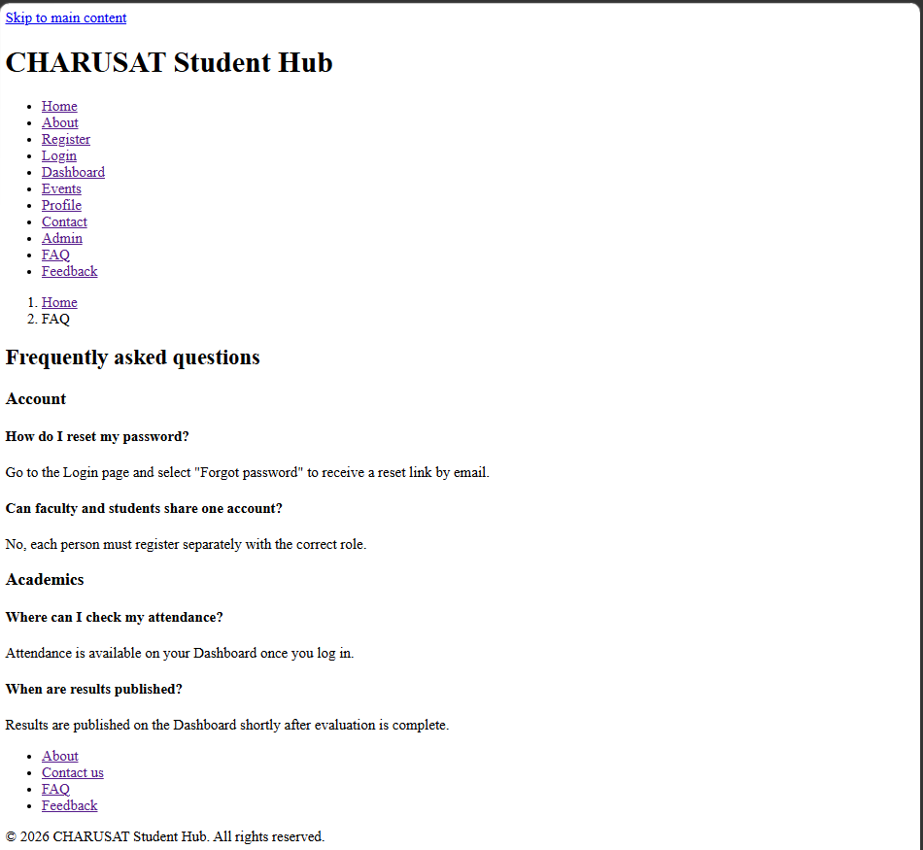
Feedback.html | <!DOCTYPE html>  <html lang="en">  <head>  <meta charset="UTF-8">  <meta name="viewport" content="width=device-width, initial-scale=1.0">  <title>Feedback | CHARUSAT Student Hub</title>  </head>  <body>  <a href="#main-content" class="skip-link">Skip to main content</a>  <header>  <h1>CHARUSAT Student Hub</h1>  <nav aria-label="Primary">  <ul>  <li><a href="index.html">Home</a></li>  <li><a href="about.html">About</a></li>  <li><a href="register.html">Register</a></li>  <li><a href="login.html">Login</a></li>  <li><a href="dashboard.html">Dashboard</a></li>  <li><a href="events.html">Events</a></li>  <li><a href="profile.html">Profile</a></li>  <li><a href="contact.html">Contact</a></li>  <li><a href="admin.html">Admin</a></li>  <li><a href="faq.html">FAQ</a></li>  <li><a href="feedback.html" aria-current="page">Feedback</a></li>  </ul>  </nav>  </header>  <nav aria-label="Breadcrumb">  <ol>  <li><a href="index.html">Home</a></li>  <li aria-current="page">Feedback</li>  </ol>  </nav>  <main id="main-content">  <h2>Feedback</h2>  <p>Your feedback helps us improve the Student Hub portal.</p>  <section aria-labelledby="feedback-form-heading">  <h3 id="feedback-form-heading" class="visually-hidden">Feedback form</h3>  <form action="#" method="post">  <fieldset>  <legend>How would you rate your experience?</legend>  <div>  <input type="radio" id="rate-good" name="rating" value="good">  <label for="rate-good">Good</label>  </div>  <div>  <input type="radio" id="rate-average" name="rating" value="average">  <label for="rate-average">Average</label>  </div>  <div>  <input type="radio" id="rate-poor" name="rating" value="poor">  <label for="rate-poor">Poor</label>  </div>  </fieldset>  <div>  <label for="feedback-comments">Comments</label>  <textarea id="feedback-comments" name="comments" rows="5"></textarea>  </div>  <button type="submit">Submit feedback</button>  </form>  </section>  </main>  <footer>  <nav aria-label="Footer">  <ul>  <li><a href="about.html">About</a></li>  <li><a href="contact.html">Contact us</a></li>  <li><a href="faq.html">FAQ</a></li>  <li><a href="feedback.html">Feedback</a></li>  </ul>  </nav>  <p>&copy; 2026 CHARUSAT Student Hub. All rights reserved.</p>  </footer>  </body>  </html>
Page | 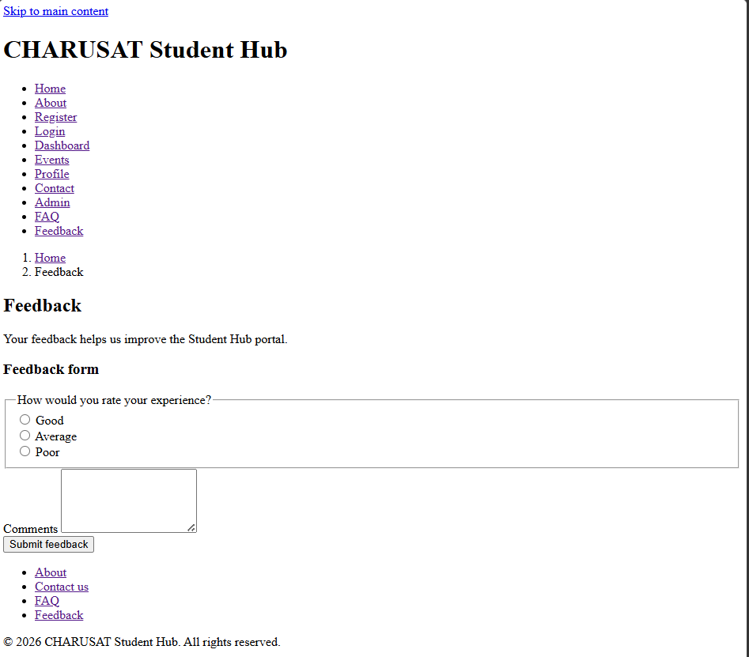

GitHub Repository Link :- https://github.com/omsutariya07/Web-Technology.git

