PRACTICAL – 3

AIM: - Responsive UI Design using CSS Grid, Flexbox, and Bootstrap/Tailwind Problem Definition Design responsive layouts for Home, About, Registration, Dashboard, and Events pages using CSS Grid and Flexbox. Optional to use CSS framework such as Bootstrap or Tailwind. Ensure mobile-first responsiveness.

FILES

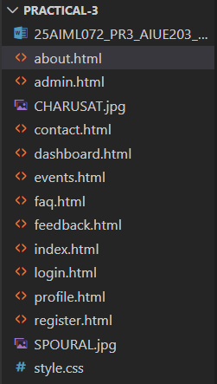

CODE

/* ---------- Reset ---------- */
* {
margin: 0;
padding: 0;
box-sizing: border-box;
}

body {
font-family: Arial, Helvetica, sans-serif;
background: #f4f6f9;
color: #333;
line-height: 1.6;

/* CSS Grid Layout */
display: grid;
grid-template-areas:
"header header"
"aside main"
"footer footer";

grid-template-columns: 250px 1fr;
min-height: 100vh;
}

/* ---------- Header ---------- */
header {
grid-area: header;
background: #003366;
color: white;
padding: 20px;

/* Flexbox */
display: flex;
justify-content: space-between;
align-items: center;
flex-wrap: wrap;

gap: 15px;
}

header h1 {
font-size: 2rem;
}

/* ---------- Navigation ---------- */
nav ul {
list-style: none;

/* Flexbox */
display: flex;
gap: 15px;
flex-wrap: wrap;
}

nav a {
text-decoration: none;
color: white;
padding: 8px 15px;
border-radius: 5px;
transition: 0.3s;
}

nav a:hover {
background: white;
color: #003366;
}

nav a[aria-current="page"] {
background: #ff9800;
color: white;
}

/* ---------- Sidebar ---------- */
aside {
grid-area: aside;
background: white;
padding: 20px;
border-right: 1px solid #ddd;
}

aside h2 {
margin-bottom: 15px;
color: #003366;
}

aside ul {
list-style: none;
margin-left: 0;
}

aside li {
margin: 12px 0;
}

aside a {
text-decoration: none;
color: #003366;
}

aside a:hover {
color: #ff9800;
}

/* ---------- Main ---------- */
main {
grid-area: main;
padding: 25px;
}

/* ---------- Footer ---------- */
footer {
grid-area: footer;
background: #003366;
color: white;
text-align: center;
padding: 15px;
}

/* ---------- Sections ---------- */
section {
background: white;
margin-bottom: 25px;
padding: 20px;
border-radius: 10px;
box-shadow: 0 0 10px rgba(0, 0, 0, 0.1);
}

section h2 {
color: #003366;
margin-bottom: 15px;
}

/* ---------- Articles ---------- */
article {
margin-top: 15px;
padding: 15px;
border-left: 5px solid #003366;
background: #f8f8f8;
border-radius: 5px;
}

/* ---------- Lists ---------- */
ul {
margin-left: 20px;
}

li {
margin: 8px 0;
}

/* ---------- Forms ---------- */
form {
margin-top: 20px;
}

fieldset {
border: 2px solid #003366;
padding: 20px;
border-radius: 8px;
}

legend {
color: #003366;
font-weight: bold;
padding: 0 10px;
}

label {
font-weight: bold;
}

input,
select,
textarea {
width: 100%;
padding: 10px;
margin-top: 8px;
margin-bottom: 15px;

border: 1px solid #ccc;
border-radius: 5px;

font-size: 16px;
}

input:focus,
textarea:focus,
select:focus {
outline: none;
border: 2px solid #003366;
}

/* ---------- Buttons ---------- */
button {
background: #003366;
color: white;
border: none;

padding: 10px 20px;
border-radius: 5px;

cursor: pointer;
transition: 0.3s;
margin-right: 10px;
}

button:hover {
background: #0055aa;
}

/* ---------- Tables ---------- */
table {
width: 100%;
border-collapse: collapse;
margin-top: 20px;
}

caption {
font-size: 20px;
margin-bottom: 10px;
font-weight: bold;
}

th {
background: #003366;
color: white;
}

th,
td {
border: 1px solid #ddd;
padding: 12px;
text-align: center;
}

tr:nth-child(even) {
background: #f2f2f2;
}

/* ---------- Dashboard Cards ---------- */
.dashboard-grid {
display: grid;
grid-template-columns: repeat(3, 1fr);
gap: 20px;
}

.card {
background: white;
padding: 20px;
border-radius: 10px;

text-align: center;

box-shadow: 0 0 10px rgba(0, 0, 0, 0.1);

transition: 0.3s;
}

.card:hover {
transform: translateY(-5px);
}

/* ---------- Event Cards ---------- */
.events-grid {
display: grid;

grid-template-columns:
repeat(auto-fit, minmax(280px, 1fr));

gap: 20px;
}

.event-card {
background: white;
padding: 20px;

border-radius: 10px;

box-shadow: 0 0 10px rgba(0, 0, 0, 0.1);

transition: 0.3s;
}

.event-card:hover {
transform: translateY(-5px);
}

/* ---------- Images ---------- */
img {
max-width: 100%;
height: auto;
border-radius: 10px;
}

/* ---------- Details ---------- */
details {
margin: 15px 0;
padding: 10px;

background: #f9f9f9;
border-radius: 5px;
}

summary {
font-weight: bold;
cursor: pointer;
color: #003366;
}

/* ---------- Address ---------- */
address {
font-style: normal;
line-height: 2;
}

/* ---------- Links ---------- */
a {
transition: 0.3s;
}

a:hover {
color: #ff9800;
}

/* =====================================================
RESPONSIVE DESIGN
===================================================== */

/* ---------- Tablet ---------- */
@media screen and (max-width: 992px) {

body {
grid-template-areas:
"header"
"aside"
"main"
"footer";

grid-template-columns: 1fr;
}

header {
justify-content: center;
text-align: center;
}

nav ul {
justify-content: center;
}

aside {
border-right: none;
border-bottom: 1px solid #ddd;
}

aside ul {
display: flex;
justify-content: center;
gap: 20px;
flex-wrap: wrap;
}

aside li {
margin: 5px;
}

.dashboard-grid {
grid-template-columns: repeat(2, 1fr);
}
}

/* ---------- Mobile ---------- */
@media screen and (max-width: 600px) {

body {
grid-template-areas:
"header"
"aside"
"main"
"footer";

grid-template-columns: 1fr;
}

header {
padding: 15px;
flex-direction: column;
text-align: center;
}

header h1 {
font-size: 1.5rem;
}

nav ul {
flex-direction: column;
align-items: center;
gap: 8px;
}

nav a {
display: block;
width: 200px;
text-align: center;
}

aside {
padding: 15px;
text-align: center;
}

aside ul {
flex-direction: column;
align-items: center;
gap: 5px;
}

main {
padding: 15px;
}

section {
padding: 15px;
}

.dashboard-grid {
grid-template-columns: 1fr;
}

.events-grid {
grid-template-columns: 1fr;
}

table {
font-size: 14px;
}

th,
td {
padding: 8px;
}

fieldset {
padding: 15px;
}

button {
width: 100%;
margin-bottom: 10px;
}
}

/* ---------- Small Mobile ---------- */
@media screen and (max-width: 400px) {

header h1 {
font-size: 1.3rem;
}

main {
padding: 10px;
}

section {
padding: 12px;
}

.card,
.event-card {
padding: 15px;
}

input,
select,
textarea {
font-size: 14px;
}
}

ABOUT PAGE

LAPTOP VIEW

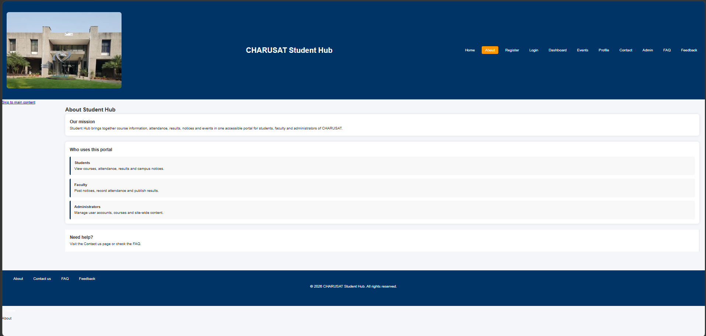

MOBILE VIEW

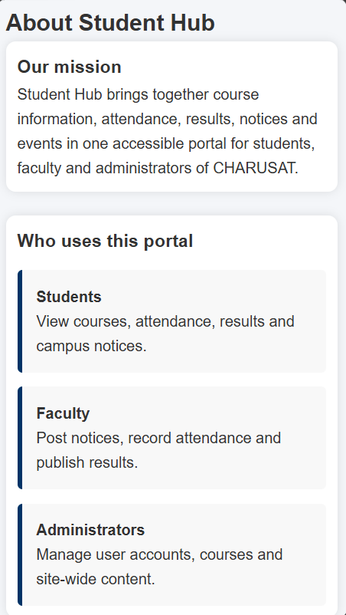

ADMIN PAGE

LAPTOP VIEW

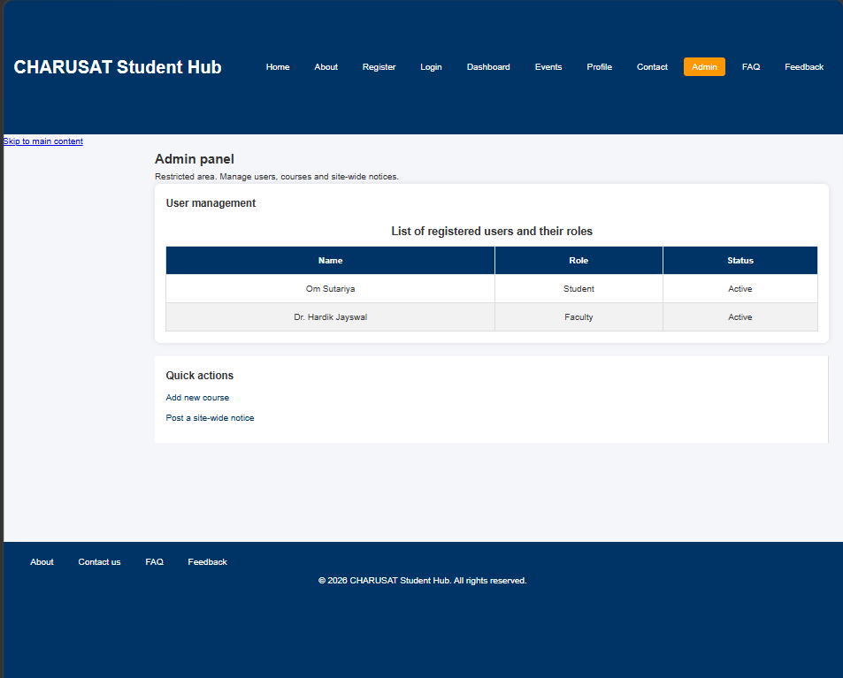

MOBILE VIEW

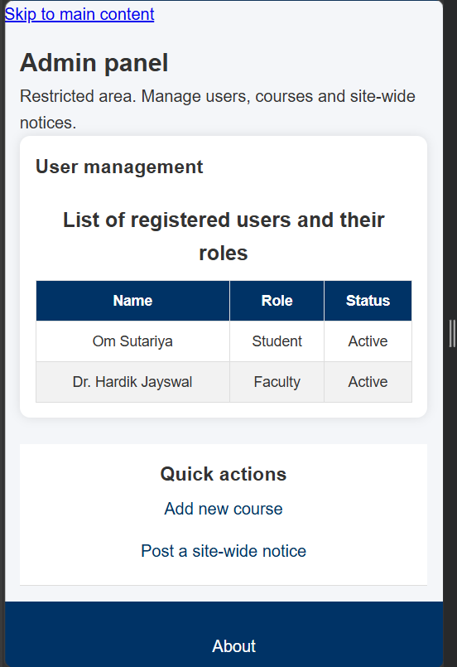

CONTACT PAGE

LAPTOP VIEW

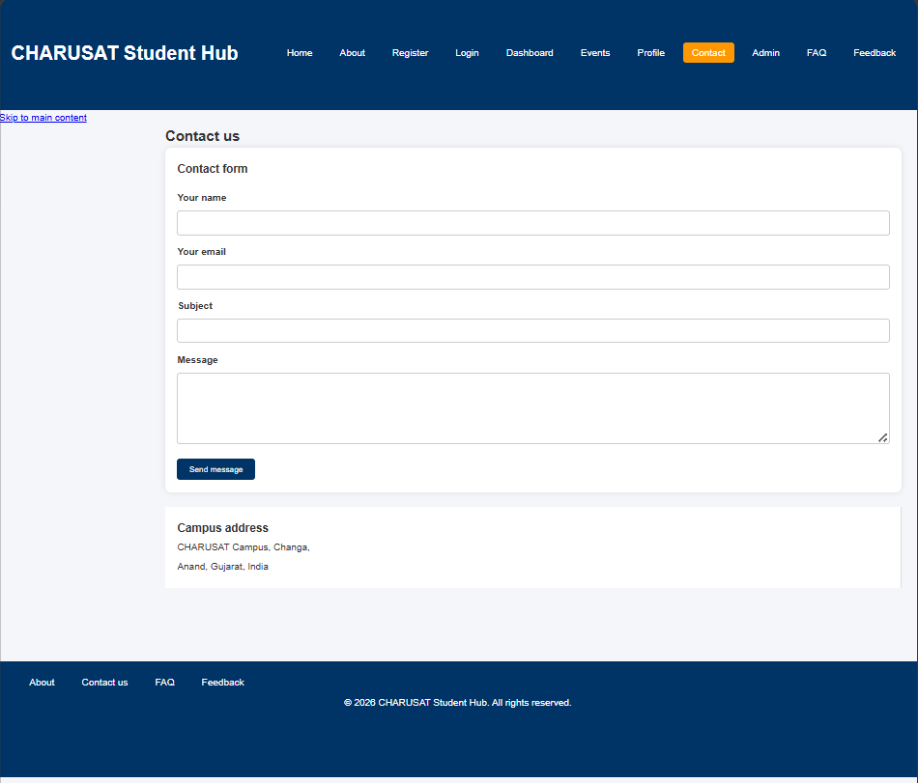

MOBILE VIEW

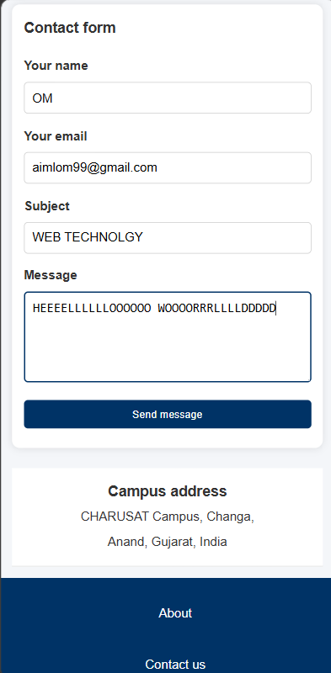

DASHBOARD PAGE

LAPTOP VIEW

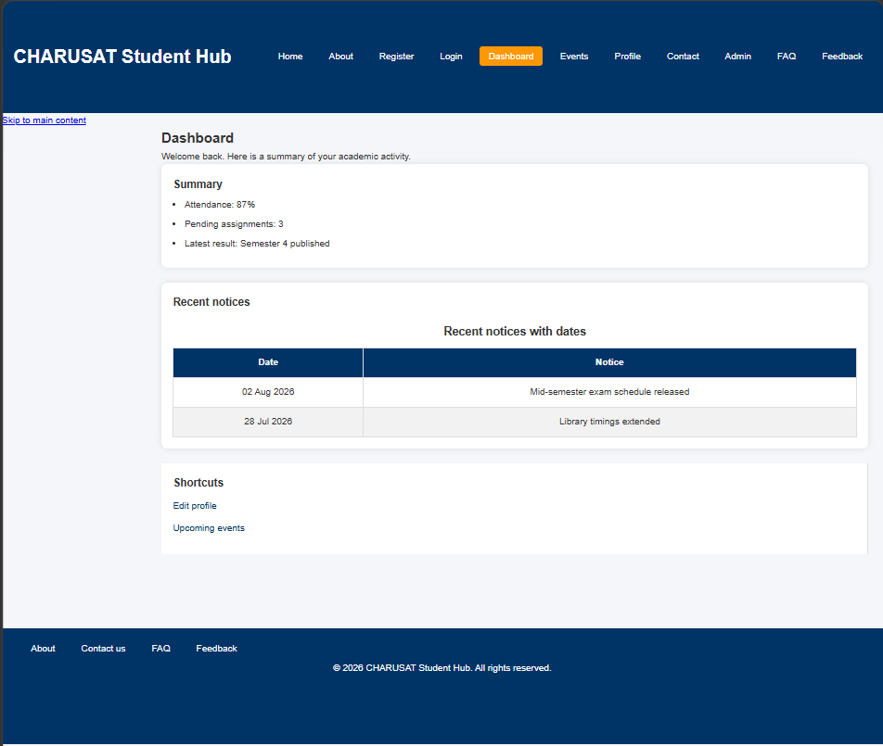

MOBILE VIEW

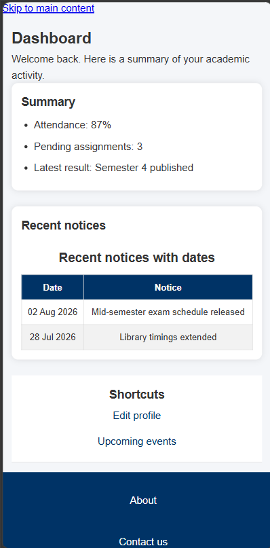

EVENTS PAGE

LAPTOP VIEW

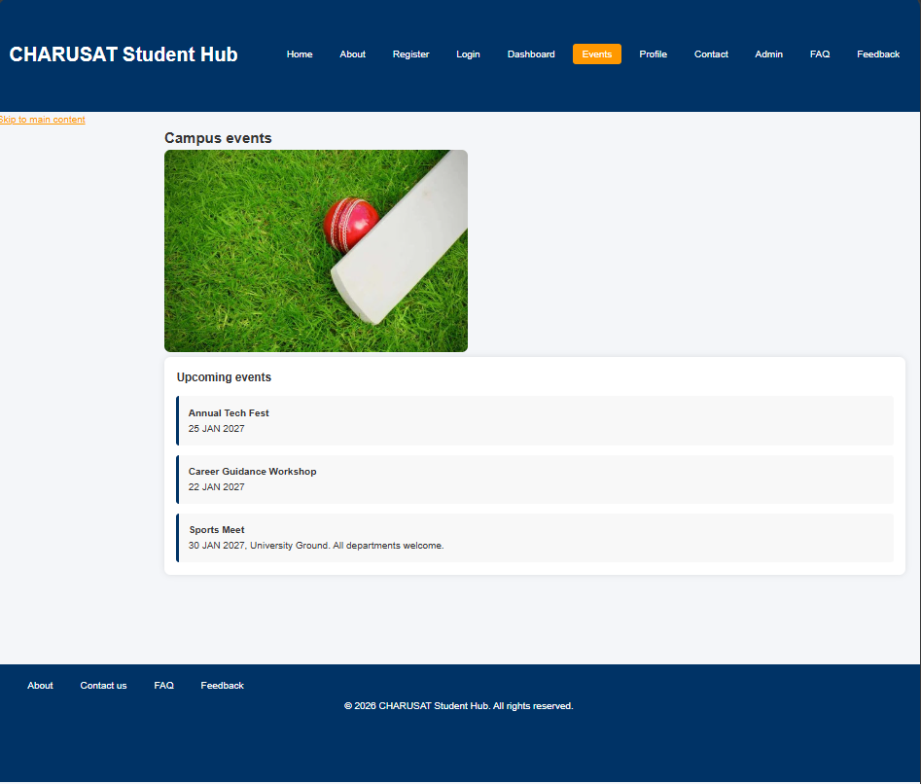

MOBILE VIEW

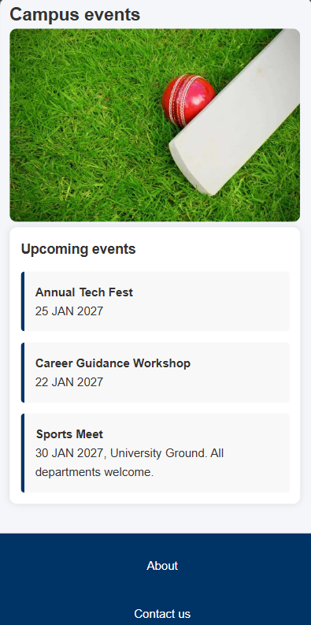

FAQs PAGE

LAPTOP VIEW

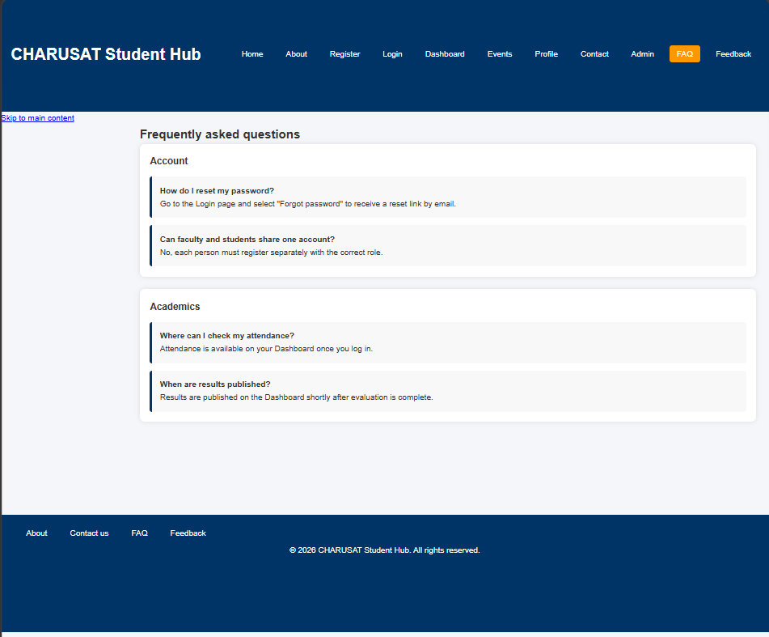

MOBILE VIEW

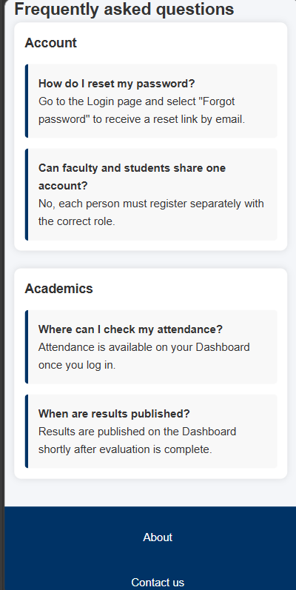

FEEDBACK FORM

LAPTOP VIEW

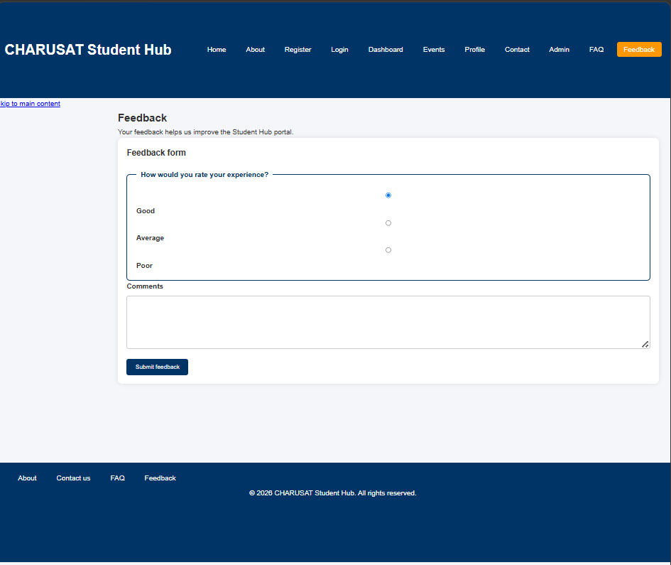

MOBILE VIEW

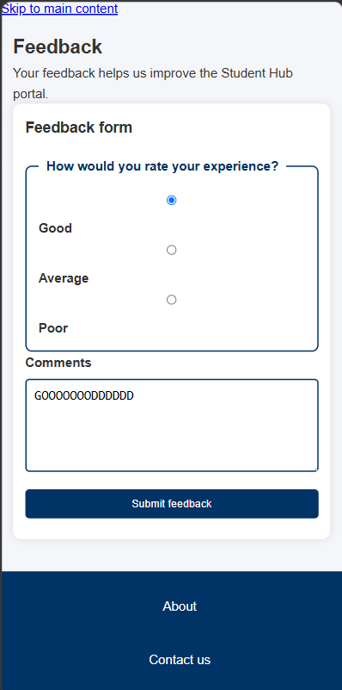

INDEX PAGE

LAPTOP VIEW

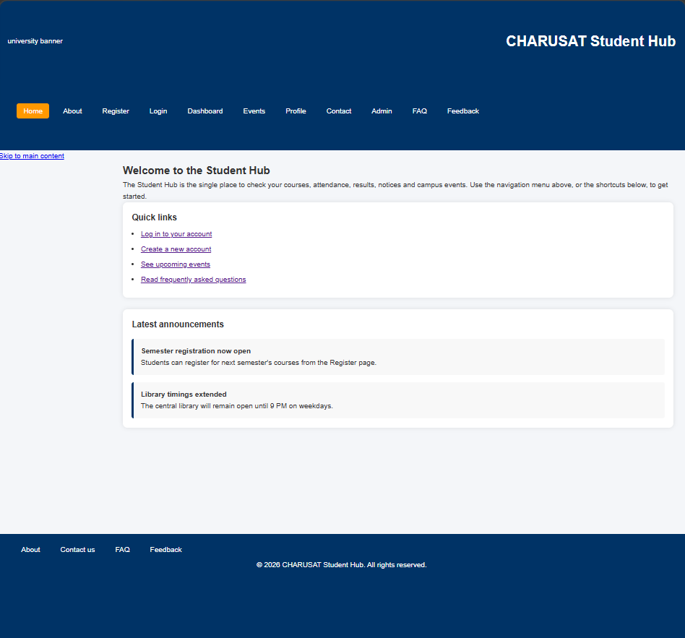

MOBILE VIEW

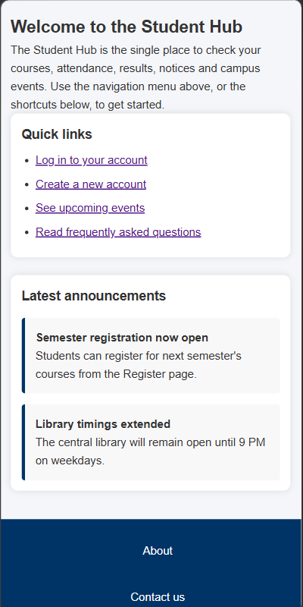

LOGIN PAGE

LAPTOP VIEW

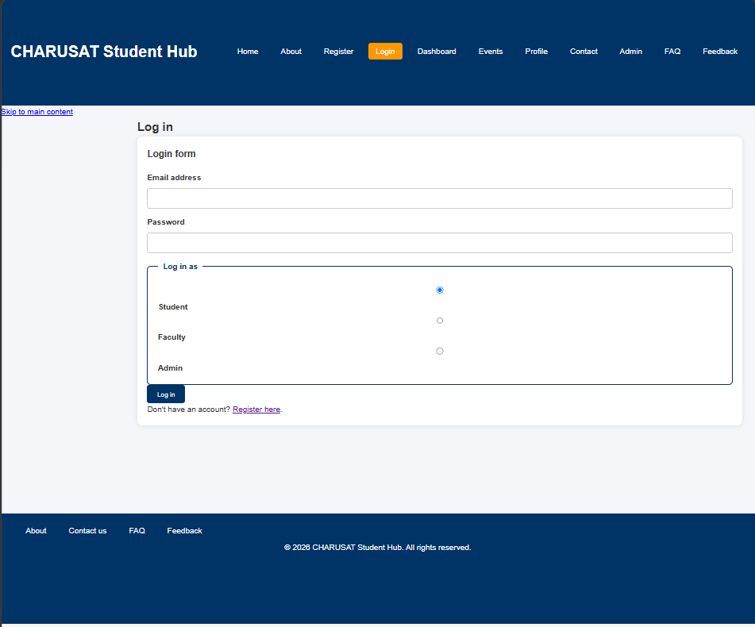

MOBILE VIEW

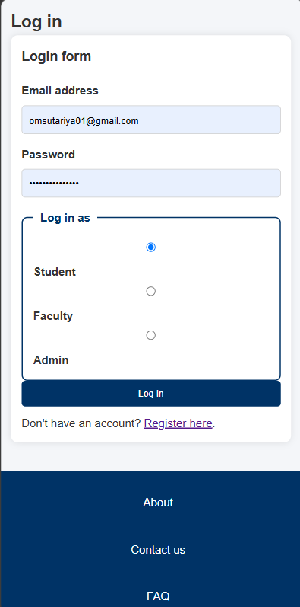

PROFILE PAGE

LAPTOP VIEW

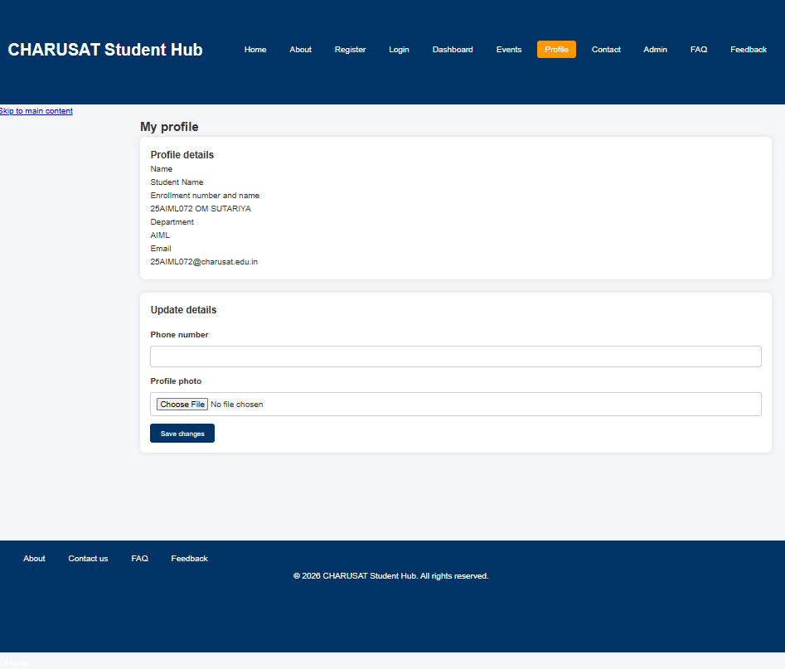

MOBILE VIEW

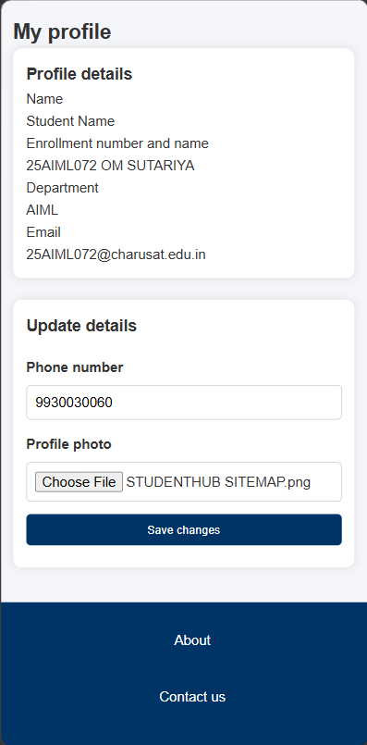

REGISTER PAGE

LAPTOP VIEW

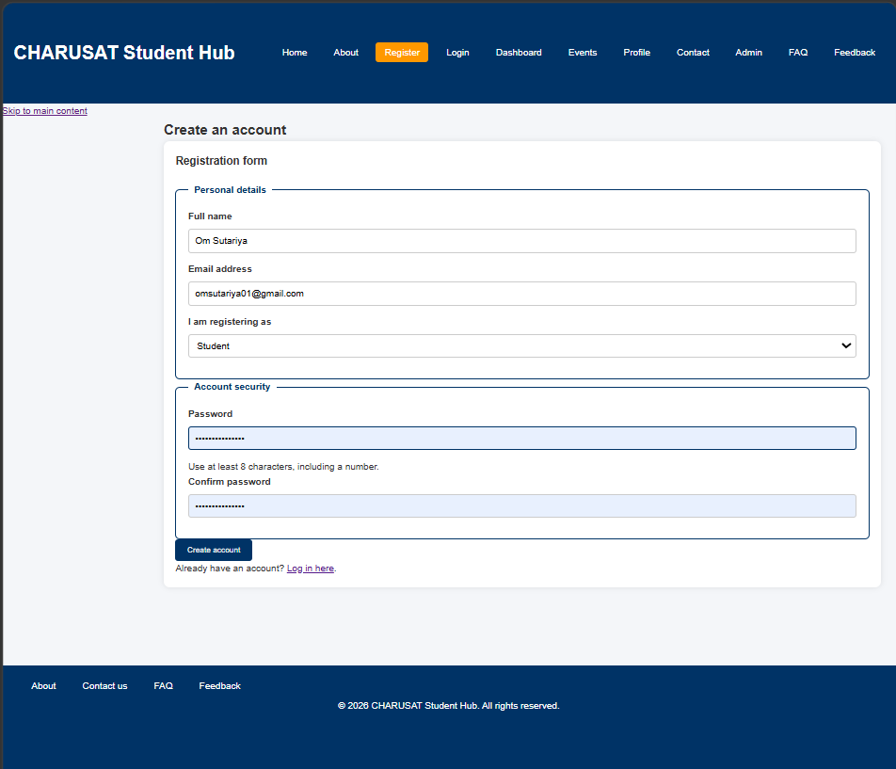

MOBILE VIEW

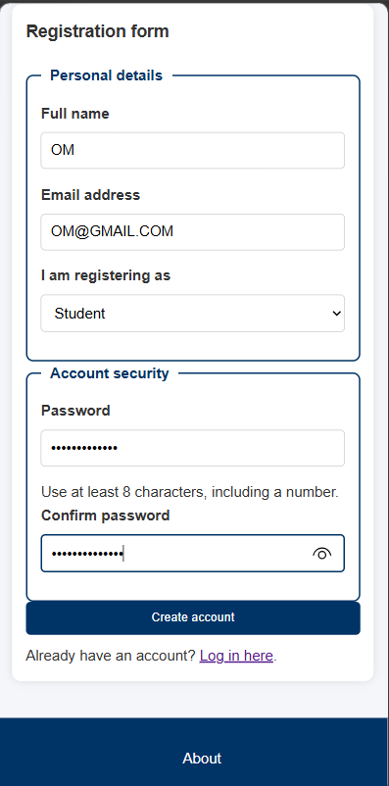

GITHUB REPOSITORY LINK: - https://github.com/omsutariya07/Web-Technology.git

