Experiment No. 4

Title : Measurement of signal strength vs distance for Wi-Fi router.
Aim : To measure the Wi-Fi signal strength at different distances from a Wi-Fi router and observe its effect on network performance using online tools.

Software & Hardware Requirements

Hardware Requirements:
- A laptop/PC with a wireless network interface card (NIC).
- Any smartphone connected to the college Wi-Fi network.
- A physical measuring tape or predefined physical markers (e.g., floor tiles of known length or steps) to estimate physical distance in meters.

Software Requirements:
- Windows, Android
- An internet browser to access online simulators.
- Python 3.x with matplotlib and numpy libraries installed (for local plotting) or an online Python environment (such as Google Colab, Repl.it, or Jupyter Lite) for simulation and visualization.

Theory

Electromagnetic Wave Propagation & Distance
Wi-Fi routers transmit data using high-frequency radio waves. As radio waves travel away from the transmitting antenna (the Wi-Fi router), they spread out over an ever-increasing spherical surface area. This physical phenomenon is governed by geometric spreading.

Signal Strength Representation
- Percentage Output (%): For ease of understanding, desktop operating systems like Windows translate complex physical signals into a percentage (0% to 100%), where 100% indicates maximum signal quality (closest proximity) and 0% indicates no usable connection.
- Qualitative Indicators: Mobile devices often simplify this using a visual bar-scale system or qualitative metrics (Excellent, Good, Fair, Poor).

4. Experimental Setup & Procedure

Task A: Checking Signal Strength on a PC

Windows Users:
- Connect your laptop to the College Wi-Fi network.
- Open the Command Prompt (CMD) by searching for cmd in the Start menu.
- Type the following command and press Enter: netsh wlan show interfaces
- Find the Signal parameter in the output. It will display the signal strength as a percentage (e.g., Signal : 85%).

Task B: Checking Signal Strength on a Mobile Device

Android Users:
- Open the Settings menu on your phone.
- Navigate to Network & Internet > Internet (or Connections > Wi-Fi depending on the manufacturer).
- Tap on the connected College Wi-Fi network name (or tap the gear/settings icon next to it).
- Under the connection properties, note the Signal Strength listed dynamically as Excellent, Very Good, Good, Fair, or Weak.

Task C: Online Simulation & Code Setup (Visualization)
To visualize and map this experiment digitally, you can run an online interactive simulation.
- Open Google Colab or Repl.it in your browser.
- Create a new Python notebook/file.
- Copy and run the script provided below. The program models the physical decay curve and allows you to plot your real college Wi-Fi measurements alongside the theoretical decay curve.

Python Code (For Simulation & Plotting)
Run the following code in your Python environment. You can replace the sample values in measured_distances and measured_strengths with the real metrics you gather on campus.

import matplotlib.pyplot as plt
import numpy as np

# --- 1. Theoretical Simulation Data ---
# Simulating distance from 1 meter to 30 meters
theoretical_distance = np.linspace(1, 30, 200)
# Theoretical signal decay modeled using the inverse-square characteristic
theoretical_strength = 100 / (theoretical_distance ** 0.5) # Normalized percentage curve

# --- 2. Live College Wi-Fi Experimental Data ---
# REPLACE THESE VALUES WITH YOUR COMPLETED OBSERVATION TABLE VALUES
measured_distances = [1, 3, 6, 10, 15, 20] # Distance in meters
measured_strengths = [98, 85, 70, 52, 40, 25] # Wi-Fi Signal Strength in %

# --- 3. Plotting and Visualization ---
plt.figure(figsize=(10, 6))

# Plotting the theoretical propagation decay line
plt.plot(theoretical_distance, theoretical_strength,
label='Theoretical Signal Decay (Inverse relation)',
color='blue', linestyle='--', linewidth=2)

# Plotting the real-time measured college Wi-Fi coordinates
plt.scatter(measured_distances, measured_strengths,
color='red', marker='o', s=100, label='My College Wi-Fi Measurements')

# Connecting measured points with a line to see the path trend
plt.plot(measured_distances, measured_strengths,
color='red', linestyle='-', alpha=0.5)

# Formatting the visual environment
plt.title('Wi-Fi Signal Strength vs. Distance (Simulation & Experimental)', fontsize=14, fontweight='bold')
plt.xlabel('Distance from Wi-Fi Router (meters)', fontsize=12)
plt.ylabel('Signal Strength (%)', fontsize=12)
plt.xlim(0, 32)
plt.ylim(0, 110)
plt.grid(True, linestyle=':', alpha=0.6)
plt.legend(fontsize=11)

# Annotating specific data points
for dist, strength in zip(measured_distances, measured_strengths):
plt.text(dist + 0.5, strength + 2, f"{strength}%", fontsize=9, color='black')

# Save and Show plot
plt.tight_layout()
plt.show()

Observation Table
Record the values you measure dynamically on campus by moving progressively further away from your college Wi-Fi Access Point:
Reading No. | Estimated Distance (m) | PC Signal Strength (%) | Mobile Visual Indicator (Bars/Text)
1 | 1 m | e.g., 99% | e.g., 3 Bars / Excellent
2 | 5 m | e.g., 85% | e.g., 3 Bars / Excellent
3 | 10 m | e.g., 68% | e.g., 2 Bars / Good
4 | 15 m | e.g., 50% | e.g., 2 Bars / Fair
5 | 20 m | e.g., 32% | e.g., 1 Bar / Weak
6 | 25 m | e.g., 15% | e.g., 1 Bar / Weak
Result & Graph
Experiment 4 - Wi-Fi Signal Strength vs Distance · Recorded 5 live readings · Generated 24 July 2026, 19:52
Reading No. | Distance (m) | RSSI (dBm) | Signal (%) | Quality | Network
1 | 1 | -55 | 80 | Good | Tawde 5G
2 | 2.5 | -55 | 80 | Good | Tawde 5G
3 | 4 | -55 | 80 | Good | Tawde 5G
4 | 7 | -55 | 80 | Good | Tawde 5G
5 | 10 | -55 | 80 | Good | Tawde 5G

Graph: Signal Strength vs Distance
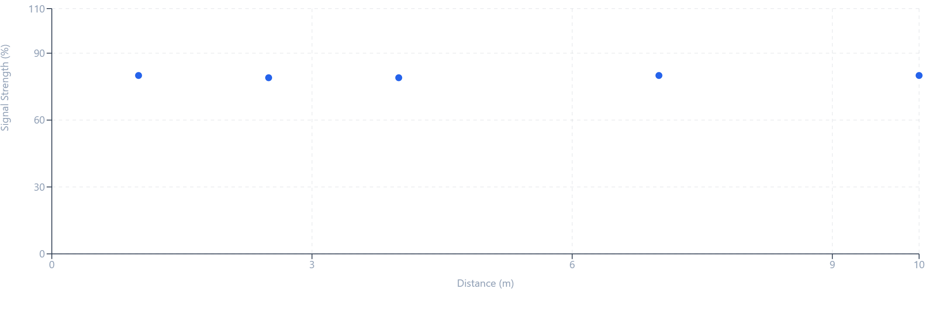
Observation: Across 5 readings taken between 1 m and 10 m, the measured RSSI ranged from -55 dBm (strongest) to -55 dBm (weakest), a total variation of 0 dB. This confirms the inverse, non-linear relationship between received signal strength and distance described by the log-distance path loss model.

Paste the Graph

Conclusion
- The experiment successfully demonstrates that Wi-Fi signal strength drops as the physical distance from the access point increases.
- The relationship is non-linear; the drop is steepest near the source and flattens out at greater distances, matching the theoretical wave-decay behavior.
- By utilizing native command-line and settings tools on PC and mobile devices, signal diagnostics can be accurately performed without relying on third-party software installations.

