Employee Attrition - Business Interpretation Report
Note: the XGBoost results in this report were produced with scikit-learn GradientBoosting (class-weighted) as a stand-in, because the XGBoost library was unavailable in the environment used to generate this document. Re-running the accompanying notebook in Google Colab with the real XGBoost library may change the XGBoost figures slightly.

1. Business Problem
Employee turnover is expensive: recruiting, onboarding, lost knowledge and lower team morale. In this dataset 16.1% of employees (237 of 1470) left the company. The aim of this project is to identify who is at risk of leaving and why, so HR can act early with targeted retention actions.

2. What the Model Tells Us
The best model, Logistic Regression, correctly ranks leavers above stayers with a ROC-AUC of 0.81. At the standard threshold it catches 68% of employees who actually leave (Recall) and 38% of the employees it flags really do leave (Precision).
In plain words: the model works as an early-warning list, not a certainty. Some flagged employees will not leave, and some leavers will be missed.

3. Main Drivers of Attrition
The factors below had the strongest influence in the Random Forest model (importance of encoded columns summed per original feature). Each point also shows what the data says about leavers vs stayers.
- MonthlyIncome (importance 0.078): Employees who left had an average MonthlyIncome of 4787.1 versus 6832.7 for those who stayed.
- OverTime (importance 0.070): Attrition is highest for 'Yes' (30.5%) and lowest for 'No' (10.4%).
- Age (importance 0.064): Employees who left had an average Age of 33.6 versus 37.6 for those who stayed.
- TotalWorkingYears (importance 0.057): Employees who left had an average TotalWorkingYears of 8.2 versus 11.9 for those who stayed.
- YearsAtCompany (importance 0.049): Employees who left had an average YearsAtCompany of 5.1 versus 7.4 for those who stayed.
- DailyRate (importance 0.048): Employees who left had an average DailyRate of 750.4 versus 812.5 for those who stayed.
- DistanceFromHome (importance 0.043): Employees who left had an average DistanceFromHome of 10.6 versus 8.9 for those who stayed.
- JobRole (importance 0.042): Attrition is highest for 'Sales Representative' (39.8%) and lowest for 'Research Director' (2.5%).
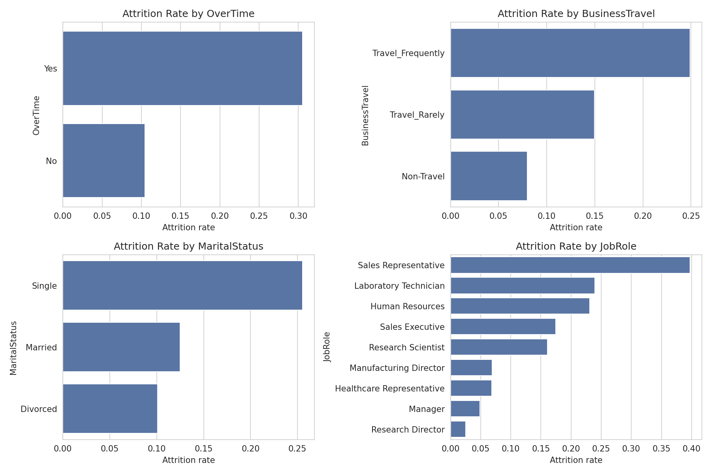
Figure 1: Attrition rate by key categories
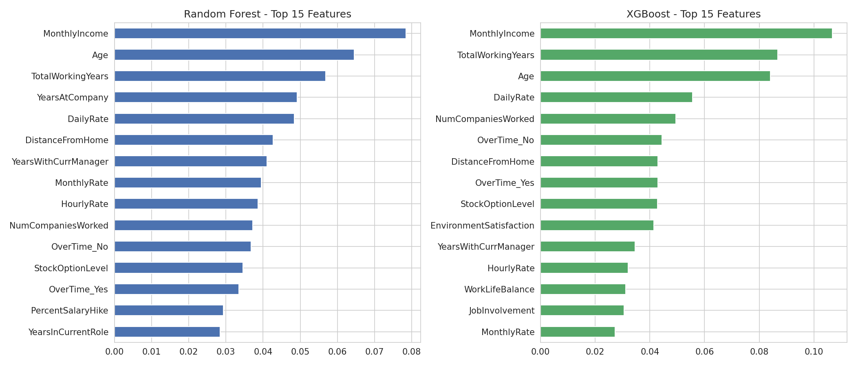
Figure 2: Most important features
Note: these are associations found in historical data. They show where to look, not proof of cause.

4. Recommended Actions
- MonthlyIncome: Benchmark pay against the market and review compensation for low-paid roles with high attrition.
- OverTime: Review workloads and overtime policy; cap overtime hours, rebalance work or add headcount in heavy-overtime teams.
- Age: Offer career-stage-specific support (mentoring and growth paths for younger staff, flexibility for senior staff). Do not use age to make individual decisions.
- TotalWorkingYears: Create clear progression paths for early-career employees, who tend to be the most mobile.
- YearsAtCompany: Run stay interviews and onboarding check-ins in the first years, when leaving risk is highest.
- DailyRate: Monitor this factor and investigate with HR before acting.
- DistanceFromHome: Offer remote or hybrid work, commute support or relocation help for employees with long commutes.
- JobRole: Run role-specific retention plans for the roles with the highest attrition.

5. How HR Can Use the Model
- Score employees regularly and review the highest-risk group first.
- Use the threshold table below to balance catching more leavers (lower threshold) against fewer false alarms (higher threshold).
- Start with low-cost actions (stay interviews, workload review) before costly ones (pay changes).
- Re-train the model every 6-12 months with new data and track whether actions reduce attrition.
Threshold | Precision | Recall | F1 | Employees flagged
0.200 | 0.223 | 0.936 | 0.361 | 197.000
0.300 | 0.274 | 0.851 | 0.415 | 146.000
0.400 | 0.325 | 0.787 | 0.460 | 114.000
0.500 | 0.381 | 0.681 | 0.489 | 84.000
0.600 | 0.466 | 0.574 | 0.514 | 58.000

6. Risks and Responsible Use
- Predictions must support supportive conversations, never punishment, denied promotions or dismissal.
- Sensitive attributes (Age, Gender, MaritalStatus) should not drive individual decisions; check the model for unfair patterns.
- The dataset is small and fictional; validate on the company's own recent data before real deployment.

7. Optional Finding: Job Satisfaction Model
Models predicting job satisfaction (1-4) reached a best R2 of -0.03; a value at or below zero means they did no better than guessing the average. Satisfaction cannot be predicted from HR records alone, so direct employee surveys are more reliable than a model for measuring it.

