Employee Attrition Prediction - Evaluation Report
Note: the XGBoost results in this report were produced with scikit-learn GradientBoosting (class-weighted) as a stand-in, because the XGBoost library was unavailable in the environment used to generate this document. Re-running the accompanying notebook in Google Colab with the real XGBoost library may change the XGBoost figures slightly.

1. Objective and Dataset
The goal is to predict whether an employee will leave the company (Attrition = Yes) using the IBM HR Analytics dataset. The dataset contains 1470 employees and 35 columns; 237 employees (16.1%) left, so the classes are imbalanced. There were no missing values and 0 duplicate rows.
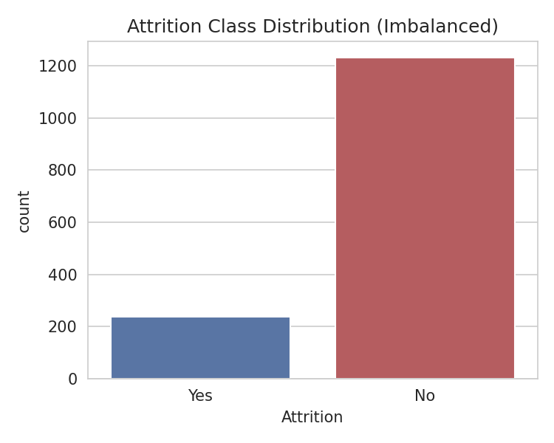
Figure 1: Attrition class distribution

2. Methodology
- Removed non-informative columns: EmployeeCount, Over18, StandardHours (constants) and EmployeeNumber (ID).
- Target encoded as Yes = 1, No = 0. Numeric features standardised; categorical features one-hot encoded inside a scikit-learn Pipeline to avoid data leakage.
- Stratified 80/20 train-test split (random_state = 42) to keep the attrition ratio equal in both sets.
- Class imbalance handled with class_weight='balanced' (Logistic Regression, Decision Tree, Random Forest) and scale_pos_weight (XGBoost).
- Models: Logistic Regression, Decision Tree, Random Forest, XGBoost.
- Metrics: Accuracy, Precision, Recall, F1 and ROC-AUC. Because only about 16% of employees leave, accuracy alone is misleading, so Recall, F1 and ROC-AUC are emphasised.
- Improvement: 5-fold stratified cross-validation, GridSearchCV hyperparameter tuning (scoring = ROC-AUC) and feature importance / SHAP analysis.

3. Baseline Results (Test Set)
Model | Accuracy | Precision | Recall | F1 | ROC-AUC
Logistic Regression | 0.752 | 0.349 | 0.638 | 0.451 | 0.803
Decision Tree | 0.755 | 0.264 | 0.298 | 0.280 | 0.570
Random Forest | 0.847 | 0.625 | 0.106 | 0.182 | 0.783
XGBoost | 0.850 | 0.588 | 0.213 | 0.312 | 0.801

4. Cross-Validation Results (Baseline, mean ± std over 5 folds)
Model | Accuracy | Precision | Recall | F1 | ROC-AUC
Logistic Regression | 0.753 ± 0.031 | 0.372 ± 0.038 | 0.737 ± 0.062 | 0.492 ± 0.034 | 0.827 ± 0.028
Decision Tree | 0.779 ± 0.024 | 0.304 ± 0.049 | 0.268 ± 0.054 | 0.280 ± 0.035 | 0.573 ± 0.018
Random Forest | 0.861 ± 0.008 | 0.876 ± 0.119 | 0.174 ± 0.057 | 0.284 ± 0.078 | 0.804 ± 0.028
XGBoost | 0.871 ± 0.013 | 0.705 ± 0.075 | 0.353 ± 0.076 | 0.465 ± 0.074 | 0.818 ± 0.026

5. Hyperparameter Tuning
Best parameters found by GridSearchCV (5-fold, scoring = ROC-AUC):
- Logistic Regression: {'C': 0.1}
- Decision Tree: {'criterion': 'entropy', 'max_depth': 5, 'min_samples_leaf': 10}
- Random Forest: {'max_depth': None, 'min_samples_leaf': 3, 'n_estimators': 400}
- XGBoost: {'learning_rate': 0.03, 'max_depth': 3, 'n_estimators': 300, 'subsample': 0.8}
Tuned model performance on the test set:
Model | Accuracy | Precision | Recall | F1 | ROC-AUC | CV ROC-AUC
Logistic Regression | 0.772 | 0.381 | 0.681 | 0.489 | 0.812 | 0.831
Decision Tree | 0.765 | 0.362 | 0.617 | 0.457 | 0.711 | 0.718
Random Forest | 0.833 | 0.462 | 0.255 | 0.329 | 0.800 | 0.810
XGBoost | 0.864 | 0.733 | 0.234 | 0.355 | 0.809 | 0.821

Baseline vs tuned (see results/baseline_vs_tuned.csv for the full side-by-side table).
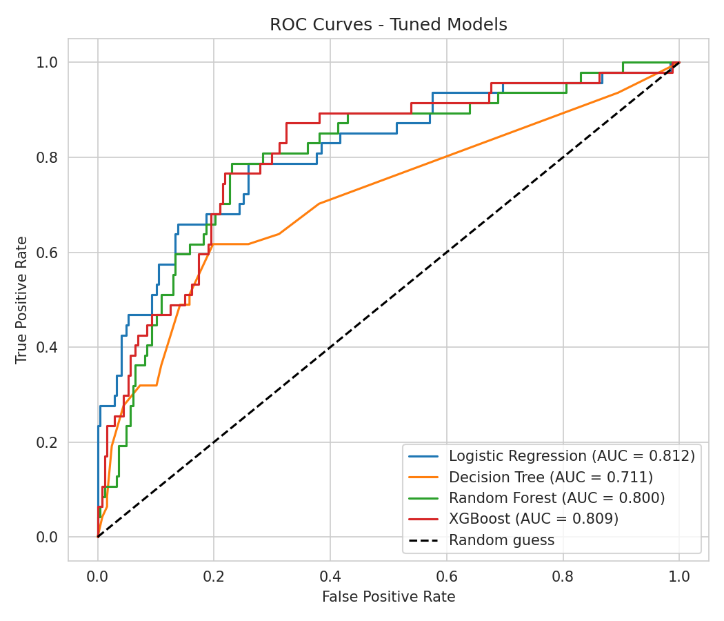
Figure 2: ROC curves of tuned models
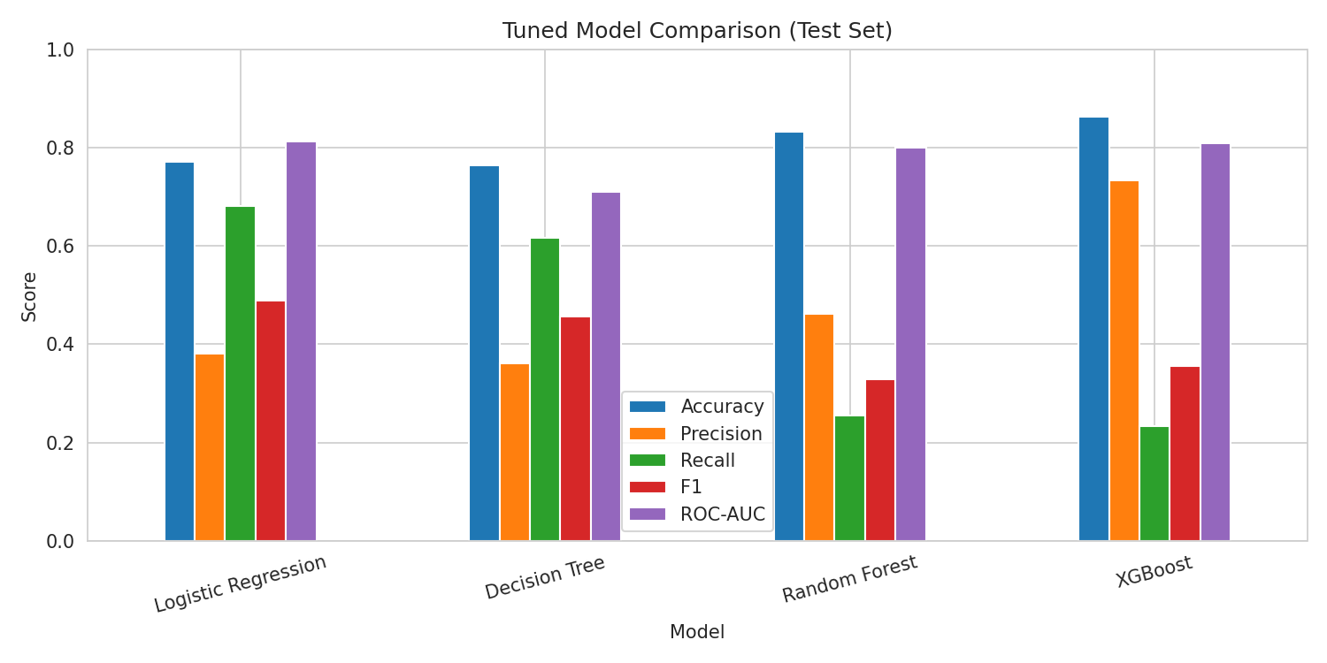
Figure 3: Metric comparison of tuned models

6. Best Model
Logistic Regression was selected because it had the highest cross-validated ROC-AUC (0.831) on the training data. On the untouched test set it achieved Accuracy 0.772, Precision 0.381, Recall 0.681, F1 0.489 and ROC-AUC 0.812. The confusion matrix shows 32 leavers correctly caught (TP), 15 leavers missed (FN), 52 false alarms (FP) and 195 stayers correctly identified (TN).
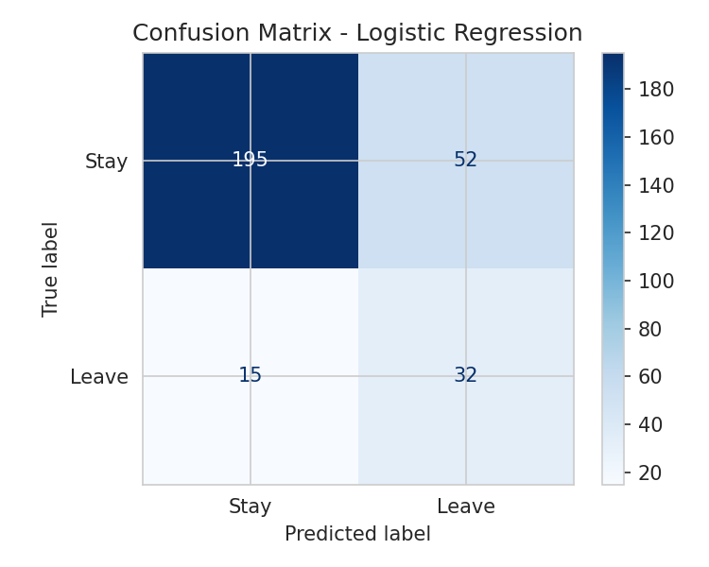
Figure 4: Confusion matrix of the best model
Effect of the decision threshold (lower threshold = more leavers caught, more false alarms):
Threshold | Precision | Recall | F1 | Employees flagged
0.200 | 0.223 | 0.936 | 0.361 | 197.000
0.300 | 0.274 | 0.851 | 0.415 | 146.000
0.400 | 0.325 | 0.787 | 0.460 | 114.000
0.500 | 0.381 | 0.681 | 0.489 | 84.000
0.600 | 0.466 | 0.574 | 0.514 | 58.000

7. Feature Importance and Explainability
Top features according to the tuned Random Forest: MonthlyIncome, Age, TotalWorkingYears, YearsAtCompany, DailyRate, DistanceFromHome, YearsWithCurrManager, MonthlyRate.
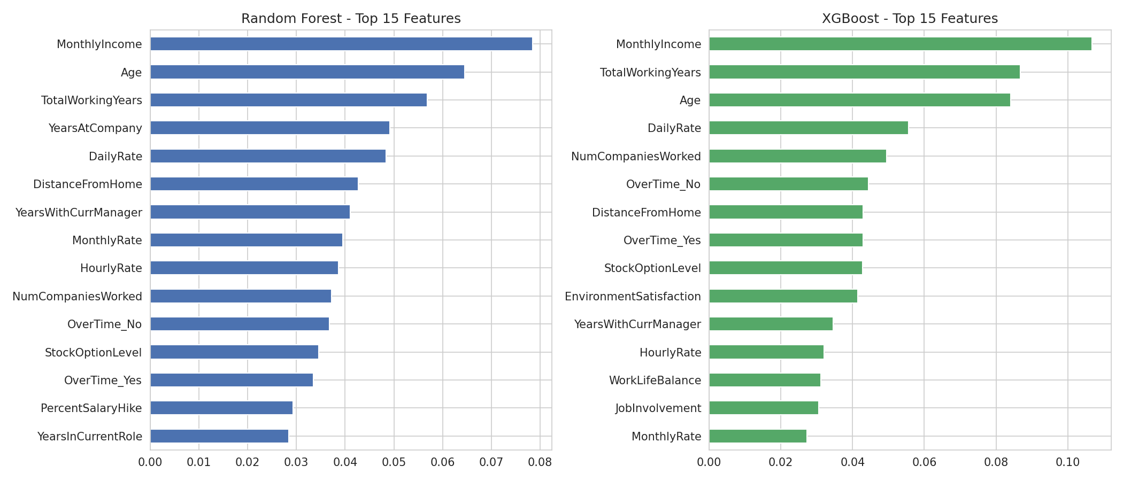
Figure 5: Feature importance (Random Forest and XGBoost)
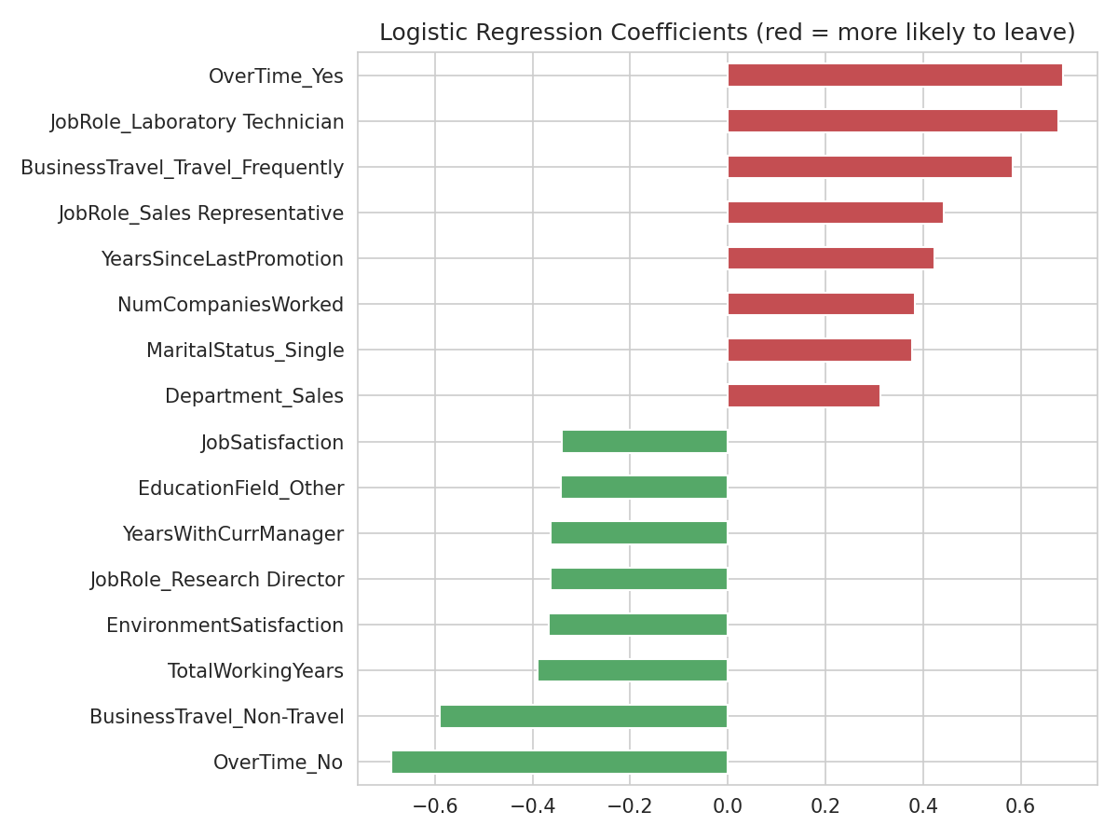
Figure 6: Logistic Regression coefficients

8. Optional Regression: Predicting Job Satisfaction (1-4)
Model | MAE | RMSE | R2
Linear Regression | 0.975 | 1.155 | -0.054
Random Forest Regressor | 0.969 | 1.138 | -0.025
XGBoost Regressor | 0.985 | 1.154 | -0.053
The best regression model by R2 was Random Forest Regressor (R2 = -0.025). An R2 at or below zero means the models predict no better than simply guessing the average satisfaction score. Job satisfaction is a 1-4 survey rating and is not explained by the other HR fields in this dataset, so this optional task shows that satisfaction cannot be predicted reliably from HR records. It should not be used for individual decisions.

9. Limitations
- The dataset is a fictional, relatively small sample (about 1,470 rows), so results may not generalise to a real company.
- Only 237 employees left, so metrics such as Recall and Precision can change noticeably with a different split.
- Feature importance shows association, not cause.
- Further work: SMOTE comparison, threshold tuning based on cost of losing an employee, and testing on newer data.

