Directory opener:
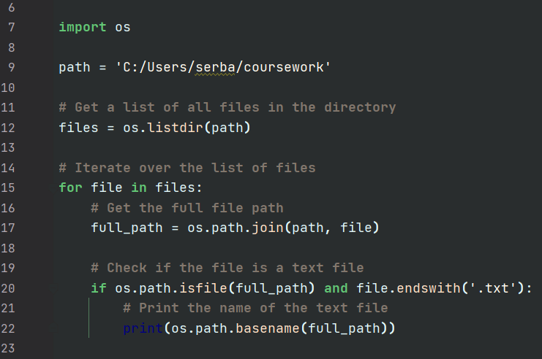
Here the script sets a variable “path” which is the directory path that holds the text files. Then it uses “os.listdir(path)” to get a list of all files in directory. Then it iterates over the list of files, and for each file it uses “os.path.join(path, file)” to get the full file path. Then it checks if this path points to the file, and it is a text file by checking if the file has “.txt” at the end. If both conditions are met, it prints the name of the file which is obtained with the “os.path.basename(full_path)”.

FileHandler:
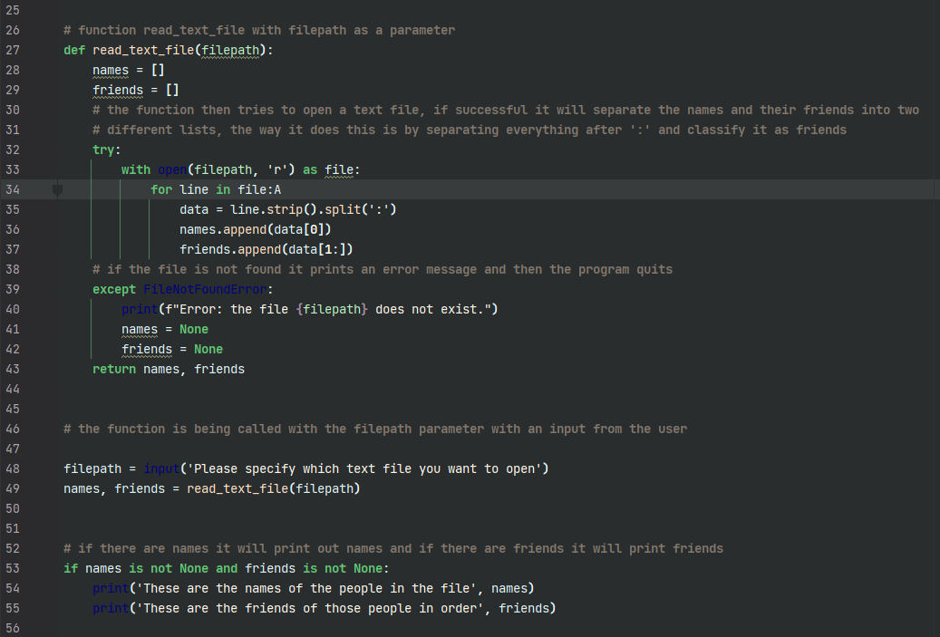

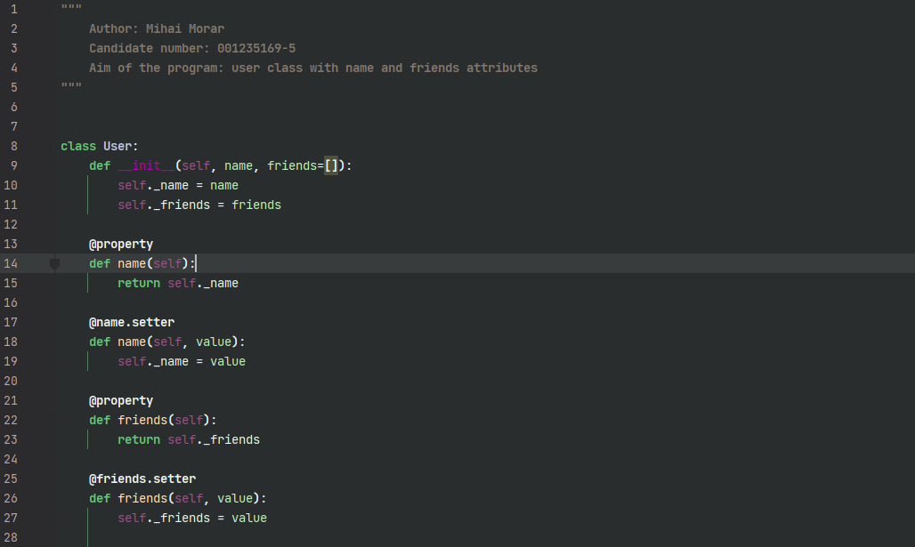
Class setup 1.0:
I’ve used the `property` and `setter` decorators to define getter and setter methods for the `name` and `friends` attributes, respectively. This allows you to interact with the attributes as if they were regular attributes, while still having the ability to control access and validation to them. This way of defining getters and setters allows for a more natural and intuitive API for the client code.

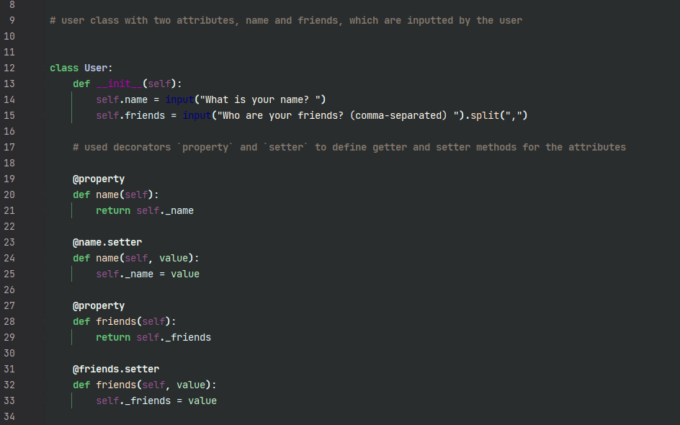
Class setup 1.1:

I’ve changed it so that the user can input their name and who their friends are, this way I don’t need to call any setter method, as the user will provide the necessary information when creating the instance.

