**Article: Cotton**

**Product Market: Sweatshirts**

1. Unfavorable weather conditions such as severe flooding in Pakistan and drought in the U.S. led to shortage in cotton harvests hence decrease in production of sweatshirts, thus shortage of supply in the market.
2. Increase in the price of inputs (cotton) needed for production of the sweatshirts.
3. An increase in input price means**increased cost of production**, this will result in lower production and thus less output will be supplied at each price level.

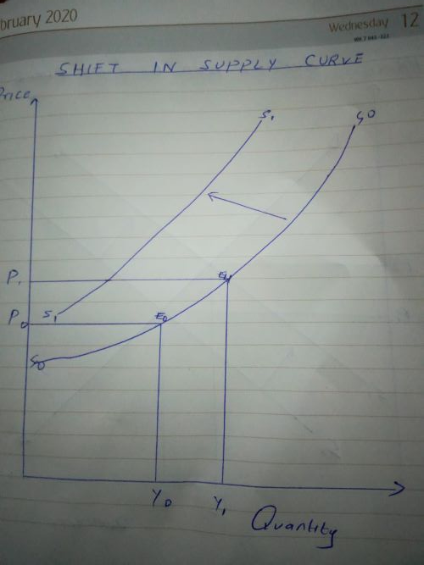

1. Supply and Demand Curve

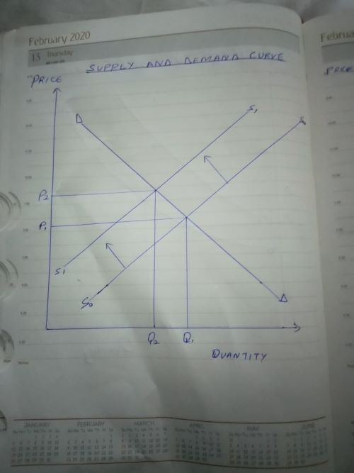

1. As supply decreases, the equilibrium price in the market increases and thus the equilibrium quantity demanded decreases.

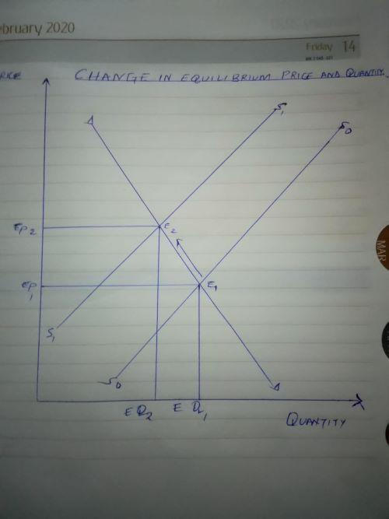

1. The demand curve in this market is elastic as the demand of sweatshirts is largely affected by increase in prices. Also, the inflation continues to shift consumers' spending priorities away from discretionary purchases and thus a decrease in demand of sweatshirts.
2. Price and total revenue have a negative relationship when demand is elastic, increases in price will lead to**decreases in the quantity demanded thus decrease in sales which results to decrease in total revenue**