Assignment 7

1. **Find out the path of the data traversing through the following network using:**

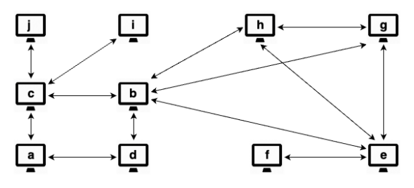

Breadth First Search Technique – there can be multiple BFS including but not limited to the ones named below.

a, d, c, b, j, I, h, e, g, f

a, c, d, j, I, b, h, e, g, f

Depth First Search Technique – there can be multiple DFS including but not limited to the ones named below.

a, c, j, I, b, h,g, e, f, d

a, d, b, h, g, e, f, c, j, i

1. **Find the transitive closure of the following graph:**

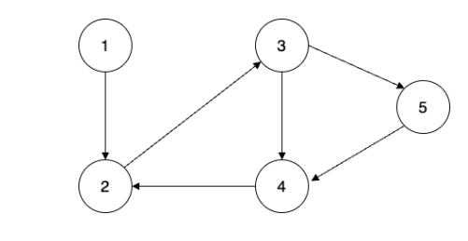

Show all the matrices – below is a table showing a matrix in bold form

|  |  |  |  |  |  |
| --- | --- | --- | --- | --- | --- |
|  | 1 | 2 | 3 | 4 | 5 |
| 1 | **1** | **1** | **1** | **1** | **1** |
| 2 | **0** | **1** | **1** | **0** | **1** |
| 3 | **0** | **0** | **1** | **1** | **1** |
| 4 | **0** | **1** | **1** | **1** | **1** |
| 5 | **1** | **1** | **1** | **1** | **1** |

1. **Using dynamic programming, find the Least Cost path of the following Graph.**

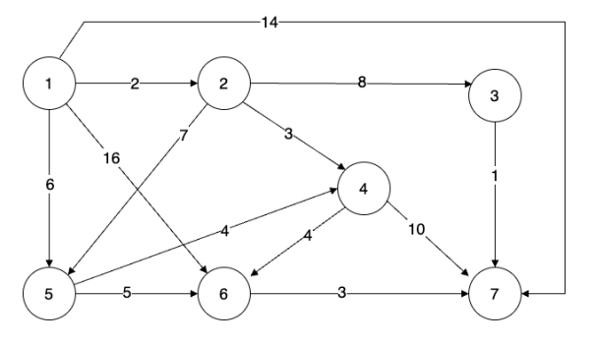

(1, 7) - 14

(1, 2) , (2,3), (3,7) - 2+8+1 = 11

(1, 2) , (2,4), (4,7) - 2+3+10 = 15

(1, 2) , (2,4), (4,6) , (6,7) - 2+3+4 + 3= 12

(1, 2) , (2,5), (5,6) , (6,7) - 2+7+5+3 = 17

(1, 2) , (2,5), (5,4) , (4,7) - 2+7+4+10 = 23

(1, 6) , (6,7) - 16+3 = 19

(1, 5) , (5,6) , (6,7) - 6+5+3 = 14

(1, 5) , (5,4) , (4,7) - 6+4+10 = 20

From the paths listed above, it is evident that  **(1, 2) , (2,3), (3,7) - 2+8+1 = 11** is the Least Cost path with **11.**

1. **Insert the following elements in the array to a Binary Search Tree (BST).**

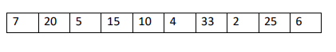

7

7

20

5

6

33

15

4

2

25

10

1. **How many different Binary Tree shapes are possible with 7 nodes?**

Total number of possible Binary Trees shapes with n different keys is calculated as follows;

Count Binary tree shapes = $\frac{\left(2n\right)!}{(\left(n+1\right)! *n!)}$

= ( 2 *7)! / ( ( 7 + 1)! * 7! )

= ( 14) ! / ( ( 7)! * 7! )

= 87178291200 / ( 5040 * 5040)

= 87178291200 / 25,401,600

= 3,432