Design, Simulate and Analyze

Local Cafeteria Using Arena Software

Instructor Name

Student Name

Date of Submission

# Executive Summary

The Arena modeling and simulation program was used for this project. A replica of a local cafeteria, which is a well-known establishment scattered throughout many market hubs. This project uses the Arena software to simulate, evaluate, and build simulations of the neighborhood café. Complex conditions can be expressed using arena logic. The data was gathered at a busy period when the neighborhood cafeteria had a high volume of patrons but not enough room or tables to accommodate everyone. The model is designed to show how Local Cafeteria encounters difficulties while dealing with a large volume of patrons that need to be handled carefully because the majority of them can be

# Problem statement

Local cafeterias are compact but popular places where people come to buy cheaply prepared food for themselves and others in the neighborhood. Due to its constrained location, scarce resources, and subpar services, the local cafeteria cannot accommodate a high volume of patrons. The simulation model's objective is to compile data, including the total number of patrons concurrently served at the Local Cafeteria. Simply put, our model is designed to observe how the entire local cafeteria system functions, particularly when a large number of customers are served, and how it strives to accommodate them because there are never enough tables inside the structure. The information was gathered when there were more people in the line.

# Assumptions

The assumptions below are valid during the entire time of conducting the simulation project;

1. That each Local Cafeteria have got a total of 10 tables inside to serve its customers.
2. That all the Local Cafeteria are found in the local base areas far away from the CBDs of the countries.
3. That each Local Cafeteria have 6 out of 10 tables out and 4 remaining inside.

# Input Parameters

The following resources were used in the model as outlined in the below;

* Customers Arrival
* System checks number of free tables (not occupied).
* Customer gets in if present (leaves if there is no free table).
* Customer places order.
* Customer is served food.
* Customer leaves.

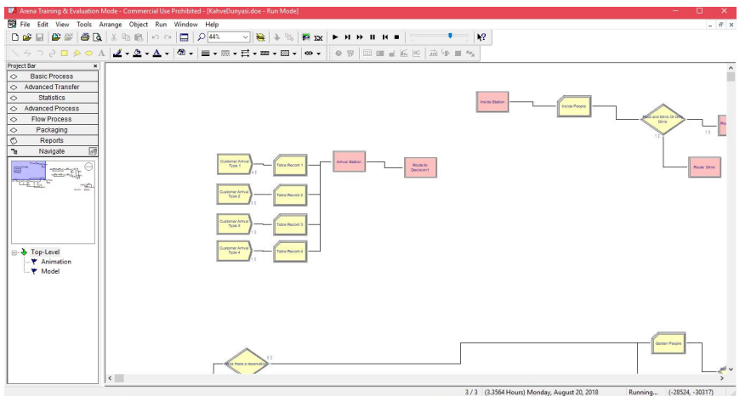

From here, we arrived on different departures. We decided by count method how many people tables were. We also checked out that in this project, we designed to have 6 tables out and 4 tables in. Using this 10 tables, we evaluated the likelihood of customers coming and going.

Here in our stations, following are some of the important screenshot taken during the simulation and modelling process;

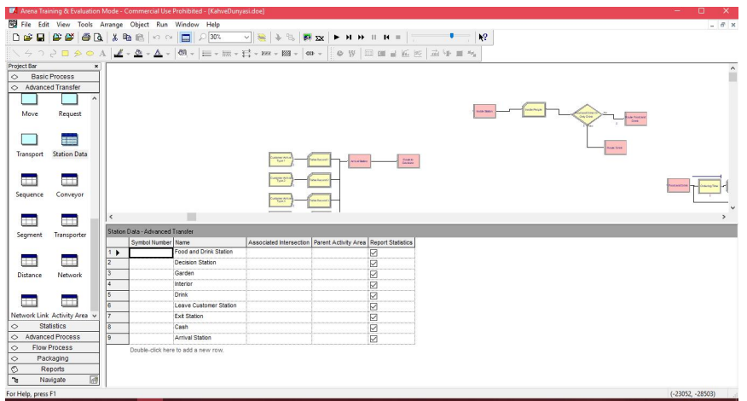

Below is the general structure of how the system looks like;

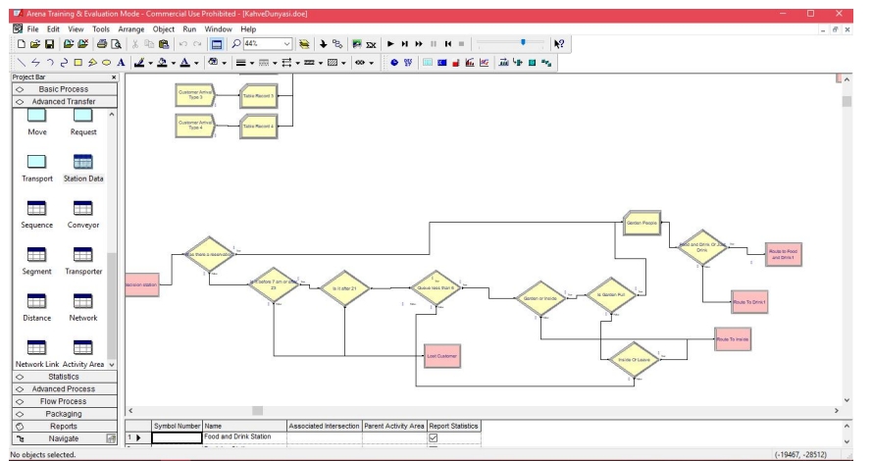

We support the following conditions;

* If the tables are full or there is no room in the queue, the person exits. He/she never enters the cafe

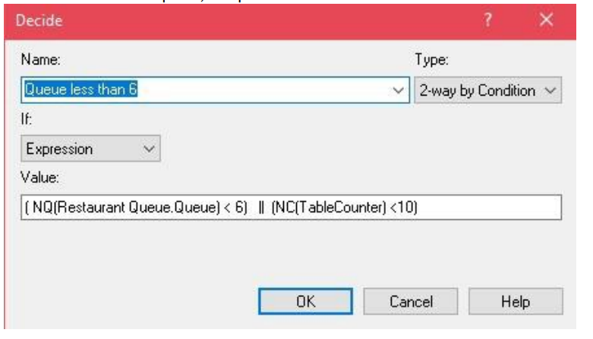

* If there are a reservation go to the food drink or just food.

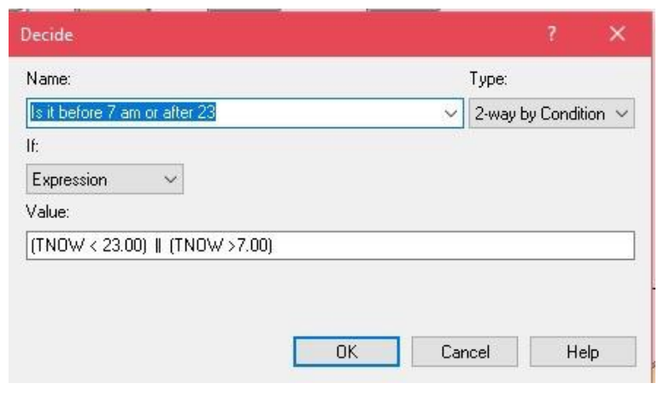

* Is the customer Inside or leaving the Café?

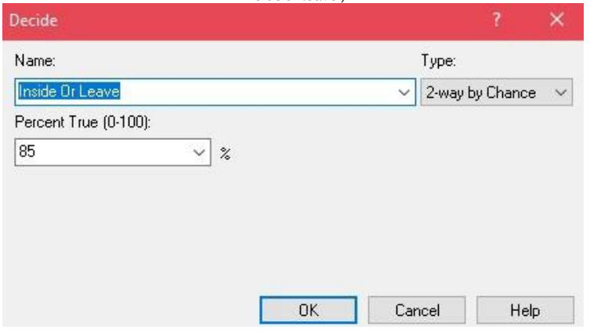

A flow chart in food and beverage service root.

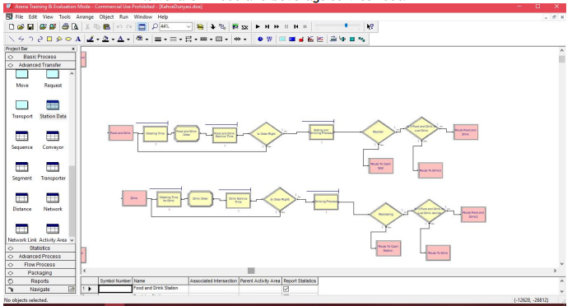

The Decide function

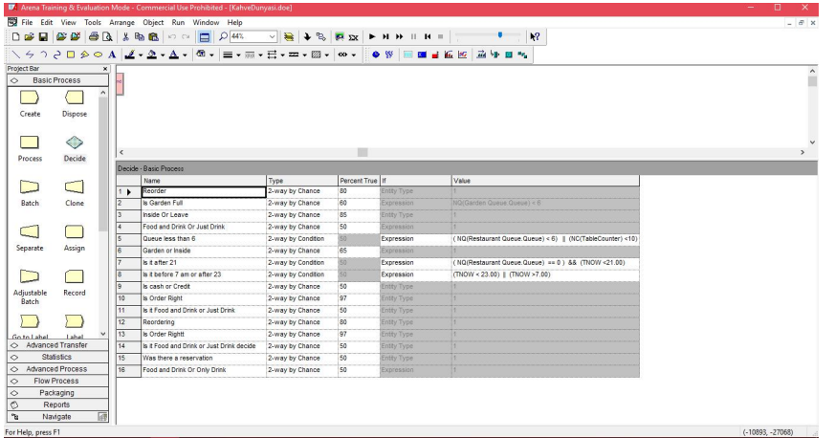

Results

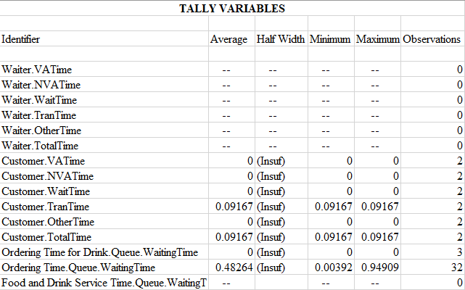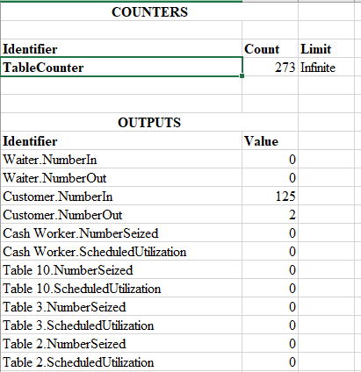

The process functions

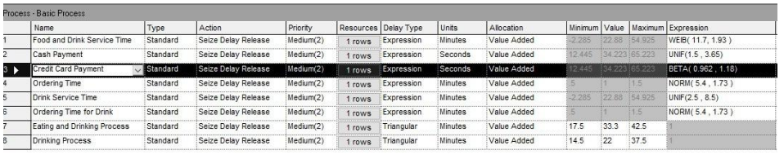

Entity

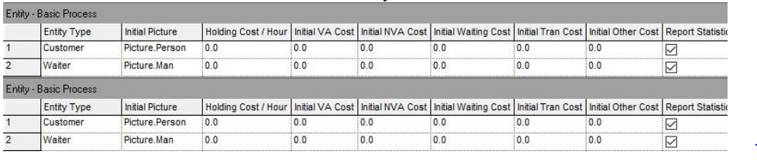

Running model

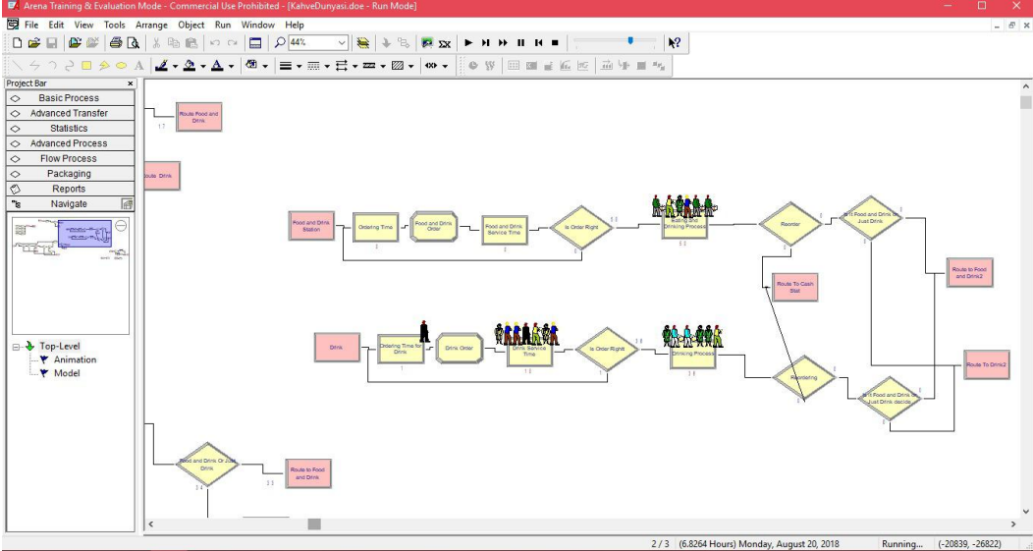

# Conclusion

From the report generated from Arena simulation software, we observe that, the Local Cafeteria normally gets more customers at almost all cases and keeps allowing the customers in yet the tables inside the serving building have already been occupied. With such take, the extra customers who are on queue and still being served goes through a hard of taking their food and drinks while standing or forced to take them from outside the building. This creates a disappointment to the Local Cafeteria at all cases and that there’s need to improve since the is the main reason why customers at the Local Cafeteria are always new( Local Cafeteria is not able to sustain a customer as a result of disappointments made every day).

# Recommendations

As discussed in the conclusion section, we need to work on how we can regulate the number of customers getting into Local Cafeteria based on the number of tables(10) available to serve the customers. By doing this, we are able to create potential customers among the other customers due to good serving conditions. The recommended model works in a manner that, if the Local Cafeteria inside is full that means all the tables inside are occupied, then it means all the customers at the queue should exit the Cafeteria. The Local Cafeteria should only let in a new customer whenever there is an empty table in the system. Thus, the proposed model works as FIFO as shown below;

