**Screenshot of Upwork ER diagram**

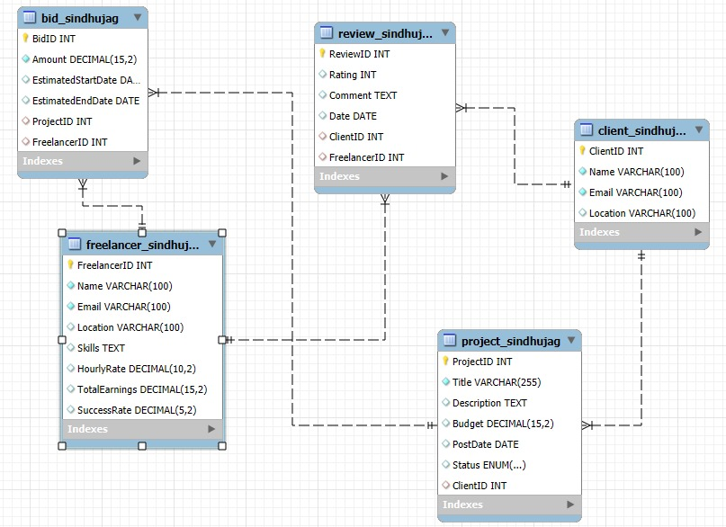

**Screenshots of Upwork database tables in MySQL showing the data.**

Client Table

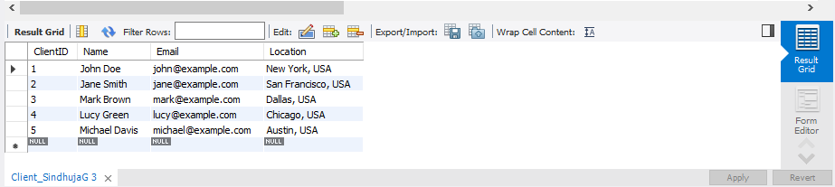

Freelancer Relation

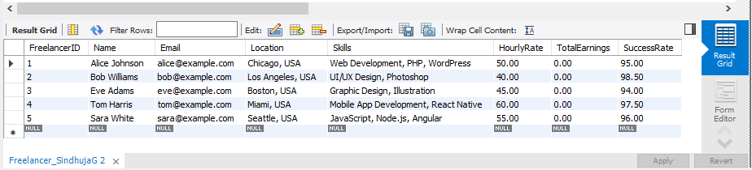

Project Relation

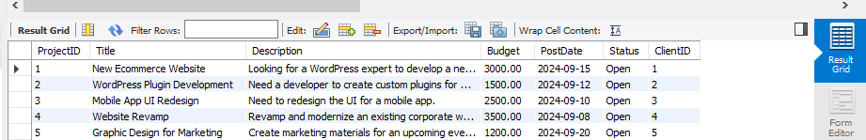

Bid Relation

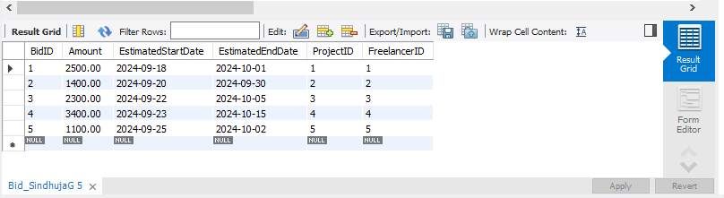

Review Relation

