1) Complete an Activity Diagram with at least 4 pairs of diamonds

(decisions and merges).

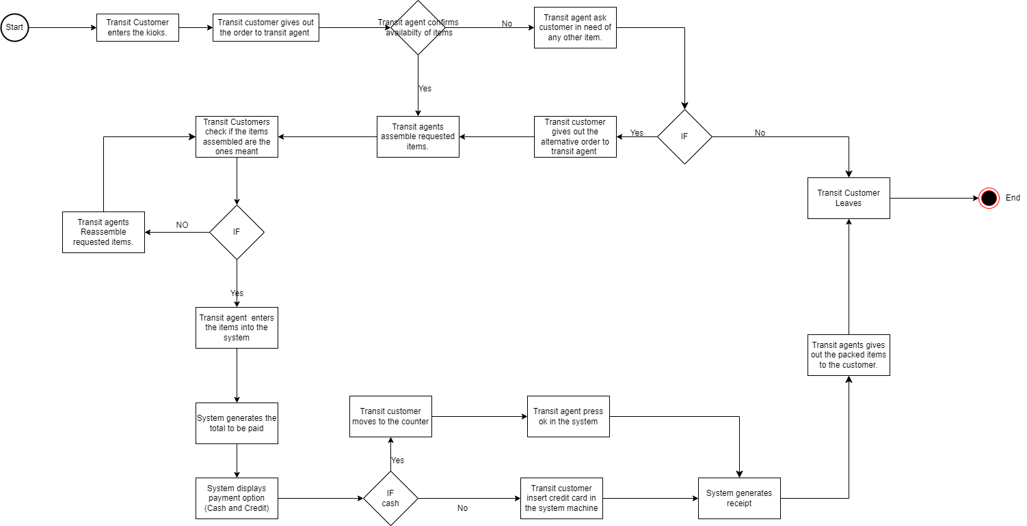

2) Develop a Swim Lane Diagram using the Activity Diagram from part 1

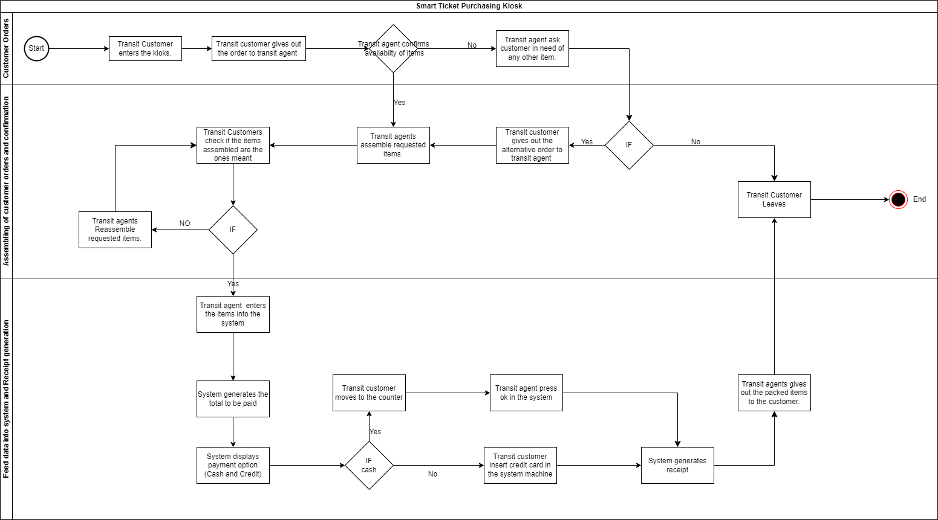

3) Develop three CRC Cards (Hint: Use the Narratives from last week’s

homework for guidance).