#### **Application of a combination of IoT and Big Data Technology in Marketing**

Student Name

Department

University Name

Contents

Abstract 3

Introduction 4

Technologies Used 6

Internet of Things 6

Big Data 9

**Big Data Architecture** 10

**5 V’s of Big Data** 13

Understanding How IOT relates with Big Data 14

The Role of Big Data in IOT 14

How does IOT and Big Data Interaction 15

Data security of IoT and Big Data Technologies 16

Differences between IoT and Big Data 16

Uses Cases of IoT and Big Data Technologies 17

Conclusion 18

References 19

Figure 1 IoT Architecture 4

Figure 2 Multi Layered Architecture for IoT Applications 5

Figure 3 Logical components of Big data architecture. 7

Figure 4 5 Vs of Big Data 8

Figure 5 IoT and Big Data Interaction 10

# Abstract

To reap the benefits of the massive amounts of data created by organizations daily, it is necessary to put that data to good use. Businesses need to be faster to adopt new technology and continue to struggle to generate enough money through product sales. For this reason, many companies in the modern world create little to no profit despite the vast amounts of data they produce. This article offers a comprehensive overview of two cutting-edge technologies. It explains how they might be utilized to address various issues plaguing the corporate world, especially in business advertising. IoT and Big Data are the two technologies that need the most attention. Information in the context of modern technology ideas. In addition, we'll have in-depth discussions of each technology and present examples wherever possible. Moreover, the connection between the chosen technologies will be displayed, as this is how these technologies will combine to address the project's issue. Contrasts between Big Data and the Internet of Things are discussed in this paper.

# Introduction

Today, technological advances are gaining momentum in the lives of users, but also the world of business[1]. One of the most promising technologies is the IoT/Internet of Things, which will allow physical objects to connect to the Internet, thus optimizing their functioning by generating data. However, in a world where data is king, it must be handled efficiently, and IT must allow the storage of ever-increasing data. This is where Big Data takes on its importance.

In the world of business, every company is trying to make more sales each day, striving to reach out to more reliable customers each day[2] These companies are also trying hard to maintain their position in the market since competitors keep increasing as the world changes due to population increase. With this in mind, the branding of the business matters more. Therefore, it’s up to each company to ensure that their marketing strategies are super powerful to maintain their position in the market. However, these strategies collide since top business managers learn from their competitors[3].

Business companies have been making a lot of data since then during their business execution operations. However, the software tools around to work with the data generated during those times include Microsoft excel. Microsoft Excel is, however, still in use but needs to be more reliable for massive data. This software holds less data when doing data analysis[4]

In addition, companies needed to have tools that could be used for collecting real-time data. This is a significant challenge since, as a company, they have to wait and perform data mining later. This is a waste of time and costly since, as a company, they need to recruit more employees to work on the data.

With all these in mind, companies produce many datasets daily from their business. This data needs to be stored so that it can be mined to find insights. Here comes Big Data technology, the only technology which solves the company’s business data problems. However much the data produced, big data technology can handle the data, store it, process it, and give back meaningful insights to the business managers for decision-making[5].

Big data comes in as a way to solve this. Before then, the companies were making a lot of data, but since there were technological tools to store and work on the data-driven later, nothing new could be found. Big data, when implemented in the business, will help in the process of data collection. This data is stored in the cloud databases where mining of such information is done later. The mining process provides insights into what the business data holds. These insights are helpful in the business since the business managers can now understand their reliable customers, the best location to run their company from, and so forth.[6].

# Technologies Used

## Internet of Things

The term "Internet of Things" (IoT) refers to bringing real-world or digital objects online. The sensor is a standard technology that enables the internet connection of everyday objects like watches, drones, and even speakers [7]. The telephone and the computer may have been the only Internet-connected devices for a while, but this is no longer the case, and every year sees the introduction of new products incorporating IoT technology.

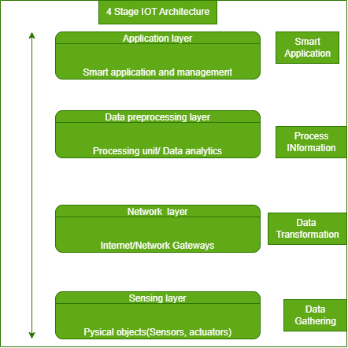

Figure 1 IoT Architecture

From this, we may deduce that there are, in fact, four distinct layers, which we will refer to as the "Sensing Layer," "Network Layer," "Data Processing Layer," and "Application Layer," respectively[7]

The following is an explanation of these.

**Sensing layer:** In this Sensing layer, you'll find sensors, actuators, and other devices. These sensors and actuators may take in information (physical or environmental characteristics), process it, and send it across a network.

**Network layer:** Gateways to the Internet and other networks, as well as the data acquisition system (DAS), can be found at this tier. DAS is responsible for collecting and transforming data (Collecting and aggregating data, then converting analog sensors data to digital data, etc.). In addition to bridging the gap between sensor networks and the Internet, advanced gateways carry out several standard gateway tasks, such as filtering incoming data for malicious software, making decisions based on the information provided, providing data management services, etc.

**Data processing layer:** It's the brains of the Internet of Things. Here, data is evaluated and pre-processed before being sent to a data center, where software applications access it—often referred to as business applications—that monitor and manage the data and prepare for further action. As a result, this is where edge analytics and IT come into play.

**Application layer** - The fourth and final layer of the Internet of Things’ architectural framework. Data centers, often known as the cloud, are a vital component of the data management stage.

The figure below shows a multi layered architecture for IoT applications

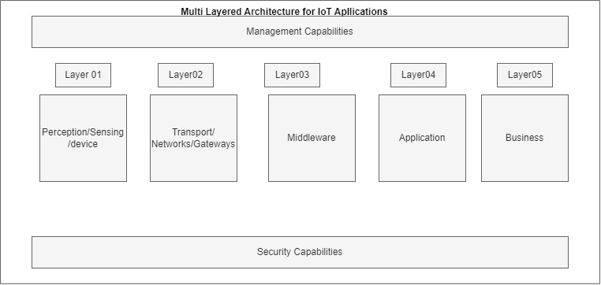

Figure 2 Multi Layered Architecture for IoT Applications

## Big Data

Big Data is an enormous quantity of information that cannot be effectively managed using traditional methods. Since then, the idea of "Big Data" has emerged to describe the instantaneous availability of vast data stores. It has three primary characteristics: How quickly information is processed, how much information is listed, and what kind of information is saved (including processed and unprocessed data from many sources). The major goals of Big Data are to enhance a company's or system's responsiveness to a vast amount of collected data, boost productivity, and refine knowledge of customer behavior to enable the delivery of targeted marketing and the development of novel markets[8].

The storage, analysis, and visualization of big data can be challenging, which might slow down or even halt subsequent procedures or findings. Big data analytics is the study of large datasets in order to discover previously unknown patterns and associations[2] Companies and organizations can benefit from this data by acquiring a competitive edge through deeper insights. Implementations of big data need to be carefully planned and carried out for this reason. In this paper, we will first examine the concept of "big data" and the various ways it has been characterized. Second, how can it best be utilized, and what are the hallmarks of big data? In the third section, we cover the Big Data models and architecture. As a fourth question, what are some of the ways in which big data could be put to use to benefit both the machines and people who choose to keep working with it? When all is said and done, we'll talk about what the future holds for Big data.

### **Big Data Architecture**

Big Data relies on a framework of tools and procedures for amassing and archiving data, keeping it safe, processing it, and transforming it into databases and file systems. Our ability to examine the obtained data and future base judgments on that analysis is greatly enhanced by the tools at our disposal [1]. This means that the more information a machine or gadget can gather and evaluate, the better its ability to make decisions. Big data uses a multilayered architecture. Big Data's logical levels are first described. It can be broken down into four distinct logical groups, as shown below.

**Big data sources layer:** Inputs to Big Data originate from many different places. A variety of sensors related to businesses and company servers can be among these sources. In addition to its real-time mode, Big Data can also store and take in data in a batch mode. Microsoft Office documents, Enterprise Resource Planning (ERP), Relational Database Management Systems (RDMS), mobile devices, social media, sensors, data warehouses, and email are all examples of programs and software that can be used to collect data.

**Data messaging and storage layer** - This layer is responsible for receiving and storing data from all other sources. This layer is accountable for transforming any incoming data from an unstructured format into one that the analytical tools can read. While relational database management systems (RDBMS) are used for structured data, Big Data stores its unstructured data in specialized file systems like Hadoop Distributed File System (HDFS) or a NoSQL database.

**Analysis layer -** Data analysis is handled at this level. Here, the accumulated data is evaluated to glean valuable insights and patterns for the business. The extensive data ecosystem is replete with numerous applications. Sampling approaches are employed for structured data, while sophisticated and often specialized analytics toolkits are required to analyze unstructured data.

**Consumption layer -** This layer takes in all the information that will be evaluated. This layer's responsibility is to deliver the studied data as an output to the appropriate recipient. Applications, corporate processes, and human viewers are all examples of possible outcomes.

Within these four logical levels, four distinct processes are at work. Cross-layer operations include connecting to data sources and performing governance: systems administration, service quality.

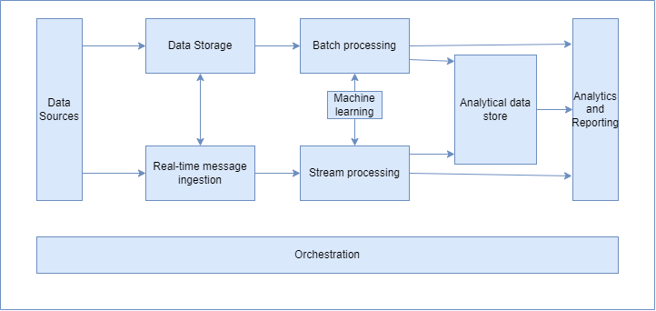

Figure 3 Logical components of Big data architecture.

### **5 V’s of Big Data**

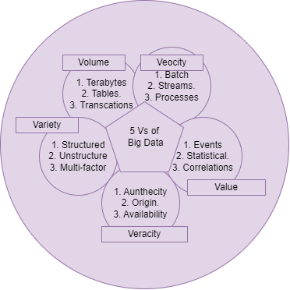

Figure 4 5 Vs of Big Data

1. Volume - the scale and quantity of big data that businesses process and evaluate
2. Value - Big data's value, the most crucial "V" from a business's perspective, stems from the insights and patterns it reveals, which in turn improve efficiency and strengthen ties with customers.
3. Variety – represents Data types, including raw data, semi-structured data, and unstructured data, can be found in a wide variety.
4. Velocity - Companies' data acquisition, storage, and management rates are often measured in terms of "velocity," which is defined as "the rate at which information is acquired, stored, and managed by an organization."
5. Veracity - When it comes to making decisions, top-level executives place a premium on veracity, which is defined as the "truth" or accuracy of data and information assets.

# Understanding How IOT relates with Big Data

Many studies, according to Röglinger[2], indicate that IoT will generate 4.4 trillion gigabytes by 2020, and this number will only grow from there. The key problem in the field of the Internet of Things is to be able to use a massive amount of data, therefore the usage of big data, and this data must be read, exploited, and communicated within particular time intervals.

## The Role of Big Data in IOT

Big Data's purpose in IoT is to provide real-time analysis of the data produced by IoT, allowing for the most effective application of this technology. Big Data uses a four-stage process to achieve this goal:

* Data from IoT devices is collected using the Big Data tenets of velocity, volume, and veracity.
* File-based data storage in the Big Data repository;
* Analyzing data with sophisticated and powerful analytic frameworks like Spark and Hadoop;
* Reporting on the results of the analysis and putting those results into action.

IoT developers will be able to optimize these technologies by using Big Data, which will have a significant impact on the efficiency of information processing and will allow for a broader perspective [3].

## How does IOT and Big Data Interaction

The connection between the Internet of Things and Big Data is not a one-way street. When applied to Big Data, IoT may also prove invaluable. The larger the role that IoT plays in your life and the life of your community, the more developers will want access to more data, driving up demand and profits in this industry [6]. As a result, it will be crucial to advance data storage technology in order to create systems that can handle even more information. Consequently, this cooperation may allow for advances in both fields at the same time.

Below is the illustration of IoT and Big Data;

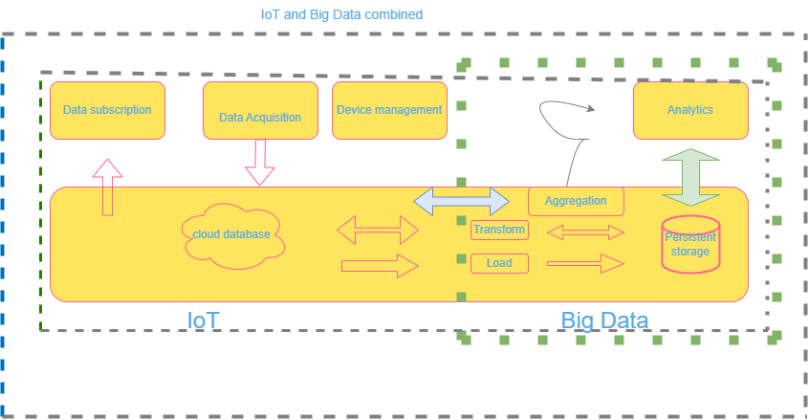

Figure 5 IoT and Big Data Interaction

## Data security of IoT and Big Data Technologies

Cybersecurity is arguably the greatest obstacle to the widespread use of these technologies [7]. Data is becoming increasingly valuable and sought after in many industries, including marketing. Both data privacy and data protection from cybercrime need to be discussed more openly in the public sphere. More and more devices are getting hooked up to the internet, making them easy targets for cybercriminals. With the advent of "smart cities," hackers may take over an entire municipality. Even though they are separate, IoT and Big Data are inseparable technologies that make possible other well-known technological developments. IoT data would mainly be gathered from physical items via various sensors [12].

In contrast, Big Data would facilitate the storing and processing this data at a higher rate and with greater efficiency. Therefore, business companies should ensure that proper security walls have been put in place to prevent attacks during data collection. This is because other competitors can get their data while processing and interfere, resulting in fake data.

## Differences between IoT and Big Data

Table 1 Difference between IoT and Big Data

|  |  |  |
| --- | --- | --- |
| Parameters of Comparison | Internet of Things | Big Data |
| Data | Sensing devices, like a steam iron, help the Internet of Things collect and process machine-generated data. | Big Data analyzes user-generated content like emails, social media posts, and other inputs from the general public. |
| Real Time | The Internet of Things relies on real-time data collection, processing, and analysis to draw actionable conclusions. | When dealing with massive amounts of data, processing times are typically not instantaneous. First comes data collection, then, after some time has passed, analysis. |
| Purpose | The basic goal of the Internet of Things is to detect and repair asset issues. | In order to get to the bottom of a problem, we can use Big Data analysis to sift through the mountains of data that have already been collected. |

# Uses Cases of IoT and Big Data Technologies

Using Big Data and the Internet of Things, we identified a problem in the marketing division of a company and defined the project problem where this new mix of technologies could have an impact. It's difficult for most companies to know when, where, and to whom they should market and promote their goods and services**[10][11]**. Since marketing is essential to the success of any business, their failure to invest in it leads to financial losses. It's clear that Internet of Things (IoT) and Big Data can have a significant impact on advertising for businesses. Massive data collecting and processing could provide considerable benefit to the corporate world, allowing for more efficient commercial outcomes**[12]**. More and more businesses are moving their data storage to the Big Data Cloud because of its improved efficiency and lower price tag.

# Conclusion

In conclusion, the chemistry between IoT and Big Data significantly impacts the world of business, especially marketing. With the help of IoT, companies can increase their sales. This is because IoT digital devices collect real-time data during regular business operations. This data is later stored in cloud databases, and insights drove from it, which helps in decision-making. This enables the top managers of the businesses to identify why the company is making few sales, how to fix it, and when. On the other hand, Big data plays a vital role in storing the collected data from IoT devices, sensors, and actuators. This data is later preprocessed, and insights are generated to boost business making. Therefore, since we have insights from the data collected, the business company can tell which product is mainly sold to customers, in which areas and during which season. This helps the company minimize time wasted in sales in areas with no interest, customers with no good, and at the wrong season. Thus, it's easy for the business to devise new plans daily on how to promote their products to reach the target customer at the right time.

# References

[1]. Agrawal, D., Bernstein, P., Bertino, E., Davidson, S., Dayal, U., Franklin, M., ... & Widom, J. (2011). Challenges and opportunities with Big Data 2011-1.

[2]. Buhl, H. U., Röglinger, M., Moser, F., & Heidemann, J. (2013). Big data. *Business & Information Systems Engineering*, *5*(2), 65-69.

[3]. Fan, S., Lau, R. Y., & Zhao, J. L. (2015). Demystifying big data analytics for business intelligence through the lens of marketing mix. *Big Data Research*, *2*(1), 28-32.

[4]. Rejeb, A., Rejeb, K., & Keogh, J. G. (2020). Potential of Big Data for Marketing: A Literature Review. *Management Research and Practice*, *12*(3), 60-73.

[5]. Remondes, J., & Afonso, C. (2019). An overview of main IoT trends applied to business and marketing. *Smart Marketing With the Internet of Things*, 245-264.

[6]. Simões, D., Filipe, S., & Barbosa, B. (2019). An overview on IoT and its impact on marketing. *Smart marketing with the internet of things*, 1-20.

[7]. Sestino, A., Prete, M. I., Piper, L., & Guido, G. (2020). Internet of Things and Big Data as enablers for business digitalization strategies. *Technovation*, *98*, 102173.

[8] Xiao, S., Yu, H., Wu, Y., Peng, Z., & Zhang, Y. (2017). Self-evolving trading strategy integrating internet of things and big data. *IEEE Internet of Things Journal*, *5*(4), 2518-2525.

[9]. Niyato, D., Alsheikh, M. A., Wang, P., Kim, D. I., & Han, Z. (2016, May). Market model and optimal pricing scheme of big data and Internet of Things (IoT). In *2016 IEEE international conference on communications (ICC)* (pp. 1-6). IEEE.

[10]. Munnia, A., Nicotra, M., & Romano, M. (2020). Big data, predictive marketing and churn management in the IoT era. In *The internet of things entrepreneurial ecosystems* (pp. 75-93). Palgrave Pivot, Cham.

[11]. Sestino, A., Prete, M. I., Piper, L., & Guido, G. (2020). Internet of Things and Big Data as enablers for business digitalization strategies. *Technovation*, *98*, 102173.

[12]. Rabah, K. (2018). Convergence of AI, IoT, big data and blockchain: a review. *The lake institute Journal*, *1*(1), 1-18.