Procure Cloud Support Software Business Process

Description of the business

Our project involves analyzing a business process for a cloud software vendor that offers numerous solutions for customer service and business operations. The company's employees use this software on a daily basis. Customers to handle interactions with their own customers, such as incoming and outgoing calls, chat sessions, and the settlement of client complaints in real time via an integrated chat feature on the customer's website.

Business Process

We use a Cloud-based service's software acquisition procedure as our primary business process. Because of this, we have coined the procurement of cloud-based software support method. The purpose of this study is to examine the existing procedures implemented by the company providing these distinct cloud-based applications for the sales team and the steps that make up the customer journey they follow that comprise these procedures, and how they affect the resources used by the business to software purchases by customers, and how we intend to enhance that procedure in our planned "To-be" procedure to provide optimal service to our clients and those who have a vested interest in the company. The new system ensures that clients will have a positive experience. Procurement of cloud-based software, while providing the business and its stakeholders with a less time and money spent on selling software to customers, better customer satisfaction, and increased software sales increase in sales conversion rate, total income, number of clients in each region, etc.

The Procure Cloud Support Software process is considered to be a business process because, as will be shown below, it consists of a sequence of events, each of which is initiated by a trigger event and culminates in a measurable and countable outcome (i.e., the procurement of software), and because it requires the participation of multiple actors acting at different times to produce value for the process's customer (i.e., other businesses that purchase software).

The "Select Product" phase begins the procedure. When a customer registers and logs in to the company's website, the system verifies the customer's account and presents the consumer with a list of the company's products from which the customer can choose. The process begins with the initiation of, or the committing of, the series of events and actions detailed below.

The actor (sales team) receives information about the customer's product requirements during the trigger phase and uses this information to create a quote, which is then sent on to the customer after being reviewed and accepted or rejected by the subsequent actor (accounts).

Create Service Order: Once the preceding steps have been approved by the accounts team, the next actor (systems) will transform the approved quote into a service order. The next step is to show the customer (the actor) the approved price for which a service order has been generated. The customer can then accept or decline the offer.

When a customer accepts a price quote for a piece of software, they are then tasked with adding the offer/product to their shopping cart and completing the purchase online.

Actor: Billings confirms customer payment and creates invoice once it has been received. When a customer clicks the button labeled "Accept Order/Purchase," it indicates that they have received a copy of the invoice generated by the billings system, that they are able to access any cloud-based customer software they have purchased, and that the purchase process is certified as complete.

Improving Current Process : “To be”

Under the "To-be" process, our business is shifting from a procurement model in which the majority of sales time is spent pursuing customers that have registered an account on the company website, and selected a product by themselves (the trigger), to a model in which sales and other actors of the process spend time making different quotes and discounts to woo a random customer to convert to a paying or subscription-based customer after their free-trial period lapses. Customers who register for an account and choose one of many available products are the natural targets of sales and other business actor operations.

Information needed from database

Our database needs to provide us with the ability to generate the following report and insight into the process:

Users who created an account and chose a cloud software product type individually are categorized by country. By doing so, we can determine which area has the most customers.

What cloud software products have the greatest and lowest conversion rates for sales, and what discounts have been offered on those products

What is the average revenue per employee in the region, and what is the total number of customers broken down by both product and geography?

ERD

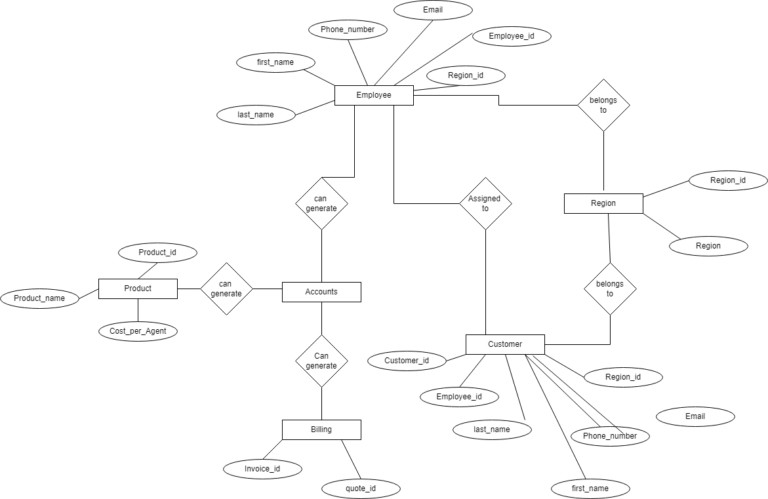

Data model

