Crime Scenes

Business summary

In this term paper, we will present our business plan for a Forensics Database in great detail. To be more specific, we will build a physical data model and a Crime Entity Relationship Diagram that include all the attributes and entities that are important for understanding each crime.

Business Overview

There is no denying the alarming rise in crime rates, which is unfortunately something that cannot be altered. Therefore, the capacity to classify each offense and offender, the ability to practically handle the material surrounding each scenario, and the ability to make conclusions through observation and comparison of instances are all of the utmost importance. The optimization of databases and the attributes they include can be of substantial assistance in the analysis, tracking, and association of criminal situations; this may be a direct technique for strengthening the instruments we acquire to fight crime.

Description

Each crime will have its own record in the database, including with information about the criminals, victims, evidence acquired, weapons used, criminal records of people involved, responsible Investigators, and much more. Our first guess is that the available users will consist of the following categories:

• Regular people, with minimal capabilities such as criminal records and general percentages for each location and time period.

• law enforcement officials with increased authority but yet restricted access.

• forensic pathologists who are trained in DNA analysis and who can store medical records.

• Attorneys/lawyers who can make greater use of the system and have full access to all information.

The database and its features are available to the respective crime investigators. All data in the database is accessible to the administrator.

ERD (Logical Schema)

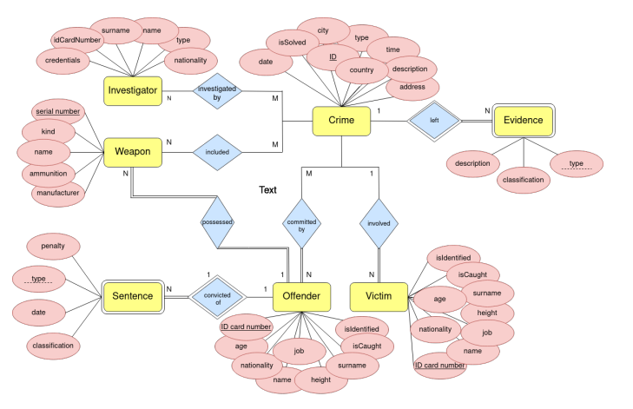

Physical data model

