REPORT

In order to build a committee of deep learning models, I will be comparing K nearest neighbors, a Single-layered neural network, and a Convolutional neural network using the Fashion mnist dataset. Following our data preprocessing, training, fitting, and evaluation procedures, our three models yielded the following findings.

There is a lot of data in the confusion matrix when using K-nearest neighbors. To emphasize, only 57% of predictions about Shirt were accurate. This is because a shirt can serve as a top, a pullover, or even a coat in a pinch. Shirts have lesser accuracy since they are often mistaken for other goods. The CNN model will show an improvement in accuracy in this regard.

As the confusion matrix shows, the accuracy for shirt is still low in Single Layer Neural Networks.

The accuracy of shirts has improved from 57 to 74 when utilizing a convolutional neural network, as seen in the confusion matrix. This is because convolutional neural networks excel at identifying structure within visual data. For the same reason, our CNN model achieved the best results in terms of accuracy and F1 score.

In conclusion, we used a graph to evaluate the committee's top three proposed solutions.

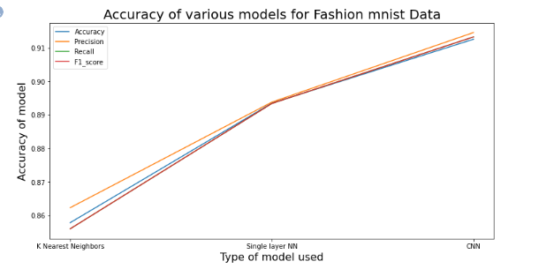

The above chart illustrates how utilizing a Neural network is superior for picture classification, and how increasing our model's accuracy by adding Convolutional layers to our neural network.