Rtest-1

Scatter Point Chart

2022-07-31

library(ggplot2)

## Warning: package 'ggplot2' was built under R version 4.1.3

##Data Reading  
iris.df <- read.csv("Iris.csv")  
  
# we have to change our target variable to factor type for it to work  
iris.df$Species <- as.factor(iris.df$Species)  
   
plt <- ggplot(data = iris.df, mapping = aes(x = PetalLengthCm, y = PetalWidthCm))   
  
plt <- plt + geom_point(alpha = 0.7, size = 6, aes(fill = factor(Species)), colour = 'purple', pch = 21)  
  
plt <- plt + labs(title = "Petal Length Vs Width" ,x = "Petal LengthCm", y = "Petal Width Cm")  
plt <- plt + theme_minimal()  
  
plt

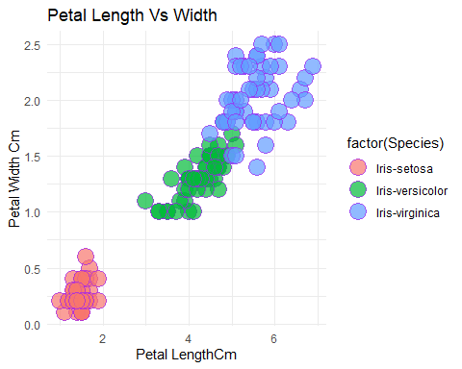 # Explanation

## Above is the Scatter point chart showing 2 out of 4 variables found in Iris dataset. In this case, Petal Length and Petal Width are the variables used. These variables are used as a way of classifying our target variable knows as “Species”. The chart will be showing: Iris-setosa, Iris-versicolor and Iris-virginica types.

# Conclusion

## From the graph We can conclude that, using Petal Length and Petal Width variables we can accurately separate Iris-Setora from the other two species clearly.

## With this regard, Iris-setosa is linearly separable from the other two species(Iris versicolor and Iris virginica) and that there is an overlap between Iris versicolor and Iris virginica.