Rtest-2

Your Name

2022-07-31

library(ggplot2)

## Warning: package 'ggplot2' was built under R version 4.1.3

##Data Reading  
df.data <- read.csv("IrisDataset.csv")  
  
# since our target variable "Species" is categorical variable  
# first lets convert it to the right data type  
  
df.data$Species <- as.factor(df.data$Species)  
   
ggplot(data=df.data,mapping=aes(x = PetalLengthCm, y = PetalWidthCm,color=Species))+  
 xlab(" Petal Length (cm)") +  
 ylab(" Petal Width (cm)") +  
 ggtitle("Petal Length vs Petal Width grouped by Species")+  
 geom_point()

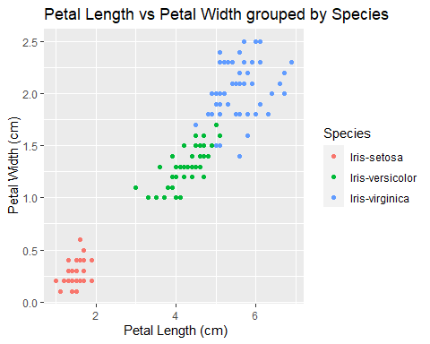

# Explanation

## The Scatter point chart above displays 2 variables found in Iris dataset. The variables are Petal Length and Petal Width. These variables have been used to classify type of species of a flower. Since Species is the target variable, it contains 3 different classes representing 3 different species of flower which are: Iris-setosa, Iris-versicolor and Iris-virginica types.

# Conclusion

## Using the graph generated above it is evident that Petal Length and Petal Width variables clearly separates Iris-Setora from the other two species.

## Thus, we can say that Iris-setosa is linearly separable from the other two species(Iris versicolor and Iris virginica) and that there is an overlap between Iris versicolor and Iris virginica.

library(ggplot2)  
   
ggplot(data=df.data,mapping=aes(x = SepalLengthCm, y = SepalWidthCm,color=Species))+  
 xlab(" Sepal Length (cm)") +  
 ylab(" Sepal Width (cm)") +  
 ggtitle("Sepal Length vs Sepal Width grouped by Species")+  
 geom_point()

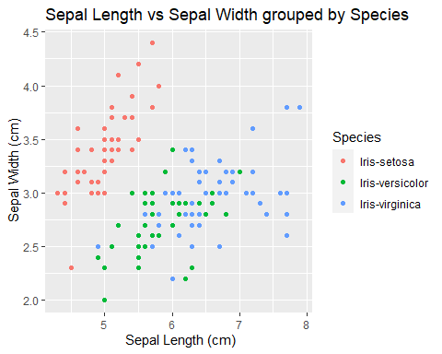

# Explanation

## The Scatter point chart above displays the other 2 variables in Iris dataset. The variables are Sepal Length and Sepal Width. These variables have been used to classify type of species of a flower. Since Species is the target variable, it contains 3 different classes representing 3 different species of flower which are: Iris-setosa, Iris-versicolor and Iris-virginica types.

# Conclusion

## Using the graph generated above it is evident that we cannot clearly separate Iris-Setora from the other two species since at least one type of setosa will still overlap with virginica and versicolor type

## Thus, we can say that Iris-setosa is not linearly separable from the other two species(Iris versicolor and Iris virginica) and that there is an overlap among the three types of species.