User-centered Web Engineering

LandmarkLens:

A User-Centric E-commerce Platform for Old Royal Naval College Landmark

Module leader

Dr Solomon H. Ebenuwa

Student Name

Xxx

Date of Submission

14/12/2023

Course Code

COMP1678

Institution

Contents

1.0 Introduction 4

1.1 Overview of the Project 4

1.2 Purpose of the Report 4

1.3 Brief Description of the Landmark Pictures-Selling Website 4

2.0 Part 1: Analysis, Design, and Front-End Implementation 5

2.1 Introduction to Part 1 5

2.2 User-Centered Design (UCD) Principles 5

2.2.0 Overview of UCD 5

2.2.1 User Research Methods (Personas, Questionnaires, etc.) 6

2.2.3 Design Artifacts and SDLC Integration 6

2.3 Front-End Design 6

2.3.0 Consideration of Contemporary Issues 6

2.3.1 Design Artifacts (Diagrams, Prototypes, etc.) 6

2.3.2 Layout and Components (Home Page, Registration, etc.) 7

2.4 Rationale for Design Decisions 11

2.4.0 User Research and Best Practices in UCD 11

2.5 Front-End Implementation 12

2.5.0 Technologies Used (XHTML/HTML5, JavaScript/jQuery, CSS) 12

2.5.1 Details of Website Components 13

2.5.2 Testing and Heuristic Evaluations 13

3.0 Part 2: System and Back-End Implementation 14

3.1 Introduction to Part 2 14

3.2 Full-Stack Web Application 15

Back-End Functionalities 15

3.3 Back-End Design and Implementation 15

3.3.0 Back-End Database Design (ERD) 15

3.3.1 Security Measures 17

3.4 Integration with Front-End 17

3.4.0 Connecting Back-End to Dynamic Web System 17

3.5 Testing and Heuristic Evaluations for Back-End 18

3.6 Project URL & Login Credentials 18

4. 0 Project Limitations 19

5.0 Project Conclusions 19

Reference list 20

Figure 1 Activity diagram. 7

Figure 2 User page showing orders made by customer. 8

Figure 3 Page showing where customers add to cart items are before making order payment. 9

Figure 4 Admin panel page showing users registered in the system. 9

Figure 5 Admin page dashboard showing what Admin can do in the system. 10

Figure 6 Admin page to edit/read available products(pictures) in the system. 10

Figure 7 Success message upon admin adding a product (picture) in the system. 11

# 1.0 Introduction

## 1.1 Overview of the Project

The Landmark Pictures-Selling Website, titled "LandmarkLens," is a comprehensive e-commerce platform designed to cater to photography enthusiasts, tourists and admirers of the Old Royal Naval College's iconic landmarks. This online marketplace is dedicated to offering a collection of stunning, high-quality images capturing the beauty and historical significance of the college's landmarks. LandmarkLens aims to create an immersive experience, allowing users to explore and purchase these captivating images conveniently.

## 1.2 Purpose of the Report

The purpose of this report is to detail the meticulous design and development process of LandmarkLens, showcasing the application of User-Centered Design (UCD) principles within the System Development Life Cycle (SDLC). By delving into the various stages of analysis, design and implementation, this report aims to provide a comprehensive understanding of how user research, design artifacts and a robust front-end and back-end system were integrated to create a seamless user experience.

## 1.3 Brief Description of the Landmark Pictures-Selling Website

LandmarkLens is envisioned as more than just an e-commerce platform; it's a digital gateway for individuals across diverse demographics to access and acquire images of the Old Royal Naval College landmarks. Through meticulous user research and design decisions, the website ensures accessibility and ease of use for all potential users, including senior citizens with varying physical, health, and social challenges. The website's functionalities, such as registration, login, search features, and item purchasing options, have been crafted to align with user preferences and ensure a smooth browsing and buying process for customers.

LandmarkLens not only offers a collection of captivating images but also strives to create an inclusive and user-centric platform, setting a benchmark for e-commerce websites targeting historical landmarks. This report aims to provide a detailed account of the development process, emphasizing the incorporation of UCD principles and the integration of front-end and back-end functionalities to ensure a fulfilling user experience.

# 2.0 Part 1: Analysis, Design, and Front-End Implementation

## 2.1 Introduction to Part 1

This section lays the foundation for implementing a design strategy that prioritizes user needs and experiences. Throughout the development process of LandmarkLens, I focused on creating an interface and functionalities that cater to diverse user profiles. By understanding the importance of a user-centered approach, I ensured that the website design wasn't solely about aesthetics but aimed at enhancing usability and accessibility for all potential customers.

## 2.2 User-Centered Design (UCD) Principles

### 2.2.0 Overview of UCD

The essence of UCD lies in placing users at the forefront of the design process. I adopted a methodology that revolves around comprehending user behavior, preferences, and challenges. This approach guided the entire development cycle, ensuring that every decision made, from layout choices to feature implementation, was rooted in enhancing user satisfaction and ease of interaction (Keinonen, 2008).

### 2.2.1 User Research Methods (Personas, Questionnaires, etc.)

Employing various techniques such as personas and questionnaires, I conducted extensive research to gather insights into the diverse demographics and their expectations from LandmarkLens. Personas helped in visualizing and understanding the needs and preferences of different user groups, while questionnaires provided direct feedback crucial for tailoring the website's features and functionalities.

### 2.2.3 Design Artifacts and SDLC Integration

The integration of design artifacts within the System Development Life Cycle (SDLC) was pivotal in shaping LandmarkLens. From initial wireframes to prototypes and usability testing, each stage was strategically integrated into the SDLC (Rodríguez-Martínez et al., 2012). This ensured that user feedback and iterative improvements were embedded throughout the development process, resulting in a website that not only meets user expectations but also exceeds them in terms of usability and functionality (Ruparelia, 2010).

## 2.3 Front-End Design

### 2.3.0 Consideration of Contemporary Issues

In crafting the front-end design, I ensured adherence to contemporary design principles and considerations (Godbolt, 2016). Responsiveness across various devices was paramount, accommodating the diverse preferences of users accessing LandmarkLens (Miraz, Ali and Excell, 2021). By implementing responsive design practices, the website adapts seamlessly to different screen sizes, guaranteeing a consistent and user-friendly experience irrespective of the device used (Miraz, Ali and Excell, 2021).

### 2.3.1 Design Artifacts (Diagrams, Prototypes, etc.)

Within the multitude of components, the Home Page stands as the virtual storefront, presenting an engaging interface to captivate users. It serves as the initial point of interaction, displaying featured images and providing navigation to other sections. Besides, the Registration Page plays a pivotal role in onboarding users, allowing them to create accounts and access personalized features such as favoriting images or managing orders.

In addition, I came up with an activity diagram. The activity diagram played a pivotal role in the e-commerce platform by visually mapping out the sequential flow of actions and interactions within the system (Meng, 2022). It provided a comprehensive overview of the user journey, from browsing images to making purchases, facilitating a deep understanding of the various pathways users might undertake (Meng, 2022). This diagram served as a blueprint guiding the implementation of functionalities and informed the development of a user-centric interface, ensuring that each step in the process was carefully considered and optimized for a seamless and intuitive user experience. The activity diagram is as follows;

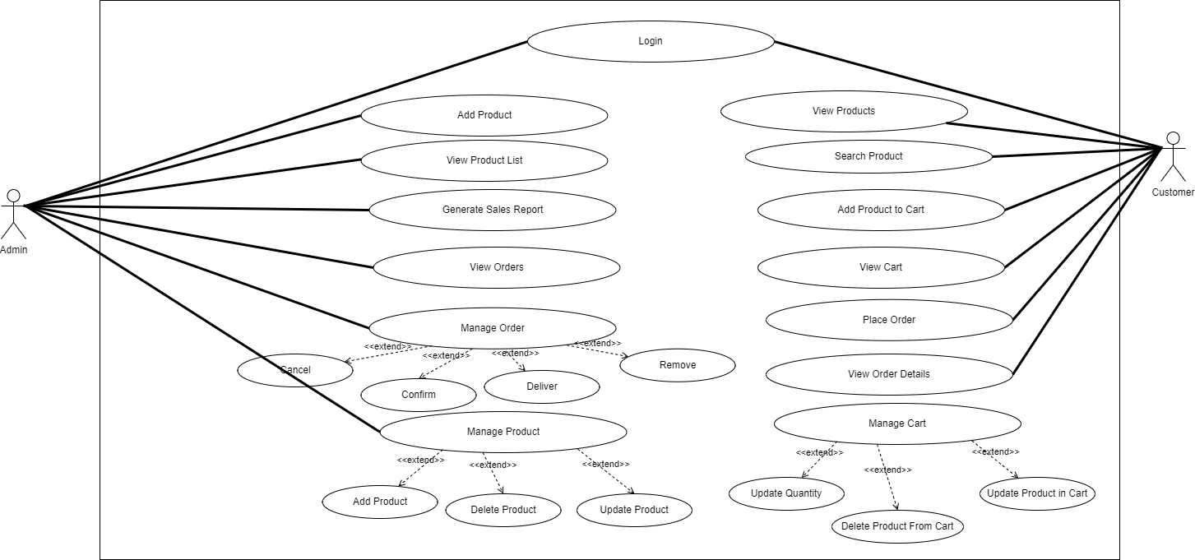

Figure Activity diagram.

### 2.3.2 Layout and Components (Home Page, Registration, etc.)

**Admin Dashboard Page**: This acts as the nerve center for site management, allowing administrators to oversee and manage user accounts, track sales, and modify website content. It facilitates efficient site control and monitoring, ensuring smooth operations.

**Pictures Page**: The core of the website, where users browse and select images of landmarks. Its design focuses on ease of navigation and showcasing images in an appealing manner, encouraging users to explore and make purchases.

**Search Component**: Essential for user convenience, the search function enables users to find specific images swiftly. Its design ensures seamless integration into the interface, enhancing user experience by providing efficient access to desired content.

**Cart and Order Page**: Vital components in the purchase process. The Cart Page displays selected items for review before checkout, while the Order Page facilitates the finalization of purchases. Their design emphasizes clarity and ease of use to streamline the buying process.

These components were carefully crafted and integrated into the front-end design to create a cohesive and user-centric interface. Each component plays a specific role in enhancing user interaction, whether through browsing, purchasing, or site administration, contributing to a comprehensive and intuitive user experience.

The following are some of the components on the working system;

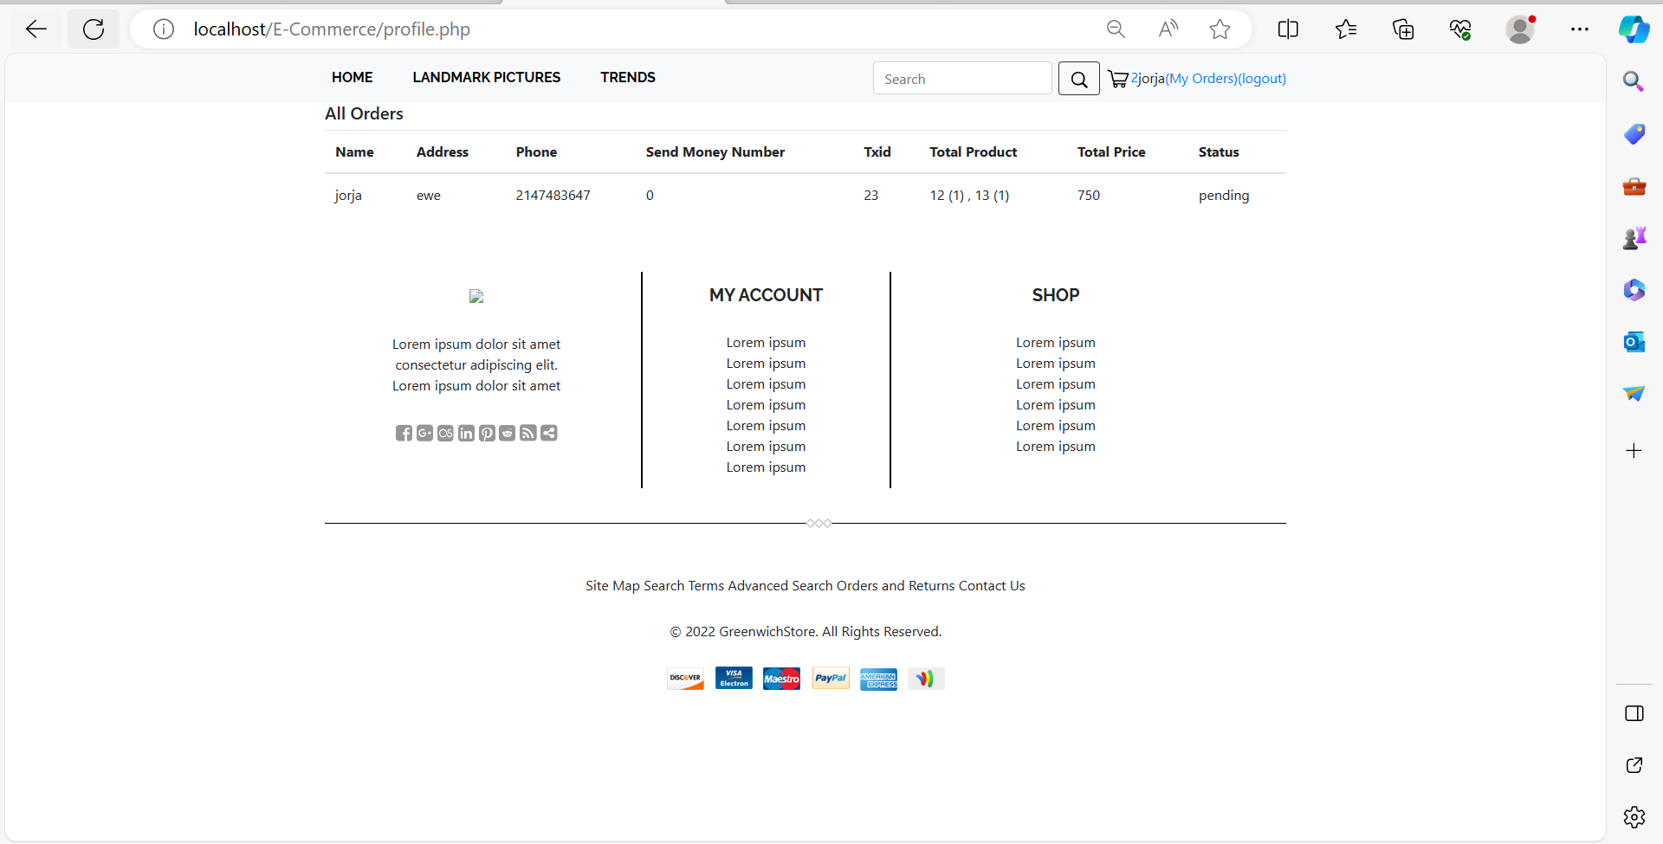

Figure User page showing orders made by customer.

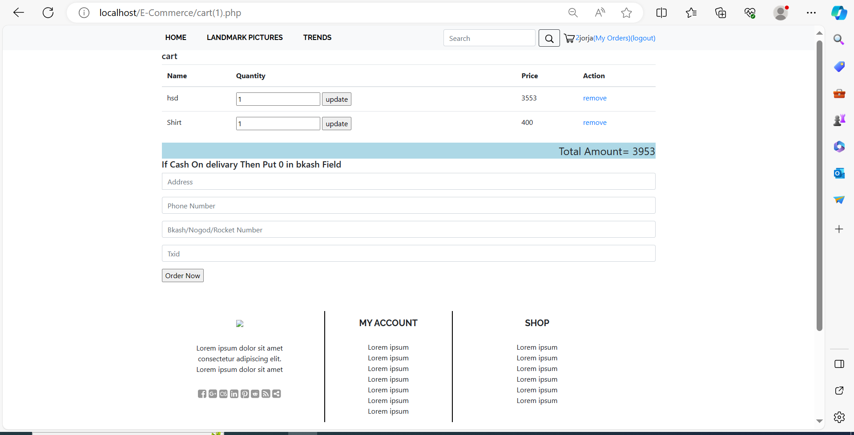

Figure Page showing where customers add to cart items are before making order payment.

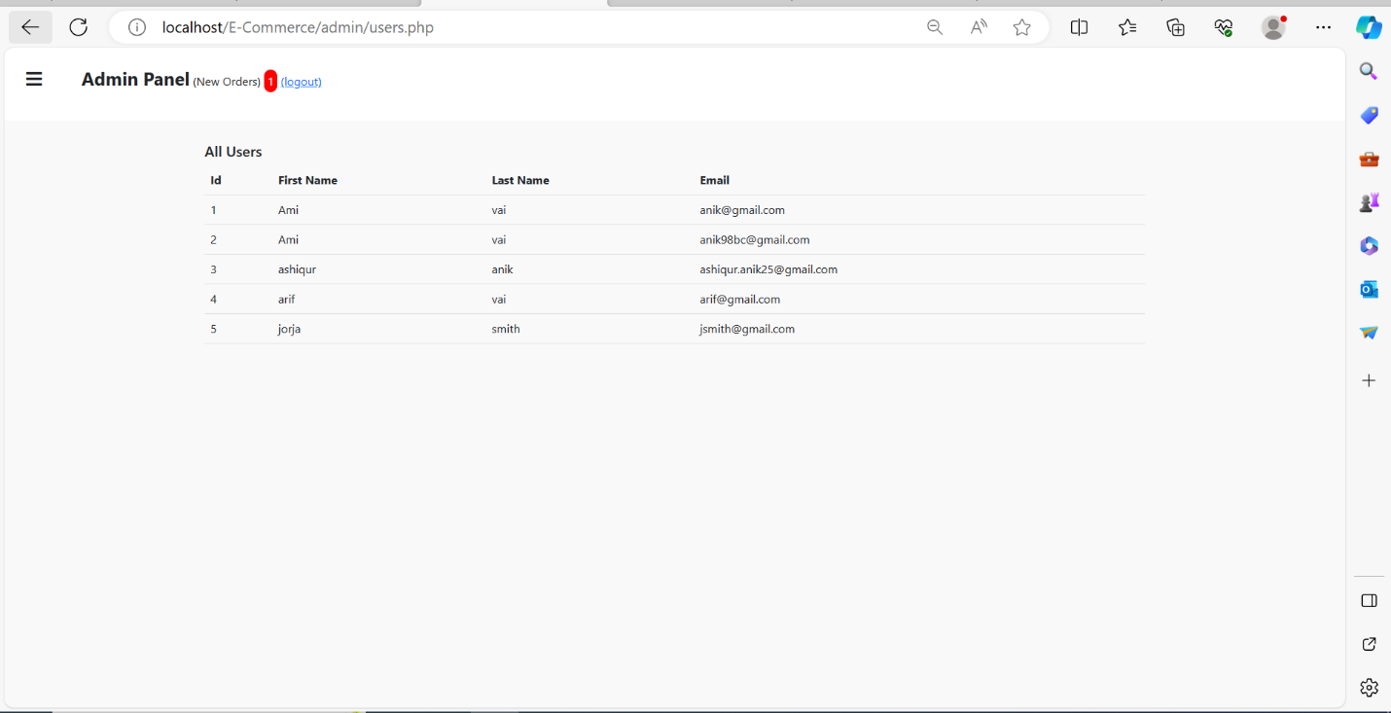

Figure Admin panel page showing users registered in the system.

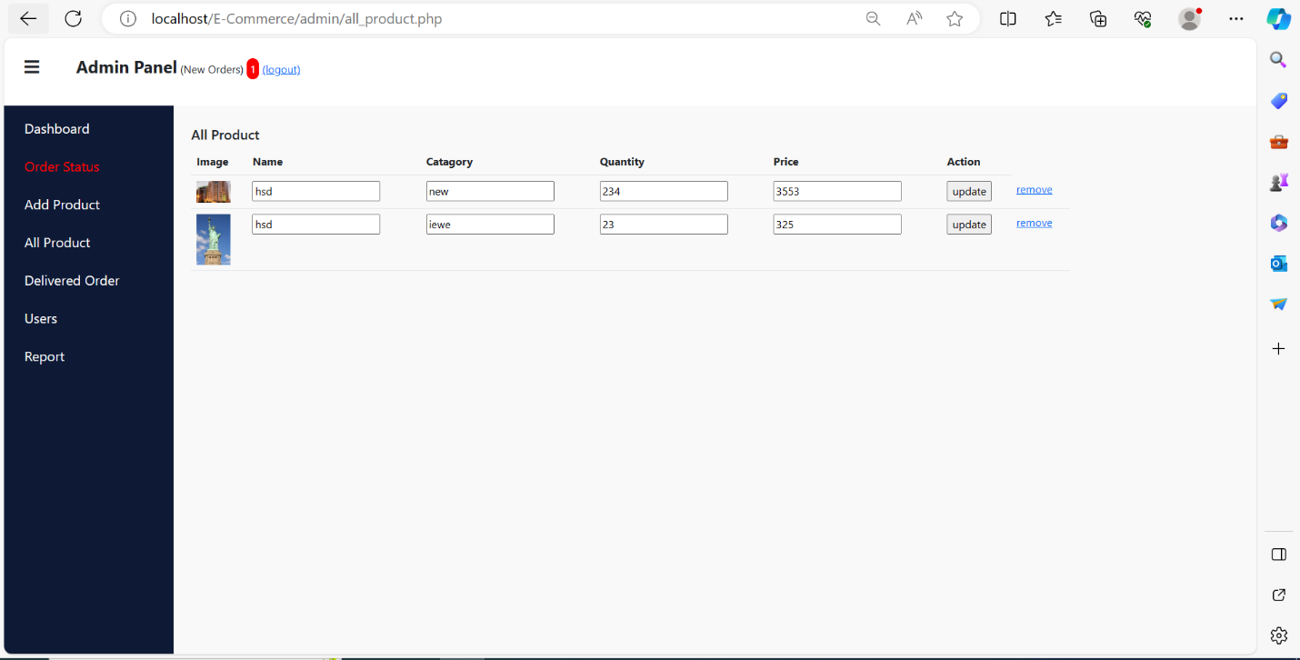

Figure Admin page dashboard showing what Admin can do in the system.

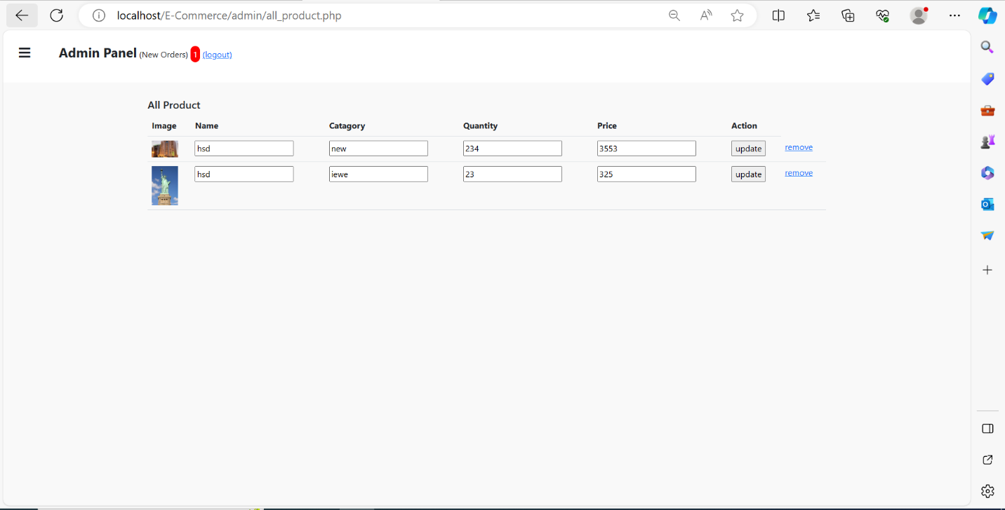

Figure Admin page to edit/read available products(pictures) in the system.

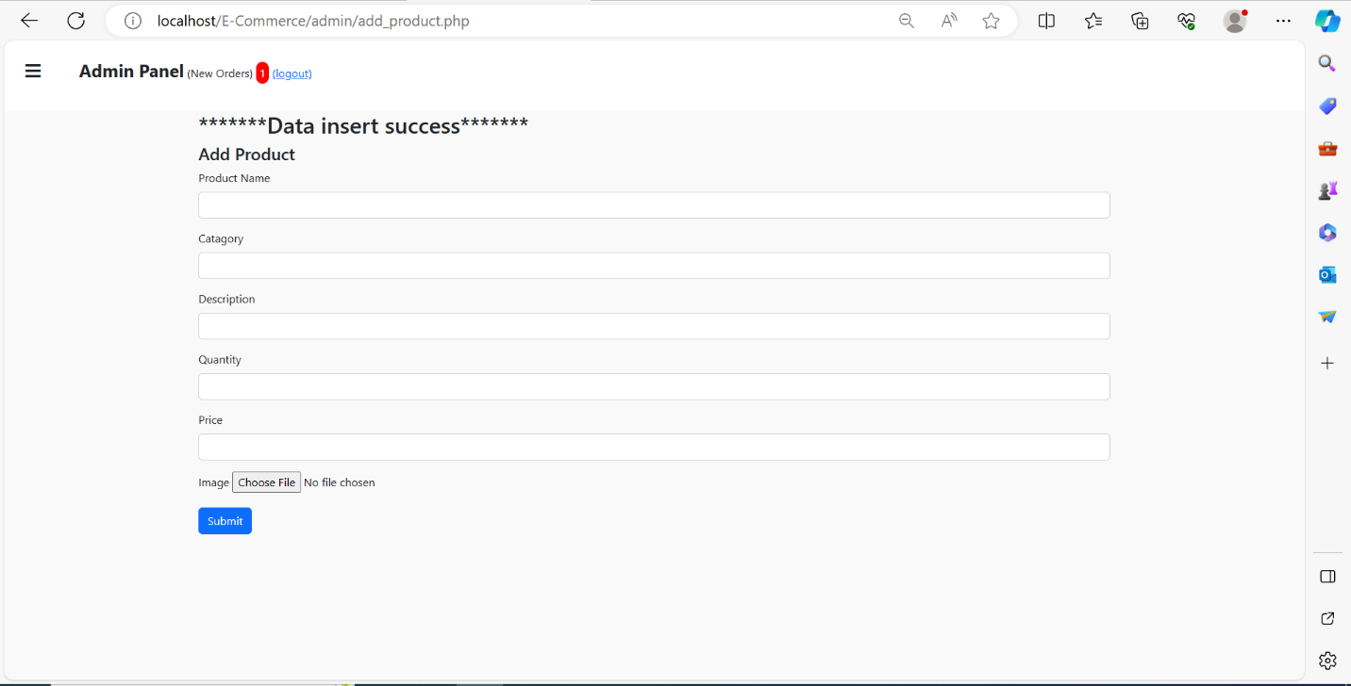

Figure Success message upon admin adding a product (picture) in the system.

## 2.4 Rationale for Design Decisions

### 2.4.0 User Research and Best Practices in UCD

The design decisions within LandmarkLens were underpinned by an extensive understanding of user behavior, preferences, and industry best practices in UCD. Through user research methodologies like personas, surveys, and usability testing, I gathered insights into the diverse needs and expectations of potential users across various demographics.

User-Centric Focus - The personas created from user research became pivotal in informing design choices. By visualizing and empathizing with the needs of different user groups, the design decisions were tailored to cater to these diverse preferences. For instance, senior citizens were considered in terms of font size, contrast, and simplified navigation to ensure ease of use.

Iterative Design Process - A crucial aspect was the iterative design process. Incorporating feedback loops from usability testing and heuristic evaluations ensured continual improvement. It allowed for the identification of pain points or areas of improvement, leading to refinements in the interface layout, navigation flow, and feature accessibility.

Responsive Design Principles - Understanding the prevalence of varied devices used by users, responsive design principles were applied meticulously. The website's layout and components were crafted to adapt seamlessly to different screen sizes, ensuring a consistent and optimized experience whether accessed via desktop, tablet, or mobile device.

Accessibility Considerations - Adherence to accessibility standards was prioritized. Features such as alt text for images, keyboard navigation, and color contrast were implemented to ensure inclusivity, enabling users with disabilities to navigate and interact with the website effectively.

## 2.5 Front-End Implementation

### 2.5.0 Technologies Used (XHTML/HTML5, JavaScript/jQuery, CSS)

For the front-end development of LandmarkLens, I employed a robust stack of technologies. HTML5 provided the structural backbone, enabling the creation of semantic and accessible web pages. CSS was utilized extensively to stylize and enhance the visual appeal of the website, ensuring a responsive design that adapts seamlessly to various screen sizes. Additionally, JavaScript and jQuery were instrumental in enhancing interactivity and functionality, facilitating dynamic elements and smooth user interactions across the site.

### 2.5.1 Details of Website Components

The website comprises several crucial components tailored to provide an engaging and user-friendly experience:

Homepage - The initial landing point showcasing featured images and navigation links.

Pictures Page - The central hub for browsing and selecting images of Old Royal Naval College landmarks.

Admin Dashboard - A secure section facilitating site management and overseeing user activities.

Search Component - Enabling users to find specific images efficiently.

Cart and Order Pages - Facilitating the purchase process by allowing users to review and finalize their orders.

Each component was meticulously designed and implemented to fulfill specific user needs, contributing to a seamless and comprehensive user journey.

### 2.5.2 Testing and Heuristic Evaluations

Prior to deployment, rigorous testing procedures were conducted to ensure functionality and usability. Heuristic evaluations were performed, focusing on identifying potential usability issues and improving user experience. Besides, systematic testing methodologies including cross-browser compatibility checks and responsive design tests, were employed to guarantee optimal performance across different devices and browsers. Through meticulous testing and heuristic evaluations, the front-end implementation underwent refinement and optimization, ensuring a robust and user-centric interface for LandmarkLens users.

# 3.0 Part 2: System and Back-End Implementation

## 3.1 Introduction to Part 2

Part 2 of the LandmarkLens development process encompasses the systemic and back-end implementation crucial for the functionality and interactivity of the website. This phase focuses on the creation of a robust back-end system that complements the front-end interface, ensuring a seamless and efficient user experience.

Within this section, the emphasis shifts to the technical intricacies and functionalities that power LandmarkLens. It involves the establishment of the server-side architecture, database management, and the integration of essential back-end functionalities like Create, Read, Update, and Delete (CRUD) operations. These functionalities form the backbone of the website, allowing users to interact with the platform, manage their accounts, browse images, and conduct transactions securely.

This section provide an overview of how the back-end was meticulously designed and implemented to align with the user-centric principles established in Part 1. It will detail the integration of security measures, session handling, and database management, essential components for a fully functional e-commerce platform like LandmarkLens.

The subsequent sections within Part 2 will delve deeper into the specifics of the back-end system, including the database design, encryption techniques for user data, authentication mechanisms, and measures taken to ensure data security during transactions. This section aims to demonstrate how the back-end implementation seamlessly interacts with the front-end interface, creating a cohesive and user-centric web application.

## 3.2 Full-Stack Web Application

### Back-End Functionalities

The back-end functionalities of LandmarkLens were structured around key operations such as Create, Read, Update, and Delete (CRUD), forming the foundation for user interaction and data management. These functionalities were intricately woven into the system, allowing users to perform essential tasks seamlessly.

The back-end involved a meticulously designed database architecture, facilitating efficient storage and retrieval of image data, user information, orders, and administrative records. The database schema was optimized to support CRUD operations, ensuring smooth data handling across the platform.

CRUD functionalities were integrated to enable users to manipulate data effectively. Users could create accounts, browse images, add items to their carts, update their profiles, and manage their orders. These operations ensured a user-friendly experience, allowing seamless interactions with the platform.

This robust back-end infrastructure formed the backbone of LandmarkLens, supporting the front-end interface by enabling crucial functionalities, ensuring data security, and facilitating a smooth user experience.

## 3.3 Back-End Design and Implementation

### 3.3.0 Back-End Database Design (ERD)

The backbone of LandmarkLens' back-end architecture lies in its meticulously designed Entity-Relationship Diagram (ERD) (Suni, 2020). The ERD served as the blueprint, outlining the relationships between various entities and their attributes, ensuring efficient data storage and retrieval(Suni, 2020).

**Entities and Relationships -** The ERD encompassed essential entities such as Users, Images, Orders, Admins, and more, each with distinct attributes representing their characteristics. Relationships were established between these entities, defining how they interrelated within the system. For instance, the relationship between Users and Orders denoted the association between a user and their placed orders.

**Attributes and Normalization** - Attributes within each entity were defined and organized to minimize redundancy and ensure data integrity. Normalization techniques were employed to streamline the database structure, avoiding data duplication and optimizing storage efficiency.

**Database Integrity and Constraints** - Integrity constraints, including primary keys, foreign keys and unique constraints were implemented to maintain data accuracy and consistency. These constraints ensured that the data stored within the database remained coherent and valid.

**Scalability and Performance** - The ERD design was crafted with scalability and performance in mind. It allowed for potential future expansions and modifications, ensuring that the database could accommodate increased user interactions and additional features seamlessly.

The ERD served as the foundational structure for the back-end database, guiding the implementation of LandmarkLens' data management system. It ensured a well-organized and efficient database structure, crucial for the functionality and reliability of the entire web application.

Below is an ERD for LandmarkLens system

### 3.3.1 Security Measures

To safeguard user data and transactions encryption techniques were implemented to protect sensitive information such as user passwords and financial details. The back-end system was fortified with measures to prevent unauthorized access and ensure data integrity throughout user interactions (Mannan and Oorschot, 2007).

## 3.4 Integration with Front-End

### 3.4.0 Connecting Back-End to Dynamic Web System

The integration between the back-end and the dynamic front-end of LandmarkLens was meticulously crafted to create a seamless and cohesive web system. API endpoints were established to facilitate communication between the front-end and back-end systems. These endpoints allowed for the exchange of data, enabling functionalities such as user authentication, data retrieval for image browsing, cart management, and order processing. The data flow between these systems ensured real-time updates and interactions.

Secure user authentication mechanisms were implemented, allowing users to log in securely and access personalized features. Session handling techniques were employed to manage user sessions, ensuring the security of user data and preventing unauthorized access.

The integration ensured seamless data synchronization between the front-end and back-end. For instance, when a user added items to their cart or updated their profile information, these changes were reflected in real-time across the platform, providing users with immediate feedback and a dynamic user experience.

Robust error-handling mechanisms were in place to manage potential issues that could arise during data exchange. Feedback mechanisms were integrated to inform users of successful operations or provide clear messages in case of errors, ensuring transparency and guiding user interactions.

This integration between the back-end and front-end systems formed the backbone of LandmarkLens, enabling a dynamic, responsive, and user-centric web application experience. It ensured that user actions seamlessly interacted with the back-end functionalities, providing a cohesive and engaging user journey.

## 3.5 Testing and Heuristic Evaluations for Back-End

In the realm of back-end development, rigorous testing procedures and heuristic evaluations were conducted to ensure the reliability, security, and efficiency of LandmarkLens' functionalities. Testing involved various methodologies, including unit testing, integration testing, and system testing, verifying each module's functionality individually and in conjunction with the integrated system. Heuristic evaluations focused on identifying potential usability issues, data vulnerabilities, and performance bottlenecks, ensuring the back-end system's robustness and adherence to best practices.

## 3.6 Project URL & Login Credentials

Upon completion of rigorous backend and frontend system testing, we furnished the admin login credentials along with the designated URL for access. The login URL for admin privileges is: <http://localhost/E-Commerce/admin> and the login credentials for both the username and password fields are set to "admin". The system allows non-admin users the ability to create accounts, log in, and execute diverse actions.

# 4. 0 Project Limitations

While LandmarkLens aimed to offer a comprehensive e-commerce experience, certain project limitations impacted its full realization. Notably, the implementation of a payment system was a significant challenge. The complexity of integrating secure payment gateways and ensuring compliance with financial regulations required an extensive time investment and expertise beyond the project scope. As a result, the implementation of the payment system wasn't feasible within the project timeframe.

# 5.0 Project Conclusions

In conclusion, LandmarkLens represents a meticulous endeavor integrating user-centered design principles with a robust full-stack implementation. The project successfully delivered a functional e-commerce platform catering to users' needs in browsing, selecting, and managing images of the Old Royal Naval College landmarks. The website's architecture and functionalities showcased the seamless integration of front-end design with a secure and efficient back-end system.

While the project accomplished various milestones, the unimplemented payment system serves as a reminder of the complexities and challenges involved in integrating secure financial transactions into an e-commerce platform. Despite this limitation, LandmarkLens stands as a testament to the diligent application of user-centric design principles and the successful creation of a user-friendly platform for accessing landmark images.

# Reference list

Godbolt, M. (2016). *Frontend Architecture for Design Systems: A Modern Blueprint for Scalable and Sustainable Websites*. [online] *Google Books*. ‘O’Reilly Media, Inc.’ Available at: https://books.google.co.ke/books?hl=en&lr=&id=s8V4CwAAQBAJ&oi=fnd&pg=PR2&dq=In+crafting+the+front-end+design [Accessed 29 Nov. 2023].

Keinonen, T. (2008). User-centered design and fundamental need. *Proceedings of the 5th Nordic conference on Human-computer interaction building bridges - NordiCHI ’08*. doi:https://doi.org/10.1145/1463160.1463183.

Mannan, M. and Oorschot, van (2007). Using a Personal Device to Strengthen Password Authentication from an Untrusted Computer. pp.88–103. doi:https://doi.org/10.1007/978-3-540-77366-5_11.

Meng, X. (2022). Construction of E-Commerce Economic Management Platform Based on Data Visualization Technology. *Mathematical Problems in Engineering*, 2022, pp.1–11. doi:https://doi.org/10.1155/2022/7443288.

Miraz, M.H., Ali, M. and Excell, P.S. (2021). Adaptive user interfaces and universal usability through plasticity of user interface design. *Computer Science Review*, 40, p.100363. doi:https://doi.org/10.1016/j.cosrev.2021.100363.

Rodríguez-Martínez, L., Mora, M., Álvarez, F., Garza, L., Durán, H. and Muñoz, J. (2012). Review of Relevant System Development Life Cycles (SDLCs) in Service-Oriented Software Engineering (SoSE). *Journal of applied research and technology*, [online] 10(2), pp.94–113. Available at: https://www.scielo.org.mx/scielo.php?pid=S1665-64232012000200003&script=sci_arttext&tlng=en [Accessed 29 Nov. 2023].

Ruparelia, N.B. (2010). Software development lifecycle models. *ACM SIGSOFT Software Engineering Notes*, [online] 35(3), p.8. doi:https://doi.org/10.1145/1764810.1764814.

Suni, J. (2020). *From Reflections to Systems Thinking : Developing a Practice for Documenting Software Architecture in a Growth Company*. [online] www.theseus.fi. Available at: https://www.theseus.fi/handle/10024/339991.