Contents

4.0 Digital Analytics Methods and Tools 1

4.1 Methods 1

4.2 Tools 1

5.0 Analytics Results 2

5.1 Live Broadcast 10

5.2 Website 10

5.3 Partnerships and User Engagement 10

5.4 Content Marketing and Personalized Marketing 10

5.5 Electronic Bulletin Board Marketing 11

6.0 Discussion of the Analytics Results 11

6.1 Live Broadcast 11

6.2 Website 11

6.3 Partnerships and User Engagement 12

6.4 Content and personalized marketing 12

6.5 Electronic Bulletin Board Marketing 12

# 4.0 Digital Analytics Methods and Tools

Through digital analytics, marketers can precisely understand customer behavior and use the data to make strategic decisions. The way digital analytics is being implemented at Stratagem Solutions comprise not only modern and sophisticated methods but also cutting-edge tools that provides actionable insights.

## 4.1 Methods

Customer segment analysis is a crucial method utilized by Stratagem Solutions for the purpose of understanding and reaching different customer groups efficiently. The RFM (Recency, Frequency, Monetary) technique enables us to group customers based on their transactional actions, thus, identify segments with high values so we can direct our marketing activities to those groups. Through utilization of RFM analysis we can help to channel our resources towards the segments that will generate the highest revenue growth.

Apart from the market segmentation this methodology also makes the data quality assessment and analysis an integral part. Our data validation approach, which is based on a careful examination of the integrity, completeness, and consistency of data, guarantees the buildup of our insights on a base of reliable information. This way of doing things enables our conclusions to be quite precise and accurate, eventually leading to informed decisions across the whole organization.

## 4.2 Tools

To bridge the gap between digital and analytics, we use the best of breed technology tools. Jupyter Notebook used together with Anaconda provides us with the base for data analysis and model building. Using libraries such as Pandas, NumPy, Matplotlib, and Seaborn, we inquire by doing deep exploratory data analysis and visualization to get valuable insights from raw data.

Moreover, with the help of Business Intelligence Tool-Tableau interactive sales dashboards are created for customer segmentation. This engaging medium for communicating our sophisticated analysis carries the ability to simply illustrate crucial metrics and trends for all the stakeholders by one glance. Tableau manipulation helps us to increase transparency and accessibility to the business data which plays a significant role in making better and accurate business decisions by all organizational levels.

Based on the usage of sophisticated tools like RFM analysis and scrutinizing data integrity standards, and the employment of the cutting-edge solutions like Jupyter Notebook, Anaconda, and Tableau, Stratagem Solutions develops the capacity to obtain meaningful insights from digital data. This business approach puts us in an advantageous position to better market, improve customer engagement, and achieve long-term business success.

# 5.0 Analytics Results

The exploratory data analysis conducted on customer segments yielded insightful observations. Firstly, concerning the age distribution of new versus old customers, it was found that the majority of both new and old customers fall within the 40-49 age bracket. However, there is a notable drop in the number of customers in the 30-39 age group among new customers. Additionally, the analysis highlighted that the automotive company is particularly popular among new customers in the age groups 20-29 and 40-49. Interestingly, the lowest number of customers for both new and old segments are found in the age brackets under 20 and above 80.

Figure 1 Old customers Age distribution.

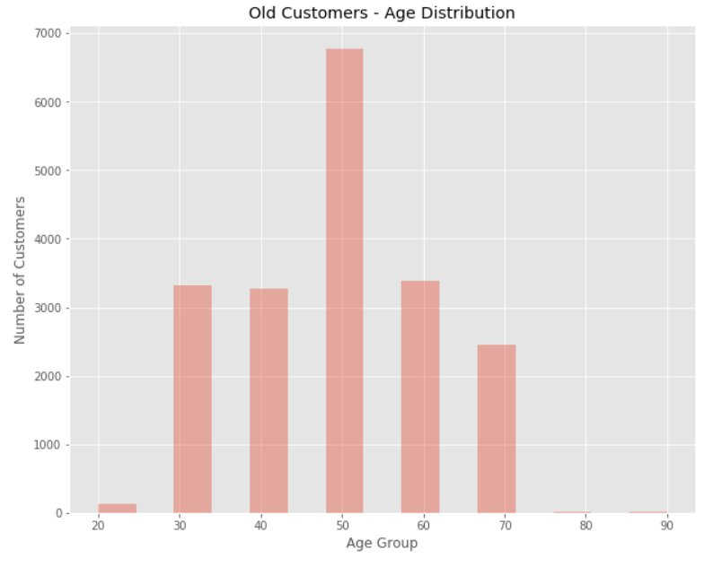

Figure 2 New customers Age distribution.

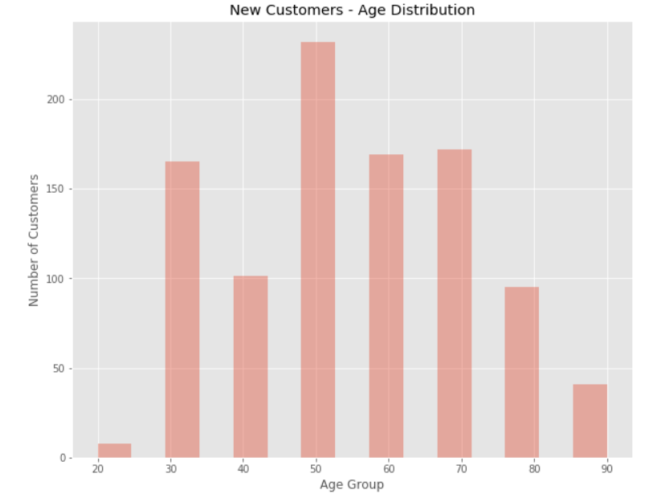

Regarding weapons purchases over the last three years by gender, the data revealed that most purchases were made by females, accounting for approximately 51% of purchases compared to 49% by males. Numerically, female purchases exceeded male purchases by 10,000 units.

Figure 3 Female vs Male past 3 years Weapons purchases.

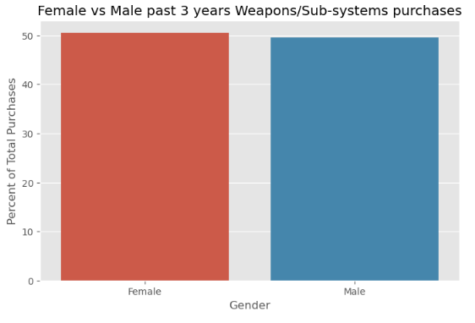

Furthermore, the distribution of new versus old customers across job industries was examined. It was observed that the majority of new customers come from the manufacturing and financial services sectors, comprising approximately 20% of the new customer base. Conversely, the lowest number of customers originate from the agriculture and telecom sectors, each accounting for approximately 3% of new customers. This trend was found to be consistent among old customers as well.

Figure 4 Old Customers Job Industry distribution.

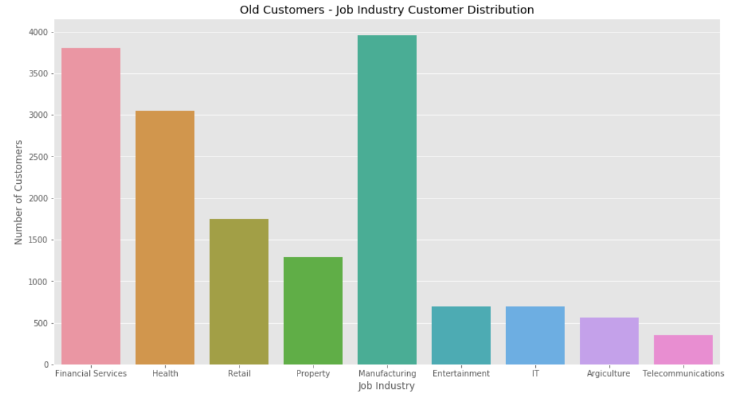

Figure 5 New Customers Job Industry distribution.

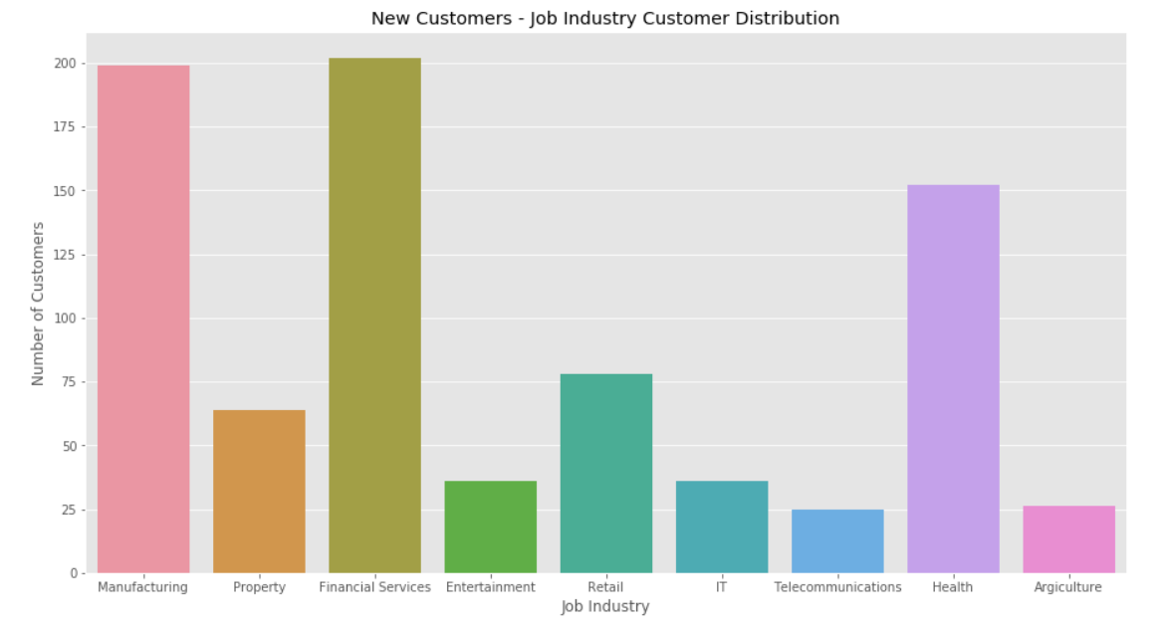

In terms of wealth segmentation by age category, the analysis indicated that across all age categories, the largest number of customers belong to the 'Mass Customer' segment, followed by the 'High Net Worth' segment. Notably, in the age group 40-49, the affluent segment outperforms the high net worth segment in terms of the number of customers.

Figure 6 Old Customers - Wealth Segmentation by Age Group.

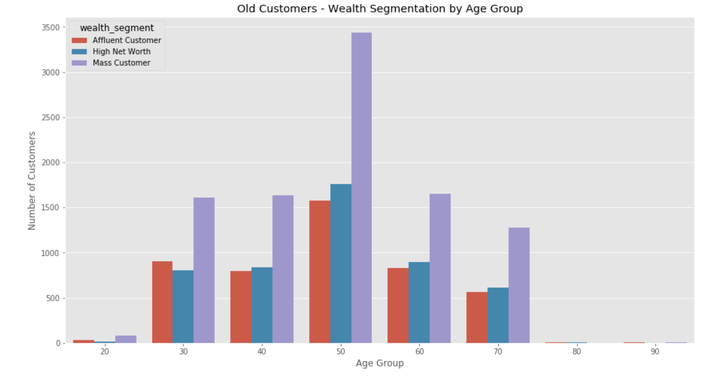

Figure 7 New Customers - Wealth Segmentation by Age Group.

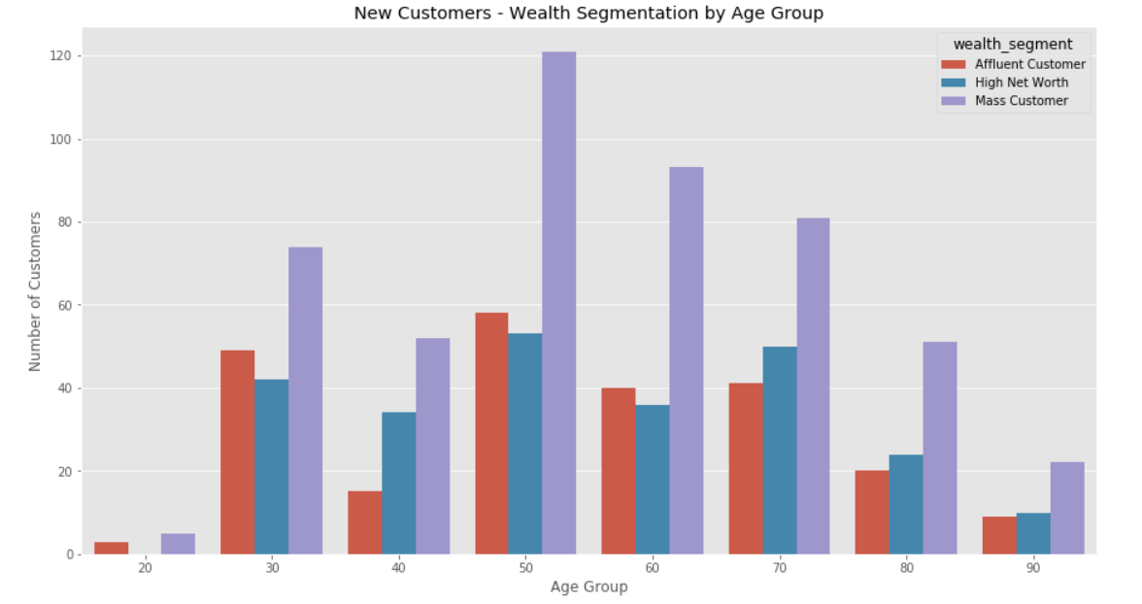

Lastly, RFM analysis was employed for customer segmentation, dividing customers into 11 groups such as Platinum Customers, Very Loyal Customers, and Potential Customers. Visualizations including scatter plots depicting Recency vs Monetary and Frequency vs Monetary were utilized to glean insights. These plots revealed that recent customers tend to purchase more products and generate relatively higher revenue, while customers in segments such as Platinum, Very Loyal, and Becoming Loyal exhibit greater frequency of purchases and higher monetary value, indicating their significance to the business.

Figure 8 Customer Segment Distribution.

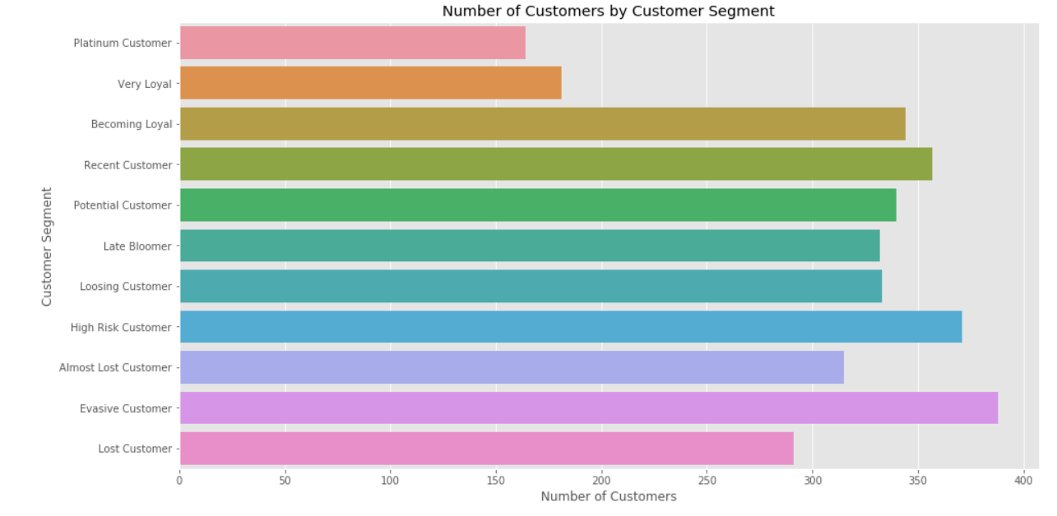

Figure 9 Recency vs Monetary.

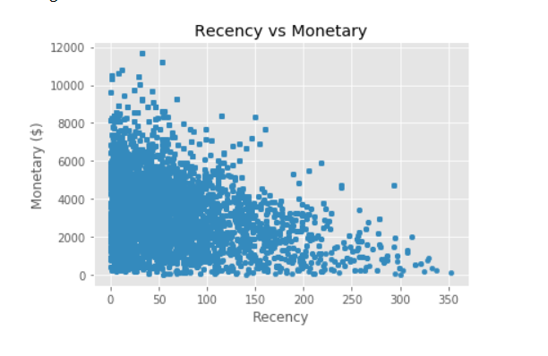

Figure 10 Frequency vs Monetary.

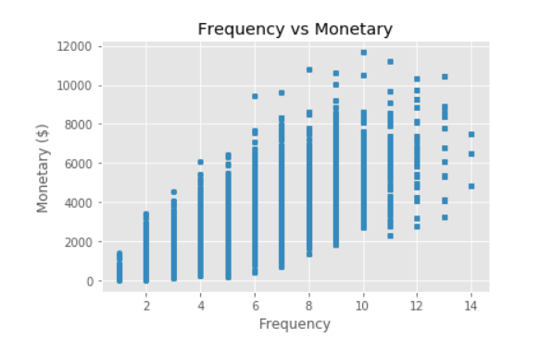

Figure 11 Tableau Sales Dashboard for Stratagem Solutions company.

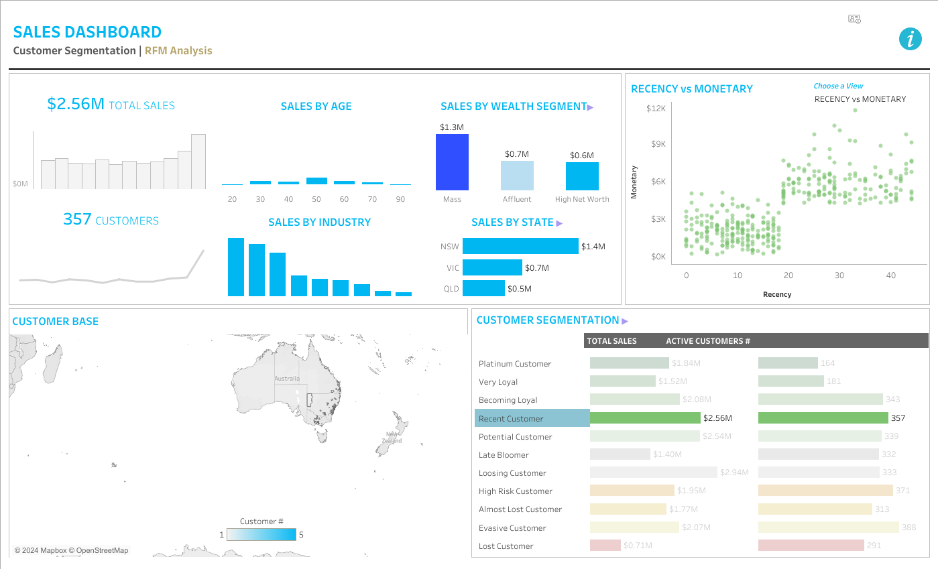

## 5.1 Live Broadcast

Developing a live broadcast plan outside our exploratory data analysis and RFM segmentation, will help Stratagem Solutions to be more targeted in terms of customer segments’ behavior. Through accurate knowledge of the customer demography, like, and behavior, it will be persuasive to choose the relevant program content and broadcast time which suits our audience. For a start, we can adjust our broadcasts to suit the 40-49 age bracket, which from our findings constitutes the majority of our first-time customers. We can start accommodating them by providing product demonstrations, educational sessions, and constant engagements. We hope to optimize viewer interaction, achieve higher exposure and eventually improve the conversion process by utilizing of this information.

## 5.2 Website

Our site is the prime channel for our communication with customers and perspective, and this analytics results create a chance to improve customer’s journey and push conversion. As it has been revealed that female clients make quite a lot of sales for the previous three years, we can customize our site content, pick images, and write the messages accordingly to these kinds of clients. More seriously, Market Segmentation explains the percentage of Job Industry sector in our customer base makes us be able to design targeted Landing Pages and Content through meeting of the different sectors’ needs such as Manufacturing and Financial Services sectors. Through the customization of the website interaction that is built on customer understanding, we try to find a way to make users have more engagement time and finally reach the goal.

## 5.3 Partnerships and User Engagement

Equipped with the output analytics, we can prioritize partnerships and collaborations for the purpose of consistently increasing customer engagement and reach. Through the process of segmentation, where we define a specific group of people that interest us such as high net worth individuals in the 40-49 age group, we can enter into partnership with influencers and brands that are targeting this segment. These collaborations may be based on co-marketing, sponsored content or brands association in events, whereby we are able to expand our reach as well as visibility of our brand among the target market. Additionally, the RFM analysis provides guide to the audience segmentation to which the different engagement strategies can be applied, for instance, elite customers receive individualized offers while the risky segment could get back in track through tailored reengagement campaigns. Encouraging the growth of mutually beneficial partnerships and initiating user engagement projects, we mean to develop the culture of brand loyalty and sustainable relations with customers.

## 5.4 Content Marketing and Personalized Marketing

Simply put, content marketing is the key factor in involving customers to our brand; our data-driven content marketing strategies forms the backbone of our content strategy at every phase. With the aged segmenting, we will succeed in establishing the content, directed the various customer groups’ needs and aims in mind, either educational resources for mass customers or the exclusive information for the wealthy people. Segmentation by RFM (recency, frequency, and monetary) provides the necessary insights to fully take advantage of specific marketing efforts, which are delivered to the right customers and based on their behavior and preferences. Whether be email campaigns, social media outreach or personalized recommendations, these endeared consumers based on their preferences as well as cultivating their engagement with us. We consider a customer-centric approach for content marketing as a core strategy to achieve an increase in engagement, loyalty and sales.

## 5.5 Electronic Bulletin Board Marketing

Electronic bulletin boards serve a solid locus of exhibiting customized content and advertising updates; after all, we use our data outputs in our playbook to maximize the value of this tool. Knowing the RFM segmentation allows us to influence the age or spending habit of the customer by adjusting their profile, we can have different content & display of offers on our electronic boards. As an example, if great discounts are offered to platinum members or announcements show the new features to loyal customers would be possible to change those to become attentive and customers. Furthermore, during the period of exploratory data analysis we equip ourselves with valuable data which gives an insight into the age distribution of new and old customers. This advanced knowledge helps us design bulletin boards that attract the interest of specific demographics. Via dissemination of persuasive and pertinent info through digital bulletins we expect that our brand will gain a lot of visibility, action and customer loyalty resulting in growth of sales.

# 6.0 Discussion of the Analytics Results

## 6.1 Live Broadcast

Livestream marketing models will be improved when live casts are tailored to specific audiences based on the customer demographics and preferences insights revealed by analytics. This leads to major marketing strategy enhancements. We are able to connect with and engage a particular set of consumers during live broadcasts by giving them content that resonates to the audience. This results in audience loyalty or brand affinity. The customized nature of this will provide higher conversion rates as clients are more likely to make purchases when content is pertinent and engaging. The company revenues will thus go up.

## 6.2 Website

Personalizing the website experience through analytics insight will improve the marketing, because it makes engagement of the users and conversion rates to grow. Through the combination of the website content, imagery, and messaging that goes in accordance with the customer demographics and industry preferences, the visitors get welcome to a seamless and responds-to individual experience which makes them explore more and purchase naturally. The optimization will result in much more traffic, longer page dwelling, and thus better revenues for the venture.

## 6.3 Partnerships and User Engagement

Matching companies with data analytics helps to strategically play up partnerships, thus leading to an increase in user engagement and revenue growth. Through the pinpointing of specified customer segments and connecting on product partners and influencers whom these customers relate to, we advance our reach and deepen brand presence. This added visibility promotes more customers, increased customer retention, and loyalty eventually, result in greater revenues for that company.

## 6.4 Content and personalized marketing

Analytics-based content marketing let us send individual and useful offers for addressed customer groups. On the basis of knowing which wealth segment each customer belongs to, as well as their behavior, we can create adapted content that caters to the specific needs and tastes of various groups of people. By this means the tailored approach leads more interaction, creates brand’s trust, and as the result conversion rates grow and company revenue is increased.

## 6.5 Electronic Bulletin Board Marketing

Catering is digital bulletin board marketing and analytics insights enable us to convey the right and importance messages to various audience groups. We grasp the attention as well as potential customers by showing content and offers that are relevant to specific groups of people and propel the sales and foot traffic. It is the sharpness of this approach that causes higher conversion rates and revenue growth because individuals are more prone to see messages that have been fit their preferences.