A STATISTICAL REPORT ON OVERWEIGHT AND OBESITY IN PINKLAND

STUDENT ID

**MSc Global Public Health**

**PSYC-1115**

**APPLIED EPIDEMIOLOGY & STATISTICS IN THE GLOBAL CONTEXT M01**

Coursework Deadline:

Word Count:

Module Leader:

Page 1 of 10

INTRODUCTION

Obesity and overweight is becoming an increasingly useful issue in Pinkland, as well as across the world. According to the World Health Organization, up to 39% of adults in Pinkland are overweight and 13% are obese (Gentile, et al., 2021). This is problematic because it has been related to an increased risk of acquiring numerous different types of cancer as well as diabetes type 2 and cardiovascular disease. The prevalence of obesity in Pinkland is comparable to the UK, with 62% of people in England being overweight or obese. This highlights the need for further research into the underlying causes of overweight and obesity in Pinkland, and to investigate how to effectively reduce the prevalence of these conditions.

In order to accomplish this goal, the National Centre for Health Research carried out the Health Survey of Pinkland (HSP) in 2011. This survey was conducted to evaluate adult participants’ dietary practices and general health. Information was collected by the National Center for Health Research and the Department of Public Health at the University of Central Pinkland using a multi-stage stratified probability sampling technique (Giles, 2002). Both institutions are located at the University of Central Pinkland (Johnson, et al., 2006). In order to conduct the survey, a random selection was made of seven thousand addresses from each of the seven hundred distinct postal zones. Interviews were conducted with a total of ten people from each household in order to collect socioeconomic data as well as physical measurements. The results of the survey will provide valuable insights into the nutritional status of adults in Pinkland, and will help inform policies and interventions to reduce the prevalence of obesity and overweight.

OBJECTIVES

This research aims to analyze the Pinkland Health Survey from 2011, with a particular emphasis on the incidence of overweight and obesity, and to determine which demographic subgroups are at the highest risk. In addition to providing an estimate of the prevalence of obesity and overweight among men and women, the report will also make use of descriptive and analytical epidemiology to study the association between body mass index (BMI) and other characteristics.

DATASET DESCRIPTION

This set of data contains information obtained from the 2011 Pinkland National Health Survey, which is carried out once every two years. In addition to more typical socio-demographic information such as age, gender, and level of education, the report also includes measurements of the subject's height and weight. This data was compiled with the help of composite hierarchal probability sampling, with postcode sectors acting as the primary sampling unit and being stratified according to the regions covered by health authority authorities. Pserial (the survey participant ID), age, sex, ethnicity, marital status, hh55size (household size), topqual3 (highest educational qualification), NS-SEC 5 (occupation classification), car (availability of car or van), limit ill (limiting longstanding illness), height (centimeters), and weight (in kilograms) are all included (weight in kilograms). The absence of a particular value in the dataset is denoted by the use of a dot ('.').

METHODS

As part of the HSP, a survey is conducted once every two years with responses coming from an adult population drawn at random from houses located all around Pinkland. The sample was chosen using a composite hierarchal probability sampling technique, with postcode sectors serving as the main sampling unit. The percentage of households headed by people in non-manual occupations and the health authority regions were used to divide the sample into subsamples.

A representative number of the households were drawn from the Postcode Address File. In the days running up to the actual survey, each household was sent a letter that provided an overview of the survey as well as its objectives. Interviews centered on collecting demographic data were carried out with the use of CATI, which stands for computer-assisted personal interviewing. In the final step of the interview, a Measurement Record Card was made for each respondent who indicated that they wanted a record of their height and weight. This took place in the final moments of the session. A Health Manager was stationed at each field location to oversee the collection of data.

Study Design:

* Adults in Pinkland households were polled as part of the HSP, making up a sample of the country's overall population.
* The survey used a composite hierarchal probability sampling methodology, with postcode sectors acting as the main sampling unit and being split into subsamples based on health authority regions and the proportion of households led by people who did not undertake physical work.
* Computer-assisted personal interviewing (CAPI) was used to collect data on age, sex, and level of education, among other socio-demographics.
* Weight and height were recorded while the subject was barefoot and wearing minimal clothing.

Quality Control:

* The Health Manager for the UCP Department of Public Health oversaw the operational details of the regional project.
* Each address received a letter outlining the survey’s objectives in advance.
* Additional information was provided to the respondent in the form of leaflets handed out by the interviewer.
* Weight was determined using Tanita digital electronic scales, while height was determined using portable stadiometers.
* Those being interviewed were requested to take off their shoes and any other bulky items.
* Because the scales' maximum capacity was 130 kg, the interviewer had to make an educated guess for respondents whose weight exceeded that threshold.
* Those interviewees who were unable to get out of a chair or who appeared to be unstable were not measured.

The variables used in the analysis were defined as follows:

* Age: Age was determined by the respondent providing their date of birth.
* Sex: Sex was determined by the respondent providing their gender.
* Educational Qualification: Educational qualification was determined by the respondent providing their highest level of education. Height:
* The subject’s height was measured using a portable stadiometer (Eriksen, et al., 2011) that has three connecting rods labeled with a metric measuring scale and a sliding head plate. While maintaining the Frankfort plane posture for the head, participants reached their maximum height potential. The measurement was made to the closest millimeter.
* Tarnita electronic scales (Kelly & Metcalfe, 2012) with a digital display were used to measure weight. Shoe removal and other articles of bulky clothing were requested of all informants. To the nearest 100g, the measurement was taken. The maximum weight that could be measured on the scales was 130 kilograms. Those respondents who were over 130 kg were given an estimated weight by the interviewer. We did not weigh those who were unable to stand or who were in a wheelchair.

Statistical Package for the Social Sciences, more commonly referred to as SPSS, will be used to evaluate the data using both descriptive and inferential statistics.

Descriptive Statistics:

Descriptive statistics will include frequencies, means, medians, and standard deviations for categorical and continuous variables (Mishra, et al., 2019). For categorical variables, we will employ frequencies, percentages, and means to provide a summary of the data. For continuous variables, we will use measures of central tendency (mean, median, mode) and dispersion (standard deviation, range, and interquartile range) to provide a summary of the data (George & Mallery, 2018).

Inferential Statistics:

We will utilize multiple linear regression to examine the relationship between two or more categorical factors for categorical variables. (Lorenzo-Seva & Ferrando, 2011). For continuous variables, we will use the t-test, ANOVA (Analysis of Variance) to assess the association between two or more continuous variables (to determine whether the proportions are statistically significant) (Morgan, et al., 2014).

Software Used:

SPSS is an incredibly powerful software package designed to help social scientists analyze and interpret data. It is user-friendly and comprehensive, allowing researchers to quickly and easily enter data, generate descriptive and inferential statistics, and create graphs and tables to visualize the data.

SPSS is a great choice for data analysis because of its statistical capabilities. It can be used to generate a variety of descriptive statistics, such as means, medians, standard deviations, and correlations, as well as more sophisticated inferential statistics, such as t-tests, ANOVAs, and regression. It also allows researchers to quickly generate a variety of graphs, such as bar and line graphs, scatterplots, and box plots, to help visualize and interpret the data. Another advantage of SPSS is its ability to quickly and easily enter data. The software includes a data editor that allows researchers to quickly enter, modify, and manage the data, making it much easier to analyze and interpret than if the data had to be entered manually (Bryman & Cramer, 2019).

SPSS is a great choice for researchers because it is incredibly user-friendly. It includes intuitive menus and dialog boxes that make it easy to access the different features of the software, and it also includes an extensive online help system that can be used to answer any questions that may arise. SPSS is an excellent choice for data analysis. It is user-friendly and comprehensive, making it easy to enter data, generate descriptive and inferential statistics, and visualize the data. With its intuitive menus and online help system, SPSS makes data analysis easier and faster than ever before.

RESULTS

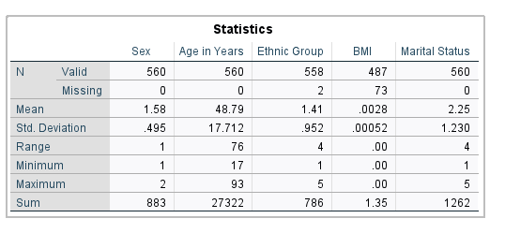

These are the descriptive statistics that were utilized in the analysis of the information obtained from the Pinkland Health Survey in 2011. The survey had a total of 560 responses, an equal number of male and female participants answering each question. With a standard deviation of 17.71 years, this group’s average age was 48.79 years. The body mass index had a standard deviation of 0.00052 whereas the average was 0.0028. We also discovered that the median age of those included in the dataset, which ranged in age from 17 to 93, was 76.

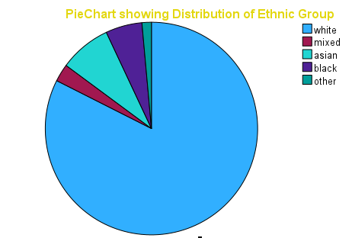

The distribution of the pinkland0 (8) dataset is shown above in the form of a pie chart. This figure reveals that the "other" category makes up the least amount of the dataset, while the "white" group of people makes up the largest portion.

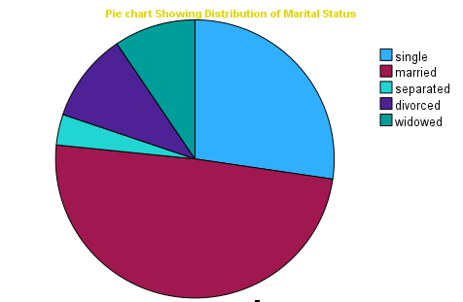

The pie chart above provides a visual representation of the marital status of the people in the pinkland0 (8) dataset. From the chart, it can be seen that the largest portion of the dataset is made up of married people approximated at (48%) while the second largest portion is made up of single people (27%). The remaining 25% of the dataset is made up of people who are either divorced (15%), widowed (6%), or separated (4%).

Marriage is an important part of many cultures, and this is reflected in the large proportion of married people in the dataset. This may be due to societal expectations, or simply because marriage is seen as a commitment and an expression of love. Similarly, the smaller proportion of single people may be because of the pressure to enter into a committed relationship.

The percentage of people who are divorced, widowed, or separated is much lower than the married and single categories. This could be because of the stigma associated with these marital statuses, or simply because these are more transitory statuses. Divorce, for example, is often seen in a negative light, and so people may be less likely to admit to being divorced. Similarly, widowed and separated people may not want to admit

According to the World Health Organization classification, 25.0% of the sample were classified as overweight (BMI 25.0-29.9), and 18.5% were classified as obese (BMI ≥ 30.0) (Gentile, et al., 2021). There was a significant difference between men and women, with 24.1% of men classified as overweight, and 29.2% of women classified as overweight. Furthermore, 16.1% of men and 20.9% of women were classified as obese.

Inferential statistics & analytical epidemiology (association between BMI and other variables)

For this analysis, we will use body mass index as a continuous variable, age as a continuous variable, and educational attainment as categorical variable with fewer categories. To investigate the association between and body mass index age, sex, and educational attainment, we will use inferential statistics. Specifically, we will use a multiple linear regression analysis to determine the relationship between body mass index and age, sex, and educational attainment. The multiple linear regression will allow us to determine the strength of the association between BMI and each of the other variables, as well as the overall contribution of the variables to the overall model. This would help to identify if there is a statistically significant association between BMI and the other variables.

Hypotheses Results

The study seeks to investigate the effect sex, age, and educational attainment on BMI. Following hypotheses were proposed.

H_{1} Sex has a notable beneficial effect on body mass index .

H_{2} Age has a highly beneficial effect on body mass index .

H_{3} Educational attainment has a highly beneficial effect on body mass index .

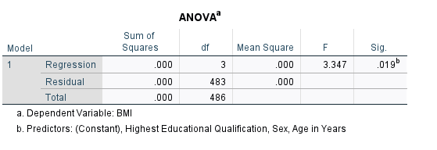

BMI was used as the dependent variable in a multiple regression analysis with sex, age, and level of education as the predictors. F(3, 483) = 3.347, p > 0.001 indicates that BMI is not significantly affected by the three factors under consideration. More importantly, the model accounts for 2.0% of the variation in BMI, as shown by the R 2 value of 0.020.

Further, the impact of each factor on the outcome variable was also evaluated through coefficient analysis (BMI).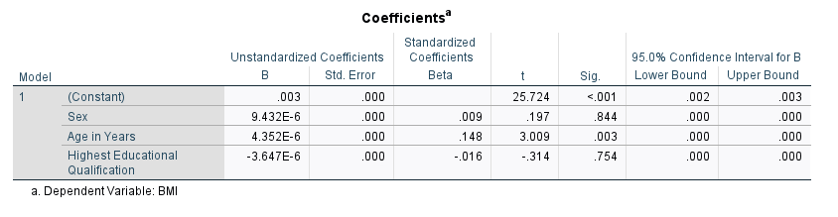

The first hypothesis (H1) examines the possibility that sexual orientation has a positive and significant effect on body mass index. No significant impact on body mass index was found (B = 0.009, t = 0.197, p = 0.844). Therefore, H1 not supported. The second hypothesis (H2) tests whether getting older has a significant impact on body mass index. No statistically significant positive effect was found on body mass index (B = 0.148, t = 3.009, p > 0.003). Therefore, H2 is not supported. The third hypothesis (H3) tests the hypothesis that higher levels of education positively affect body mass index. According to the data, higher education does not significantly lower body mass index (B = -0.016, t = -0.314, p > 0.754). Since this was not the case, H3 not supported. The results showed that age, sex, marital status, and educational qualifications have no significant impact on BMI.

DISCUSSION AND CONLCUSIONS

Pinkland's nutritional status as an adult population is illuminated by the survey results from 2011. Two-fifths of respondents (25.0%) were deemed to be overweight, and nearly one-in-five (18.5%) were deemed to be obese by the survey's criteria. The percentage of overweight men was 24.1%, while the percentage of overweight women was 29.2%, a statistically significant difference. Age, marital status, educational qualifications were all not significantly associated with BMI. These findings highlight the need for further research into the underlying causes of overweight and obesity in Pinkland, and to develop effective interventions to reduce the prevalence of these conditions. Overall, the findings of the 2011 Health Survey of Pinkland suggest that overweight and obesity is an important issue in Pinkland, and that there are significant differences in the prevalence of obesity and overweight between population subgroups. These findings highlight the need for further research into the underlying causes of overweight and obesity in Pinkland, and to investigate how to effectively reduce the prevalence of these conditions.

REFERENCES

Bryman, A. & Cramer, D., 2019. *Quantitative data analysis with SPSS 14, 15 & 16: A guide for social scientists..* s.l.: Routledge/Taylor & Francis Group..

Eriksen, L. et al., 2011. The Danish health examination survey 2007-2008 (DANHES 2007-2008).. *Scandinavian journal of public health,* pp. 203-211..

Gentile, G. et al., 2021. *Health assessment of the pink land iguana, Conolophus marthae. bioRxiv..* s.l.:s.n.

George, D. & Mallery, P., 2018. *Descriptive statistics. In IBM SPSS Statistics 25 Step by Step (pp. 126-134)..* s.l.:Routledge..

Giles, J., 2002. *Sampling: Principles and Applications..* s.l.:John Wiley & Sons..

Johnson, A., Sastry, N. & Smith, P., 2006. *Sampling Methods: Exercises and Solutions..* s.l.: CRC Press..

Kelly, J. & Metcalfe, J., 2012. Validity and Reliability of Body Composition Analysis Using the Tanita BC418-MA.. *Journal of Exercise Physiology Online.*

Lorenzo-Seva, U. & Ferrando, P., 2011. *FIRE: an SPSS program for variable selection in multiple linear regression analysis via the relative importance of predictors..* s.l.:Behavior Research Methods.

Mishra, P. et al., 2019. *Descriptive statistics and normality tests for statistical data..* s.l.: Annals of cardiac anaesthesia.

Morgan, G., Leech, N., Gloeckner, G. & Barrett, K., 2014. *SPSS for introductory statistics: Use and interpretation..* s.l.:Psychology Press..