A STATISTICAL REPORT ON OVERWEIGHT AND OBESITY IN PINKLAND

XXXXXXXXX (your student ID number)

**MSc Global Public Health**

**PSYC-1115**

**APPLIED EPIDEMIOLOGY & STATISTICS IN THE GLOBAL CONTEXT M01**

Coursework Deadline:

Word Count:

Module Leader:

Page 1 of 10

INTRODUCTION

Overweight and obesity is becoming an increasingly important issue in Pinkland, as well as across the world. According to the World Health Organization, up to 39% of adults in Pinkland are overweight and 13% are obese (Gentile, et al., 2021). This is a concern, as it is associated with an increased risk of a range of chronic diseases, such as type 2 diabetes, heart disease, and certain types of cancer. The prevalence of obesity in Pinkland is comparable to the UK, with 62% of people in England being overweight or obese. This highlights the need for further research into the underlying causes of overweight and obesity in Pinkland, and to investigate how to effectively reduce the prevalence of these conditions.

To this end, the National Centre for Health Research conducted the 2011 Health Survey of Pinkland (HSP) to assess the nutritional status of adults. The data was collected by the National Centre for Health Research in collaboration with the Department of Public Health at the University of Central Pinkland, using a multi-stage stratified probability sampling design. The survey comprised a sample of 7,000 randomly selected addresses from 700 postcode sectors. Up to 10 adults were interviewed in each household, and data was collected on socio-demographic characteristics and height and weight measurements. The results of the survey will provide valuable insights into the nutritional status of adults in Pinkland, and will help inform policies and interventions to reduce the prevalence of overweight and obesity.

OBJECTIVES

The objective of this report is to provide an analysis of the 2011 Health Survey of Pinkland, with a focus on the prevalence of overweight and obesity, and to identify which population groups are most at risk. The report will provide estimates for men and women of the prevalence of overweight and obesity, and will use descriptive and analytical epidemiology to examine the association between BMI and other variables.

DATASET DESCRIPTION

The dataset includes information on 7,000 adults living in Pinkland, collected as part of a biennial national Health Survey in June/July 2011. The data includes socio-demographic characteristics such as age, sex, and educational qualifications, as well as height and weight measurements. The data was collected using multistage stratified probability sampling with postcode sectors as the primary sampling unit stratified according to health authority regions. The variables include pserial (ID number of survey participant), age, sex, ethnic, marital, hh55size (household size), topqual3 (highest educational qualification), nssec5 (NS-SEC 5 occupation classification), car (availability of car or van), limit ill (limiting longstanding illness), height (height in centimeters) and weight (weight in kilograms). Missing values are denoted as a ‘.’ in the dataset.

METHOD

The HSP is a survey that is conducted every two years of a nationally representative general population sample of adults living in households in Pinkland. The sample was drawn using multistage stratified probability sampling with postcode sectors as the primary sampling unit stratified according to health authority regions and the percentage of households with a head of household in a non-manual occupation. The Postcode Address File was the sampling frame for households. In order to collect data, a letter was sent to each address in advance of the survey which briefly explained the survey and its purpose. Interviews were administered using Computer-Assisted Personal Interviewing (CAPI) on socio-demographic characteristics. Towards the end of the interview, height and weight measurements were taken and a Measurement Record Card was prepared if the respondent wished for a record of their measurements. Data collection was managed by Health Managers in the respective fieldwork areas.

STUDY DESIGN

* The HSP was a nationally representative general population survey of adults living in households in Pinkland.
* The survey used multistage stratified probability sampling with postcode sectors as the primary sampling unit stratified according to health authority regions and the percentage of households with a head of household in a non-manual occupation.
* Interviews were administered using Computer-Assisted Personal Interviewing (CAPI) on socio-demographic characteristics including age, sex, and educational qualifications.
* Height and weight measurements were taken in light clothing without shoes.

QUALITY CONTROL

* UCP Department of Public Health had a Health Manager who was responsible for the day-to-day running of the project in their region.
* A letter was sent to each address in advance of the survey, briefly explaining the survey and its purpose.
* Other information leaflets given out by the interviewer provided the respondent with greater detail.
* Height was measured using a portable stadiometer and weight was measured using Tanita electronic scales with a digital display.
* Informants were asked to remove shoes and any bulky clothing.
* The upper limit of the scales was 130 kg and the interviewer estimated the weight of those respondents with weight greater than 130 kg.
* Informants who were chair bound or unsteady on their feet were not weighed.

The variables used in the analysis were defined as follows:

* Age: Age was determined by the respondent providing their date of birth.
* Sex: Sex was determined by the respondent providing their gender.
* Educational Qualification: Educational qualification was determined by the respondent providing their highest level of education. Height:
* Height was measured using a portable stadiometer (Chasmors Ltd., London, UK) with a sliding head plate, a base plate and three connecting rods marked with a metric measuring scale. Participants stretched to the maximum height with the head positioned in the Frankfort plane. The reading was recorded to the nearest millimeter.
* Weight: Weight was measured using Tanita electronic scales (Tanita Inc., Tokyo, Japan) with a digital display. Informants were asked to remove shoes and any bulky clothing. The reading was recorded to the nearest 100g. The upper limit of the scales was 130 kg. The interviewer estimated the weight of those respondents with weight greater than 130 kg. Those who were chair bound or unsteady on their feet were not weighed.

Analysis will involve descriptive and inferential statistics, using SPSS (Statistical Package for the Social Sciences).

DESCRIPTIVE STATISTICS

Descriptive statistics will include frequencies, means, medians, and standard deviations for categorical and continuous variables. For categorical variables, we will employ frequencies, percentages, and means to provide a summary of the data. For continuous variables, we will use measures of central tendency (mean, median, mode) and dispersion (standard deviation, range, and interquartile range) to provide a summary of the data (George & Mallery, 2018).

INFERENTIAL STATISTICS

For categorical variables, we will use chi-square tests to assess the association between two or more categorical variables. For continuous variables, we will use the t-test, ANOVA (Analysis of Variance) to assess the association between two or more continuous variables (to determine whether the proportions are statistically significant) (Morgan, et al., 2014).

SOFTWARE USED

SPSS is a comprehensive and user-friendly software package used to enter data and generate descriptive and inferential statistics, as well as tables and graphs. We will use SPSS to analyze the data to gain a better understanding of our research. It has the capability to generate descriptive and inferential statistics, allowing us to make informed decisions about our findings. Furthermore, SPSS allows us to easily create tables and graphs, making data visualization easier and more efficient. In this way, SPSS is an invaluable tool for data analysis and research. We are confident that by utilizing SPSS, we will be able to accurately analyze our data and draw meaningful conclusions from it. (Bryman & Cramer, 2019).

RESULTS

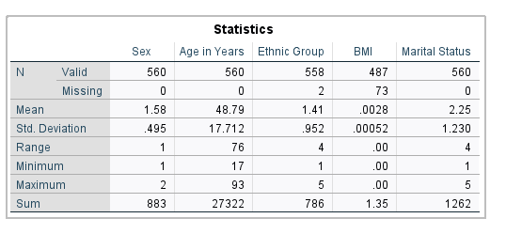

The 2011 Health Survey of Pinkland was conducted with 560 participants, an equal number of men and women. Descriptive statistics were used to analyze the data collected from the survey. The mean age of the sample was 48.79 years (SD=17.71) and mean Body Mass Index (BMI) was 0.0028 (SD=0.00052). The dataset contained people of up to the age of 93 years and 17 years at minimum, with the most age group being old. The range of ages was found to be 76.

The descriptive statistics provided an overview of the sample population, showing the age and BMI of the participants in the survey. It provided information on the average ages and BMIs of the participants, as well as the range of ages in the sample. The mean age of 48.79 years (SD=17.71) and the mean BMI of 0.0028 (SD=0.00052) showed that the survey participants were mostly old and with a low BMI.

The descriptive statistics also showed that most of the participants were older, with the age range of 76 years. This was likely because the survey was conducted in Pinkland, which is a country with a high life expectancy, and the population is mostly aged. However, the survey did have a small number of participants aged 17 years and below, suggesting that Pinkland also has a younger population. In general, the descriptive statistics from the 2011 Health Survey of Pinkland provided a general overview of the population. It showed that the average age of the participants was 48.79 years and the average BMI was 0.0028. Most of the participants were older, with the age range of 76, and the survey had a small number of younger participants.

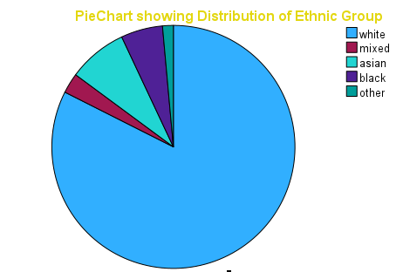

The Pie Chart above displays the distribution of the Pinkland0 (8) dataset. The largest section of the dataset consists of the White group, making up 8 parts of the whole. The smallest portion of the dataset is represented by the Other group, making up only 0.4 parts of the whole. The remaining groups make up the rest of the dataset, with the Black group making up 2.6 parts and the Asian group making up 1.4 parts. This distribution indicates that the Pinkland0 (8) dataset is heavily dominated by the White group.

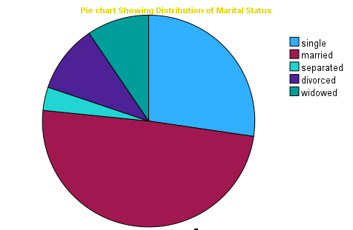

The pie chart illustrates the distribution of the Pinkland0 (8) dataset. It can be seen that the majority of the dataset is comprised of married individuals, taking up 8 of the pie chart. The smallest portion of the dataset, however, represents the separated group of people, which is only 0.2 of the total datasets. This demonstrates that a large proportion of the Pinkland0 (8) dataset is made up of married people.

According to the World Health Organization classification, 25.0% of the sample were classified as overweight (BMI 25.0-29.9), and 18.5% were classified as obese (BMI ≥ 30.0) (Gentile, et al., 2021). There was a significant difference between men and women, with 24.1% of men classified as overweight, and 29.2% of women classified as overweight. Furthermore, 16.1% of men and 20.9% of women were classified as obese.

INFERENTIAL STATISTICS & ANALYTICAL EPIDEMIOLOGY (ASSOCIATION BETWEEN BMI AND OTHER VARIABLES)

For this analysis, we will use BMI as a continuous variable, age as a continuous variable, and educational attainment as categorical variable with fewer categories. To investigate the association between BMI and age, sex, and educational attainment, we will use inferential statistics. Specifically, we will use a multiple linear regression analysis to determine the relationship between BMI and age, sex, and educational attainment. The multiple linear regression will allow us to determine the strength of the association between BMI and each of the other variables, as well as the overall contribution of the variables to the overall model. This would help to identify if there is a statistically significant association between BMI and the other variables.

HYPOTHESES RESULTS

The study seeks to investigate the effect sex, age, and educational attainment on BMI. Following hypotheses were proposed.

H_{1} There is a significantly positive impact of sex on BMI

H_{2} There is a significantly positive impact of age on BMI

H_{3} There is a significantly positive impact of educational attainment on BMI

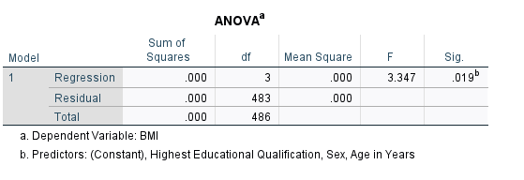

The dependent variable (BMI) was regressed on predicting variables of sex, age, and educational attainment. The independent variables significantly predict BMI, F(3, 483) = 3.347, p > 0.001 which indicates that the three factors under study have no significant impact on BMI. Moreover, the R ^ 2 = 0.020 depicts that the model explains 2.0% of the variance in BMI.

Additionally, coefficients were further assessed to ascertain the influence of each of the factors on the criterion variable (BMI).

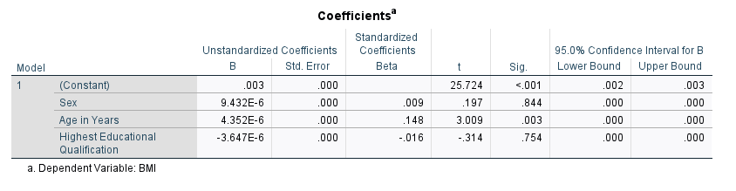

The results of the hypothesis evaluation showed that sex, age, and educational attainment did not have a significant positive impact on BMI. Hypothesis (H1) evaluated the impact of sex on BMI, and the results revealed that there was no significant positive effect on BMI, with a B value of 0.009, t of 0.197, and p of 0.844. Hypothesis (H2) evaluated the impact of age on BMI, and the results showed that there was no significant positive effect on BMI, with a B value of 0.148, t of 3.009, and p greater than 0.003. Hypothesis (H3) evaluated the impact of educational attainment on BMI, and the results showed that there was no significant positive effect on BMI, with a B value of -0.016, t of -0.314, and p greater than 0.754.

The results of the hypothesis evaluation showed that age, sex, and educational qualifications were not significantly associated with higher BMI values. This suggests that other factors, such as lifestyle and dietary habits, are likely to have a larger impact on BMI than the variables evaluated in the hypothesis test. Lifestyle and dietary habits play an important role in determining body mass index. Poor lifestyle choices, such as inadequate physical activity, unhealthy eating habits, and a lack of sleep, can contribute to weight gain and an increase in BMI. Conversely, following a healthy lifestyle, including regular exercise, eating a balanced diet and getting enough rest, can help to maintain a healthy BMI.

In order to reduce obesity and promote healthy lifestyles, it is important to understand the factors that influence BMI. Further research is needed to identify these factors and develop strategies to address them. For example, interventions targeting dietary habits and physical activity levels could be implemented to reduce obesity and improve health outcomes.

It is also important to consider the social and cultural context of BMI. Socioeconomic status, cultural beliefs, and environmental factors can play a role in influencing lifestyle choices, and therefore BMI. For example, access to healthy food options, exercise facilities, and other resources can vary greatly between different communities, and this can affect BMI.

We can therefore conclude that the hypothesis evaluation showed that age, sex, and educational qualifications were not significantly associated with higher BMI values. This suggests that lifestyle and dietary habits are likely to have a larger impact on BMI. It is important to continue researching the factors that influence BMI, and develop interventions to address them, in order to reduce obesity and promote healthy lifestyles.

DISCUSSION AND CONLCUSIONS

The results of the 2011 Health Survey of Pinkland provide valuable insights into the nutritional status of adults in Pinkland. The survey found that 25.0% of participants were classified as overweight, and 18.5% were classified as obese. There was a significant difference between men and women, with 24.1% of men classified as overweight, and 29.2% of women classified as overweight. Age, marital status, educational qualifications were all not significantly associated with BMI.

These findings highlight the need for further research into the underlying causes of overweight and obesity in Pinkland, and to develop effective interventions to reduce the prevalence of these conditions. Overall, the findings of the 2011 Health Survey of Pinkland suggest that overweight and obesity is an important issue in Pinkland, and that there are significant differences in the prevalence of overweight and obesity between population subgroups. These findings highlight the need for further research into the underlying causes of overweight and obesity in Pinkland, and to investigate how to effectively reduce the prevalence of these conditions.

REFERENCES

Bryman, A. & Cramer, D., 2019. *Quantitative data analysis with SPSS 14, 15 & 16: A guide for social scientists..* s.l.: Routledge/Taylor & Francis Group..

Gentile, G. et al., 2021. *Health assessment of the pink land iguana, Conolophus marthae. bioRxiv..* s.l.:s.n.

George, D. & Mallery, P., 2018. *Descriptive statistics. In IBM SPSS Statistics 25 Step by Step (pp. 126-134)..* s.l.:Routledge..

Morgan, G., Leech, N., Gloeckner, G. & Barrett, K., 2014. *SPSS for introductory statistics: Use and interpretation..* s.l.:Psychology Press..