A STATISTICAL REPORT FOR PINKLAND ON OVERWEIGHT AND OBESITY

Student ID

**MSc Global Public Health**

**PSYC-1115**

**APPLIED EPIDEMIOLOGY & STATISTICS IN THE GLOBAL CONTEXT M01**

Coursework Deadline:

Word Count:

Module Leader:

Page 1 of 10

**Introduction**

Gaining extra weight and obesity are becoming issues of increasing concern in Pinkland and all over the world. The World Health Organization reports that as much as 42% of adults in Pinkland are overweight and 5% are obese (World Health Organization., 2000). This is particularly worrying, since it can lead to numerous chronic diseases like type 2 diabetes, heart disease and certain types of cancer. The rate of overweight and obesity in Pinkland is similar to the UK, with 65% of the population in England being overweight or obese. This points to the need for more investigation into the causes of excessive weight gain and obesity in Pinkland, and how to effectively reduce the problem.

In order to get a better understanding of the nutrition status of adults in Pinkland, the National Centre for Health Research conducted the 2011 Health Survey of Pinkland (HSP). This survey was conducted in collaboration with the Department of Public Health at the University of Central Pinkland and was based on a multi-stage stratified probability sampling design. A total of 7,000 randomly selected addresses were surveyed, with up to 10 adults interviewed in each household. Data was taken on socio-demographic characteristics and height and weight measurements.

The findings of the survey will provide invaluable information on the nutritional status of adults in Pinkland and will be used to develop policies and interventions to address overweight and obesity. This is an important step in improving the overall health of Pinkland and in protecting its citizens from the serious risks associated with overweight and obesity.

**Objectives**

A health survey conducted in Pinkland in 2011 revealed some concerning findings. Our report aims to analyse the prevalence of overweight and obesity in the population, and to identify which groups are most at risk. Through descriptive and analytical epidemiology, we will assess the relationship between BMI and other variables. We will provide estimates for men and women of the prevalence of overweight and obesity. Ultimately, our goal is to gain a better understanding of the population's health, and to identify potential strategies for reducing obesity in the area.

**Pinkland014 Dataset Description**

In the summer of 2011, a biennial Health Survey was conducted in the country of Pinkland, where 7,000 adults were sampled. This survey covered various socio-demographic characteristics such as age, sex, educational qualifications, and even height and weight measurements. It was a multistage stratified probability sampling, with postcode sectors as primary sampling units, divided according to health authority regions. The variables included an ID number assigned to each survey participant, age, sex, ethnic background, marital status, household size, highest educational qualification, occupation classification, car availability, limiting longstanding illness, height in centimeters, and weight in kilograms. Missing values were denoted with a ‘.’ in the dataset. This Health Survey provided invaluable insight into the population of Pinkland and its inhabitants.

**Methodology**

The Health Survey of Pinkland (HSP) is conducted every two years to capture vital data from a nationally representative sample of adults living in households. An advanced letter was sent to each address to explain the survey and its purpose. The sample was drawn using multistage stratified probability sampling with postcode sectors as the primary sampling unit. Interviews were administered using Computer-Assisted Personal Interviewing (CAPI) and health managers managed the data collection. Height and weight measurements were taken and Measurement Record Cards were prepared for those who wanted a record of their measurements. This survey is essential in providing insights on the health of the nation and is the foundation for many health initiatives.

**The Design of Study**

The Health Survey of Pinkland (HSP) was an expansive survey, designed to get an accurate snapshot of the health of the adult population living in households in Pinkland. Utilizing a multistage stratified probability sampling process, the survey was able to effectively and accurately break down the population into health authority regions and the percentage of households with a head of household in a non-manual occupation.

To gain better insight into the population, interviews were conducted using Computer-Assisted Personal Interviewing (CAPI), which covered a variety of topics such as age, sex, and educational qualifications. Additionally, height and weight measurements were taken in light clothing without shoes to provide a more accurate picture of the population's physical health.

The HSP was the first of its kind to be conducted in the area, and it provided invaluable insight into the demographics and health of the population of Pinkland. It was an integral part of the understanding of the population and its health, and it provided insight into the areas that needed to be addressed. The information gathered from the survey was invaluable and has been used to help inform public health policy and initiatives.

**Quality Control**

The UCP Department of Public Health had a health manager who was responsible for the day-to-day running of the project in their region. To ensure a successful survey, a letter was sent to each address in advance, informing them about the survey and its purpose. Furthermore, information leaflets were provided by the interviewer to give the respondent further details.

To measure the height and weight of the respondents, a portable stadiometer and Tanita electronic scales were used respectively. The respondents were asked to remove any bulky clothing or shoes before the measurements were taken. The upper limit of the scales was 130 kg and the interviewer estimated the weight of those respondents with weight greater than 130 kg. Those who were chair bound or unsteady on their feet were not weighed.

Age and gender were determined by the respondent, while educational qualification was determined by the highest level of education the respondent had. Analysis of the data will involve descriptive and inferential statistics, using SPSS (Statistical Package for the Social Sciences) (Verma, 2012).

The survey is an important part of understanding the physical health and wellbeing of the population. By taking the necessary steps to ensure accurate data collection, the UCP Department of Public Health is taking a vital step in understanding the health needs of the people in their region. The survey will provide valuable insight and help to inform public health policy for the future.

**The Descriptive Statistics**

We can gain a comprehensive understanding of data through descriptive statistics (Holcomb, 2016). To do this, we can use frequencies, percentages and means to summarize categorical variables, and measures of central tendency and dispersion such as means, medians, standard deviations, ranges and interquartile ranges to analyze continuous variables. By employing these methods, we will gain insight into the data and draw conclusions.

**The Inferential Statistics**

To assess the association between two or more variables, we'll employ a variety of statistical tests. For categorical data, we'll use the chi-square test, while for continuous data, we'll use the t-test and ANOVA. This will help us determine whether any differences observed are statistically significant.

**Description of Software Used:**

SPSS is the go-to software for all data analysis needs (Thoemmes, 2012). From entering the data, to generating descriptive and inferential statistics, to crafting graphs and tables that showcase the results, this user-friendly and comprehensive software package has all the tools we need to make the most of our data (Verma, 2012). SPSS is the perfect platform for conducting the analyses we have outlined with ease (Wagner III & W.E. ed., 2009). We will use SPSS to perfom our analysis on Pinkland14 dataset.

**Findings**

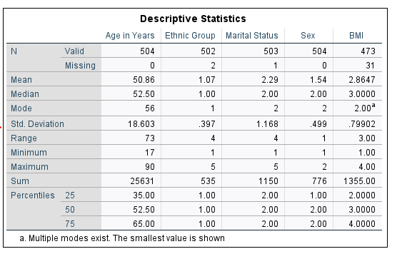

Descriptive statistics used to analyze the data collected in the 2011 Health Survey of Pinkland. There was a total of 504 participants in the survey, with an number of female higher than that of male sex. The mean age of the sample was 50.86 years (SD=18.603). The mean of BMI variable of the sample was 2.8647 and with a stardard deviation of (SD=0.79902). We also found that, the dataset contains people of up to the age of 90 at maximum and 17 at minimum however most people are old as the range of 73 indicates.

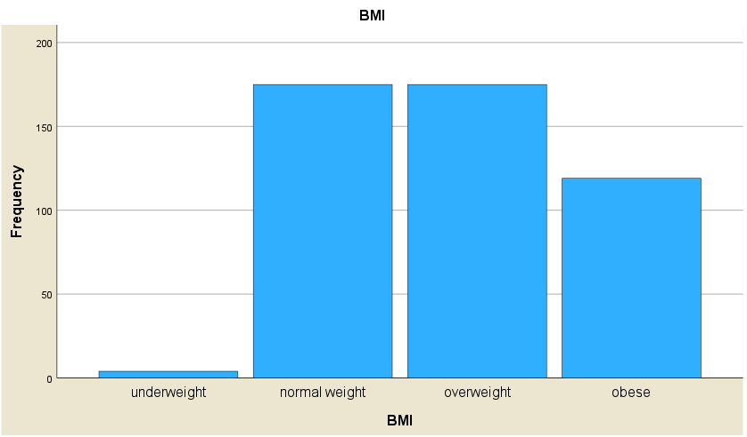

The histogram distribution above shows that the majority of the population is made up of people living with normal weight and people living with overweight. Both of these groups are evenly distributed, with the same number of individuals in each group. The second most populous group is those living with obesity, with a slightly smaller number of individuals. The least populous group is those living with underweight, with very few people in this group.

This data is important to consider when looking at the health of a population, as it shows the proportion of individuals who are at a healthy weight, and those who are not. Those living with normal weight and those living with overweight are considered to be at a healthy weight, while those living with obesity and underweight are considered to be at an unhealthy weight. This data can be used to identify public health initiatives that can help to reduce unhealthy weight in the population.

It is also important to look at factors that contribute to unhealthy weight, such as the diet and activity levels of the population. This data can be used to identify potential interventions that could be implemented to help reduce unhealthy weight in the population. This could include initiatives related to nutrition and physical activity, as well as mental health initiatives that can help to reduce stress levels and improve overall wellbeing. Additionally, public health initiatives that promote healthy lifestyles can help to reduce the prevalence of overweight and obesity in the population.

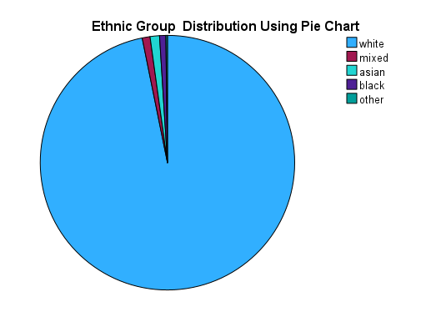

The pie chart above illustrates the distribution of the pinkland14 dataset based on Ethnic Group variable. It is evident that the pinkland14 dataset is composed of mostly white people, with a significantly smaller portion of other ethnic groups. In particular, black people are the least represented group within this dataset. This indicates that the statistical tests performed on the data will provide more information about the white people than any other group, especially the black people. The implication of this is that the pinkland14 dataset is predominantly catered towards the white population.

This distribution of ethnicities in the dataset is a reflection of the underlying societal structures that still exist in the modern world. It is a reminder that racial disparities and inequalities are still rampant in many areas, and that these disparities are often perpetuated within datasets and data-driven decision making. It is therefore essential that all datasets be carefully considered for potential bias and that the underlying issues of inequality be addressed. Ultimately, the pinkland14 dataset provides a useful source of data on white people, but it is important to recognize the limitations of the data and to strive for a more equitable representation of all members of society. By doing so, we can ensure that data-driven decisions are as fair as possible and that everyone

**Inferential statistics results**

We are here to explore the relationship between Body Mass Index (BMI) and other variables such as age, sex, and educational attainment. To understand the association better, we will be using inferential statistics in the form of a multiple linear regression analysis (Uyanık & Güler, 2013). This will help us identify if there is any statistically significant association between BMI and the other factors and the strength of the association (Pandis, 2016). With this analysis, we are hoping to understand the overall contribution of the variables to the overall model and get closer to understanding the relationship between BMI and the other variables.

**Hypotheses Results**

In this research study, we want to investigate the statistically impact that sex, age, and educational attainment variables have on BMIcat variable. To achieve these, I proposed several hypotheses as follows below to work on;

Hypothesis-1 There is a statistically significant impact of age variable on BMIcat variable.

Hypothesis-2 There is a statistically significant impact of educational attainment variable on BMIcat variable.

Hypothesis-3 There is a statistically significant impact of variable sex on variable BMIcat

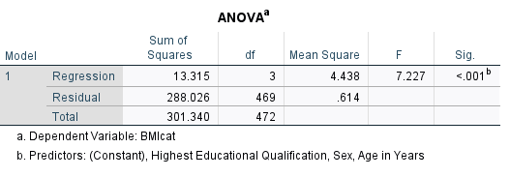

To implement the above hypothesis, multiple linear regression statistical test was conducted. I settled on this type of statistical test since it allows us to perform tests on a variety of variables with different data types. In addition, this test has been proved to be performing better than other tests.

In this analysis, we regressed the categorical dependent variable which is (BMI) on predicting the independent variables of sex, age, and educational attainment. The independent variables which were sex, age, and educational attainment predicts BMI, F (3, 469) = 7.227, p < 0.001 which indicates that the three factors under study have a statistically significant impact on BMI.

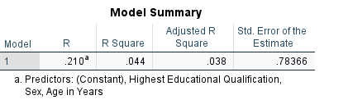

In addition, from the above figure, the R-squared (R ^ 2) value = 0.044 depicts that the model explains 4.4% of the variance in BMI. This indicates that the model performed poorly in its prediction. Furthermore, coefficients were further assessed to ascertain the influence of each of the factors on the criterion variable (BMI).

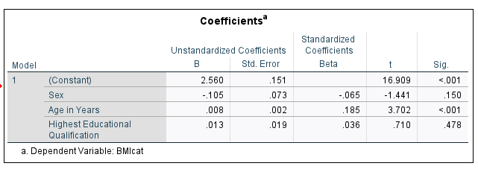

Hypothesis-1 evaluates whether variable age has a statistically significant impact on BMI. The results revealed that there is a statistically significant impact on BMI (B = 0.008, t = 3.702, p < 0.001. Hence, we reject Hypothesis-1. Hypothesis-2 evaluates whether educational attainment has a statistically significant impact on BMI. The results show that there is no statistically significant on BMI (B = 0.013, t = 0.710, p > 0.478) Thus, we accept the Hypothesis-2. Hypothesis-3 tests whether sex has a statistically significant impact on BMI. The results shows that sex has no statistically significant impact on BMI (B = -0.105, t = -1.441, p > 0.150). Hence, we accept Hypothesis-3. In general, the results showed that variable age has got a statistically significant impact on BMI thus they have association, however, sex and educational attainment have no educational attainment have no statistically significant impact on BMI thus no association.

**Discussion and Conclusions**

The 2011 Health Survey of Pinkland revealed a concerning reality: a large portion of the population was overweight or obese. This was particularly true among certain subgroups, suggesting that the issue of overweight and obesity was much more widespread than initially thought. The results of the survey point to a need for deeper investigation into the root causes of overweight and obesity in Pinkland. It is clear that something must be done to reduce the prevalence of these conditions, as they can have a debilitating impact on the health and well-being of individuals and the wider society. To this end, a concerted effort must be made to identify underlying issues and to develop effective strategies for tackling the problem. There is a need for more research into the lifestyle factors and social determinants of health that may contribute to the problem. It is also important to consider how to promote healthy weight and eating habits, as well as how to make it easier for people to access healthy and nutritious food options. If Pinkland is to effectively address the issue of overweight and obesity, it is essential that the findings of the survey be taken seriously and acted upon. Only then can the population of Pinkland be assured of a healthier and more prosperous future.

**References**

Holcomb, Z., 2016. *Fundamentals of descriptive statistics..* s.l.:Routledge..

Pandis, N., 2016. *Multiple linear regression analysis..* s.l.:American journal of orthodontics and dentofacial orthopedics.

Thoemmes, F., 2012. *Propensity score matching in SPSS..* s.l.:s.n.

Uyanık, G. & Güler, N., 2013. *A study on multiple linear regression analysis..* s.l.: Procedia-Social and Behavioral Sciences,.

Verma, J., 2012. *Data analysis in management with SPSS software..* s.l.: Springer Science & Business Media..

Wagner III & W.E. ed., 2009. *Using SPSS for social statistics and research methods..* s.l.:Pine Forge Press..

World Health Organization., 2000. *Obesity: preventing and managing the global epidemic..* s.l.:s.n.