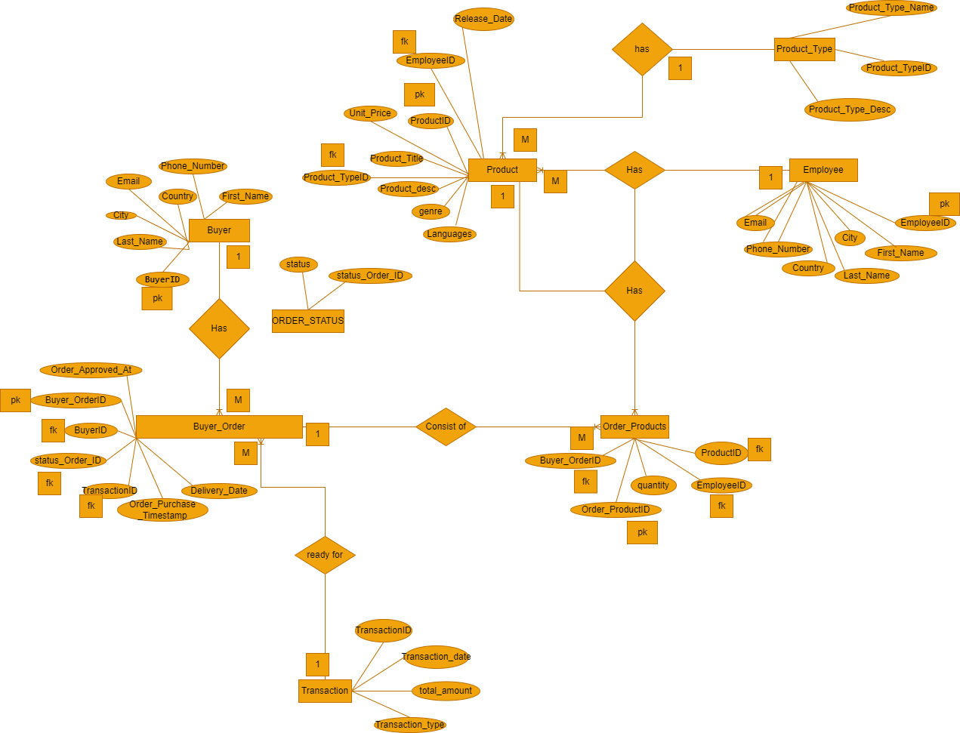

Figure 1 Entity Relationship diagram and Cardinality

Above is the ER diagram presented for my online e-shop. I was able to develop the SQL scripts to perform the creation of the online e-shop database, its relations and their relationships and later perform insertion of data of at least 5 rows in each relation to provided correct queries as per the questions.

The following are the SQL statements for the following queries:

# SQL Queries

**4. Provide SQL statements for the following queries:**

**a. Extract all the customers from a specific city.**

SELECT * from Buyer as c

WHERE

c.city = "Washington";

**b. Search for a product of a specific genre**

SELECT * from Product as p

WHERE

p.genre = 'genre-b';

**c. Count how many customers are from a specific city.**

SELECT COUNT(BuyerID)

FROM Buyer

WHERE

city = "Washington";

**d. Calculate the average of the unit price.**

SELECT AVG(Unit_Price)

FROM Product;

**e. Extract all current orders**

SELECT *

FROM

Buyer_Order WHERE

Order_Purchase_Timestamp = "2022-1-12"

;

**f. Extract all orders for books that has the keyword “the” in their description**

SELECT *

FROM Order_Products as op

INNER JOIN Product ON op.ProductID=Product.ProductID

WHERE

Product.Product_desc LIKE '%the%';

**g. Extract all Transactions with credit cards for music records.**

SELECT *

FROM Order_Products as op

INNER JOIN Product ON op.ProductID=Product.ProductID

INNER JOIN Product_Type ON Product.Product_TypeID=Product_Type.Product_TypeID

INNER JOIN Buyer_Order ON op.Buyer_OrderID=Buyer_Order.Buyer_OrderID

INNER JOIN Transaction ON Buyer_Order.TransactionID=Transaction.TransactionID

WHERE

Product_Type.Product_Type_Name = "music records" AND

Transaction.Transaction_type = "Credit card"

;

**h. Count how many employees handle music records.**

SELECT COUNT(Employee.EmployeeID)

FROM Product

INNER JOIN Employee ON Product.EmployeeID=Employee.EmployeeID

INNER JOIN Product_Type ON Product.Product_TypeID=Product_Type.Product_TypeID

WHERE

Product_Type.Product_Type_Name = "music records";

**i. Count how many employees first name is John.**

SELECT COUNT(EmployeeID)

FROM Employee

WHERE

Employee.First_Name = "John";

**j. Count how many orders are in the system.**

SELECT *

FROM

Buyer_Order;

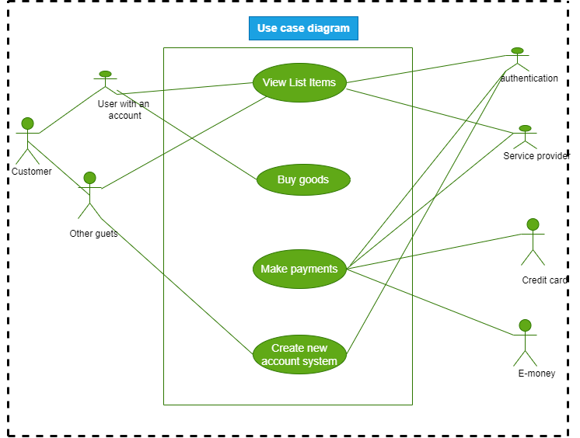

Figure 2 Use case diagram

# Data governance plan from the above Use case

1. The system buyer makes payments under one condition in the e-shop; if the buyer has a registered active account in the system. If the buyer is a guest user, he/she is only allowed to browse the products in the system.
2. The buyer payment is said to be successful( complete state) or incomplete. The transaction has to be either complete or incomplete