**HW3**

The data below represents the fields of specialization for a randomly selected sample of undergraduate students. We want to determine whether there is any dependency between the fields of specialization and the regions of the country.

|  |  |  |  |  |  |
| --- | --- | --- | --- | --- | --- |
|  | **Northeast** | **Midwest** | **South** | **West** | **Total** |
| Business | 54 | 65 | 28 | 93 | 240 |
| Engineering | 15 | 24 | 8 | 33 | 80 |
| Liberal Arts | 65 | 84 | 33 | 98 | 280 |
| Fine Arts | 13 | 15 | 7 | 25 | 60 |
| Health Sciences | 3 | 12 | 4 | 21 | 40 |
|  | **150** | **200** | **80** | **270** | **700** |

1. State the null and alternative hypotheses to be tested.

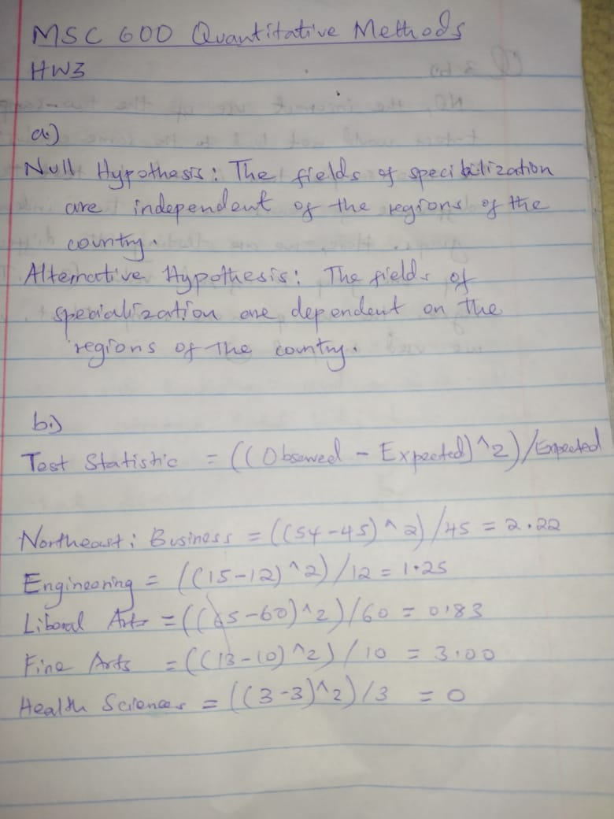

1. Compute the test statistic.



1. The null hypothesis is to be tested at the .05 level of significance. Determine the critical value for this test. What do you conclude?

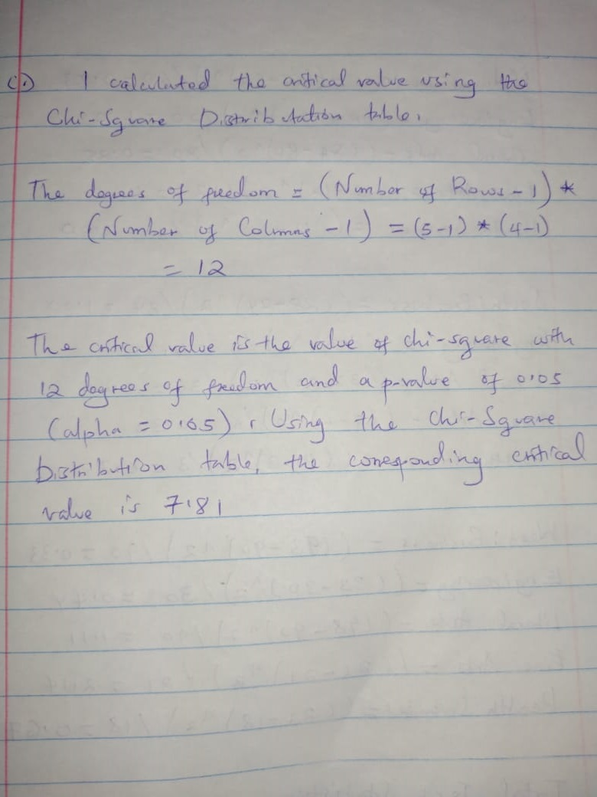

1. Determine the *p*-value

