**BSAN53800 Visualizing Information - Assignment 5 (6 points)**

After reviewing Week5 lectures, please complete the following steps.

* Download a dataset from any public data sources (e.g., data.gov, data.worldbank.com).
  + You can reuse the dataset from the previous assignments.
* Visualize the multiple variables (3 or more variables) using Tableau.
* Visualize the distribution of one or two variables.
* Optimize the charts based on the principles of good statistical graphics from E.R . Tufte, and describe how you optimized (to optimize) the charts.
* Using the Story function in Tableau, briefly explain any insights you found from the datasets.
* Submit the results in the MS word format.

# SOLUTIONS

Link to the downloaded dataset (loan dataset) -https://www.kaggle.com/datasets/zhijinzhai/loandata

**LOAN DATASET**

**TWO VARIABLES ( EDUCATION VS PAST DUE DAYS)**

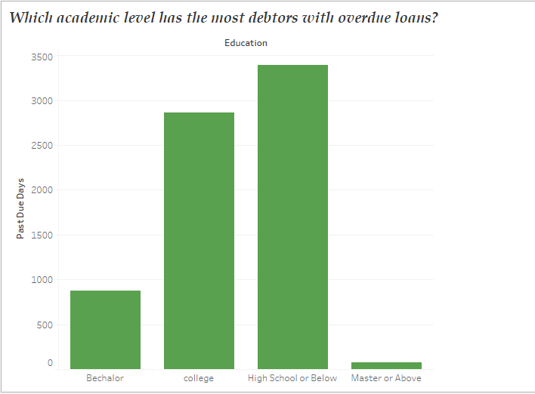

The loan borrowers are shown in the following bar graph based on their educational attainment. Those in high school education or less clearly take the longest to repay their loans. This is because the due date for the loan has passed and the number of overdue days is significant. However, borrowers with a master's degree or higher tend to repay their loans promptly. If there is a delay, it will only be for a few days at most. This suggests that those with higher levels of education are more likely to be gainfully employed, and hence more likely to be able to make timely payments on their obligations.

**MULTIPLE VARIABLES ( GENDER VS PRINCIPAL VS LOAN STATUS)**

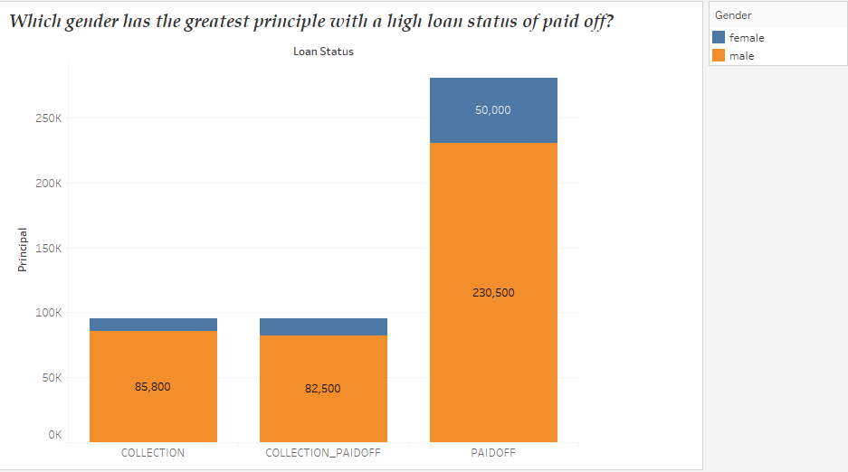

Debtors' sex, loan amount, and repayment status are displayed in a vertical bar chart up top. As can be seen from the graphs, men are more likely to borrow large sums of money. Similarly, once the due date has passed, debtors who are male are more likely to be coaxed into paying late fees and interest. Women, on the other hand, borrow less money and are more likely to pay back their loans on time. We put less effort into promoting the feminine gender under the guise of monetary gain.