**Database Design**

**Scope of the project**

The scope of the project is to design and implement a database management system for a public library. The system will manage library resources, including books, magazines, digital media, and other materials, and provide efficient access to member information and facilitate borrowing and tracking of library materials.

The entities and their relationships are:

Material: A library item available for borrowing, such as books, magazines, e-books, and audiobooks.

Catalog: A record of library materials with information on their availability and location.

Genre: A category or type of library materials.

Borrow: The borrowing activity of library materials by members.

Author: An individual who has created library materials.

Authorship: The relationship between authors and the materials they have created.

Member: A person who is a member of the library and can borrow and reserve materials.

Staff: A staff member who manages library resources and assists members.

**Entity-Relationship (ER) diagram:**

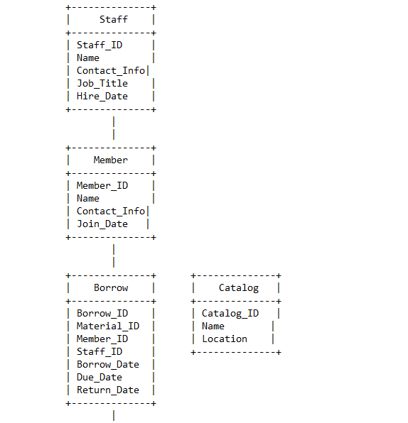

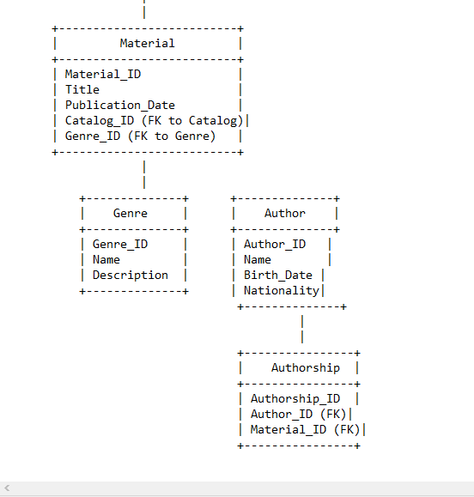

**Database normalization**

Database normalization is the process of organizing the attributes and tables in a database to minimize redundancy and ensure data integrity. Normalization ensures that the database is free from inconsistencies, update anomalies, and data redundancy, which can affect database performance and accuracy.

The database schema presented in the ER diagram is already normalized. The entities and their relationships are in a third normal form (3NF), which means that each attribute is dependent only on the primary key and there are no transitive dependencies. Therefore, further normalization is not required.

**DDL COMMANDS**

CREATE TABLE Authors (

Author_ID INT PRIMARY KEY,

First_Name VARCHAR(50),

Last_Name VARCHAR(50)

);

CREATE TABLE Authorship (

Material_ID INT,

Author_ID INT,

CONSTRAINT pk_authorship PRIMARY KEY (Material_ID, Author_ID),

CONSTRAINT fk_authorship_material FOREIGN KEY (Material_ID)

REFERENCES Material(Material_ID)

ON DELETE CASCADE,

CONSTRAINT fk_authorship_author FOREIGN KEY (Author_ID)

REFERENCES Authors(Author_ID)

ON DELETE CASCADE

);

CREATE TABLE Material (

Material_ID INT PRIMARY KEY,

Title VARCHAR(255),

Publication_Date DATE,

Catalog_ID INT,

Genre_ID INT,

CONSTRAINT fk_material_catalog FOREIGN KEY (Catalog_ID)

REFERENCES Catalog(Catalog_ID),

CONSTRAINT fk_material_genre FOREIGN KEY (Genre_ID)

REFERENCES Genre(Genre_ID)

);

CREATE TABLE Catalog (

Catalog_ID INT PRIMARY KEY,

Name VARCHAR(50),

Location VARCHAR(50)

);

CREATE TABLE Genre (

Genre_ID INT PRIMARY KEY,

Name VARCHAR(50),

Description VARCHAR(255)

);

CREATE TABLE Borrow (

Borrow_ID INT PRIMARY KEY,

Material_ID INT,

Member_ID INT,

Staff_ID INT,

Borrow_Date DATE,

Due_Date DATE,

Return_Date DATE,

CONSTRAINT fk_borrow_material FOREIGN KEY (Material_ID)

REFERENCES Material(Material_ID)

ON DELETE CASCADE,

CONSTRAINT fk_borrow_member FOREIGN KEY (Member_ID)

REFERENCES Member(Member_ID)

ON DELETE CASCADE,

CONSTRAINT fk_borrow_staff FOREIGN KEY (Staff_ID)

REFERENCES Staff(Staff_ID)

ON DELETE CASCADE

);

**QUERIES**

Which materials are currently available in the library?

SELECT *

FROM material

WHERE available_count > 0;

Which materials are currently overdue? Suppose today is 04/01/2023, and show the borrow date and due date of each material?

SELECT material.material_id, material.title, borrow.borrow_date, borrow.due_date

FROM material

JOIN borrow ON material.material_id = borrow.material_id

WHERE borrow.return_date IS NULL AND borrow.due_date < '2023-04-01';

What are the top 10 most borrowed materials in the library? Show the title of each material and order them based on their available counts?

SELECT material.title, COUNT(borrow.borrow_id) AS borrow_count, material.available_count

FROM material

JOIN borrow ON material.material_id = borrow.material_id

GROUP BY material.material_id

ORDER BY borrow_count DESC, material.available_count DESC

LIMIT 10;

How many books has the author Lucas Piki written?

SELECT COUNT(*)

FROM material

JOIN book_author ON material.material_id = book_author.book_id

JOIN author ON book_author.author_id = author.author_id

WHERE author.name = 'Lucas Piki' AND material.type = 'book';

How many books were written by two or more authors?

SELECT COUNT(DISTINCT book_id)

FROM book_author

GROUP BY book_id

HAVING COUNT(author_id) >= 2;

What are the most popular genres in the library?

SELECT genre, COUNT(material_id) AS material_count

FROM material_genre

GROUP BY genre

ORDER BY material_count DESC;

How many materials have been borrowed from 09/2020-10/2020?

SELECT COUNT(*)

FROM borrow

WHERE borrow_date >= '2020-09-01' AND borrow_date < '2020-11-01';

How do you update the “Harry Potter and the Philosopher's Stone” when it is returned on 04/01/2023?

UPDATE borrow

SET return_date = '2023-04-01'

WHERE material_id = (SELECT material_id FROM material WHERE title = 'Harry Potter and the Philosopher\'s Stone')

AND return_date IS NULL;

How do you delete the member Emily Miller and all her related records from the database?

DELETE FROM member WHERE name = 'Emily Miller';

DELETE FROM borrow WHERE member_id NOT IN (SELECT member_id FROM member);

How do you add the following material to the database?

INSERT INTO material (title, type, total_count, available_count, publish_year)

VALUES ('The Catcher in the Rye', 'book', 5, 5, 1951);

INSERT INTO book (material_id, ISBN, edition)

VALUES (LAST_INSERT_ID(), '9780316769174', 'First Edition');

INSERT INTO book_author (book_id, author_id)

VALUES (LAST_INSERT_ID(), (SELECT author_id FROM author WHERE name = 'J.D. Salinger'));

INSERT INTO material_genre (material_id, genre)

VALUES (LAST_INSERT_ID(), 'Fiction');