Student Name: Alluri Harika

Student ID:

Assignment:-3 1.

1. **Website Link with Privacy Notice**

<https://harika243.wixsite.com/harika/faq>

1. **Twitter Developer Account**

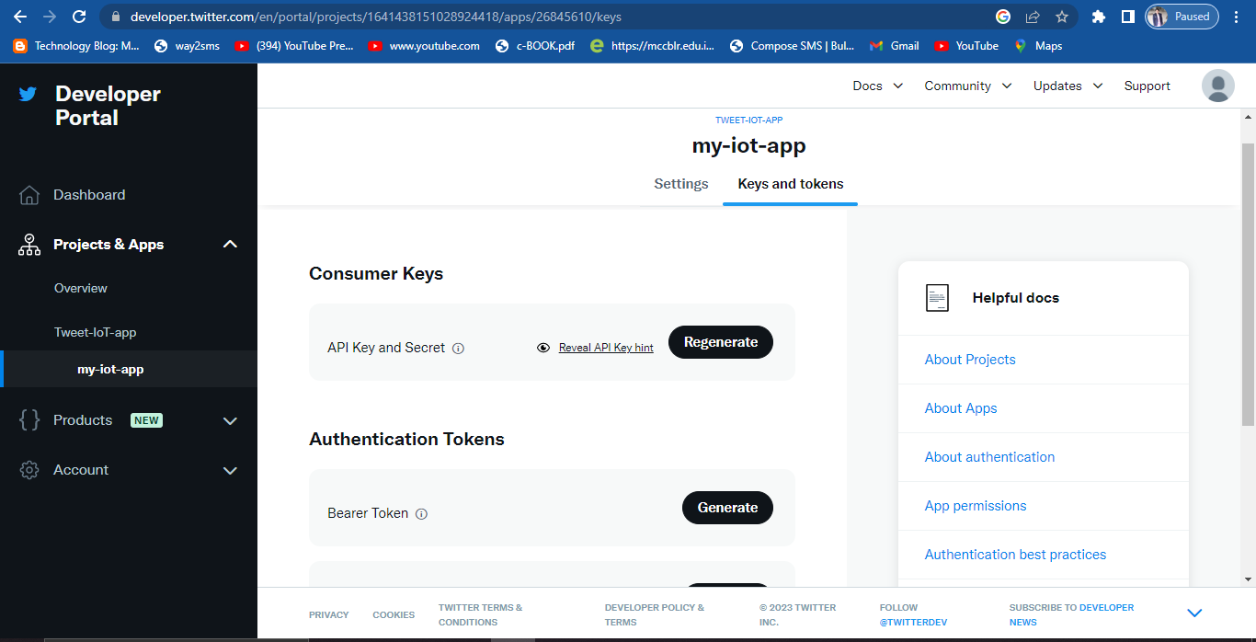

All the necessary keys including API key, API key secret, Bearer token, Access token, Access token secret keys have been saved.

1. **Topics for Paper/Project:-**

Role of Internet of Things(IoT) in Healthcare

1. **4. Complete the following 4 questions:-**
2. Could you complete the assignment? Yes
3. Did you have questions on the assignment? No
4. Did you contact the instructor? No
5. Did you get a response from the instructor in a reasonable time? N/A