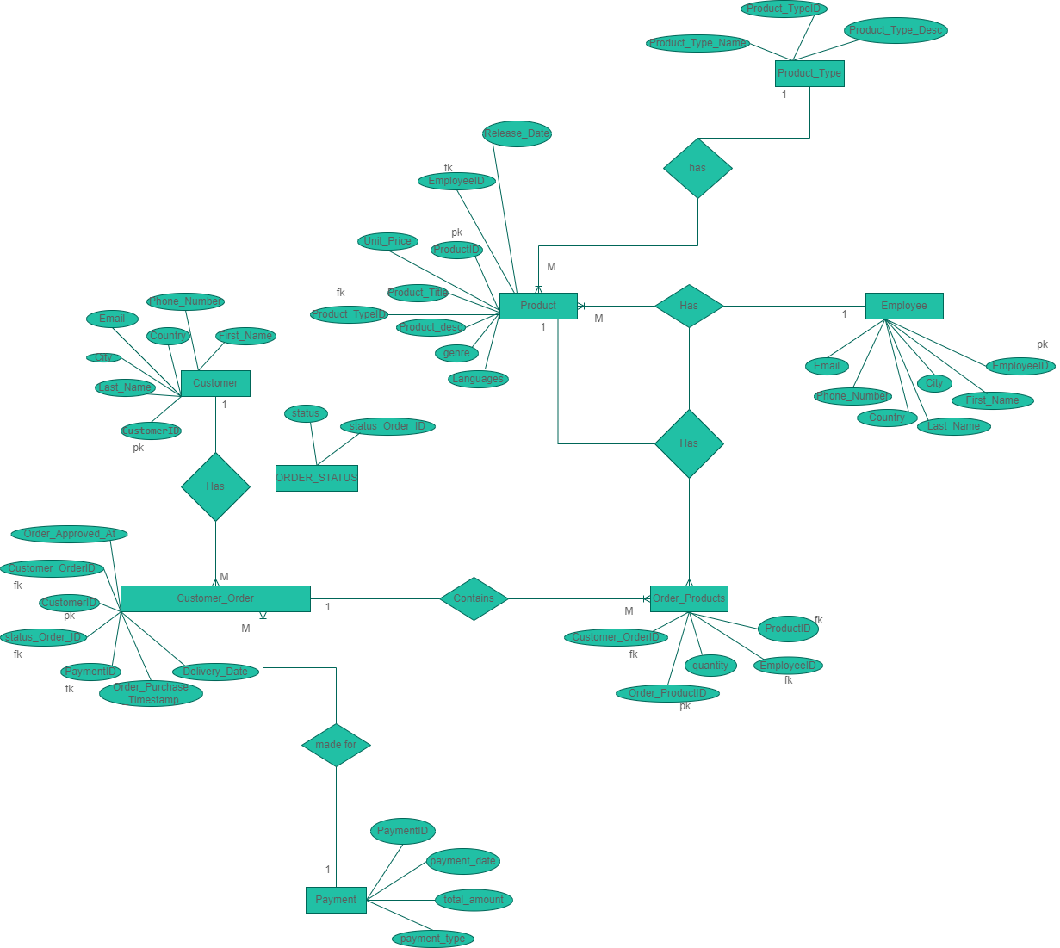

Figure ER Diagram with appropriate relationship and cardinality for Use case provided

Using the ER diagram above, I was able to develop the SQL scripts to perform the creation of e-shop database, its tables and their relationships and later perform insertion of data of at least 5 rows in each table for answering the queries asked.

The following are the SQL statements for the following queries:

-- SQL Queries

-- 4. Provide SQL statements for the following queries:

-- a. Extract all the customers from a specific city.

SELECT * from Customer as c

WHERE

c.city = "Lloyds";

-- b. Search for a product of a specific genre

SELECT * from Product as p

WHERE

p.genre = 'genre-b';

-- c. Count how many customers are from a specific city.

SELECT COUNT(CustomerID)

FROM Customer

WHERE

city = "Lloyds";

-- d. Calculate the average of the unit price.

SELECT AVG(Unit_Price)

FROM Product;

-- e. Extract all current orders

SELECT *

FROM

Customer_Order WHERE

Order_Purchase_Timestamp = "2022-12-11"

;

-- f. Extract all orders for books that has the keyword “the” in their description

SELECT *

FROM Order_Products as op

INNER JOIN Product ON op.ProductID=Product.ProductID

WHERE

Product.Product_desc LIKE '%the%';

-- g. Extract all payments with credit cards for music records.

SELECT *

FROM Order_Products as op

INNER JOIN Product ON op.ProductID=Product.ProductID

INNER JOIN Product_Type ON Product.Product_TypeID=Product_Type.Product_TypeID

INNER JOIN Customer_Order ON op.Customer_OrderID=Customer_Order.Customer_OrderID

INNER JOIN Payment ON Customer_Order.PaymentID=Payment.PaymentID

WHERE

Product_Type.Product_Type_Name = "music records" AND

Payment.payment_type = "Credit card"

;

-- h. Count how many employees handle music records.

SELECT COUNT(Employee.EmployeeID)

FROM Product

INNER JOIN Employee ON Product.EmployeeID=Employee.EmployeeID

INNER JOIN Product_Type ON Product.Product_TypeID=Product_Type.Product_TypeID

WHERE

Product_Type.Product_Type_Name = "music records";

-- i. Count how many employees first name is John.

SELECT COUNT(EmployeeID)

FROM Employee

WHERE

Employee.First_Name = "John";

-- j. Count how many orders are in the system.

SELECT *

FROM

Customer_Order;

Below is the USE CASE diagram for our case:

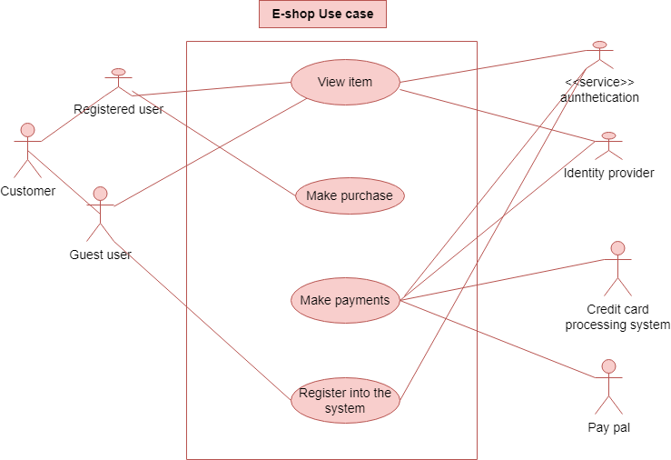

Data governance plan from the above Use case

1. User/customer can only make payments in the e-shop if and only if is a registered user in the system otherwise, he/she will be allowed for browsing the products only.
2. Also, the payment is passed under strict authentication. The system only allows authenticated payments from registered users.