Report

Java Programming
Om Bharat Vaghela

Title
Co-Workspace Booking Management System a desktop site application managed by the Working Staff.

Introduction –
This is the desktop site application created for staff to check the user credentials and manage the user data. This application contains login page in which its ask’s staff for their id, and password for safety, also after successful login the user is redirected to the dashboard in which several categories are shown like add inquiry, add booking, add resources(rooms), show inquiry, show bookings, show resources, and logout button. Every button has different perspectives as name represents. Moreover, in this we have used multiple SQL queries for data manipulation, and we have used Java AWT components for creating the application, and we have used “NetBeans IDE” 8.0 for testing, and compilation.

Background information – What is the advantage and target users.
I have used Java language to create this desktop application, as Java language is considered as one of the safest languages in the world so, every data is stored safely, moreover it can support large-scale application like Zomato, Amazon, and Teemu so it has functionality to handle large data and multiple data at same time. Another reason for using this application is that the staff can easily read and write the data of the user without having knowledge of IT background. It is very clean and simple to use, and the button name itself represents the working. For security reasons we can create id and password according to the type we need. This application makes the work easier and fast to make the bookings for the user so the staff can easily check availability of the resources and manage the data.

Main modules of the system –

Screenshots with explanation –
Login Page
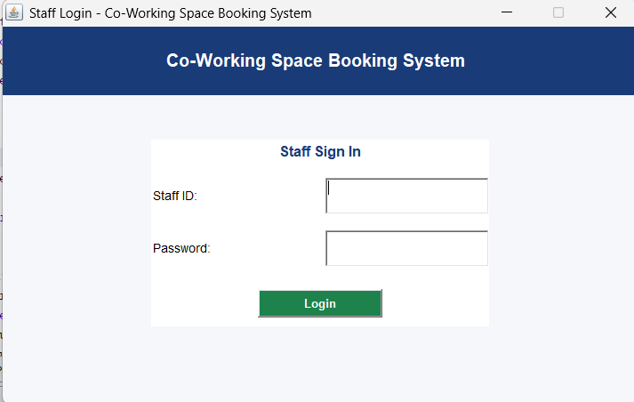
This is the login page which shows to fill id and password, if both are correct then only user can go further. This is created for verifying the user(for security purpose).
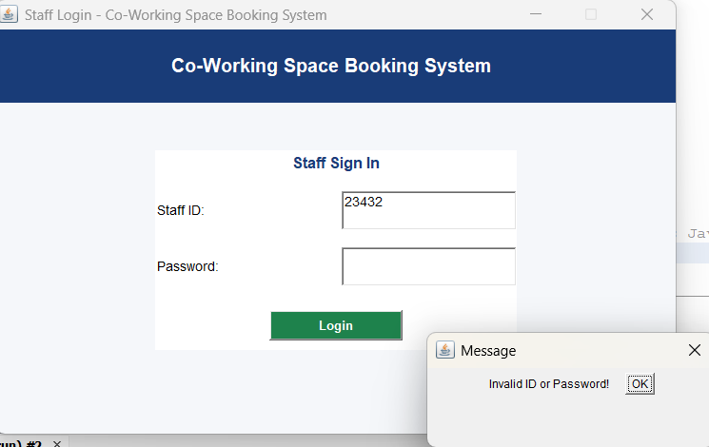
Dashboard
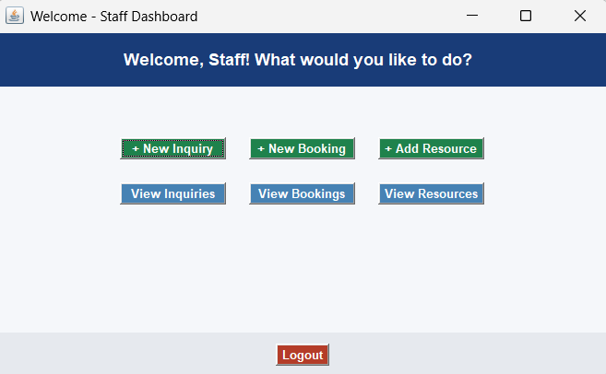
Dashboard opens after logging in successfully. And this are the buttons with different usage.

Inquiry Form
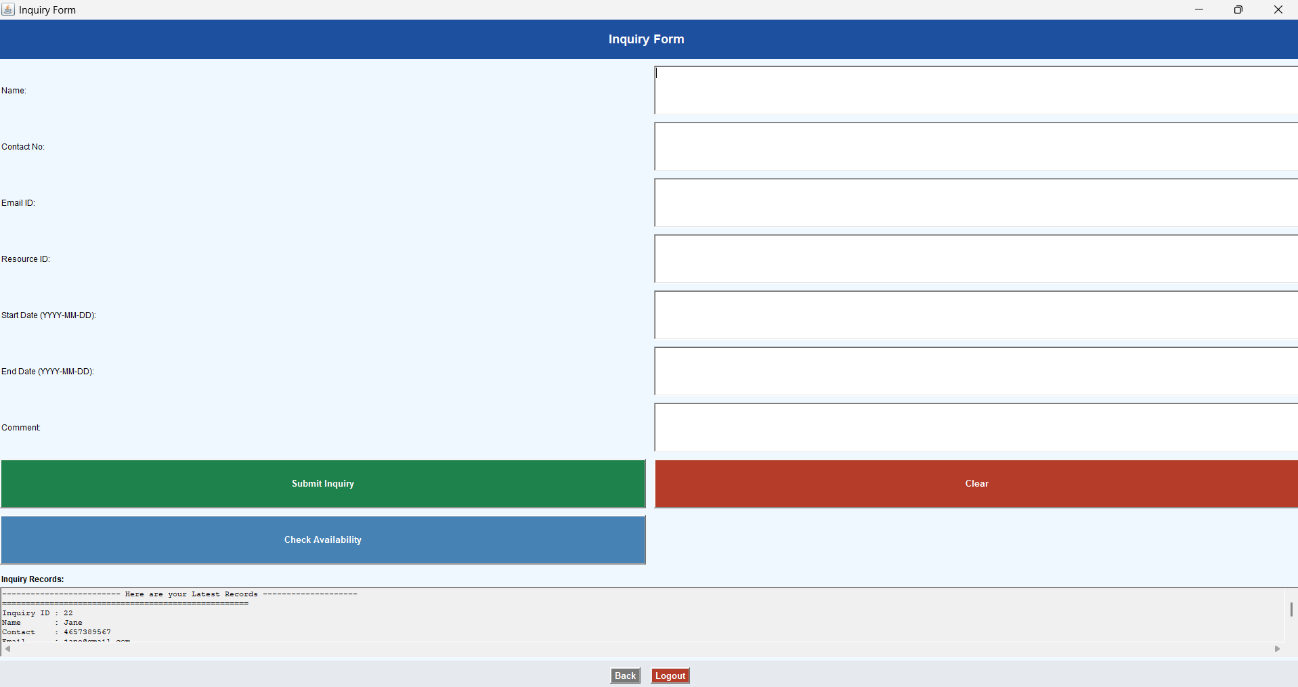
Invalid Credentials in Inquiry Form (Room Already Booked)
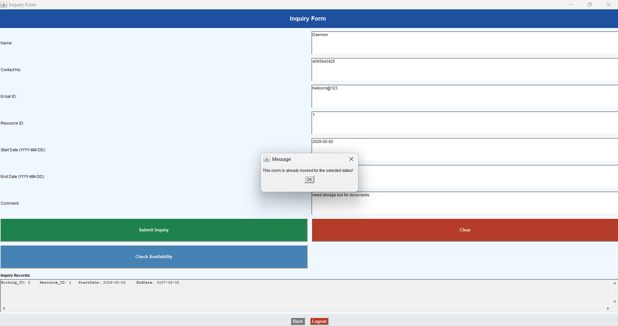
Yes, You can book the room
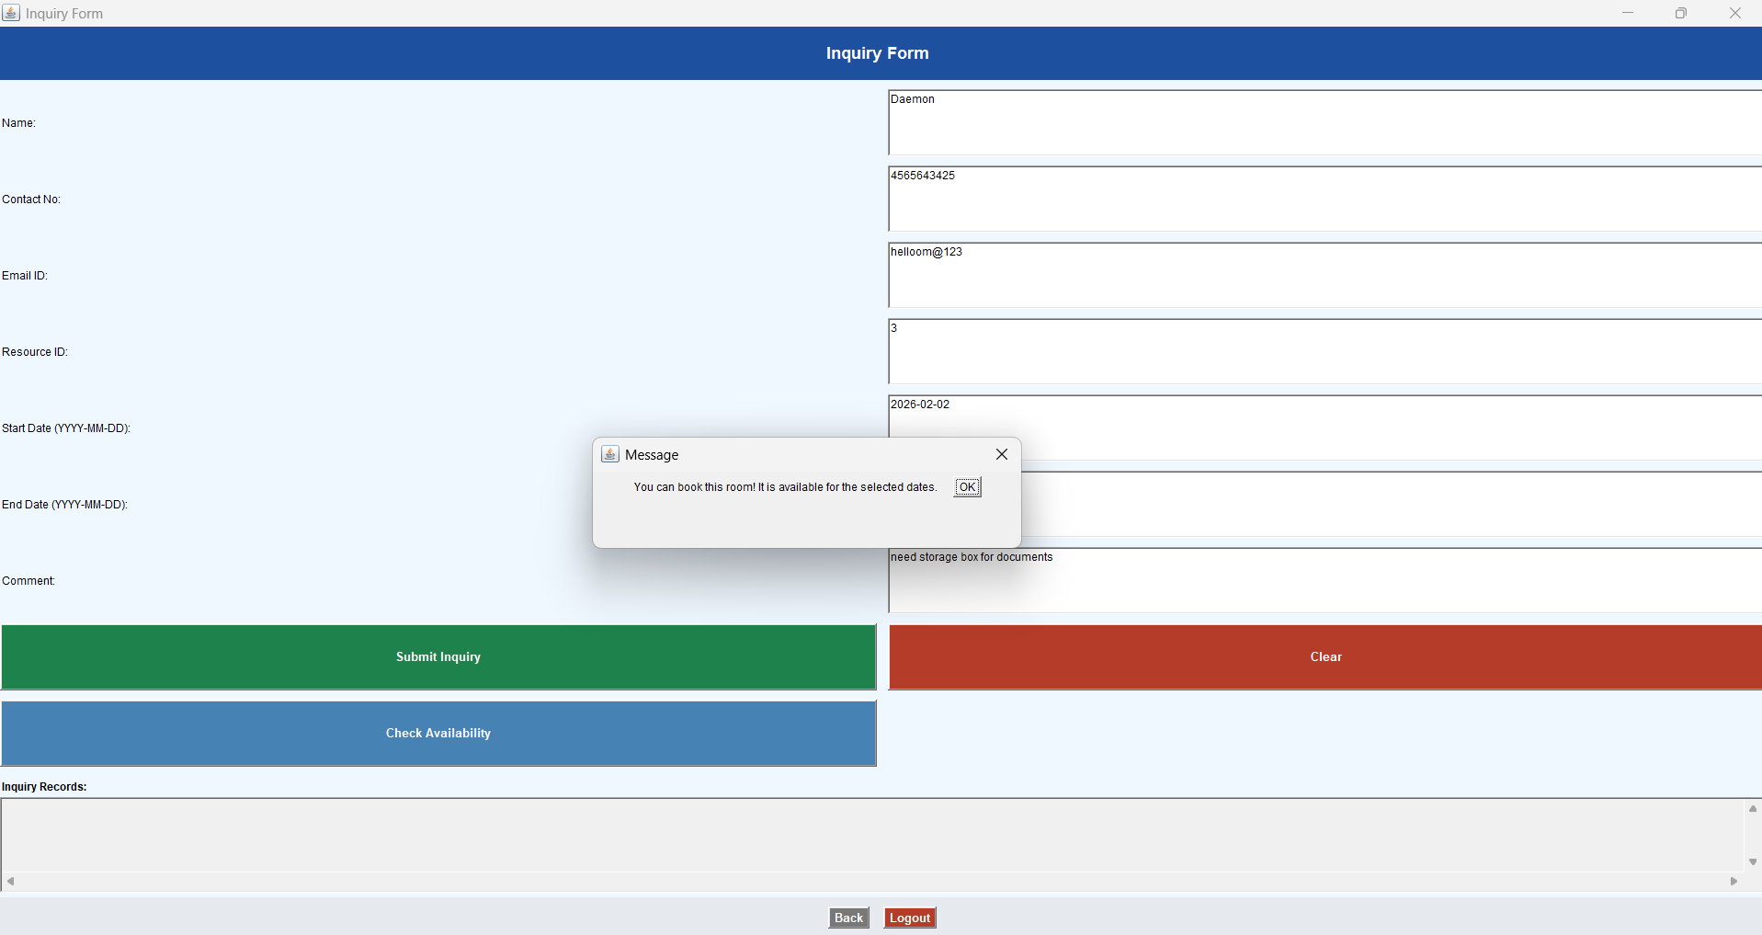

Inquiry Form Data
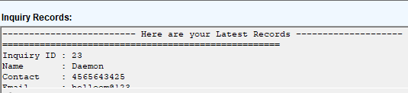

Booking Form
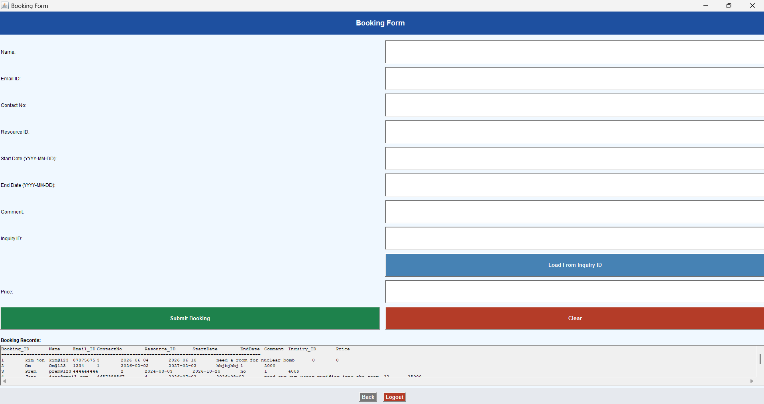

Booking form Load details by inquiry ID
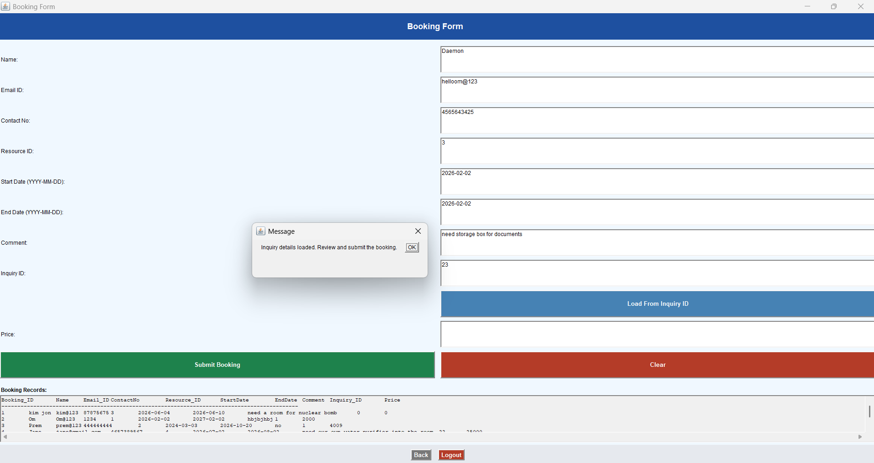
Error if user does not enter Inquiry ID
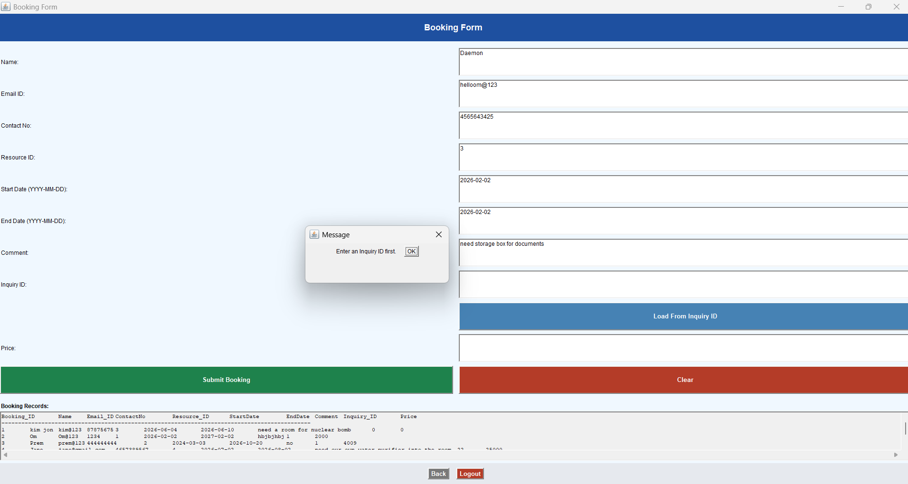
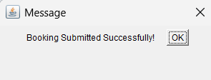

Booking Details

Resource Page
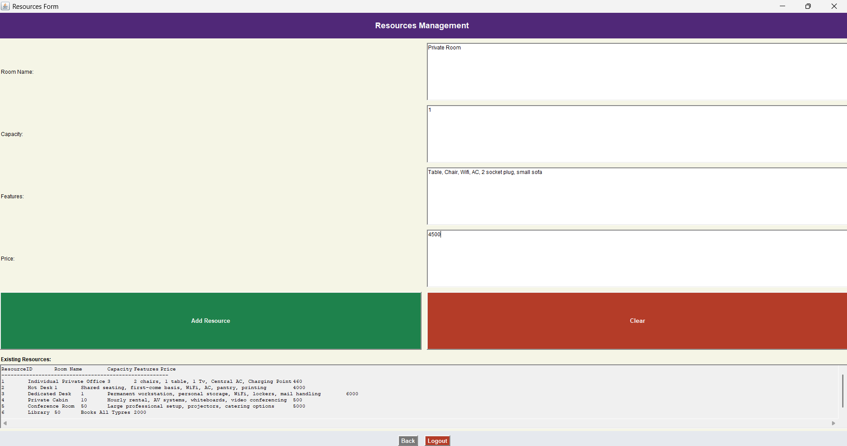

Inquiry Details
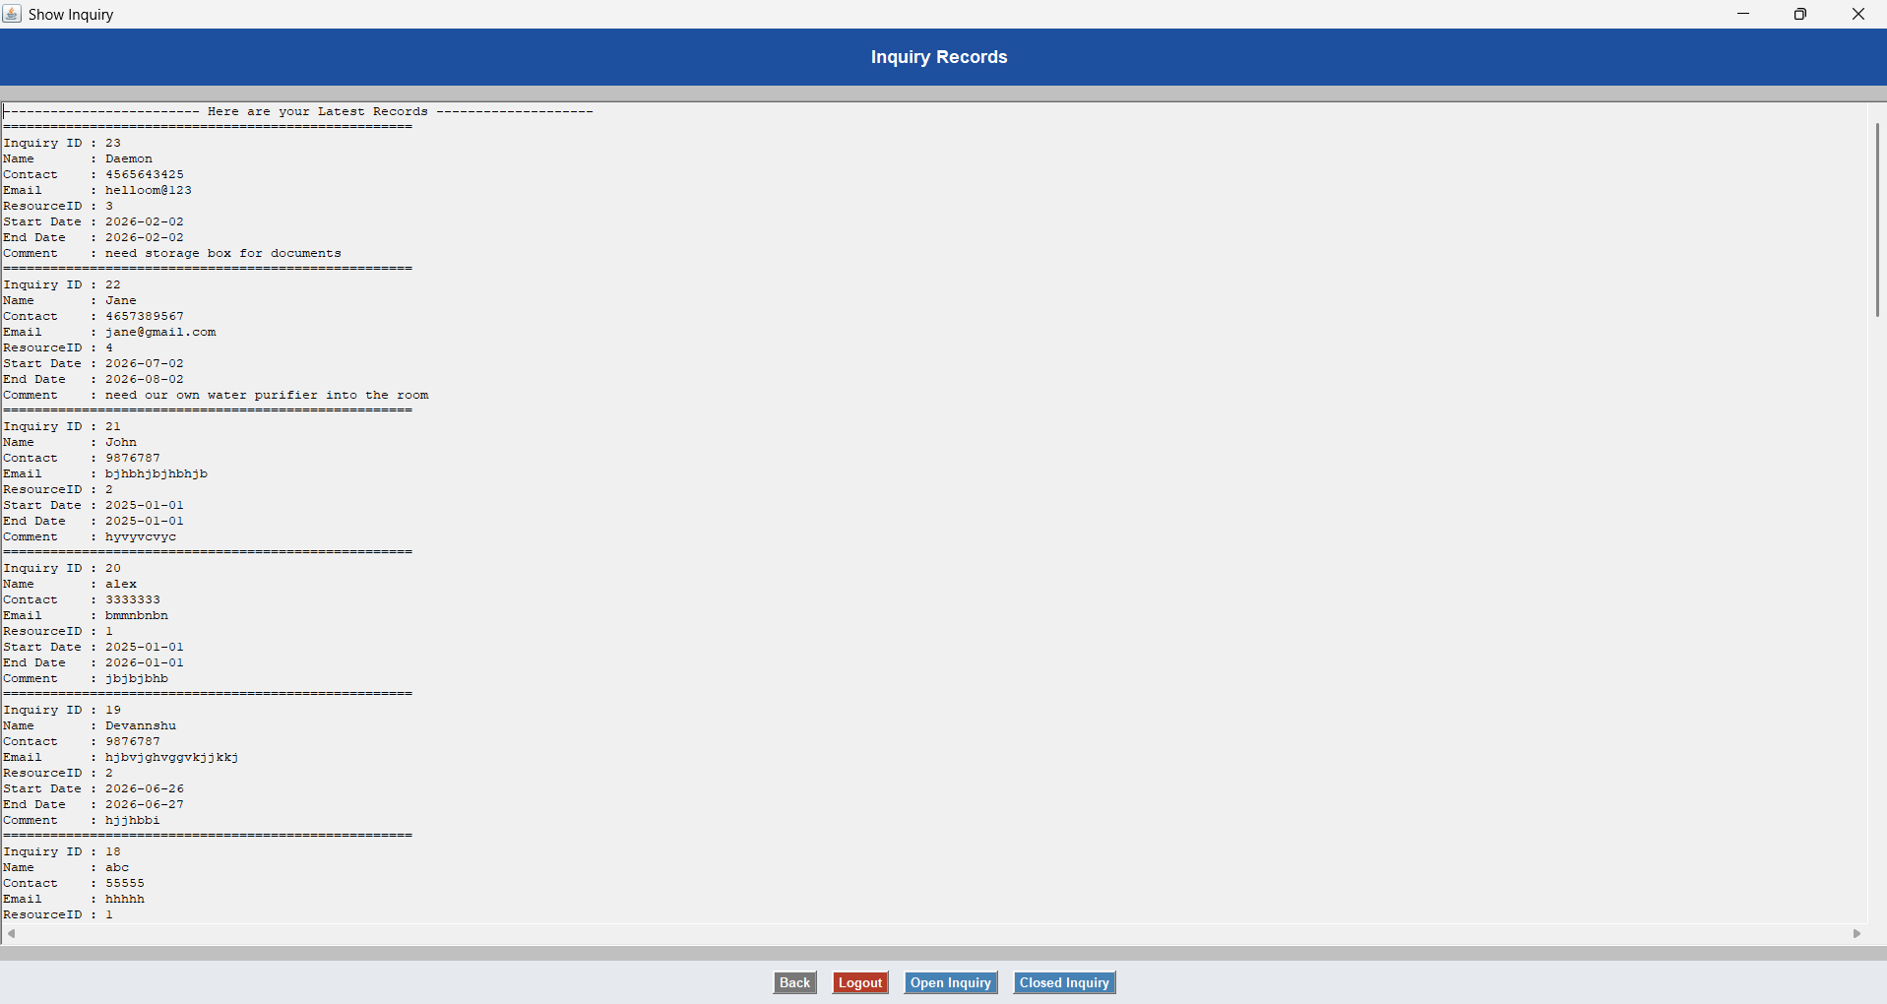

Booking Details
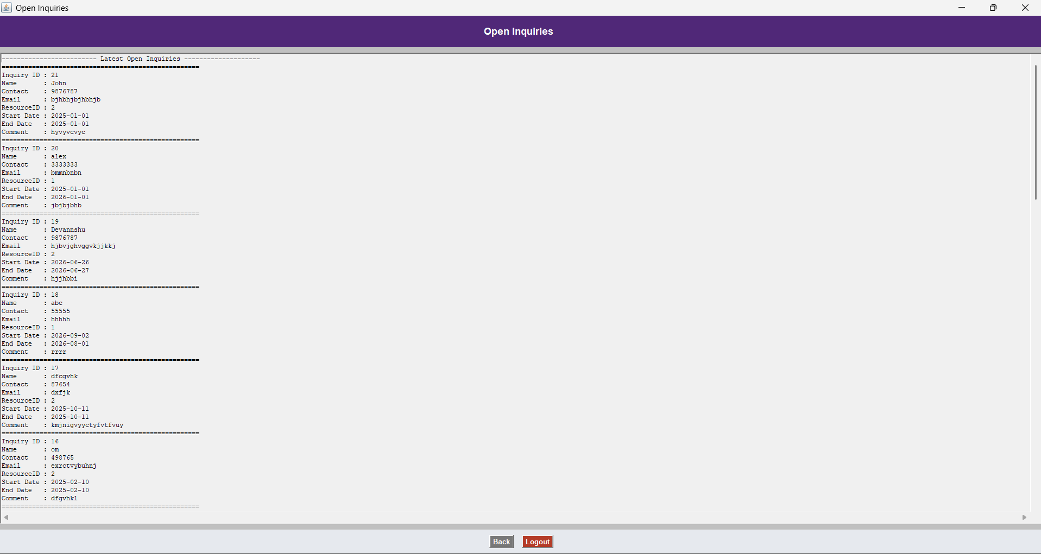

Closed Inquiries
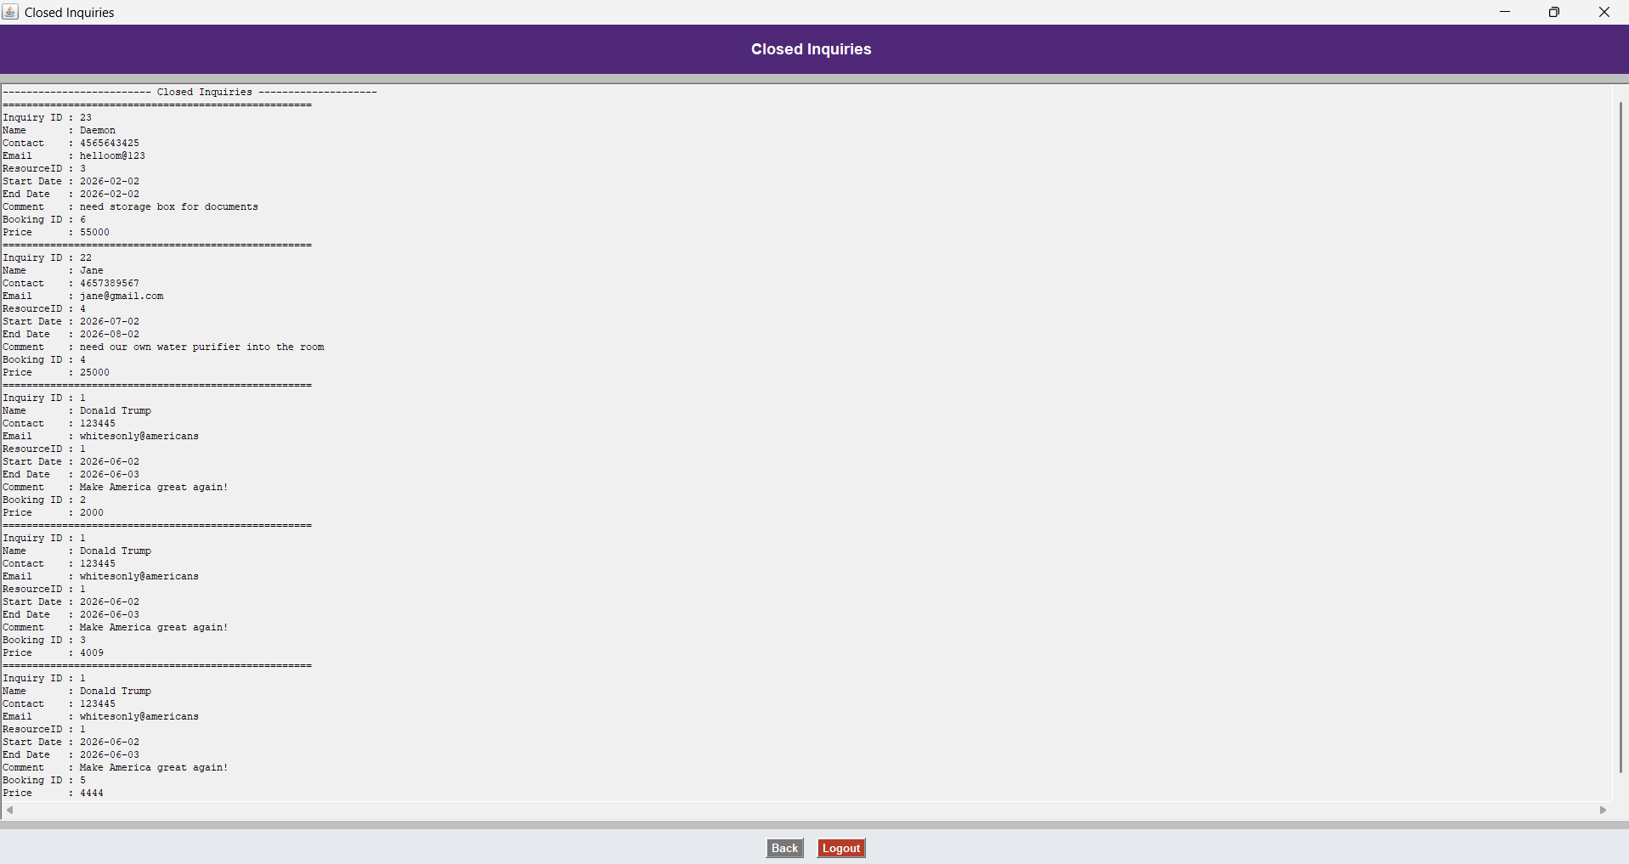

Booking Details
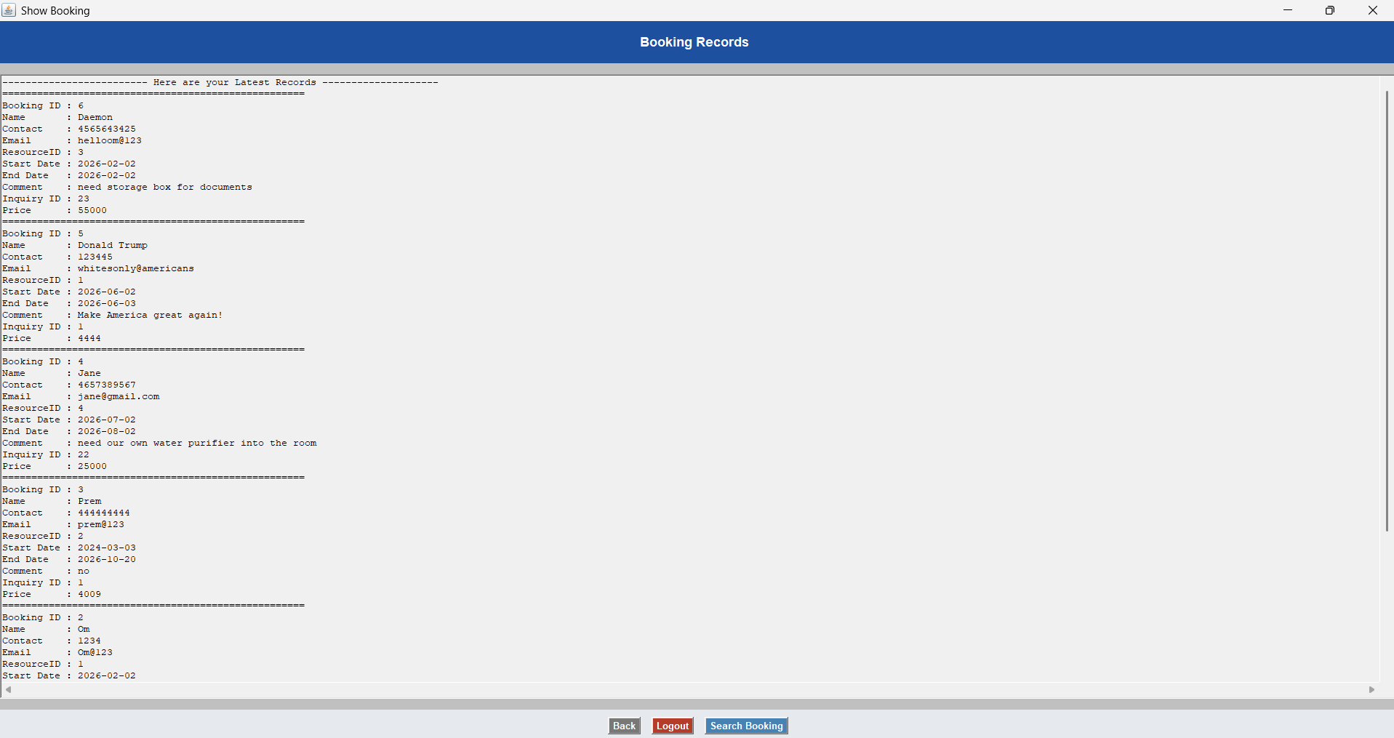

Search Bar for the Date
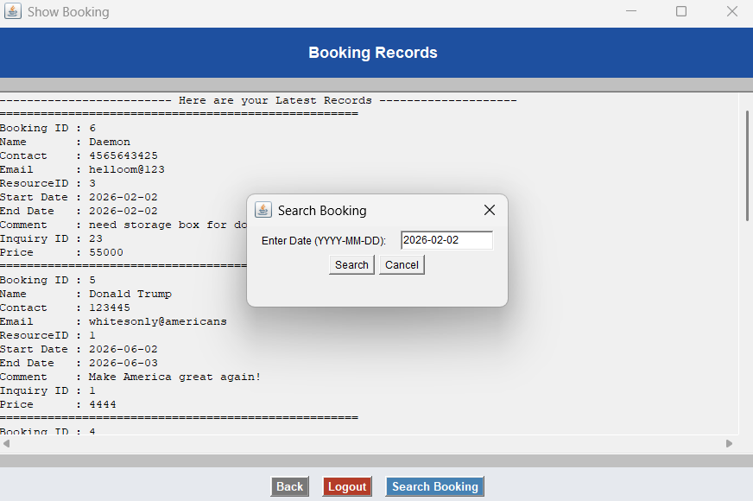
Show According to Date entered by the user
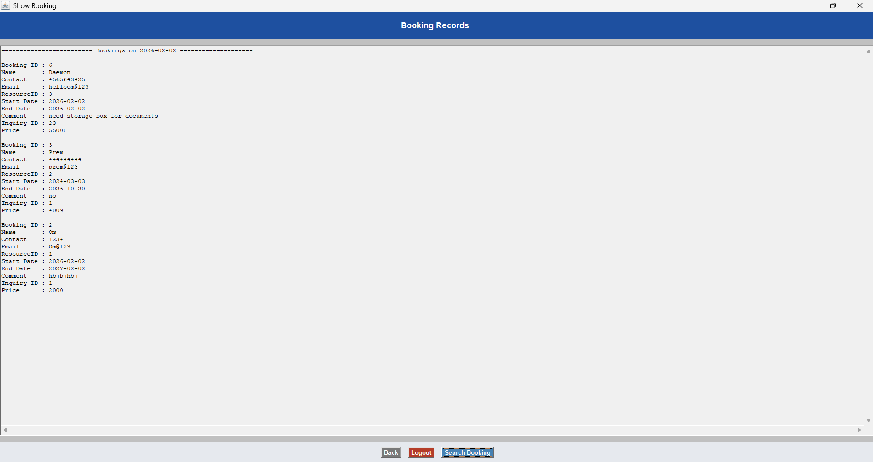
Resource (Room) Data
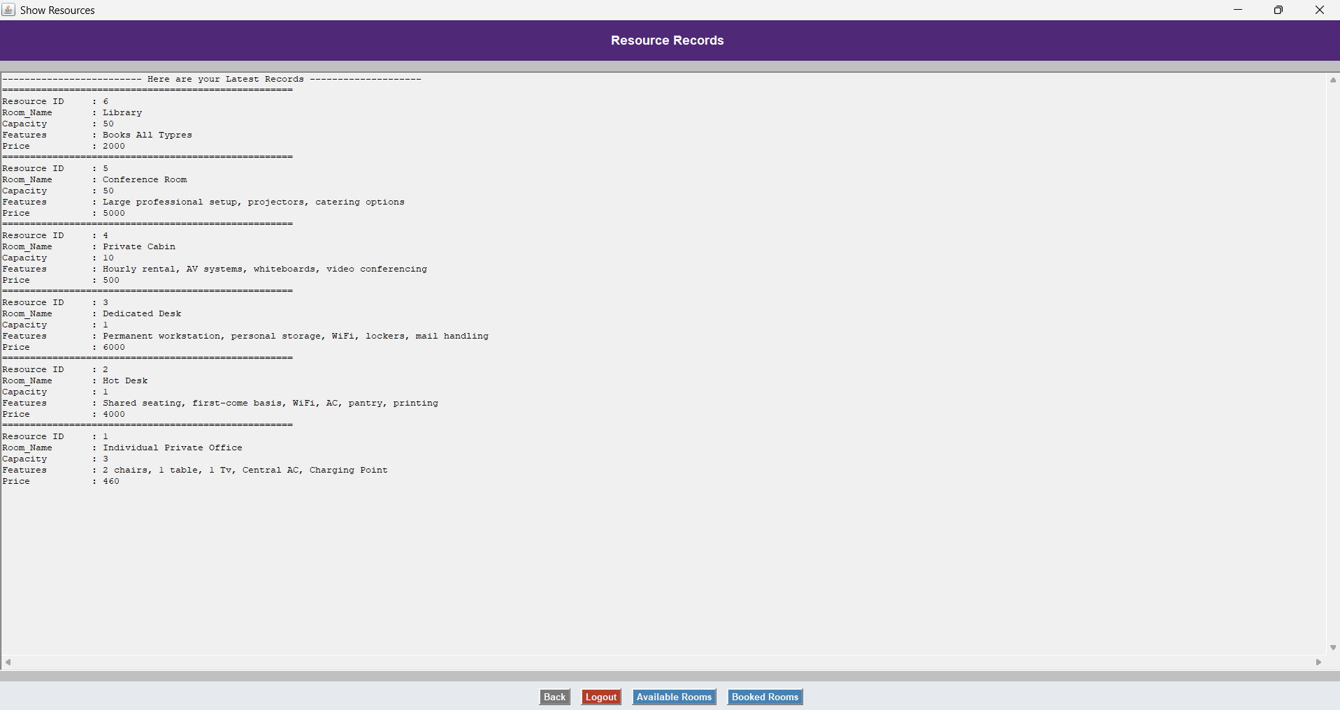
Available Room = Room which are not Booked
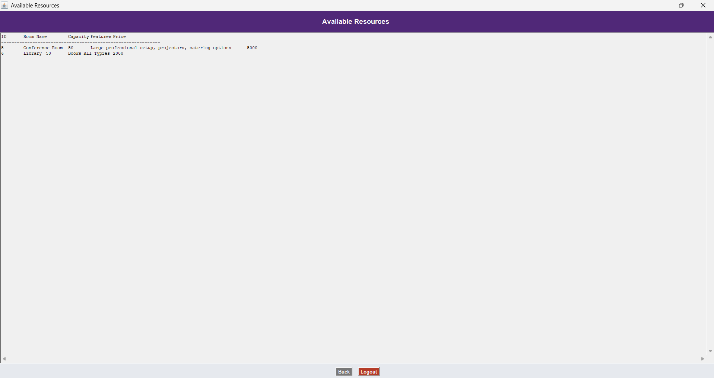

Rooms Which are Booked
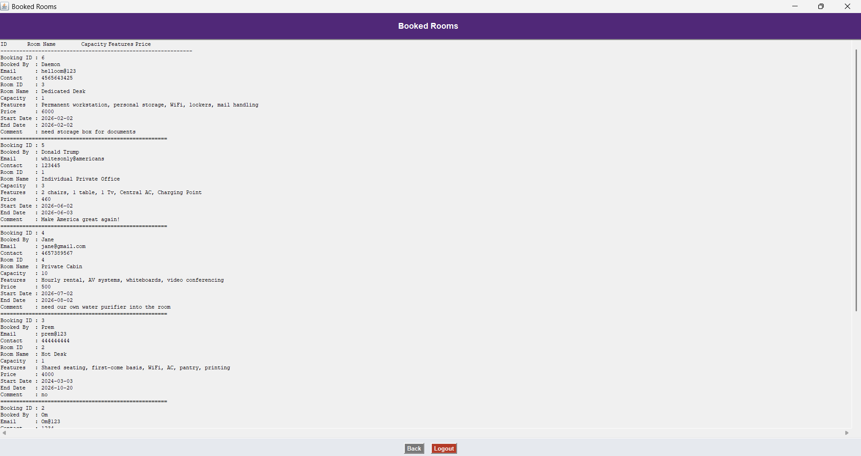

Conclusion –
This is a system developed using Java language and the resources which are used here are Net Brains version 8.0, SQL Database, Java AWT components.
This system is developed for managing the booking of the people which are done by the staff. The most important thing in this is staff can check whether the room is booked or not. If it’s booked, then it will not allow them to book that room.

References and bibliography –

From the Internet

www.regus.com
www.coworker.com
www.hotdesk.com
wework.co.in

