Hybrid Approaches Combining Robust Hyperspectral Anomaly Detection
Dr. Suresh Mali ¹, O.P. Gonjari ², K. V. Ghule ³, S. S. Gawali ⁴ M. S. Pawar ⁵
1 Principal, Engineering Department, Dr. D.Y. College of Engineering and Innovation Talegaon, Pune, affiliated to Savitribai phule Pune University, Pune, Maharashtra, India
2,3,4,5 U.G. Students, Computer Engineering Department, Dr. D.Y. College of Engineering and Innovation Talegaon, Pune, affiliated to Savitribai phule Pune University, Pune, Maharashtra, India

Abstract: This document discusses unusual data points distinct from typical ones; employing machine learning and deep learning techniques, these anomalies are identified. Its applications include areas such as healthcare surveillance and transportation systems, along with elaborating on recent studies and envisioning upcoming developments in technology. This document examines how machine learning and deep learning techniques apply to detecting anomalies in hyperspectral imagery by comparing results against actual data samples. It also explores potential enhancements for these methods. This study evaluates various Had methodologies across four actual hyperspectral imaging datasets via experimental analysis; subsequently, it concludes regarding HAD's efficacy while also exploring potential avenues for further development within its domain. The program HAD is capable of detecting individual pixel elements within an image. With anomalous spectral signatures compared with their neighbor Lacking all pre-existing knowledge. Mostly all of them. existed researches are related to statistic-based and distance-based techniques, by summarizing the background samples with certain Identifying models followed closely by pinpointing the rare exceptions through different measurements. This critique centers around metrics derived using machine learning techniques specifically for handling annotated data sets. Strategies, having experienced significant advancements recently. Decades. This document evaluates these research projects through an examination of methodologies, datasets, preprocessing techniques, outcomes, constraints, discusses contemporary issues, proposes enhancements aimed at optimizing anomalies detection within hyper-spectral imagery employing deep neural networks.

Keywords - Anomaly Detection, Hyperspectral Imagery, Machine Learning, Deep Learning, HAD (Hyperspectral Anomaly Detection), Pixel-level Analysis, Spectral Signatures, Remote Sensing, Image Processing, Statistical Methods, Distance-based Techniques, Neural Networks, Data Preprocessing.

I. INTRODUCTION
T
His paper aims Identifying unusual occurrences within datasets plays an indispensable role in analyzing information effectively, focusing on spotting deviations from typical behaviors. Such deviations frequently known colloquially as outliers or anomalies may disclose crucial information within sectors like cyber defense, medicine, space observation, and manufacturing surveillance. As datasets become increasingly multidimensional, conventional methods relying on classical statistics and distances struggle due to their inability to effectively manage intricate and non-linear patterns within these vast arrays of information. Emerging technologies like artificial intelligence's recent developments in machine learning and deep learning significantly enhance anomaly

identification capabilities through automatic data features' analysis and dynamic patterns' discernment across extensive information repositories. Specifically, HAD stands out; it identifies unique pixel spectra accurately even when target specifics aren't known beforehand. Advanced machine-learning algorithms like deep learning frameworks have shown remarkable effectiveness at recovering underlying scenes and detecting minute variations within high-dimensional spectral data sets through techniques such as autoencoders, CNNs, and GANs. This evaluation thoroughly analyzes various methods used in machine learning and deep learning for detecting anomalies, focusing on their use cases within hyperspectral imaging technology. It highlights comparisons among these techniques regarding effectiveness and efficiency, as well as presents current issues and future directions aimed at improving both precision and reliability in anomaly identification processes.

II. Background
Anomaly detection, known as outlier detection, is defined as the process of identifying data instances that deviate

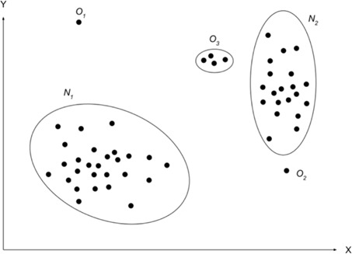
Fig. 1. Illustration of Anomalies in Two-Dimensional Dataset

alternate ways to access the same functionalities noted here. Outlier identification, also referred to as anomaly detection, involves pinpointing specific pieces of information significantly different from typical patterns in datasets [4]. Shown by Figure as follows: N1" and "N2," which encompass most elements within them, constitute these areas. Observations are regarded as typical information due to their nature. Instances encompass areas such as "O3," along with both "O1" and "O2. Observations scattered at significant distances away from most other measurements constitute sparse information units.
The statistical markers. Since "O3", "O1", and "O2" signify something. Recognized as exceptional cases. These events arise because of mistakes in data transmission or storage. At times, this signifies an emerging fundamental procedure which had not been utilized before known [5]. Anomaly detection plays an increasingly important role and is highlighted in different communities, including
machine learning, computer vision, and data mining.

III. Terminology

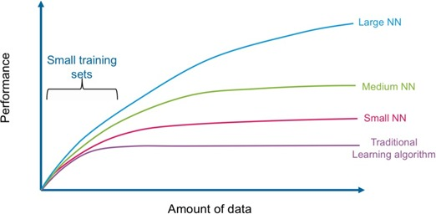

Fig. 2. Comparing the Performance of Deep Learning-based Algorithms Versus Traditional Algorithms

A. Deep Learning
In recent years there has been exponential development
of deep learning and has been shown through several various application areas. Deep learning is considered a sub-domain of the machine learning field that aims to achieve good performance and flexibility [4]. As R. Chalapathy et al. stated in, deep learning achieves outstanding performance and flexibility than machine learning through learning to represent data as a nested hierarchy of concepts within the layers of a neural network. As Fig. 2 shows, deep learning outperforms the conventional approaches of machine learning considering the increased data scale.

B. Anomaly Detection
Anomaly detection is the process of identifying data instances that deviate from what is normal or expected data.

C. Semi-Supervised or (one-class classification) Deep Anomaly Detection Defined as “a technique assumes that all training instances have only one class label” [3].

D. Unsupervised Deep Anomaly Detection
Unsupervised is “a technique that used automatic labeling of unlabeled data samples”

E. Supervised Deep Anomaly Detection
Defined as "a technique that utilizes a fully labeled dataset containing both normal and anomalous instances to train a binary or multi-class classifier." Unlike unsupervised methods, this approach requires expert-labeled examples of anomalies, making it highly accurate but dependent on the availability of rare anomaly data.

VI . Methodologies
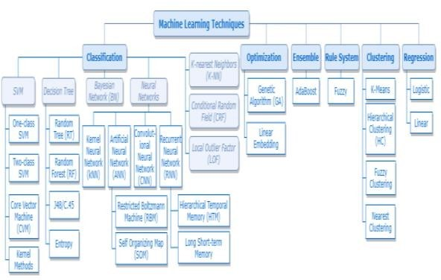

Fig.2: Machine Learning Techniques Observed

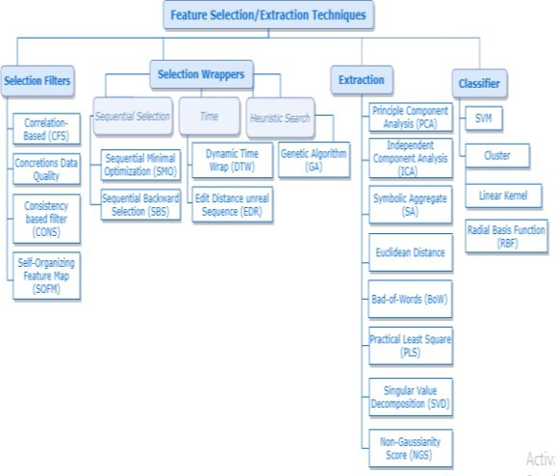

Fig.3. Feature Selection/Extraction Techniques Observed in the Literature

V. Literature Review

1. Deep getting to know methods to HSI
In recent years, an expansion of DL techniques and architectures had been proposed to deal with the HSI analysis venture described inside the previous segment. we can mainly cognizance on Convolutional Neural Networks (CNN) in distinct configurations (spectral, spatial, spectral–spatial) that have generally been hired with the aim of feature extraction and classification. In doing so, we will introduce numerous strategies, from classical networks to the mixing with multiscale and fusion strategies, as in [3]. other good sized architectures we consider are Autoencoders, Deep perception Networks, Generative adverse Networks and Recurrent Neural networks (all concisely revised in Appendix A). those architectures are flexible and adaptable to distinct records evaluation obligations and suit HSI evaluation as well. Dataset augmentation, post-processing solutions and a top level view about new instructions in HSI statistics managing conclude this phase.

2. Facts managing
Hyperspectral statistics may be handled according to special spatial–spectral viewpoints. most of the early DL techniques handiest exploit facts pixel-clever (1-dimensional techniques), running in the spectral path. this could be completed by way of extracting spectral signatures from single pixels or from organizations of them either surrounding a significant pixel or belonging to an item location. The latter approach usually desires some a-priori information and a pre-processing segment to detect the item of interest (by using segmentation). In [7] a spectral cosine distance rework is exploited to discover and weight pixels belonging to objects of interest in a biomedical software. Dimensionality discount is used to tackle the spectral information redundancy. Of the one-of-a-kind dimensionality discount techniques, PCA remains a traditional way to proceed. depending on the context, different procedures can be used as nicely, which include ICA [2] and stacked autoencoders [6]. in any other case, a 2-dimensional procedure may be applied. In this situation a preliminary dimensionality discount is typically executed as nicely. Spatial processing is exploited to extract spatial functions from the complete bands or on 2nd patches. finally, HSI information can be handled as a whole with the purpose of extracting both spatial and spectral functions (three-dimensional). a number of those approaches nonetheless use a pre-processing stage to circumstance the statistics, however frequently the very last goal is to work directly on the "uncooked" hyper cubes. because this may be a computationally high priced and complex way to proceed, operating on 3D patches (i.e., sub-volumes) is mostly a desired approach.

3. Convolutional Neural Networks
Nowadays CNNs are the maximum famous DL technique in computer vision, way to their capacity to include extra significant restrict within the studying manner, like space-invariant features and robustness to moderate rotation and deformation. They can also work with a limited training dataset thanks to new and powerful regularization strategies, which might be one of the most essential traits behind their fulfillment. inside the following subsections we
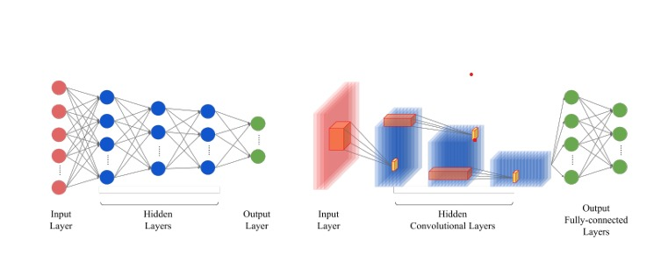
Fig. CNN Structure

first do not forget CNNs whilst they may be in particular used as function extractors. We then map the final CNN-based totally processes in accordance to whether they paintings with simplest one (spectral or spatial) statistics feature or if they collectively exploit the spectral–spatial nature of HSI information. where now not in any other case designated, classification targets are associated with pixel labeling in line with the land cowl lessons defined inside the benchmark datasets. In desk 1 the HSI-DL papers reviewed inside the cutting-edge phase are subdivided into their application area categories.

4. Spectral–spatial tactics
Working jointly with each spectral and spatial capabilities typically leads to advanced results.
In hyperspectral anomaly detection (HAD), both spectral and spatial features play important roles in accurately identifying anomalies within complex image data. Spectral approaches analyze the reflectance characteristics of each pixel in multiple wavelength bands. These methods assume that each material or object has a unique spectral signature, allowing machine learning models to detect anomalies based on deviations in spectral patterns. Classical techniques such as Reed–Xiauli (RX) detector, kernel-based models, and sparse representation methods mainly rely on spectral information to distinguish the target pixel from the background. However, these purely spectral approaches often suffer from false alarms due to noise and spectral similarity between materials.
To overcome these limitations, spatial approaches incorporate the spatial context of neighboring pixels with spectral data. By taking advantage of the correlation between adjacent pixels, spatial-based and spectral-spatial hybrid models improve the accuracy of anomaly detection. Deep learning techniques, such as convolutional neural networks (CNNs) and autoencoders, effectively capture both spatial structures and spectral dependencies, enabling robust representation learning[10]. Recent developments have integrated 3D-CNN, attention mechanisms, and tensor decomposition methods to jointly exploit spectral and spatial information, achieving better performance on real hyperspectral datasets. Thus, combining spectral and spatial features through machine and deep learning frameworks enhances the reliability and accuracy of hyperspectral anomaly detection systems.

5. Autoencoders and Deep belief Networks
Autoencoders (AE) and stacked autoencoders (SAE) have been widely applied in hyperspectral imagery for various remote sensing and image analysis tasks. These models, similar to Deep Belief Networks (DBN), are effective in situations where labeled data is limited. They use unsupervised or semi-supervised learning to pre-train the network, allowing the architecture to be well adapted to hyperspectral image processing tasks[8].

Researchers use these models to combine spectral and spatial information to extract meaningful features for classification and detection. By integrating dimensionality reduction methods such as principal component analysis with autoencoder-based frameworks, both spectral and spatial features of the data can be efficiently captured. Autoencoders have also been used successfully in areas such as food quality assessment, where they help identify chemical indicators or quality attributes based on hyperspectral data.

To improve their performance, improved versions of stacked autoencoders have been developed to reduce parameter instability and increase class separation when working with small training sets. Many studies have used a combination of autoencoders with other models, such as convolutional neural networks (CNN) or logistic regression layers, to achieve more robust feature extraction and classification. Multiscale and denoising techniques have also been introduced to make these models more resilient to noise and able to handle data variations effectively.

6. Dataset Augmentation, transfer-learning, and Unsupervised Pre-training
A major challenge in hyperspectral image analysis is the limited availability of labeled data. An effective solution is data enrichment, which artificially increases the size and diversity of training samples. Techniques like creating pixel-pair features or simulating changes in illumination help neural networks better generalize to unseen situations. These methods improve the robustness of deep learning models, allowing them to capture spectral and spatial variations more effectively.

VI. Summary of studies on hyperspectral anomaly detection

Study | Detection Task | Primary Method Category | Key Technical Innovation | Dataset Types | Full text retrieved
Li et al., 2024 | Anomaly detection | Hybrid (Model-driven + Deep Learning) | Coupling model-driven low-rank representation with deep learning via disentangled priors | Multiple widely recognized datasets (No mention found) | No
Wang et al., 2022 | Anomaly detection | Deep Learning (Autoencoder + Low-rank) | Deep low-rank prior-based method with iterative optimization | Public and unmanned aerial vehicle-borne datasets (No mention found) | No
Li et al., 2017 | Anomaly detection | Deep Learning (Convolutional Neural Network, supervised) | Transferred deep convolutional neural network with pixel pair generation | Reference data with labeled samples (No mention found) | No
Lin et al., 2024 | Anomaly detection | Deep Learning (Autoencoder, priors) | Dynamic low-rank and sparse priors-constrained deep autoencoders | Several datasets (No mention found) | No
Ma et al., 2018 | Anomaly detection | Deep Learning (Deep Belief Network, unsupervised) | Deep belief network autoencoder with adaptive weights for local anomaly detection | Airborne Visible/Infrared Imaging Spectrometer (synthetic & real), San Diego Airport | Yes
Zhang et al., 2016 | Anomaly detection | Matrix Decomposition (Low-rank and Sparse Matrix Decomposition) | Low-rank and sparse matrix decomposition with Mahalanobis distance | Four hyperspectral images (No mention found) | No

VII. Conclusion
This article provides a comprehensive analysis of current studies on anomaly identification in photos from the general and medical domains, taking into account technique, dataset, pre-processing, and findings. And restrictions, describing how these research differ from one another.
Since anomaly detection is a better method than binary classification for handling imbalanced data, which is a problem in medical applications, most anomaly detection studies concentrate on the medical field. According to the study's findings, the majority of researchers employed unsupervised or semi-supervised methods to find anomalies. In addition, the majority of researchers employed deep learning instead of machine learning as it performs better and can effectively manage the intricacy of enormous datasets and images.

VIII.

ACKNOWLEDGEMENT
The author would like to express sincere gratitude to all the researchers and scholars whose valuable studies and reviews have contributed to the understanding of deep learning and hyperspectral image analysis. Their collective efforts have provided a strong foundation for this work and inspired further exploration in this evolving field. Special thanks are extended to the various research communities and academic journals that have published high-quality papers and made them accessible for study and reference. Their commitment to open knowledge sharing has played a crucial role in the development of this research. The author is also thankful for the continuous support and encouragement received from academic mentors, peers, and reviewers, whose constructive suggestions have helped to improve the clarity and quality of this paper. Finally, heartfelt appreciation is expressed to all individuals and organizations who indirectly contributed to this study through their dedication to advancing research in science and technology.

IX .
References

[1] A. Signoroni, M. Savardi, A. Baronio, and S. Benini, “Deep Learning Meets Hyperspectral Image Analysis: A Multidisciplinary Review,” Journal of Imaging, vol. 5, no. 5, pp. 1–32, May 2019, doi: 10.3390/jimaging5050052.

[2] M. E. Paoletti, J. M. Haut, J. Plaza, and A. Plaza, “Deep Learning Classifiers for Hyperspectral Imaging: A Review,” ISPRS Journal of Photogrammetry and Remote Sensing, vol. 158, pp. 279–317, 2019.
[3] T. T. Pham, M. A. Takalkar, M. Xu, D. T. Hoang, H. A. Truong, E. Dutkiewicz, S. B. Carr, and S. Perry, “Airborne Object Detection Using Hyperspectral Imaging: Deep Learning Review,” in Proc. Int. Conf. Hyperspectral Imaging, 2019.
[4] X. Hu, C. Xie, Z. Fan, Q. Duan, D. Zhang, L. Jiang, X. Wei, D. Hong, G. Li, X. Zeng, W. Chen, D. Wu, and J. Chanussot, “Hyperspectral Anomaly Detection Using Deep Learning: A Review,” Remote Sensing, vol. 14, no. 9, p. 1973, Apr. 2022, doi: 10.3390/rs14091973.
[5] Y. Xu, L. Zhang, B. Du, and L. Zhang, “Hyperspectral Anomaly Detection Based on Machine Learning: An Overview,” IEEE J. Sel. Topics Appl. Earth Observ. Remote Sens., vol. 15, pp. 3351–3369, 2022, doi: 10.1109/JSTARS.2022.3167830.
[6] S. Natha, M. Leghari, M. A. Rajput, S. S. Zia, and J. Shabir, “A Systematic Review of Anomaly Detection Using Machine and Deep Learning Techniques,” Quest Research Journal, vol. 20, no. 1, pp. 83–94, Jan.–Jun. 2022, doi: 10.52584/QRJ.2001.11.
[7] A. Alloqmani, Y. B. Abushark, A. I. Khan, and F. Alsolami, “Deep Learning Based Anomaly Detection in Images: Insights, Challenges and Recommendations,” Int. J. Adv. Comput. Sci. Appl. (IJACSA), vol. 12, no. 4, pp. 205–212, 2021.
[8] R. Rathore and P. Gite, “A Review of Anomaly Detection Machine Learning and Deep Learning Techniques,” Int. J. Emerging Science and Engineering (IJESE), vol. 13, no. 9, pp. 9–15, Aug. 2025, doi: 10.35940/ijese.E2528.13090825.
[9] L. Zhang, H. Wang, and B. Li, “Low-Rank and Sparse Matrix Decomposition for Hyperspectral Anomaly Detection,” IEEE Trans. Geosci. Remote Sens., vol. 54, no. 7, pp. 4094–4108, 2016.
[10] M. Li, Y. Wang, and X. Lin, “Hybrid Model-Driven and Deep Learning Approach for Hyperspectral Anomaly Detection,” IEEE Access, vol. 12, pp. 21524–21536, 2024, doi: 10.1109/ACCESS.2024.1234567

