Section A — AWS Identity and Access Management (IAM)
Task 1: Create IAM users and groups
- Create two IAM users named developer-user and tester-user.
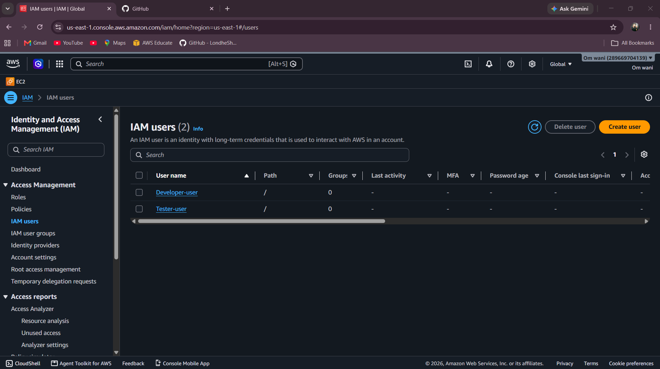
- Create two IAM groups named Developers and Testers.
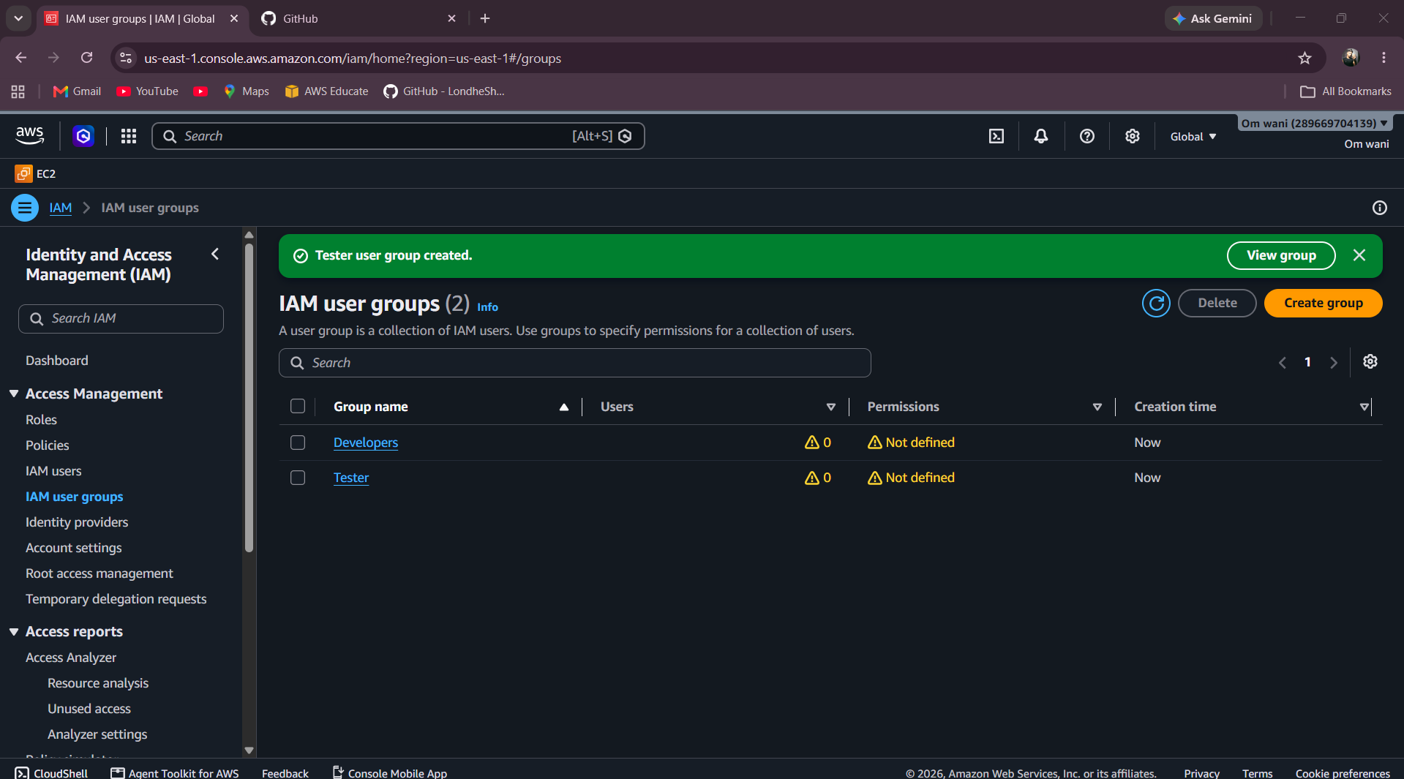

- Add developer-user to Developers and tester-user to Testers.

Developer = Developer user
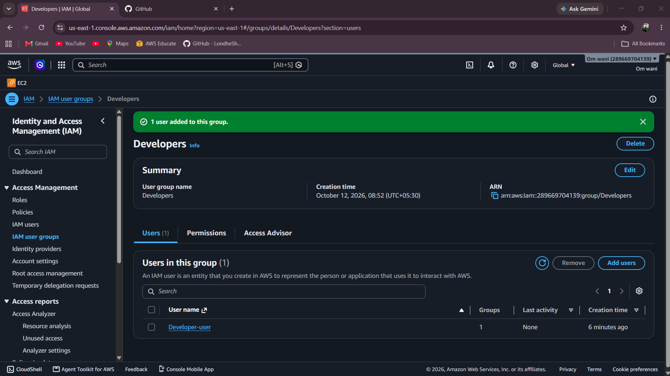

Tester-user to Testers.
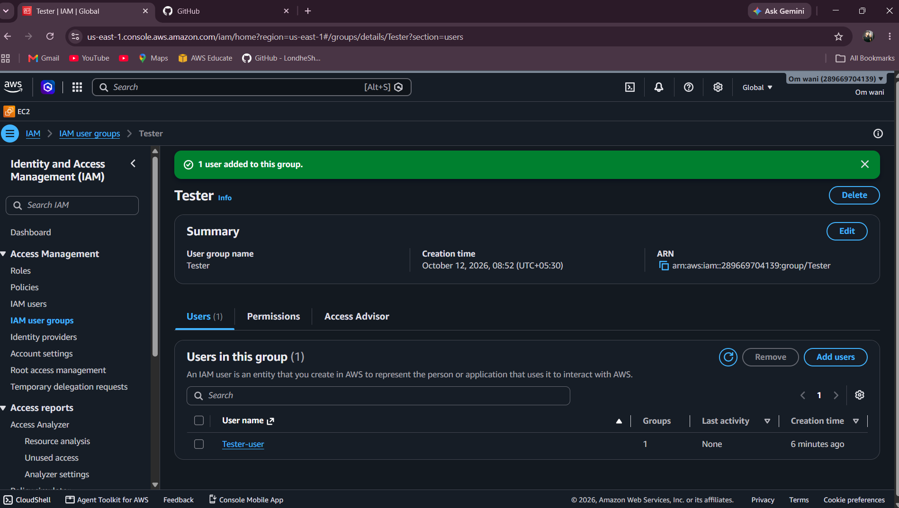

Task 2: Attach IAM policies
- Attach the AWS managed policy AmazonS3ReadOnlyAccess to the Developers group.
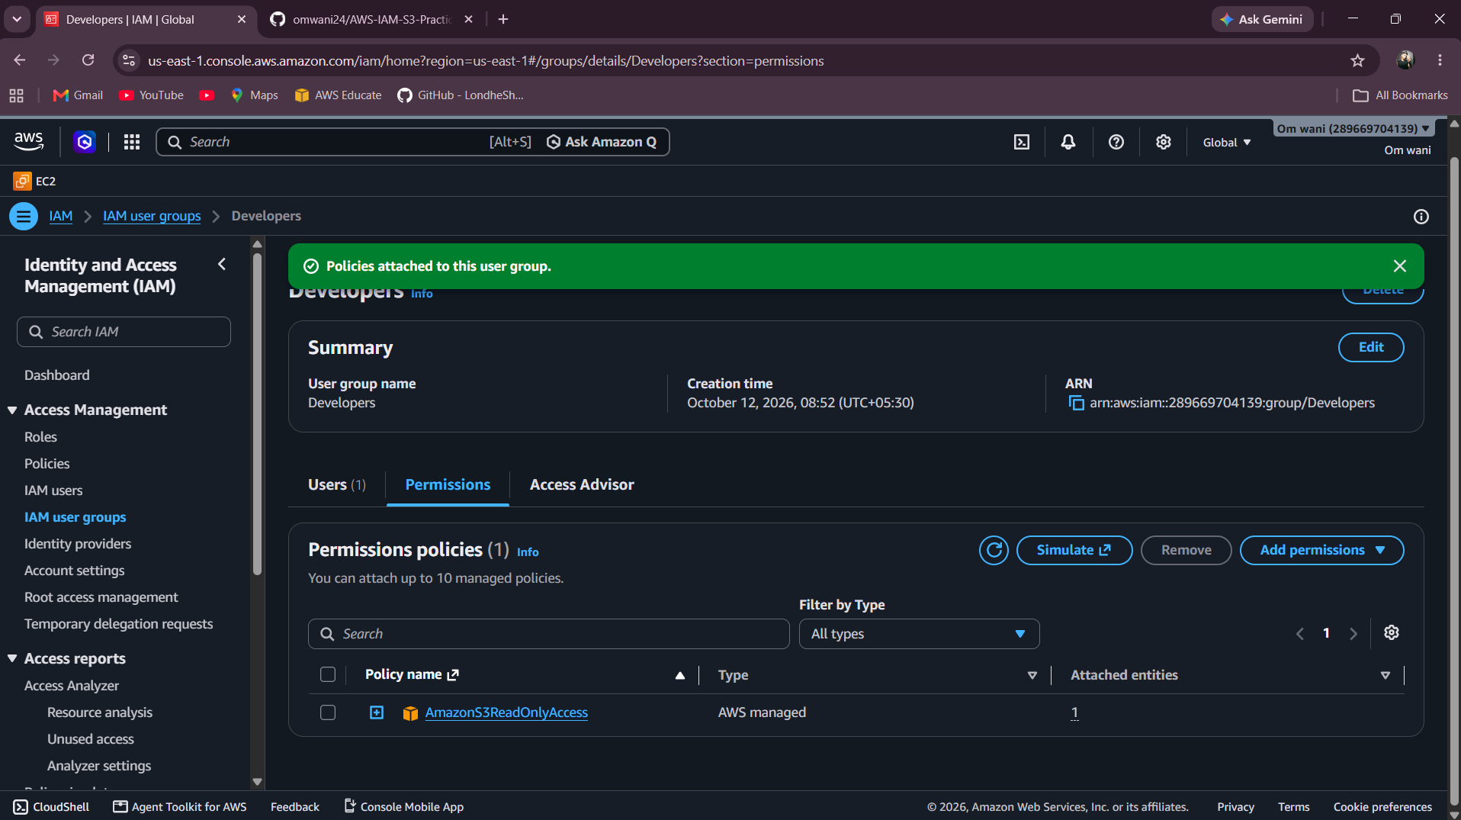

- Attach the AWS managed policy AmazonS3FullAccess to the Testers group.
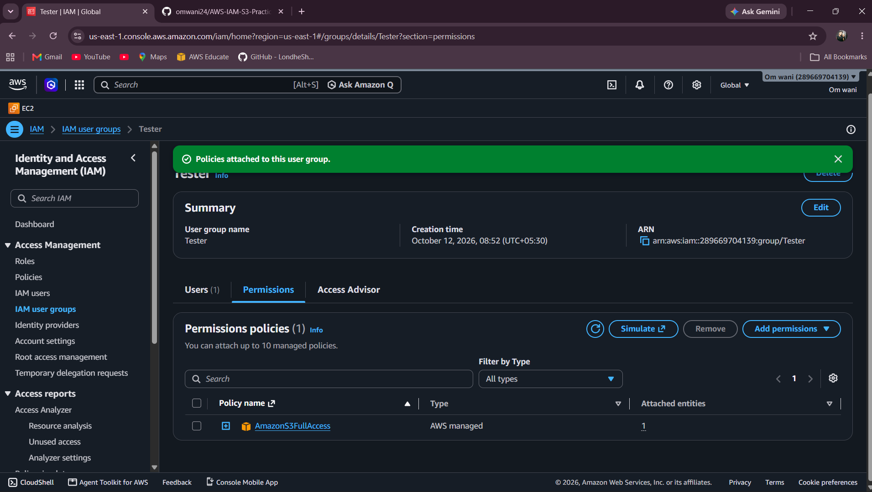

- Write one or two sentences explaining the difference between these policies.
Policies 1: AmazonS3ReadOnlyAccess= It only alow user to read and view
Policies 2: AmazonS3FullAccess= It allows to Full access to user like modife, Update

Task 3: Create a custom IAM policy
- Create a customer-managed policy named CustomS3ReadPolicy.
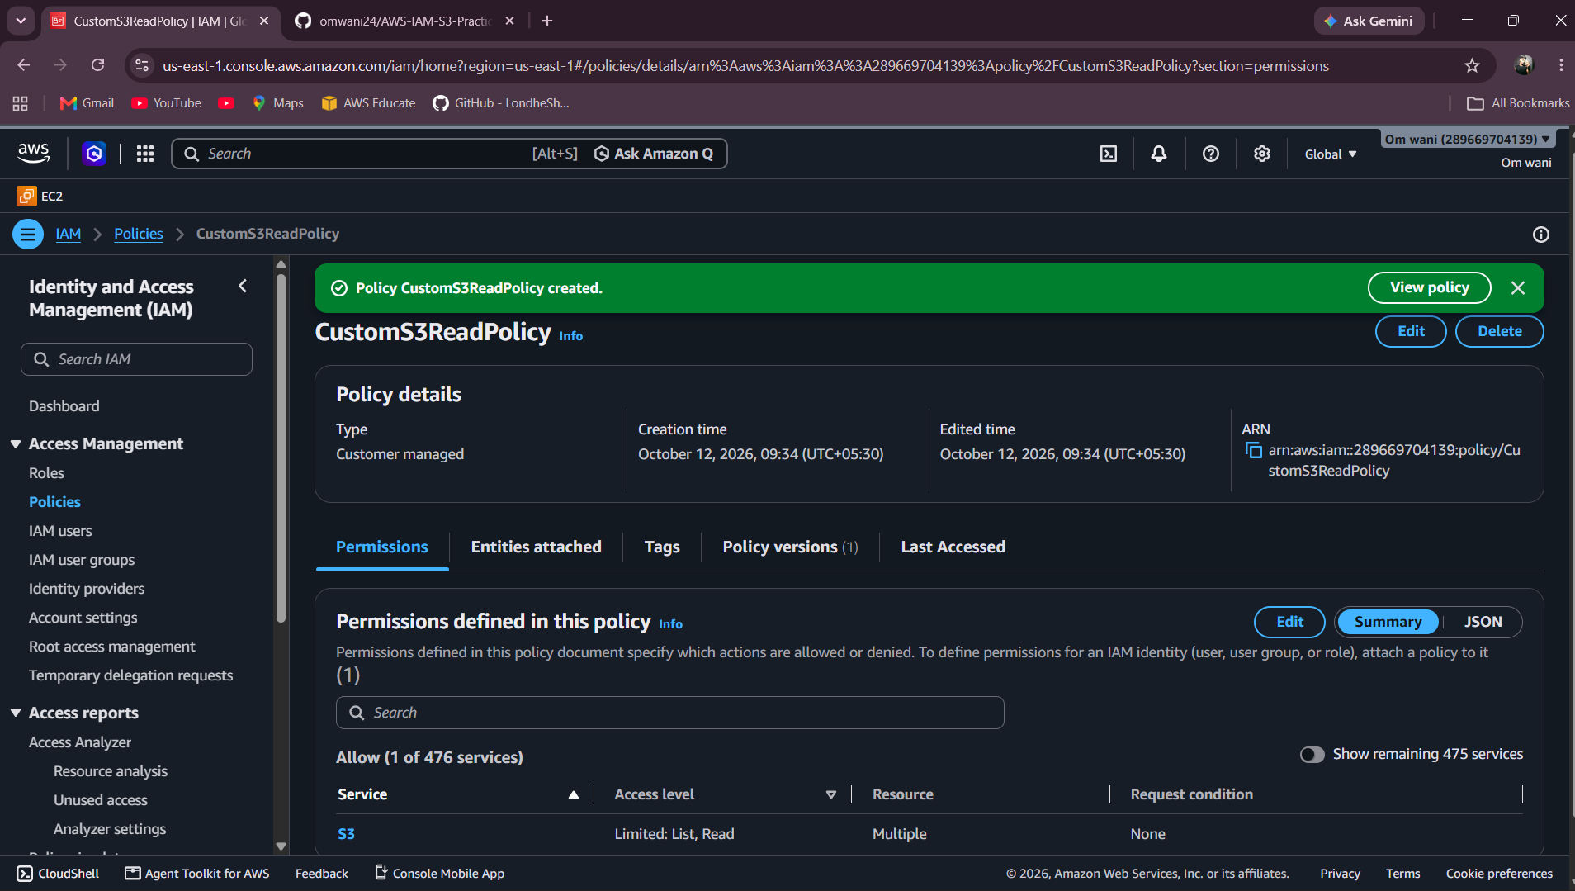

- The policy must allow listing your practical S3 bucket and reading objects in that bucket only.
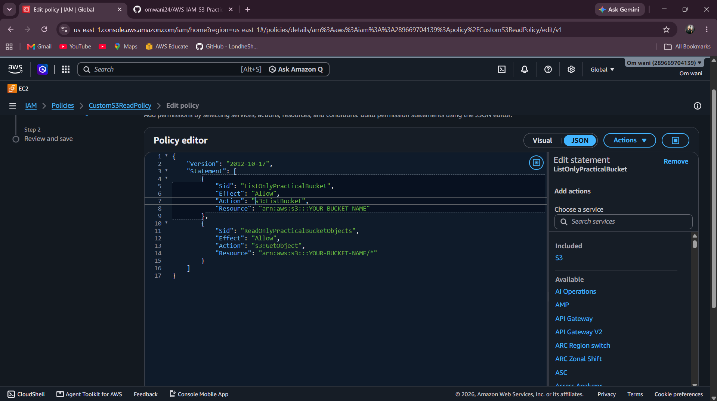

- The policy must not grant permission to upload, overwrite, or delete objects.

- Attach the policy to the appropriate test user or group. Use your actual bucket ARN and object ARN in the policy.
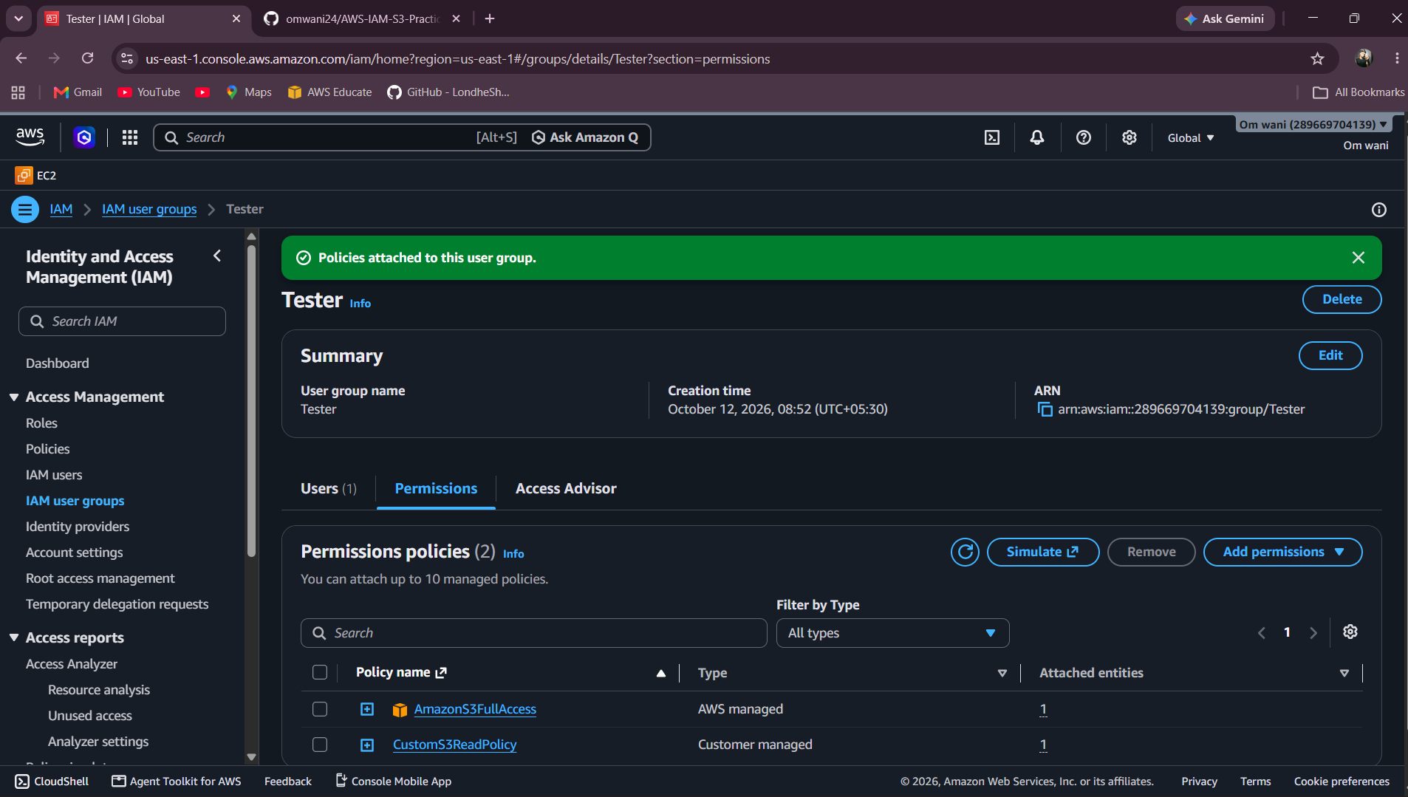

Task 4: Create an IAM role for EC2
- Create an IAM role named EC2S3ReadRole with EC2 as its trusted service.
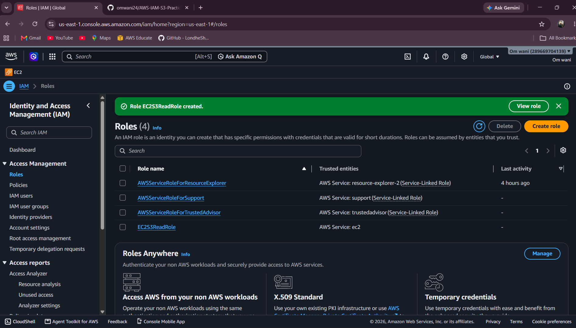

- Give the role permission to read objects from your practical S3 bucket only.
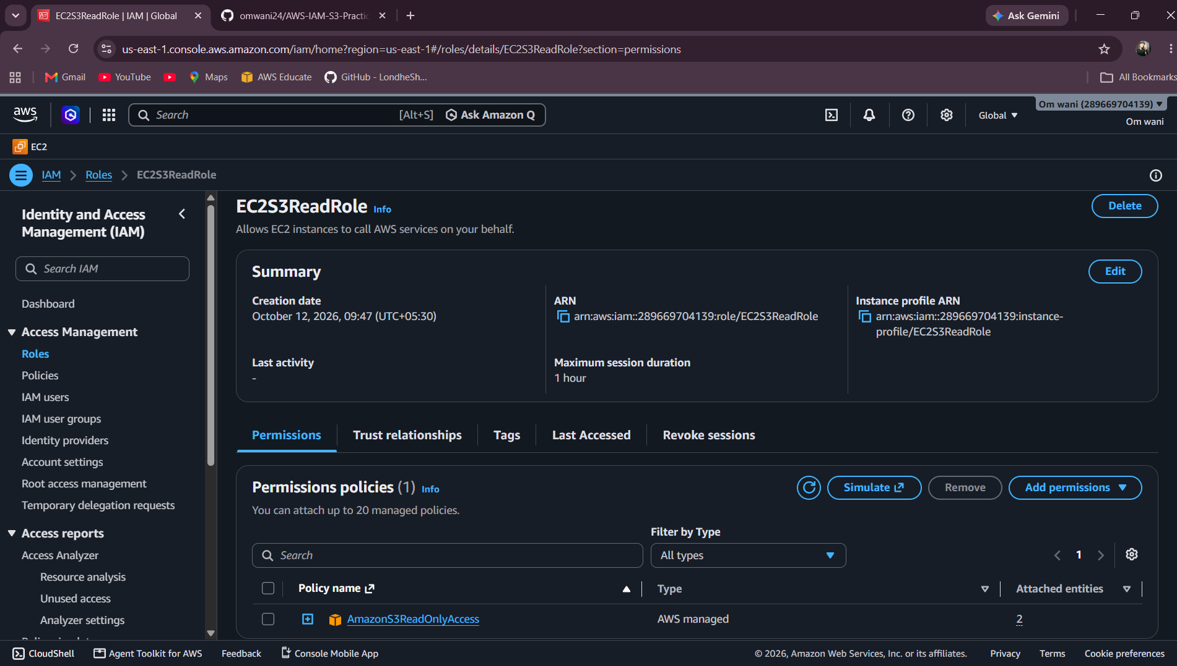
- Do not create or store long-term access keys for the EC2 instance.

- You are not required to launch an EC2 instance unless your instructor asks you to.
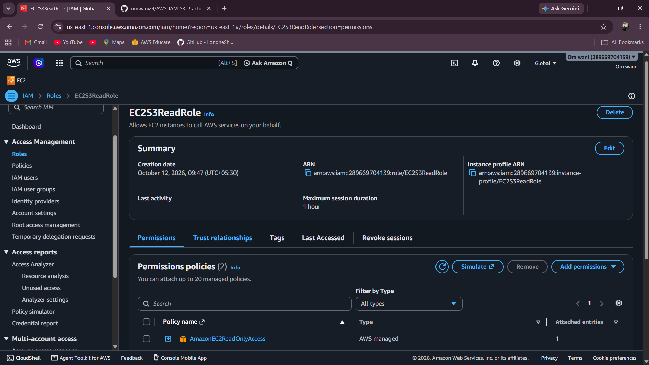
Evidence to submit: Screenshots of the role's trust relationship and permissions.
Task 5: Verify IAM permissions
- Sign in as developer-user or use an instructor-approved test method.
- Verify that the user can list and download permitted objects.
- Verify that uploading and deleting objects are denied.
- Record the action tested and whether it was allowed or denied.
Evidence to submit: A short test-results table and screenshots of successful and denied actions.

Section B — Amazon Simple Storage Service (S3)
Task 6: Create and secure an S3 bucket
- Create a uniquely named S3 bucket in the AWS Region specified by your instructor.
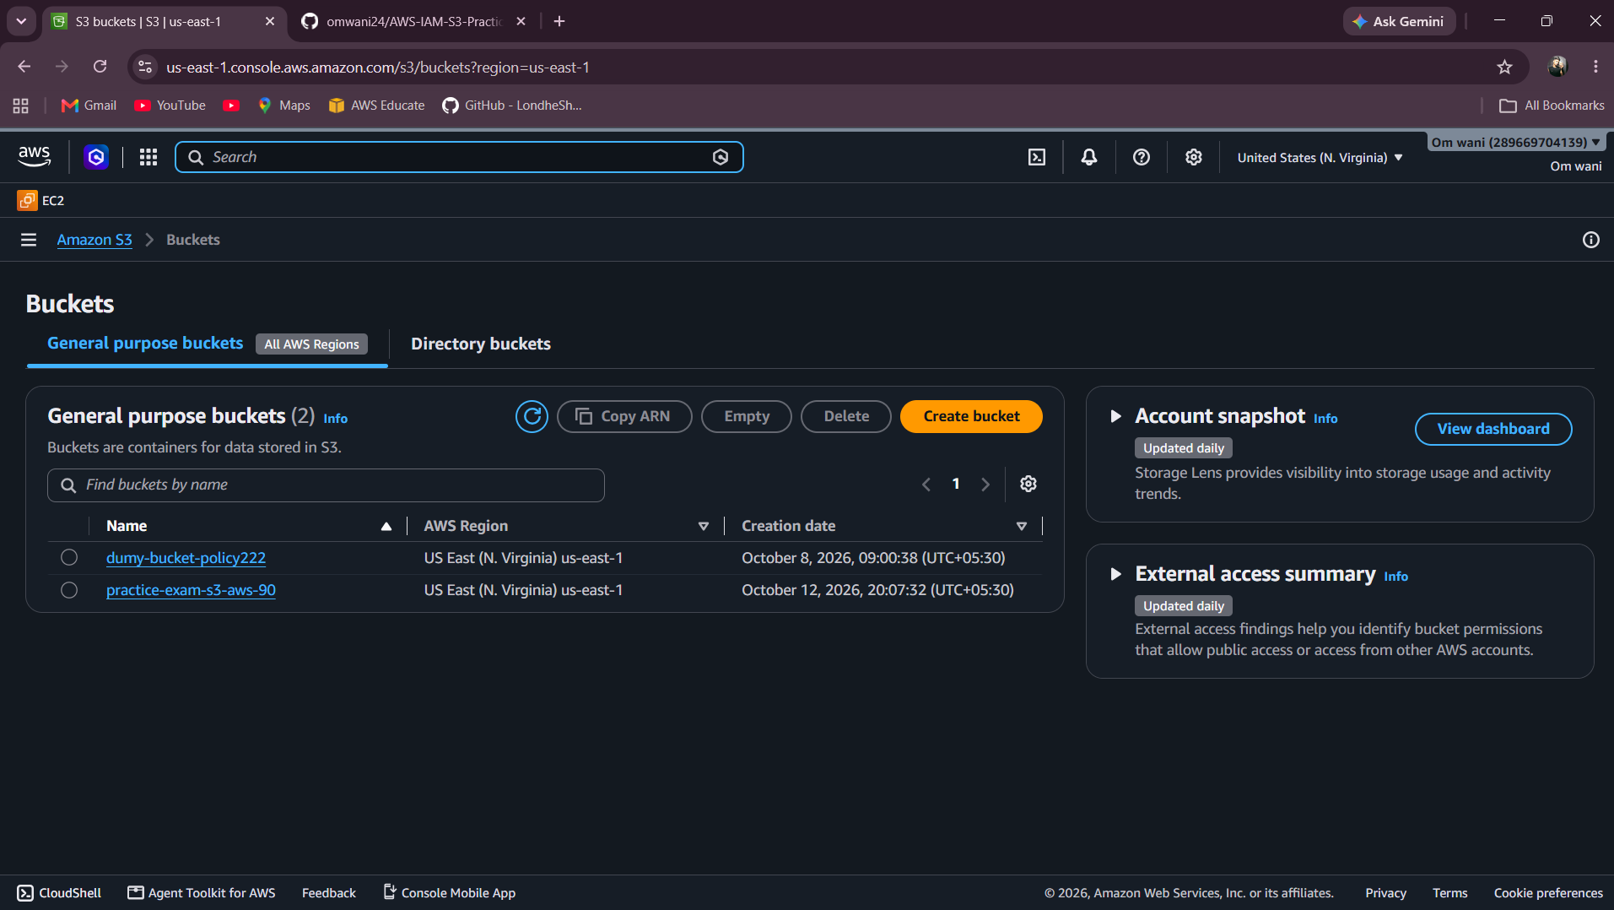

- Keep Block Public Access enabled.
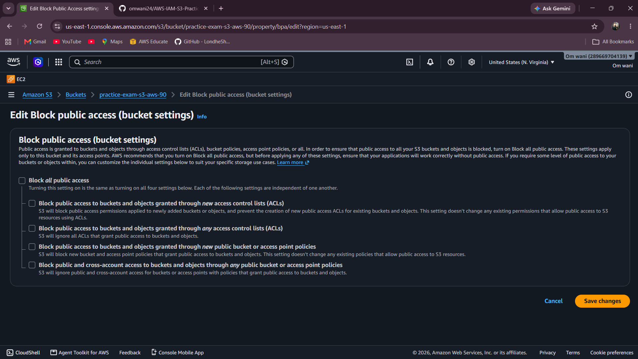

- Enable default server-side encryption using the available AWS-managed encryption option.
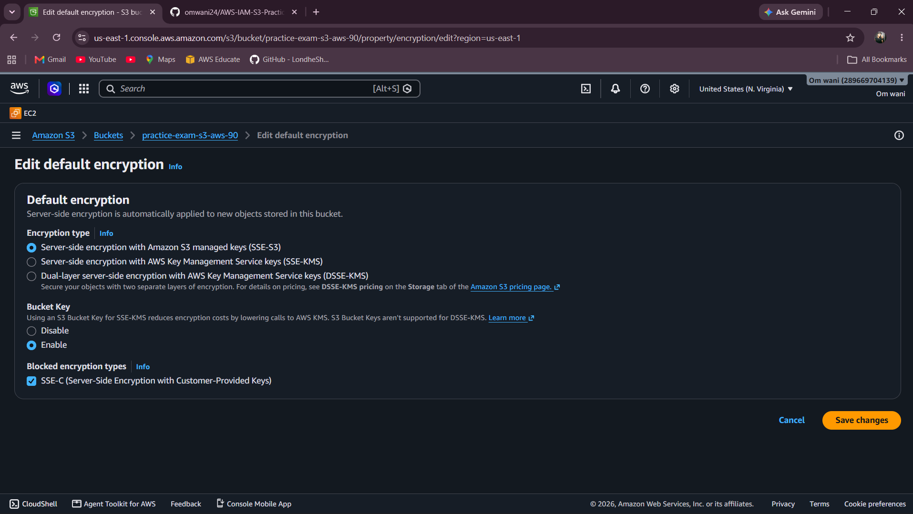

- Upload three sample files to the bucket.
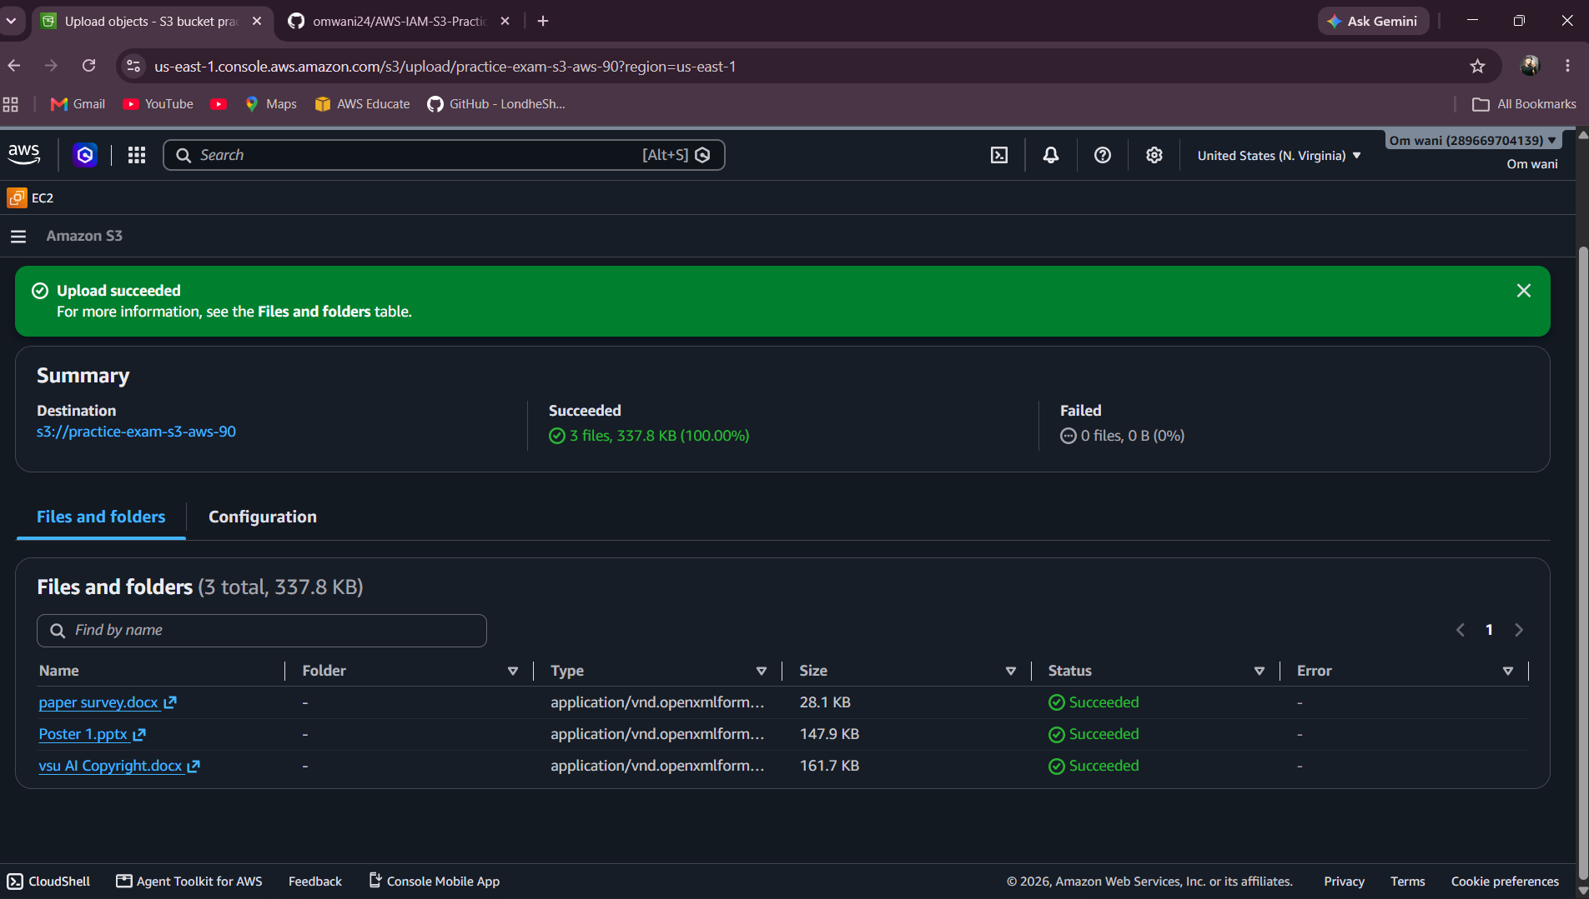

Task 7: Organize objects and enable versioning
- Create the prefixes documents/, images/, and backups/ in your bucket.
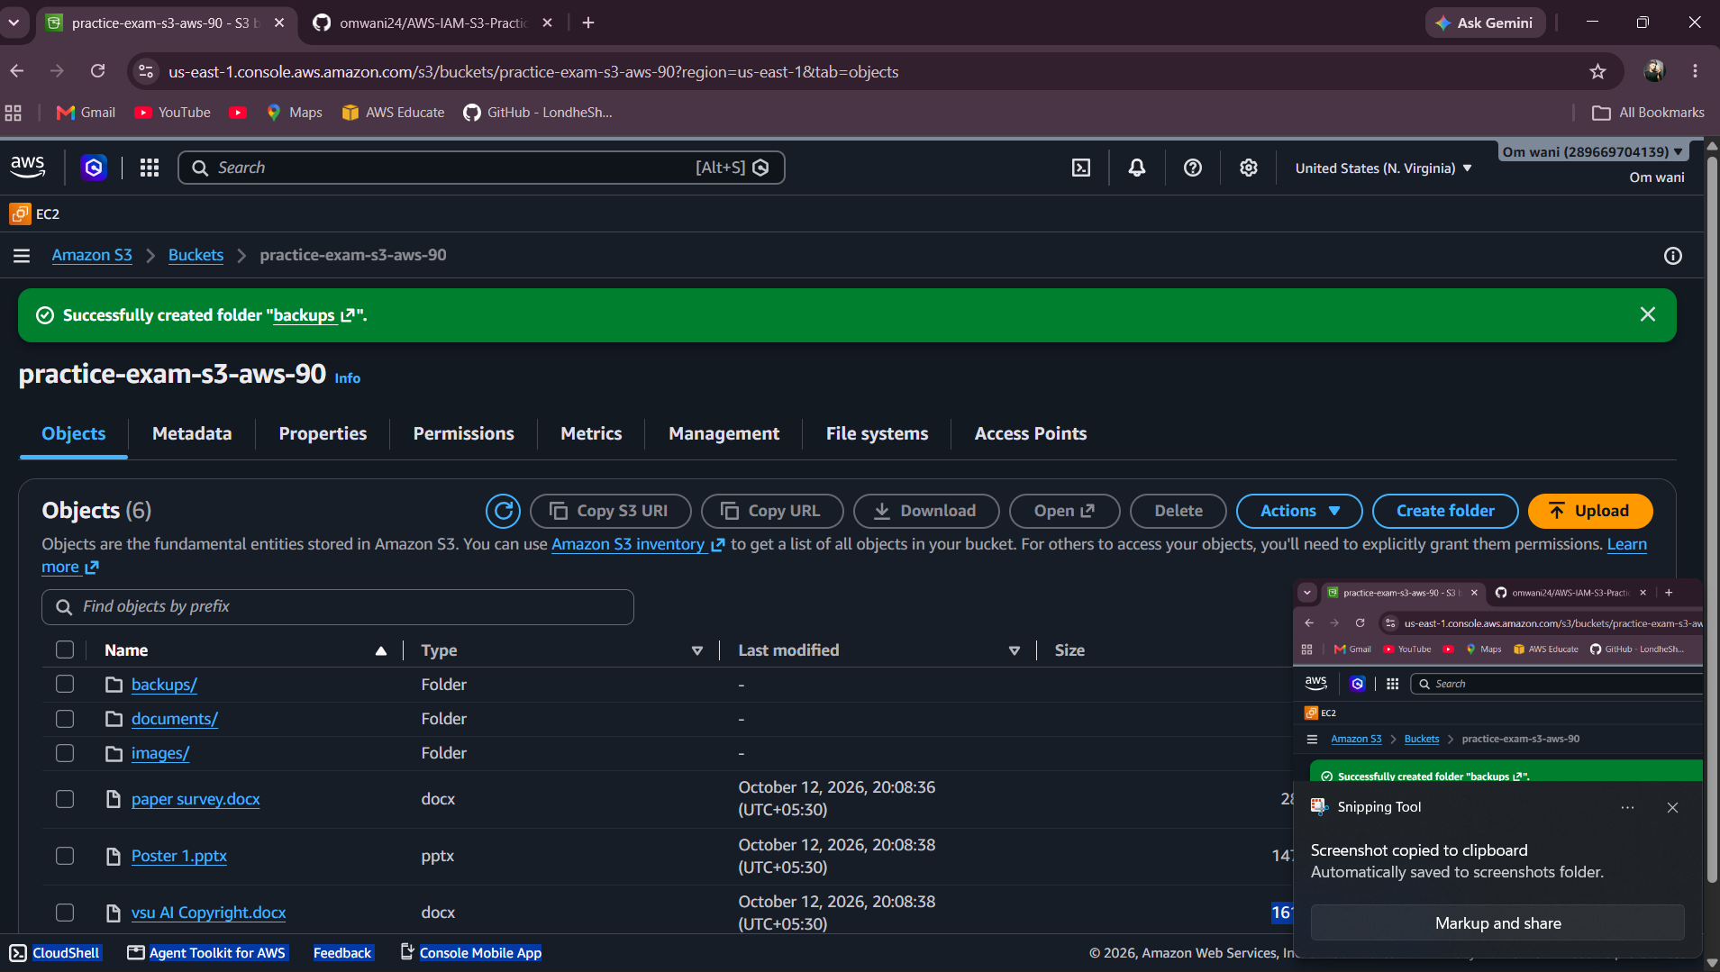

- Place at least one appropriate sample object under each prefix.
1.documents
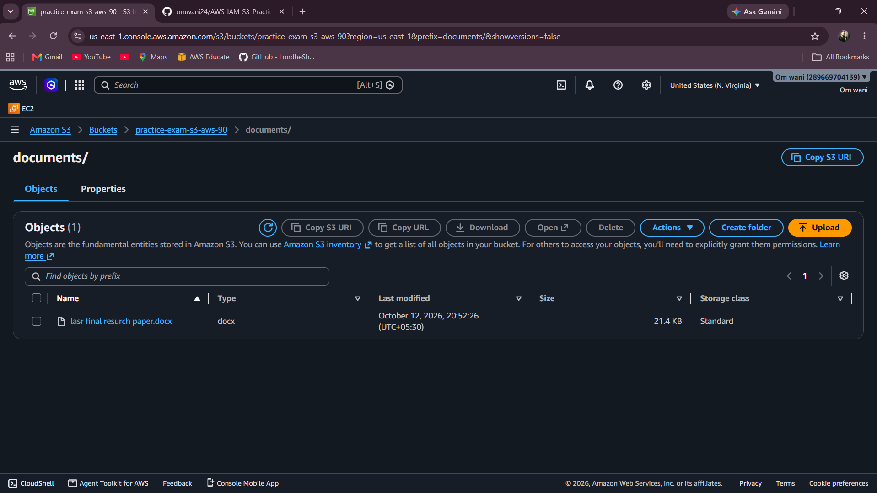

2.image
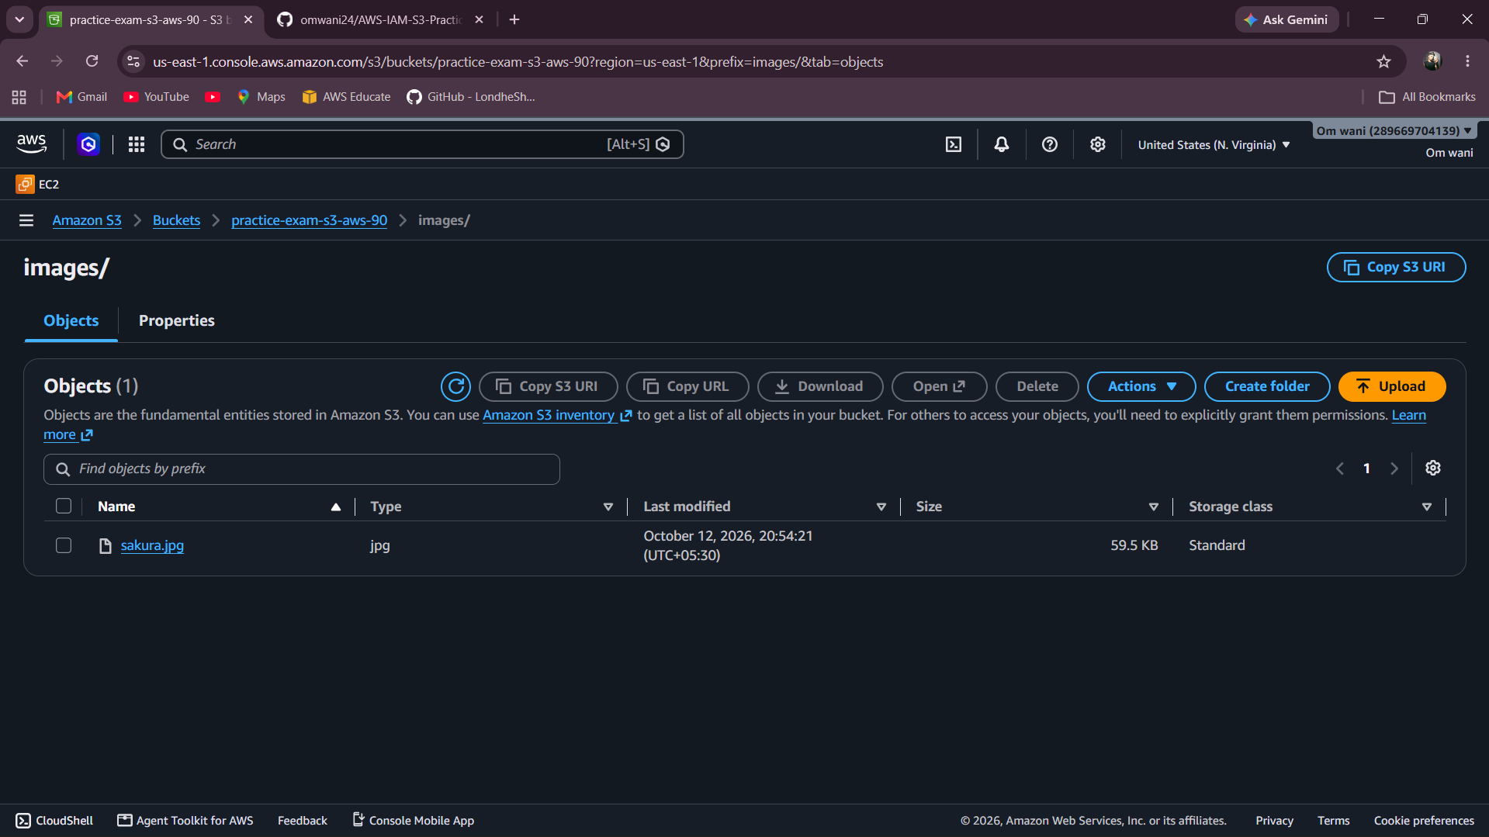

3.backup
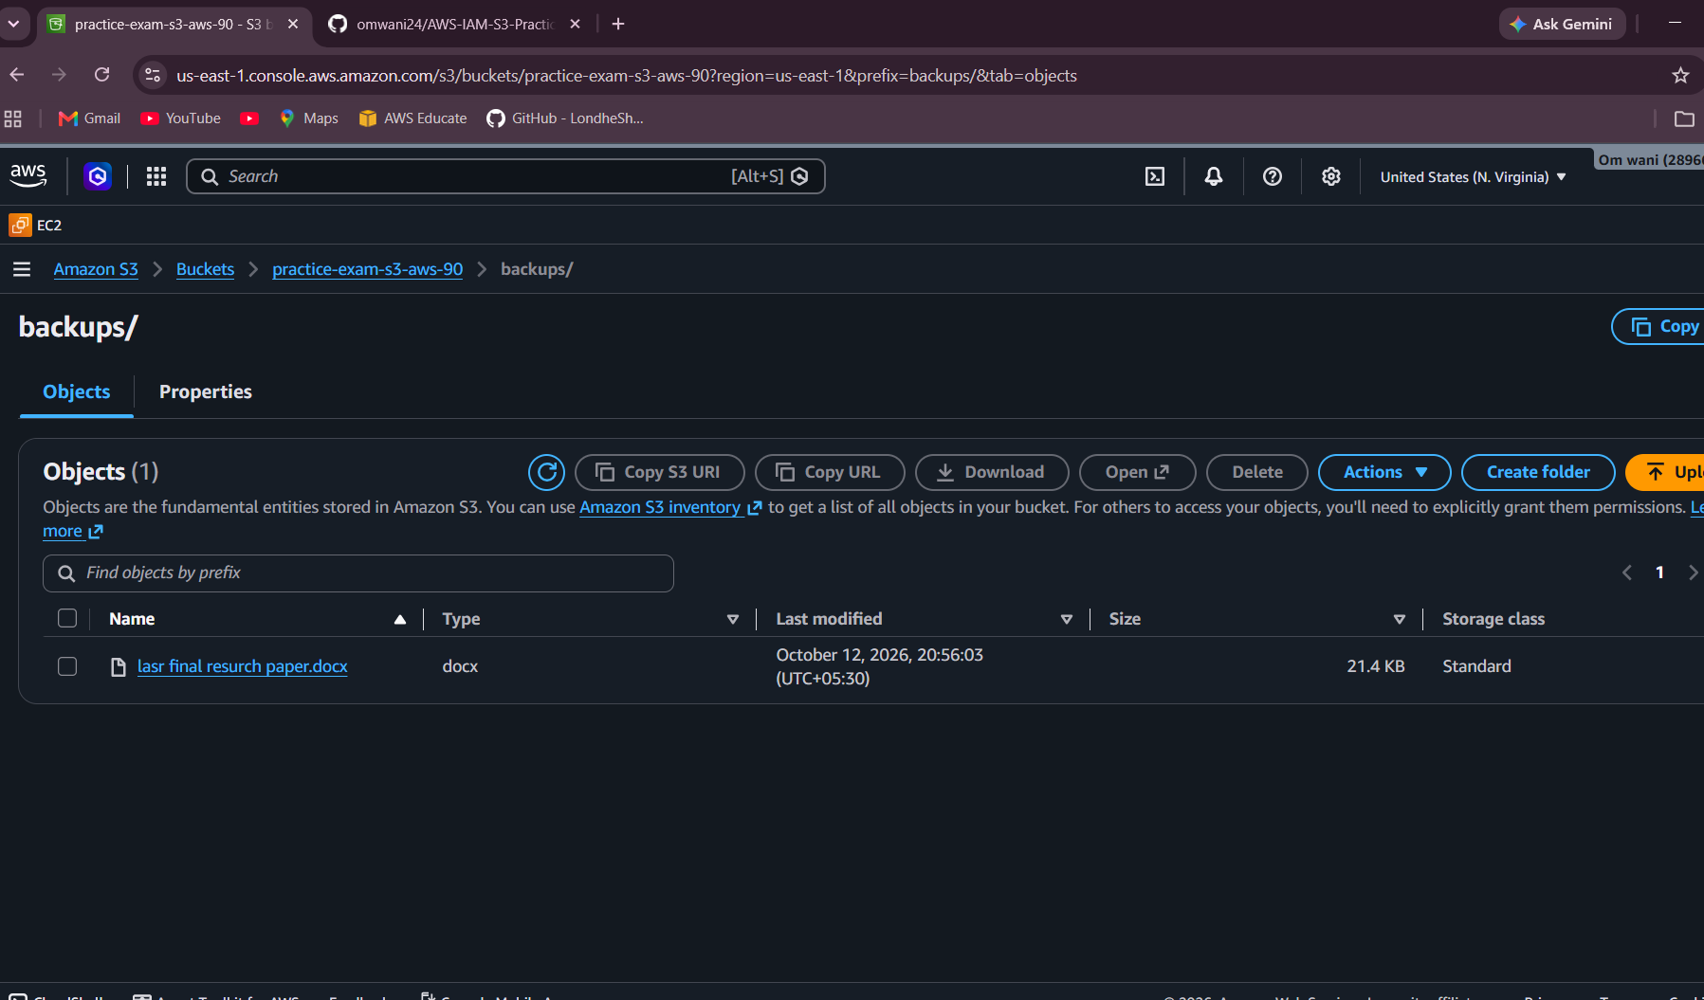

- Enable bucket versioning.
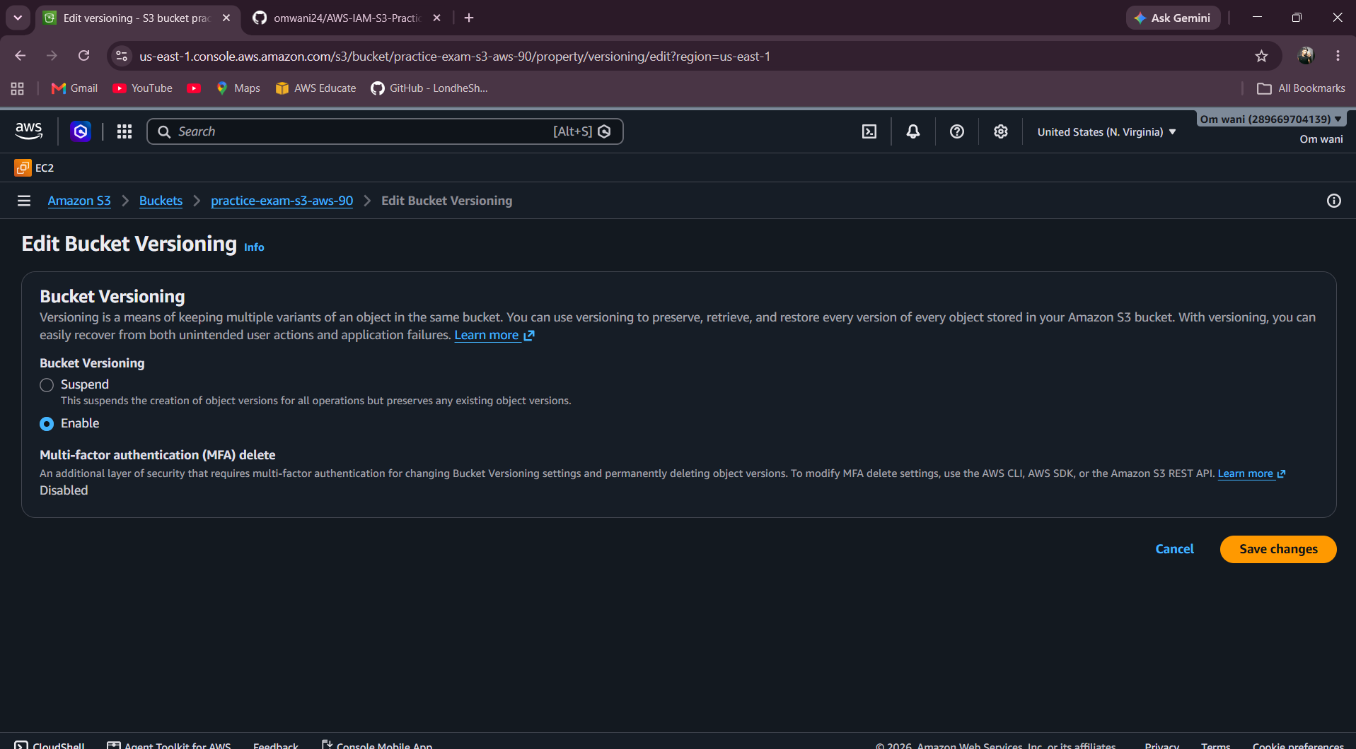

- Upload report.txt, change its content, and upload it again using the same object key.
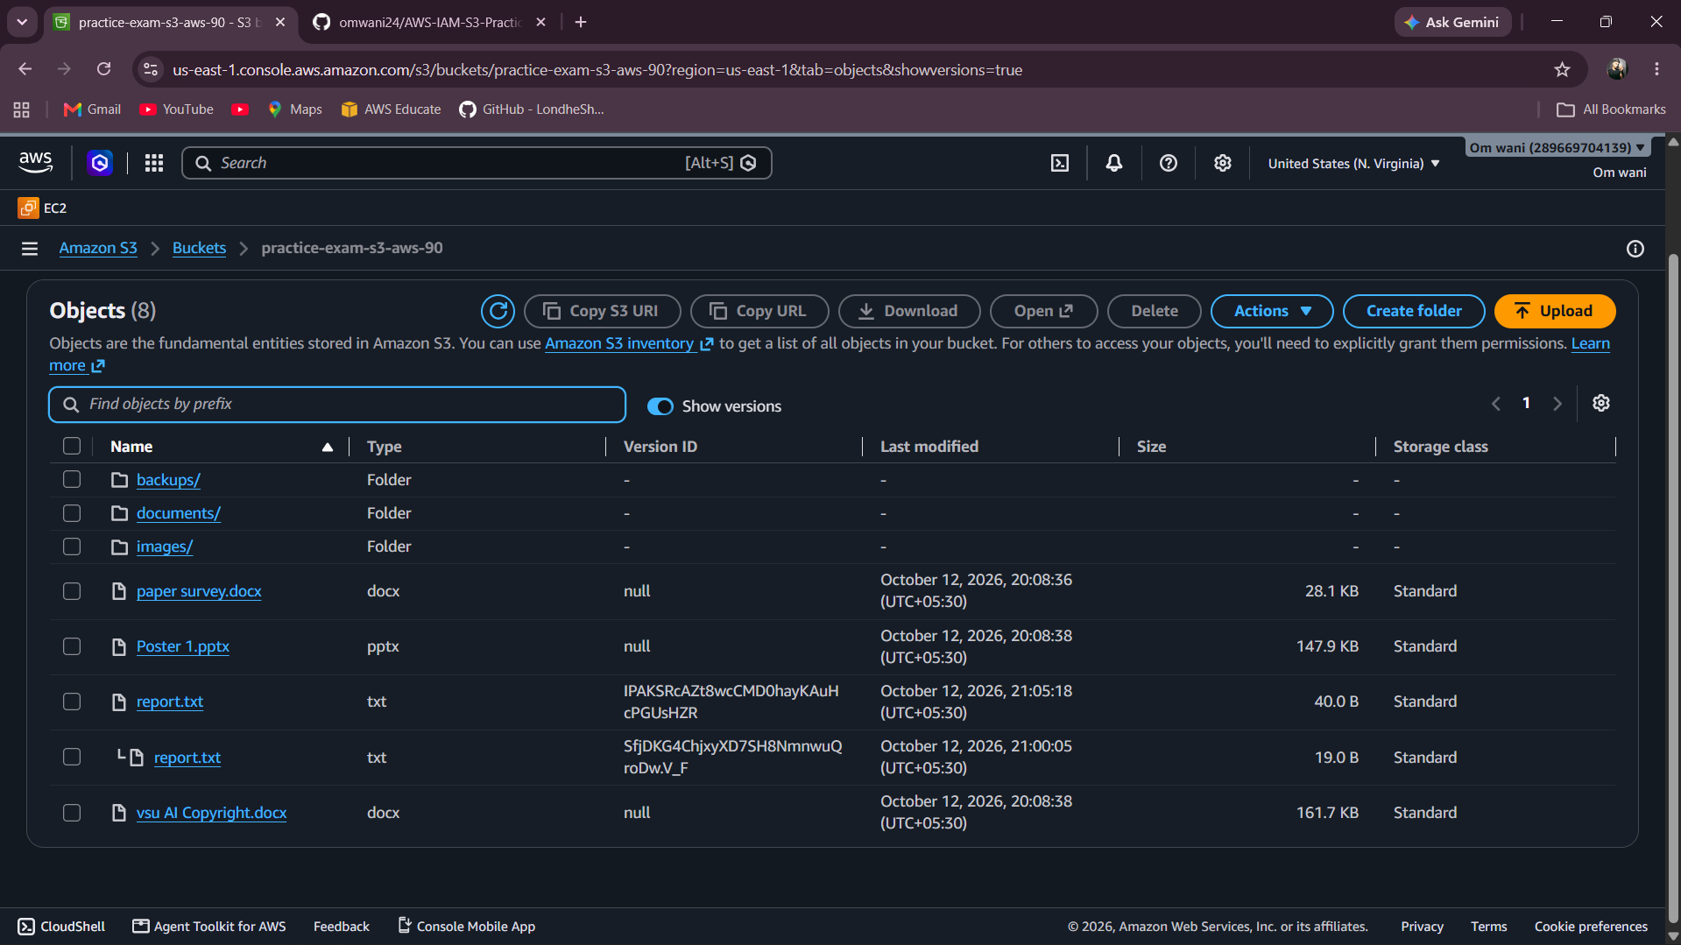

- Show the versions and demonstrate how to restore the earlier content as the current version.
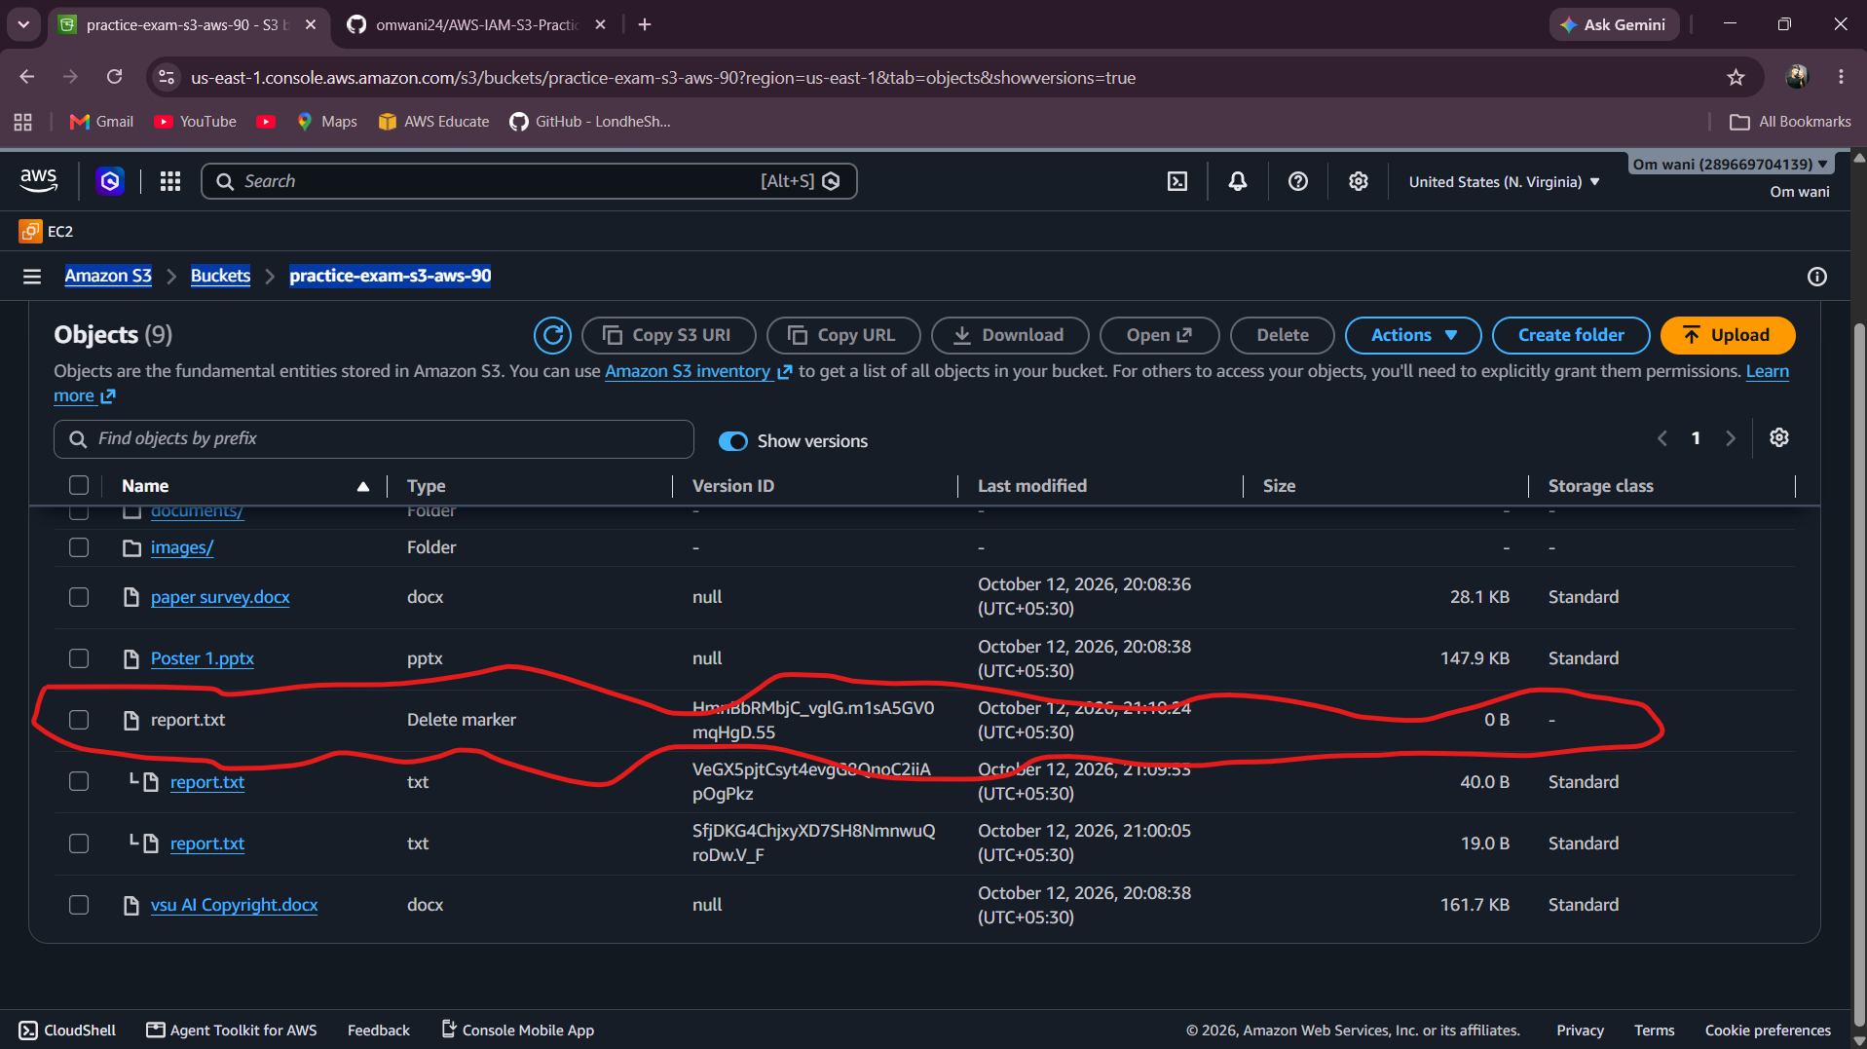

Task 8: Configure an S3 bucket policy
- Configure the bucket so that the IAM principal developer-user can read objects from it.
- Use the correct bucket and object ARNs in the policy.
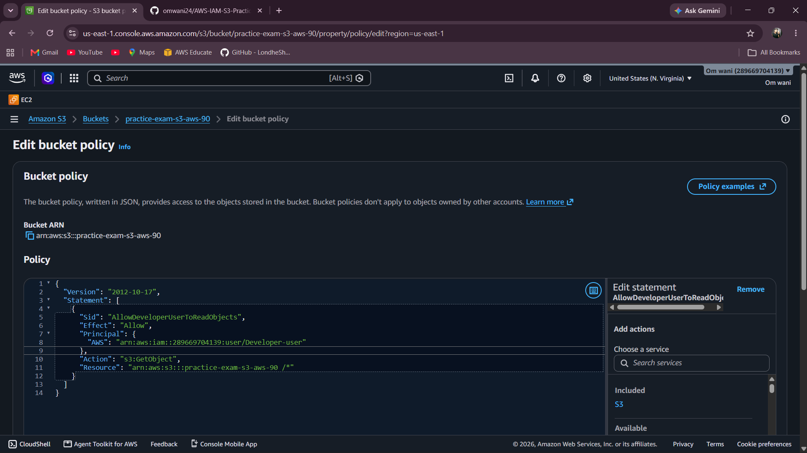

- Keep anonymous/public access blocked. Do not add a public Allow statement.
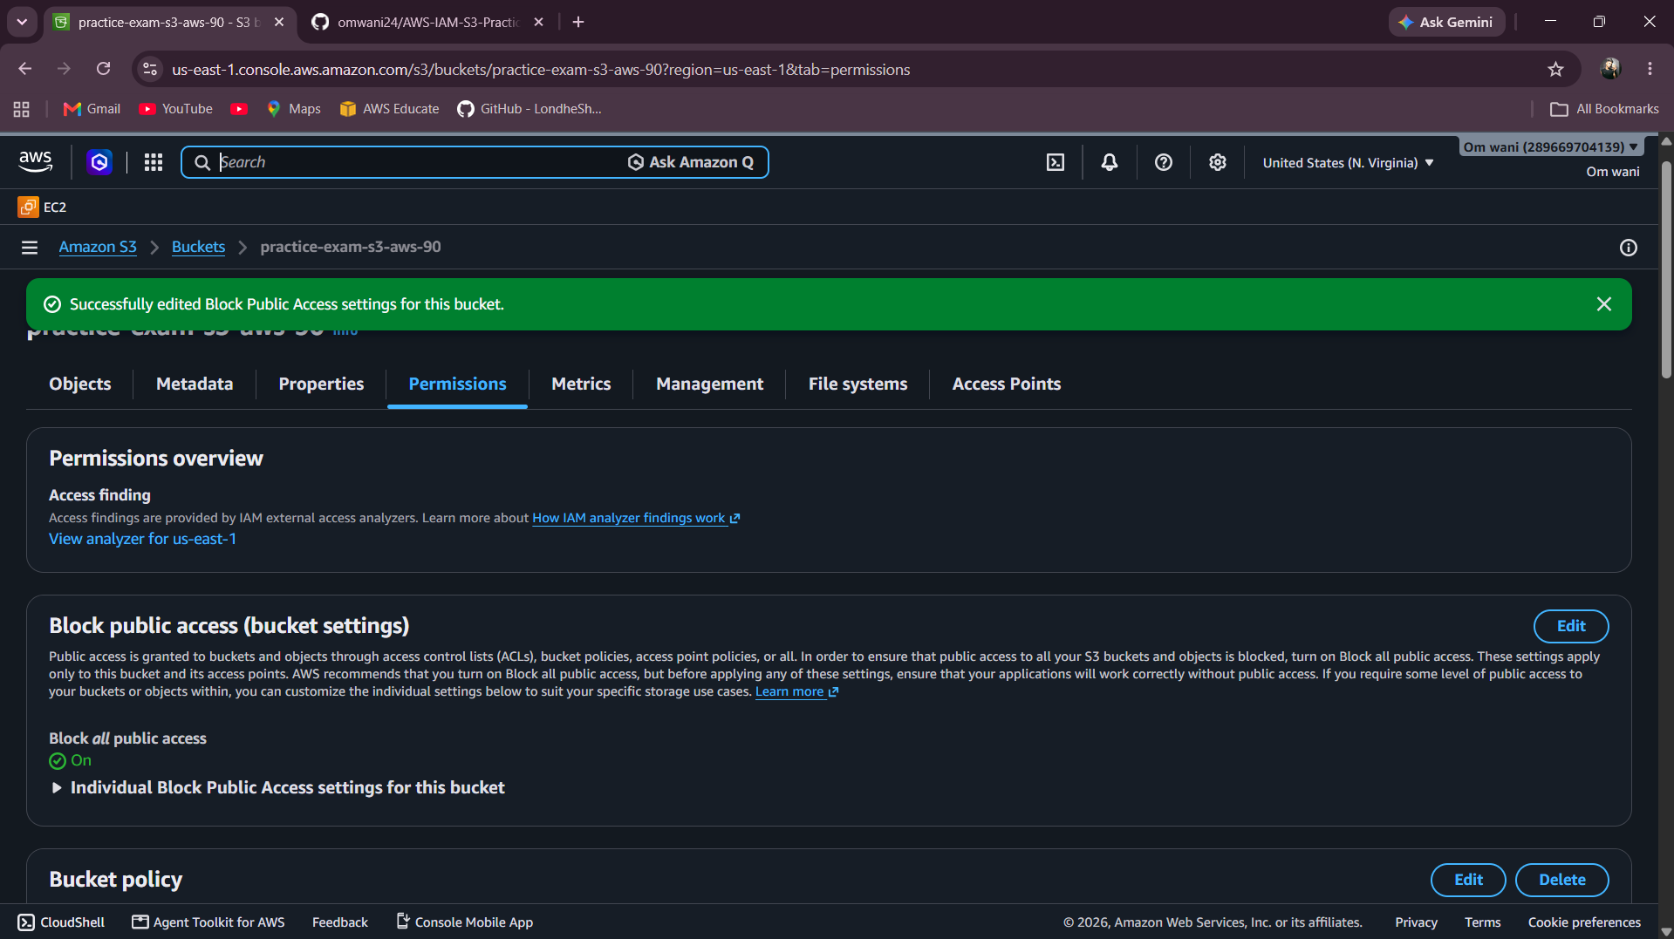

- Test access as the intended principal and explain how you confirmed that public access remains blocked.

Evidence to submit: Bucket policy JSON and screenshots of access tests. If the bucket policy and IAM policy both apply, explain how you checked the effective permissions.
Task 9: Configure a lifecycle rule
- Create a lifecycle rule named BackupTransitionRule for objects under the backups/ prefix.
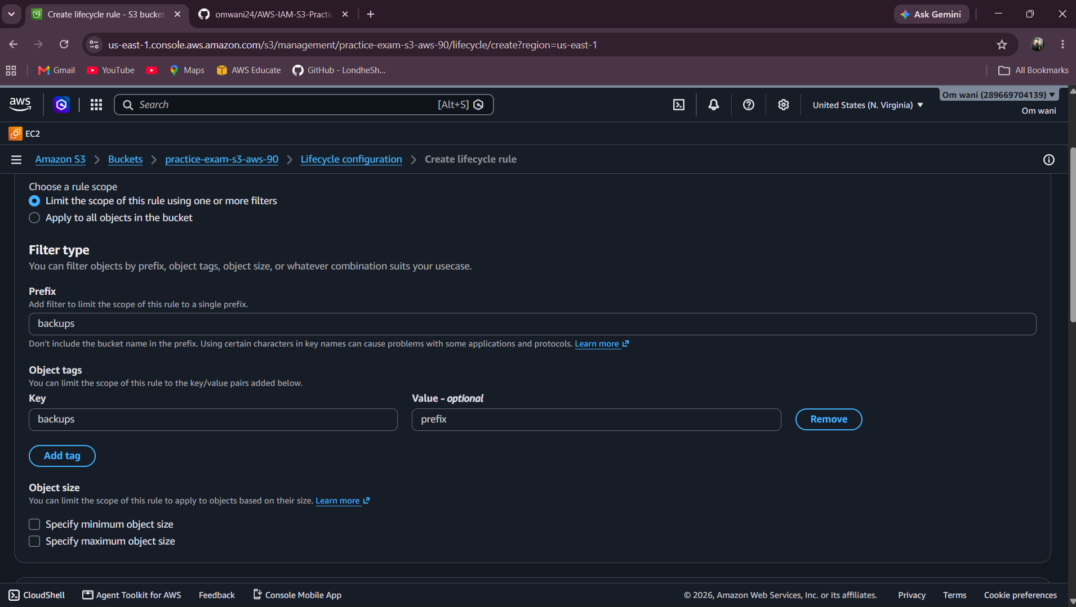

- Configure eligible objects to transition to S3 Standard-IA after 30 days.
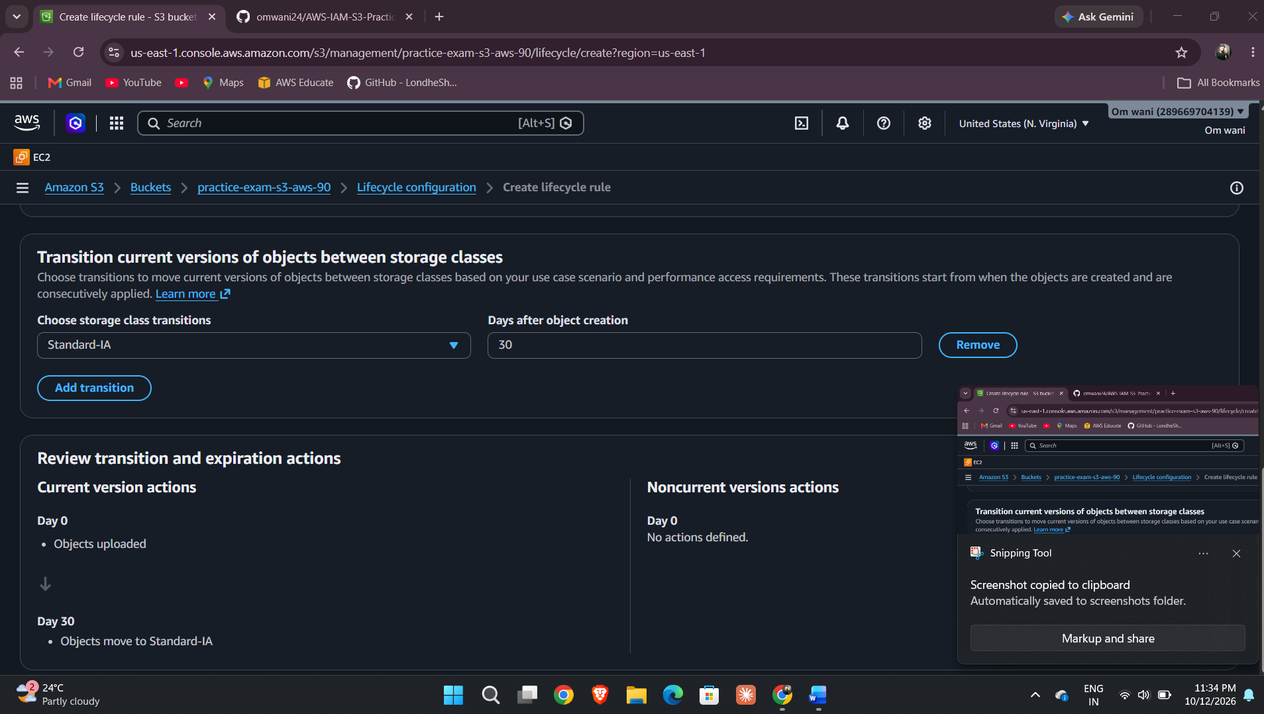

- Ensure the rule is enabled and inspect the rule summary.
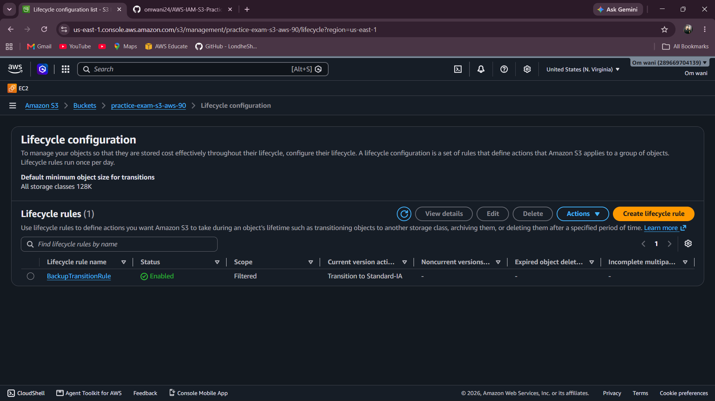

- Explain why a newly uploaded object may not transition immediately and mention relevant storage-duration or object-size considerations.
Ans= because it is in waiting of 30 days period, it has a minimum storage duration of 30 days.

Task 10: Configure server access logging
- Create a separate destination bucket for access logs.
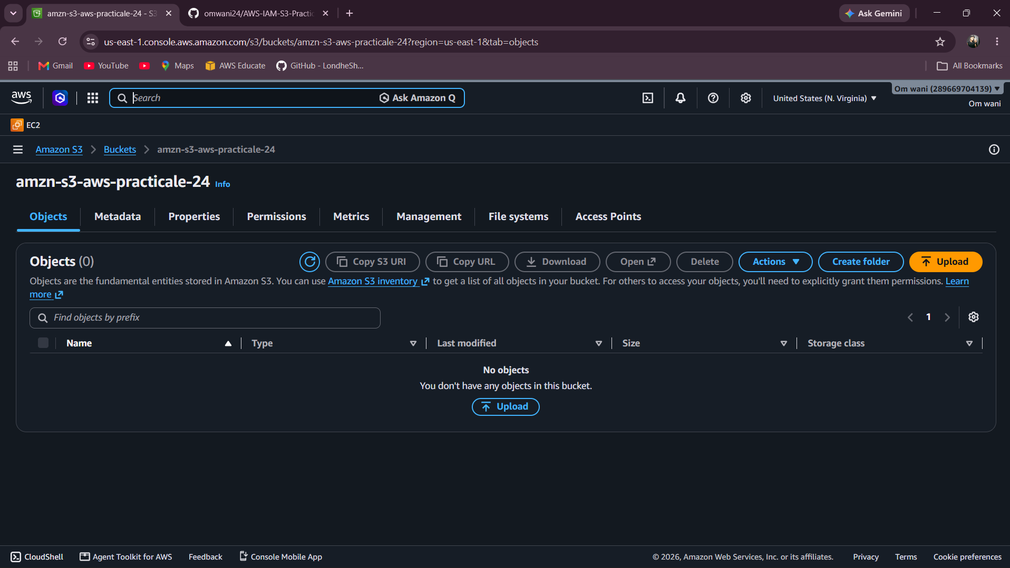

- Configure the source bucket to deliver server access logs to the destination bucket.
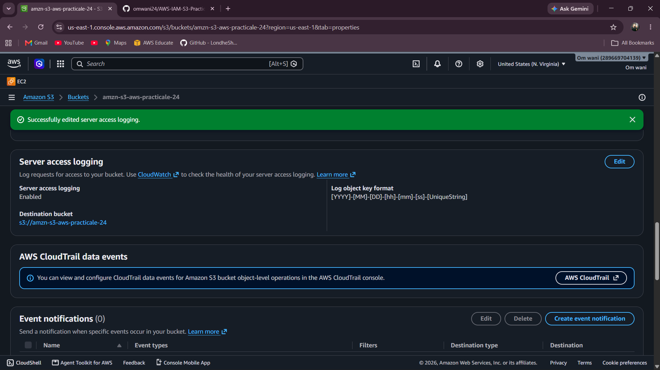

- Verify the logging configuration and destination permissions.

- State why logs may not appear immediately after you enable logging.

Evidence to submit: Screenshots of the source logging configuration and destination bucket. Do not claim log delivery is verified until a log object is present.
Task 11: Explain encryption and access controls
- Open the properties of one uploaded object and identify the server-side encryption setting.
- Explain the difference between IAM permissions and an S3 bucket policy.
- Explain why Block Public Access is useful.
Evidence to submit: Screenshots of object encryption details and brief written answers.

