Advanced Data Visualization and Storytelling
  - Understanding penguin size through five visual perspectives
YuvaIntern Week 2
Virtual Data Science with Python Apprentice Intern

The story in brief
Penguins in this sample do not share one typical body size. Gentoo are generally heavier than Adelie and Chinstrap, and males have higher median mass than females within each species. Longer flippers accompany greater mass, but the relationship looks stronger when different species are pooled. Five visualizations explain these findings while showing why sampling context matters.

Audience and purpose
This report is written for a non-technical reader reviewing a biological field dataset. It develops the Week 1 analysis into a visual narrative: first understand who was sampled, then compare distributions, examine sex differences, inspect relationships within species, and finally check whether the broad contrast appears across collection years.

Data and methodology
The source is the public Palmer Penguins simplified dataset, distributed by the palmerpenguins project [1, 2]. The source snapshot was downloaded on 30 September 2026 for Week 1 and reused here. It describes three species on three islands during 2007–2009. The original 344 rows contain eight variables, including body mass in grams and flipper length in millimetres.
Pandas loads the unchanged source, normalizes text labels and checks numeric parsing and duplicates. Zero exact duplicate rows are found. Two rows without physical measurements are excluded, leaving 342. Nine retained records have unknown sex; only the sex comparison excludes these, using 333 records. Physical measurements are not imputed and extreme values are retained. Group summaries and charts are generated by the included Python script using Matplotlib.
All results describe this sample. No significance tests, causal claims or population forecasts are made. Source and derived CSV files, five chart images and numerical audit tables accompany this report.

Start with the sample
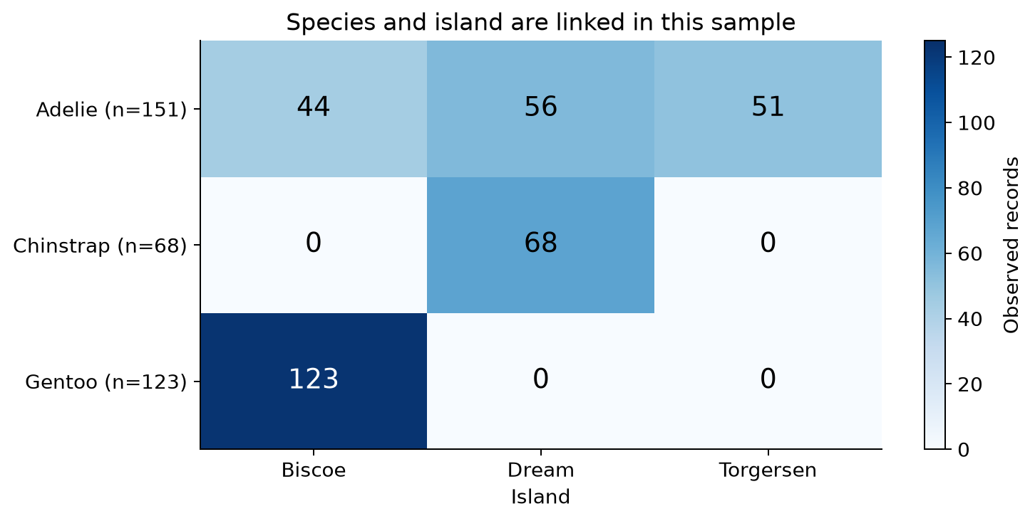
Figure 1. Annotated heatmap of species by island after cleaning, n = 342. Each cell is an observed record count; darker blue means more records.

What the chart shows
Read across each row to see where a species was sampled. Adelie appears on Biscoe (44), Dream (56) and Torgersen (51). All 68 Chinstrap records are from Dream and all 123 Gentoo records are from Biscoe. A zero means no retained observation in this dataset, not proof that the species is absent from that island.

Why this visual works
A heatmap condenses nine counts into a single view. Printed counts preserve precision, while shading makes the uneven coverage apparent. This is more useful for the opening question than a species-only bar chart, which would hide location.

Interpretation and limits
Species and island are linked in the sample. An overall comparison of island body masses would mix differences in species composition with any location differences. Future comparisons should control or stratify by species and inspect the original sampling design.

Python excerpt
composition = pd.crosstab(df.species, df.island)
ax.imshow(composition, cmap='Blues', vmin=0, vmax=125)

Compare whole distributions
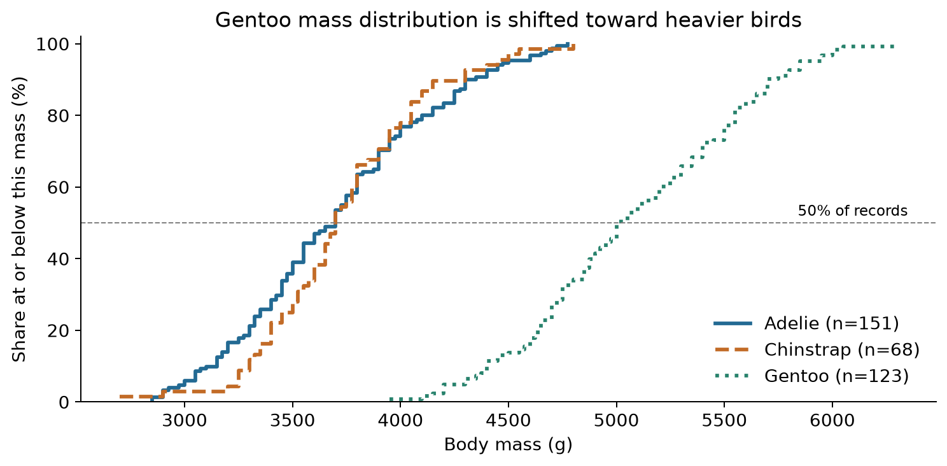
Figure 2. Empirical cumulative distributions of body mass: Adelie n = 151, Chinstrap n = 68, Gentoo n = 123. Line styles supplement species colors.

What the chart shows
Choose a body mass on the horizontal axis, then read the line height to find the percentage of that species at or below that mass. Gentoo is shifted to the right, meaning heavier observations. The species medians are 3,700 g for Adelie, 3,700 g for Chinstrap and 5,000 g for Gentoo. The Gentoo median is 1,300 g higher.

Why this visual works
The cumulative chart shows every observation without choosing histogram bins or smoothing settings. Percentages let readers compare groups with unequal sample sizes. The 50% reference line makes the middle of each distribution easy to locate. With an even sample size, the reported median averages the two middle observations and may lie within a step.

Interpretation and limits
The distributions overlap, so mass alone does not perfectly identify species. The contrast concerns measured individuals; it does not establish a universal threshold or estimate the proportion of each species in the wild.

Python excerpt
x = np.sort(df.loc[df.species == s, 'body_mass_g'])
y = np.arange(1, len(x) + 1) / len(x) * 100
ax.step(x, y, where='post', label=s)

Look within species and sex
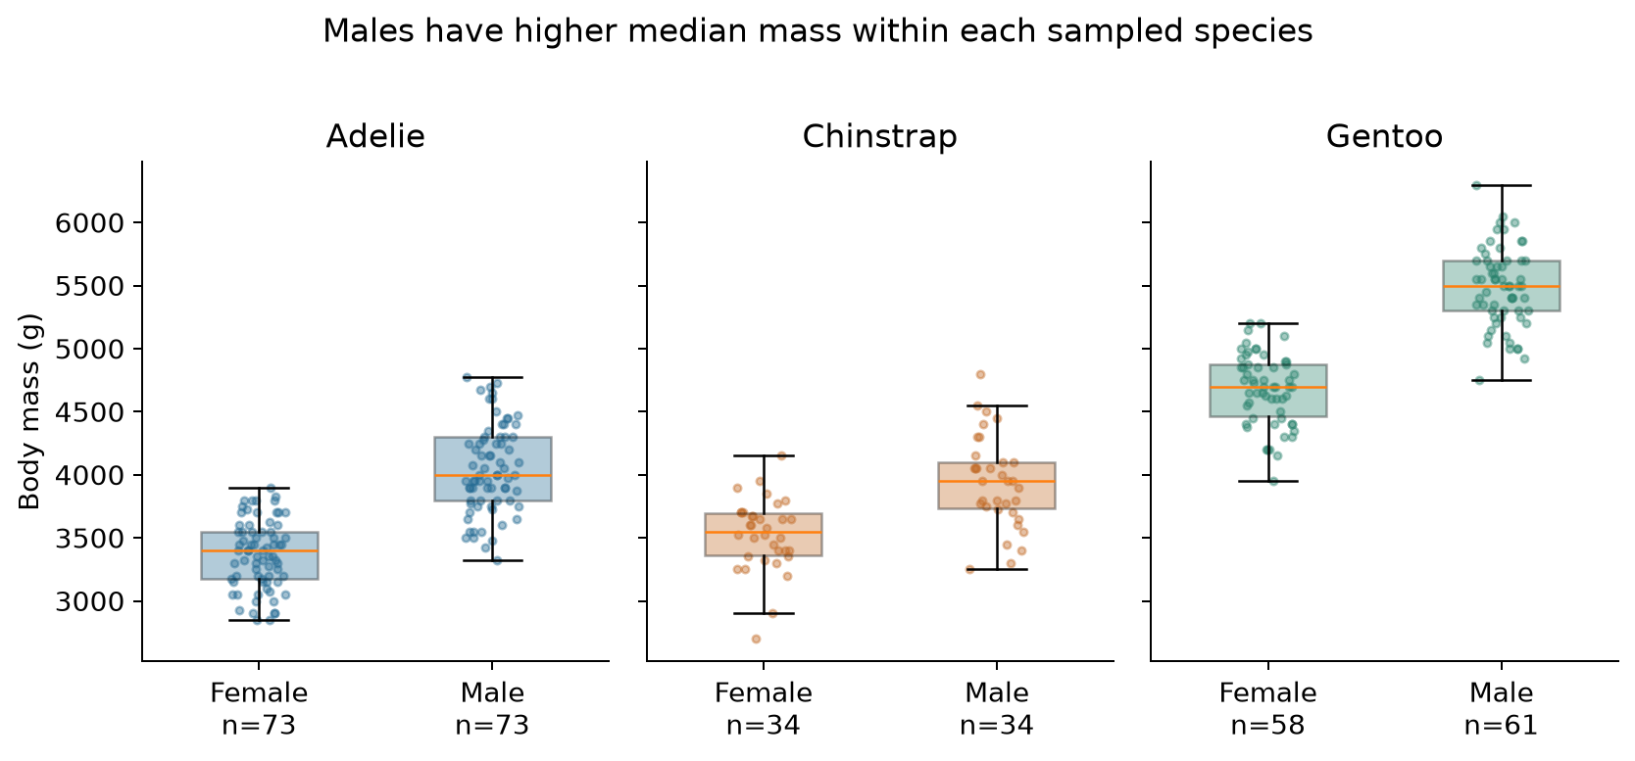
Figure 3. Box plots with individual observations for known-sex records, n = 333. Boxes span the middle 50%, orange lines mark medians, and whiskers use 1.5 IQR. All observations are shown as points.

What the chart shows
Within each species, the male median exceeds the female median: Adelie 4,000 versus 3,400 g; Chinstrap 3,950 versus 3,550 g; and Gentoo 5,500 versus 4,700 g. The corresponding median gaps are 600, 400 and 800 g. The sexes still overlap in measured mass.

Why this visual works
Separate species panels prevent different species from being mistaken for a sex effect. A common vertical scale supports honest comparison. Box plots summarize spread, while transparent points show the underlying observations. A small horizontal jitter separates coincident points without changing mass; its random seed is fixed at 42.

Interpretation and limits
Nine records with unknown sex are omitted only here: five Adelie and four Gentoo. Missing sex may affect representativeness. The chart suggests that sex composition belongs in future comparisons, but does not quantify an adjusted effect or establish statistical significance.

Python excerpt
known = df.loc[df.sex != 'Unknown']
sex_summary = known.groupby(['species', 'sex'])
print(sex_summary.body_mass_g.agg(['size', 'median']))

Separate the relationships
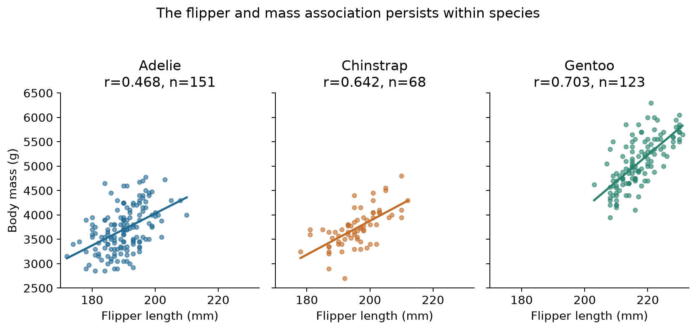
Figure 4. Faceted scatter plots with identical axes, observed sample sizes and Pearson correlations. Lines are least-squares descriptive fits within each species, drawn only across observed flipper lengths.

What the chart shows
Within all three species, longer flippers tend to accompany larger mass. Pearson r describes the strength and direction of a linear association: values nearer +1 indicate a stronger positive linear relationship. The observed values are 0.468 for Adelie, 0.642 for Chinstrap and 0.703 for Gentoo. The pooled value is larger, at 0.871.

Why this visual works
Splitting the scatter plot into species panels reveals relationships that a pooled view can obscure. Shared axis limits preserve the true differences in position and spread. The fitted lines guide the eye; individual points show that birds with similar flipper lengths can have different masses.

Interpretation and limits
Between-species differences contribute to the strong pooled pattern. The lines are not evaluated prediction models and have no uncertainty bands. Sex and other factors are not controlled. A future model would need appropriate covariates, independent evaluation data and checks on repeated observations.

Python excerpt
g = df.loc[df.species == s]
r = g.flipper_length_mm.corr(g.body_mass_g)
slope, intercept = np.polyfit(
g.flipper_length_mm, g.body_mass_g, 1)

Check the three sampled years
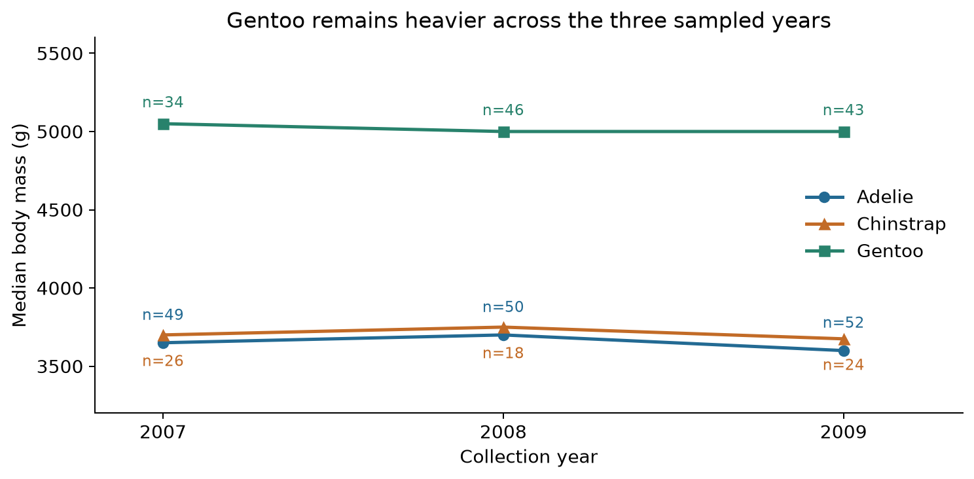
Figure 5. Median body mass by collection year and species. Labels give the number of measured records in each group. Lines connect group summaries and do not track individual birds.

What the chart shows
Gentoo medians are 5,050 g in 2007 and 5,000 g in both 2008 and 2009. Adelie medians are 3,650, 3,700 and 3,600 g; Chinstrap medians are 3,700, 3,750 and 3,675 g. The larger Gentoo median therefore appears in each of the three sampled years.

Why this visual works
A connected point chart makes the ordering across years easy to follow. Medians reduce the influence of unusually large or small values. Species markers and colors remain consistent, and counts reveal uneven group sizes, including only 18 Chinstrap records in 2008. The vertical axis starts at 3,200 g to show differences among these medians; it is not a bar chart of absolute magnitudes.

Interpretation and limits
Three annual summaries are insufficient to infer a long-term ecological trend. Yearly samples can differ in sex composition and other characteristics. No confidence intervals are shown, so small fluctuations should not be treated as meaningful changes. The supported message is the repeated species ordering in this sample.

Python excerpt
annual = df.groupby(['species', 'year']).body_mass_g
annual = annual.agg(['size', 'median', 'mean'])
annual.to_csv(ROOT / 'tables/annual_mass.csv')

Scientific implications and conclusion

What the five views establish
The story progresses from sampling context to increasingly specific comparisons. Gentoo has a higher median mass than the other two species overall and in every sampled year. Sex matters within each species, and the positive flipper–mass relationship remains after splitting the data by species. The heatmap explains why a simple island comparison would be difficult to interpret.

Implications for future research
Report distributions and subgroup sizes alongside averages. A single overall mean can change when the proportions of species or sexes change, even if individual groups do not change. For monitoring work, compare similar species and sex groups under a consistent sampling protocol before interpreting shifts in overall mass.
Improve future data collection by documenting reasons for missing sex or measurements, retaining stable individual identifiers, and recording sampling effort. Inspect the original study metadata before treating records as independent. More years and more balanced subgroup coverage would help assess whether observed differences persist beyond this dataset.
A follow-up analysis could model mass using flipper length, species, sex and collection year, with suitable checks for dependence and sampling bias. The current results identify useful questions and visual patterns; they do not validate a conservation intervention, a causal mechanism or a forecasting model.

Design choices and alternatives
The five visuals use different encodings because each answers a different question. A count heatmap shows sampling coverage; cumulative distributions avoid binning; box plots plus points show subgroup spread; faceting reveals conditional relationships; and connected medians show yearly ordering. A species-only bar chart would omit location, a histogram would depend on bin width, and a pooled scatter plot would hide subgroup strength. Three-dimensional effects and dual axes are avoided because they add reading effort without answering these questions.
Units, sample sizes and explanations accompany each visual. Colors are consistent wherever they identify species; the heatmap instead uses a single sequential scale for counts. Line styles, markers, printed values and panel titles help readers interpret the charts without relying only on color. No chart removes a plausible extreme observation.

Conclusion
Effective data storytelling connects visible evidence to a carefully bounded message. Here the central message is that species and sex provide essential context for body-size comparisons. Five complementary visualizations turn the cleaned data into a coherent explanation while making sample composition, missing sex, overlapping distributions and the short observation period visible. These limits should guide the next analysis rather than be hidden by a simple overall summary.

Reproduction and references

Run the analysis
The package includes the source snapshot, a Python script with notebook-style cells, an equivalent Jupyter notebook, the cleaned CSV, five PNG images and supporting tables. From the package folder, run:
python -m pip install -r requirements.txt
python analysis.py
The script uses paths relative to its own location and does not require a fresh download. In Jupyter, open the notebook from the package folder and run all cells. The script regenerates the data, figures and numerical tables; it does not rebuild this Word report. The notebook contains the same code with empty outputs for the reader to execute.
Tested package versions: Pandas 3.0.1, NumPy 2.5.3 and Matplotlib 3.11.2, using Python 3.12.14. A fixed seed controls only display jitter. Source integrity is recorded as a SHA-256 checksum in tables/audit.json; its checksum matches the Week 1 snapshot.

References
[1] Horst AM, Hill AP and Gorman KB (2020). palmerpenguins: Palmer Archipelago penguin data. Documentation, provenance and CC0 data license. https://allisonhorst.github.io/palmerpenguins/ Accessed 30 September 2026. Data collection is credited to Kristen Gorman and Palmer Station LTER.
[2] palmerpenguins project. Simplified penguins.csv, downloaded 30 September 2026. https://raw.githubusercontent.com/allisonhorst/palmerpenguins/main/inst/extdata/penguins.csv. The local filename penguins_raw.csv denotes this downloaded eight-column file, not the separate 17-column dataset.
[3] YuvaIntern. Virtual Data Science with Python Apprentice Intern. Week 2 Task: Advanced Data Visualization and Storytelling with Python. Supplied internship task PDF, pages 3–4. https://yuvaintern.com/my-internship/443485

Week 2 requirement coverage
The report includes an introduction, methodology, five visualizations made with Matplotlib, readable captions, chart-selection rationale, interpretation, a connected narrative, scientific implications and a concluding summary. The code documents how the charts and statistics are reproduced. A separate portal description exceeds 200 words. The internship specifies an estimated 30–35 hour workload; this report does not claim hours worked.

