Machine Learning Model Development and Evaluation
  - Predicting penguin species from physical measurements
YuvaIntern Week 4
Om Shivraj Singh Yadav
1 October 2026

Executive summary
This project builds a classifier for Adelie, Chinstrap and Gentoo penguins using four physical measurements. After excluding two records without measurements, 342 observations are split into 273 training and 69 test records. Five-fold cross-validation on the training set selects logistic regression over a shallow decision tree and a majority-class baseline.
Logistic regression achieves a mean validation macro F1 of 0.977 and correctly classifies all 69 test records. Test accuracy, macro F1 and macro one-versus-rest ROC AUC are each 1.000. The result is specific to a small fixed split: a conditional 95% Wilson interval for test accuracy is 94.73% to 100%. Cross-validation still shows errors, so the test score is not a guarantee of perfect future performance.

Problem and intended use
The supervised learning target is species. The inputs are bill length, bill depth and flipper length in millimetres, plus body mass in grams. A simple classifier demonstrates how measured attributes can support identification of the three known species. It is an educational prototype requiring expert review and external validation before field use.
Island, sex and year are excluded from predictors. Island is strongly associated with species in this sample and could encourage a location-specific shortcut. Sex has missing values and is unnecessary for this measurement-only question. Species labels are used only as the target; source row numbers identify records for audit and are not model inputs.

Evidence and deliverables
The report documents data preparation, algorithm selection, training, validation and limitations. Three figures compare candidate models, show the test confusion matrix and display probability-based ROC curves. The package includes the original CSV, modeling data, split membership, predictions, numerical results, a Python script and an equivalent Jupyter notebook.

Data preparation and evaluation design
The public Palmer Penguins simplified dataset contains 344 observations from 2007–2009 [1, 2]. This project reuses the source snapshot downloaded on 30 September 2026. Data collection is credited to Kristen Gorman and Palmer Station LTER; the dataset is distributed under CC0. The SHA-256 checksum is stored with the results.

Cleaning decisions
Strip category whitespace and parse the four numeric features with errors raised on invalid input. Check for exact duplicates: none are present. Exclude the two rows missing physical measurements rather than inventing all four inputs. Retain plausible extreme values and the nine remaining records with unknown sex because sex is not used. Assert positive measurements and the three expected target labels. No scaling, feature selection or statistical imputation is fitted before the split.
Species | All retained | Training | Test
Adelie | 151 | 121 | 30
Chinstrap | 68 | 54 | 14
Gentoo | 123 | 98 | 25

Split and model selection
Use an 80/20 stratified random split with seed 42. Stratification approximately preserves the species proportions. Keep 69 records aside for final evaluation; compare models only within the 273 training records, using five shuffled stratified folds with seed 42. Every validation record is predicted by a model fitted without that fold. Mean validation macro F1 selects the candidate; exact ties favor insertion order in the script.
The logistic regression pipeline fits StandardScaler inside each training fold, preventing validation statistics from entering scaling. After selection, refit the winning pipeline on all 273 training records and evaluate the test set once. The fixed majority baseline is also evaluated on the test set for context. Test results do not change model settings [3].

Scope of the holdout
Earlier weeks examined the complete dataset descriptively, so this is not an entirely unseen external study. Computational separation prevents fitted preprocessing and model selection from using the test split, but prior exploratory familiarity remains a limitation. No individual identifier is available to verify independence or construct an animal-grouped split.

Algorithms and training

Candidate models
Logistic regression uses standardized measurements, C = 1.0, the lbfgs solver and a maximum of 2,000 iterations. It estimates class probabilities using a regularized linear model in transformed feature space. Scaling prevents measurement units from dominating the regularization. The implementation fails on a convergence warning rather than silently reporting an unconverged result.
The decision tree uses maximum depth 3, minimum leaf size 5 and seed 42. A small tree offers simple nonlinear rules while limiting complexity. Scaling is unnecessary for threshold splits. These settings are fixed in advance of evaluation; no hyperparameter search is performed.
The majority baseline always predicts the most frequent training species, Adelie. It establishes the score achievable without learning relationships between measurements and labels. Unequal class counts make accuracy alone insufficient, so macro F1 is the selection metric.

Complete split and pipeline example
from sklearn.model_selection import train_test_split
from sklearn.pipeline import make_pipeline
from sklearn.preprocessing import StandardScaler
from sklearn.linear_model import LogisticRegression
features = ['bill_length_mm', 'bill_depth_mm',
'flipper_length_mm', 'body_mass_g']
X_train, X_test, y_train, y_test = train_test_split(
df[features], df['species'], test_size=0.20,
random_state=42, stratify=df['species'])
model = make_pipeline(StandardScaler(),
LogisticRegression(C=1.0, solver='lbfgs', max_iter=2000))
Here df is the cleaned 342-record table defined on the previous page. The supplied script uses row indices for the identical split so it can export an auditable membership manifest. The example makes the feature list, target and fitted transformation explicit.

Validation example
from sklearn.model_selection import StratifiedKFold, cross_validate
cv = StratifiedKFold(n_splits=5, shuffle=True, random_state=42)
scores = cross_validate(model, X_train, y_train, cv=cv,
scoring={'accuracy': 'accuracy', 'macro_f1': 'f1_macro'},
return_train_score=True)
print(scores['test_macro_f1'].mean())
The full script repeats this evaluation for all three candidates and saves each fold score. The standard deviation across five folds measures fold-to-fold variability; it is not a confidence interval or an independent estimate of deployment uncertainty.

Model comparison and selection
Model | Train F1 | CV F1 | CV F1 SD | CV accuracy
Logistic regression | 0.985 | 0.977 | 0.017 | 0.982
Decision tree | 0.954 | 0.909 | 0.021 | 0.923
Majority baseline | 0.205 | 0.205 | 0.002 | 0.443

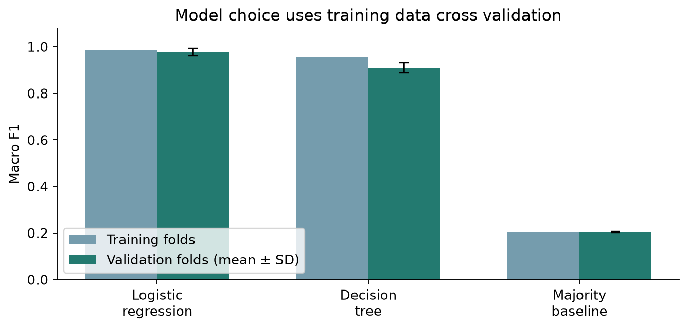
Figure 1. Mean training-fold and validation-fold macro F1 for the same five partitions. Error bars show one sample standard deviation of validation scores. The vertical axis begins at zero.
Logistic regression has the highest mean validation macro F1, 0.977, versus 0.909 for the tree and 0.205 for the baseline. Its mean training-fold macro F1 is 0.985, a gap of approximately 0.008. The tree gap is approximately 0.045. These patterns favor logistic regression for this task, while not proving that a larger or differently tuned tree would always perform worse.

Overfitting and underfitting
The small logistic training–validation gap gives limited evidence of overfitting in these folds. The tree shows a larger gap, so simply increasing its depth could increase variance. The baseline underfits by ignoring measurements and failing to identify minority classes. Neither model is retuned after seeing the test outcomes. A future search should stay inside training cross-validation and preserve a fresh final test set.

Final test classification results
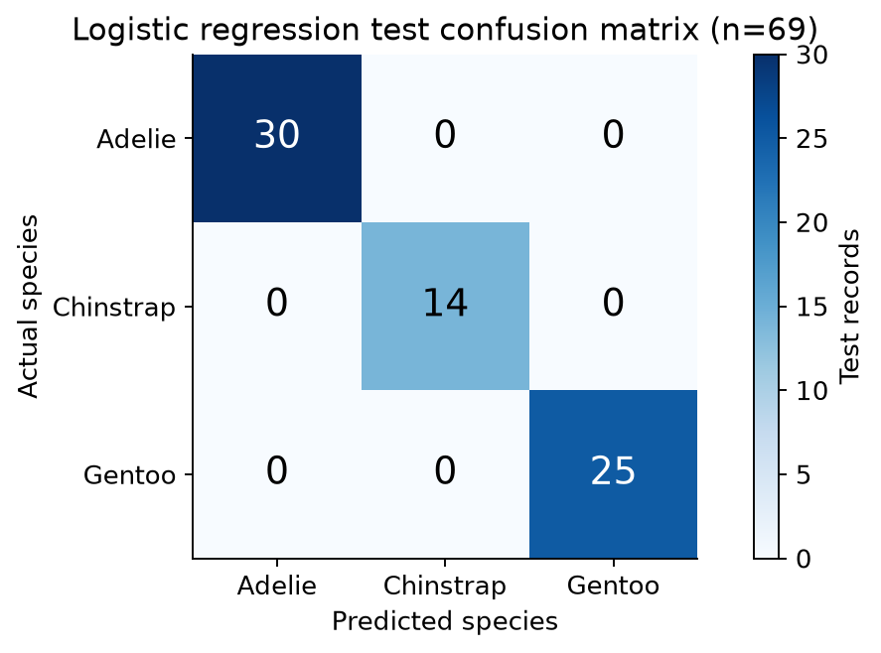
Figure 2. Actual species are rows and predicted species are columns. Counts use only the 69 held-out records. The diagonal contains all predictions; off-diagonal cells are zero.
Species | Precision | Recall | F1 | Support
Adelie | 1.000 | 1.000 | 1.000 | 30
Chinstrap | 1.000 | 1.000 | 1.000 | 14
Gentoo | 1.000 | 1.000 | 1.000 | 25

Precision is the fraction of predictions for a class that are correct; recall is the fraction of actual members of that class correctly identified. F1 balances precision and recall. Macro F1 gives each species equal weight. Balanced accuracy averages class recalls. For this split all are 1.000, and the observed error rate is 0%.
The majority baseline achieves 43.48% test accuracy and macro F1 0.202. The selected classifier therefore improves observed accuracy by 56.52 percentage points over that fixed baseline. All 69 predictions and class probabilities are exported; the test_errors.csv file has only headers because no test record was misclassified.
The refitted model classifies 98.90% of training records correctly, while test accuracy is 100%. An easier small test subset can outperform the training score by chance. This does not imply leakage by itself or prove that the true error rate is zero. Split disjointness and class-probability order are checked in the code.

ROC analysis and uncertainty
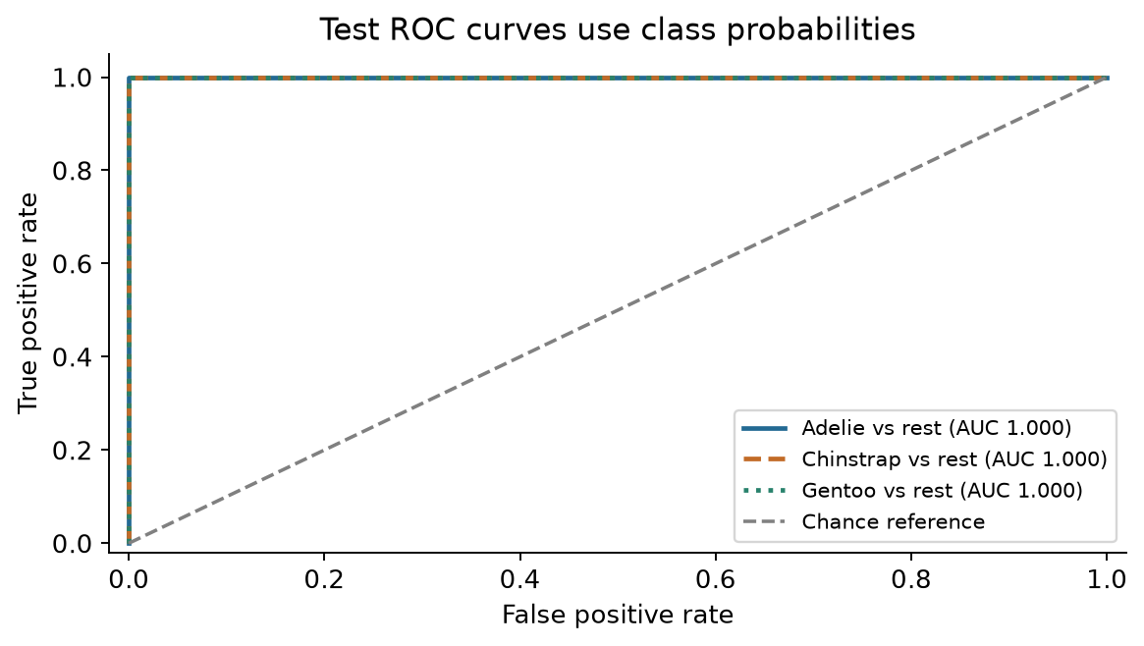
Figure 3. One-versus-rest ROC curves use the predicted probability for each species. Each curve treats that species as positive and the other two as negative. All three AUCs equal 1.000 on this split, so the curves overlap near the top-left corner.
The false positive rate is the share of other-species records incorrectly accepted as the focal species at a probability threshold. The true positive rate is its recall at that threshold. ROC AUC summarizes ranking across thresholds; it is not a probability-calibration score. The macro one-versus-rest AUC averages the three class AUCs [4].

How uncertain is perfect observed accuracy
A 95% Wilson interval for 69 successes in 69 trials is 94.73% to 100%. This interval conditions on the fitted model and treats test outcomes as independent Bernoulli observations. It omits uncertainty from training, model selection, possible repeated animals and changes in location or sampling. It therefore cannot be treated as a deployment guarantee.
The five-fold validation accuracy is 98.16%, showing that errors occur outside the particular holdout subset. No test errors are invented for discussion. Future error analysis should inspect mistakes on independent data, including species confusion, measurement quality and performance for uncommon subgroups.

Final evaluation code
from sklearn.metrics import accuracy_score, classification_report
from sklearn.metrics import roc_auc_score
model.fit(X_train, y_train)
pred = model.predict(X_test)
proba = model.predict_proba(X_test)
print(accuracy_score(y_test, pred))
print(classification_report(y_test, pred, zero_division=0))
print(roc_auc_score(y_test, proba, labels=model.classes_,
multi_class='ovr', average='macro'))

Limitations recommendations and conclusion

Sources of error and bias
Sampling is limited to three species, three islands and three historical years. Random stratification estimates performance on similar records and does not measure transfer to new locations, years or protocols. Unknown dependencies between records can inflate performance if related observations appear in both partitions. Exact-row duplicate checks cannot resolve this without original identifiers.
Removing two measurement-missing rows restricts the model to complete inputs. Missingness could be systematic, and the model has no tested behavior for absent measurements. Measurement rounding, instrument error and unusual body sizes can affect predictions. No probability calibration or out-of-distribution detector was assessed; a prediction among three known species can be wrong for an unseen species.
Earlier exploratory work used the same source, and the candidate comparison itself introduces selection uncertainty. A single seeded split is reproducible but cannot establish robustness across independent datasets. No causal interpretation should be attached to the fitted measurement relationships.

Practical improvements
First obtain stable animal identifiers and sampling metadata, then design grouped or temporal evaluation when the target use calls for it. Collect independent records from the intended deployment setting. Review uncertain predictions with a qualified observer and retain the original measurements so errors can be traced.
Use training-only nested validation if tuning regularization or tree complexity. Assess calibration and define an abstention rule with a validation set before evaluating it on fresh data. If missing inputs must be supported, test an imputation pipeline with fold-specific fitting and report performance separately for missingness patterns. Compare sensitivity to measurement perturbations and subgroup coverage.

Conclusion
Four physical measurements support strong species classification within this dataset. Logistic regression wins the predefined comparison and predicts all 69 test records correctly, but cross-validation and sampling limitations require a cautious interpretation. The result demonstrates a reproducible model-development workflow, not a validated field-identification service.

Requirement coverage
The Week 4 task requires documented preprocessing, algorithm selection, training, evaluation, code and at least two performance visualizations. This report supplies all of those, with three charts and a discussion of overfitting, underfitting and improvement opportunities. The stated 30–35 hour workload is an estimate from the task; no hours-worked claim is made.

Reproduction and references

Run the complete project
python -m pip install -r requirements.txt
python analysis.py
Download and extract YuvaIntern_Week4_Complete_Package.zip first. Keep the data folder beside the script. The notebook contains the same analysis with empty outputs; open it from the extracted project folder and run all cells. The analysis regenerates data exports, tables and three PNG charts. It does not rebuild this Word report. No data download is needed after dependency installation.
The tables folder contains five-fold scores, candidate summaries, split membership, class counts, classification metrics, confusion matrix, all test predictions, a test-error table and a JSON result audit. Row identifiers refer to one-based data-record positions in the source CSV, excluding the header. They do not identify animals. The split and tree use seed 42.
Tested with Python 3.12 and numpy 2.5.3, pandas 3.0.1, scipy 1.18.1, scikit-learn 1.9.1, matplotlib 3.11.2. requirements.txt pins these direct dependencies. No serialized executable model is required: running the script recreates the fitted pipeline.

References
[1] Horst AM, Hill AP and Gorman KB (2020). Palmer Penguins project documentation and provenance. https://allisonhorst.github.io/palmerpenguins/ Data collected by Kristen Gorman and Palmer Station LTER; CC0 license.
[2] Palmer Penguins simplified source CSV. https://raw.githubusercontent.com/allisonhorst/palmerpenguins/main/inst/extdata/penguins.csv Downloaded 30 September 2026. Local penguins_raw.csv denotes this eight-column snapshot, not the separate extended dataset.
[3] scikit-learn. Common pitfalls and recommended practices. https://scikit-learn.org/1.9/common_pitfalls.html Accessed 1 October 2026. Guidance for separating training/test data and fitting preprocessing within pipelines.
[4] scikit-learn. roc_auc_score API documentation. https://scikit-learn.org/stable/modules/generated/sklearn.metrics.roc_auc_score.html Accessed 1 October 2026. Multiclass one-versus-rest scoring and probability order.
[5] YuvaIntern. Virtual Data Science with Python Apprentice Intern. Week 4 Task: Machine Learning Model Development and Evaluation. Supplied internship PDF and task portal https://yuvaintern.com/my-internship/443485

