DAY1 – TRYHACKME – BLUE ROOM – NMAP + METASPLOIT
5 PHASES:
1. RECONNAISSANCE
2. SCANNING
3. EXPLOIT
4. GAINING & MAINTAINING ACCESS
5. COVERING TRACKS & DOCUMENTATION
ATTACKER IP: 10.49.134.195
VICTIM IP: 10.49.134.8
EternalBlue is an exploit targeting a vulnerability in Windows SMBv1 that can allow remote code execution on vulnerable systems. It was associated with MS17-010 / CVE-2017-0144. MS17-010 is Microsoft's security bulletin for several SMBv1 vulnerabilities, including the vulnerability exploited by EternalBlue. It is commonly associated with CVE-2017-0144 and is the vulnerability being checked/exploited in this room.
SMB (Server Message Block) is a Windows network protocol used for file/printer sharing and other network communication. TCP port 445 is commonly used for SMB, which is why the open 445 port made SMB the relevant attack surface in this room.
In this vulnerable configuration, EternalBlue exploits the SMB service in a privileged Windows context, so the resulting Meterpreter session can run as SYSTEM. SYSTEM is a highly privileged Windows account, above ordinary users and administrators.
IN ATTACKER:
IN COMMAND PROMPT:
whoami > root
- RECON:
VICTIM IP: 10.49.134.8 (GIVEN!)
- SCANNING
Nmap (already on attack box) – checks ports if they are open/close

• nmap <IP> → scans the target for open ports and basic services.
• -sV → identifies the service and version running on open ports.
• -sC → runs Nmap's default scripts to gather more information and detect common issues.

Nmap's NSE vulnerability scripts send specific probes to the target and analyze the responses for signs of known vulnerabilities. In this room, the scan identifies the target as vulnerable to the relevant SMB vulnerability.
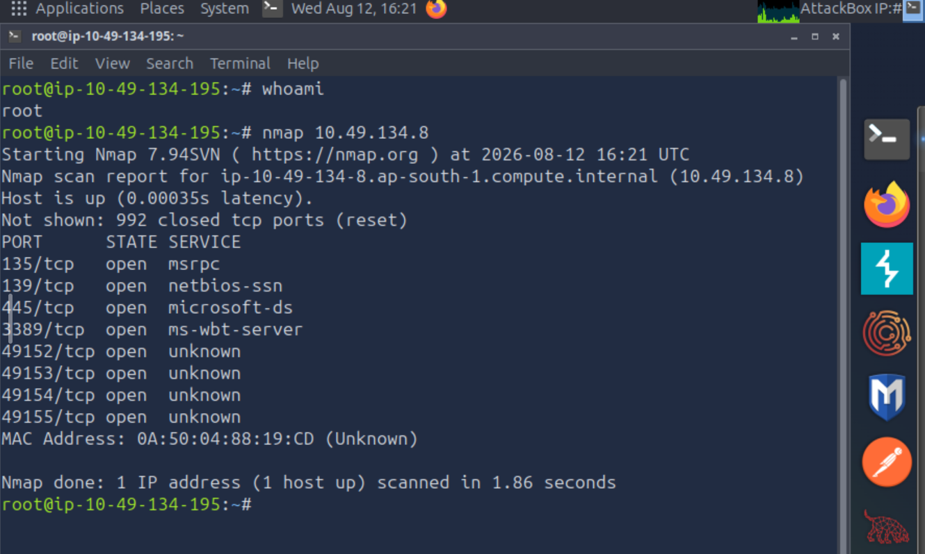
SMB – Server Message Block

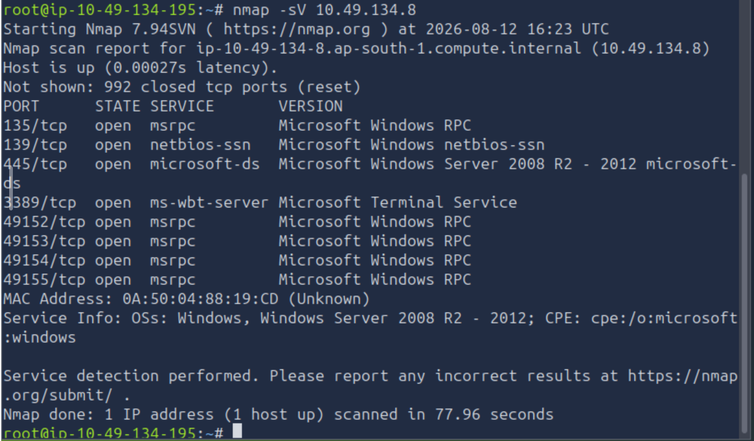

PORT 445 !!! IS OPEN AND ACTING AS SMB
-sV : Version Info in addition to State Service
-sC : scripting : finds common problems that could exist on the ports

TCP 445 was identified as microsoft-ds, Nmap's service label for SMB over TCP. Since SMB commonly operates on port 445, it was identified as the relevant attack surface for investigating MS17-010/EternalBlue.
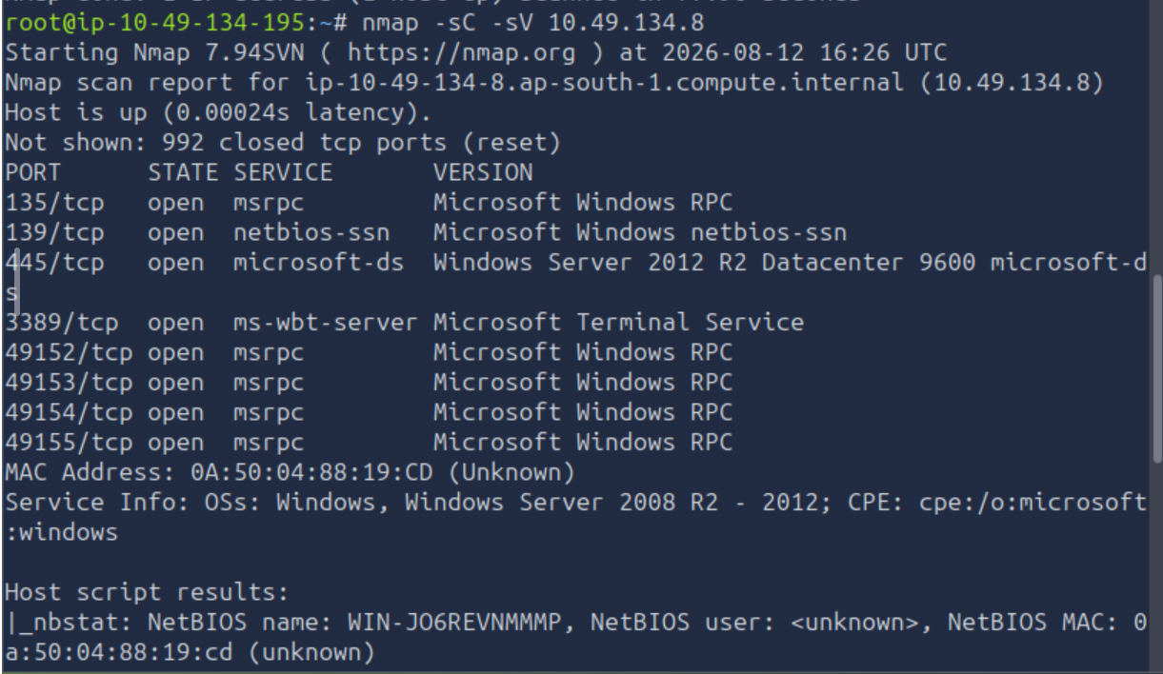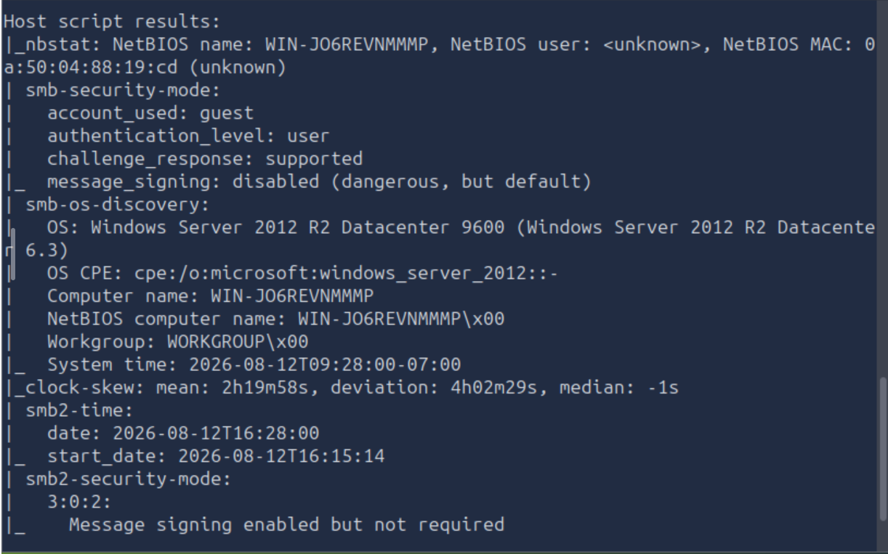

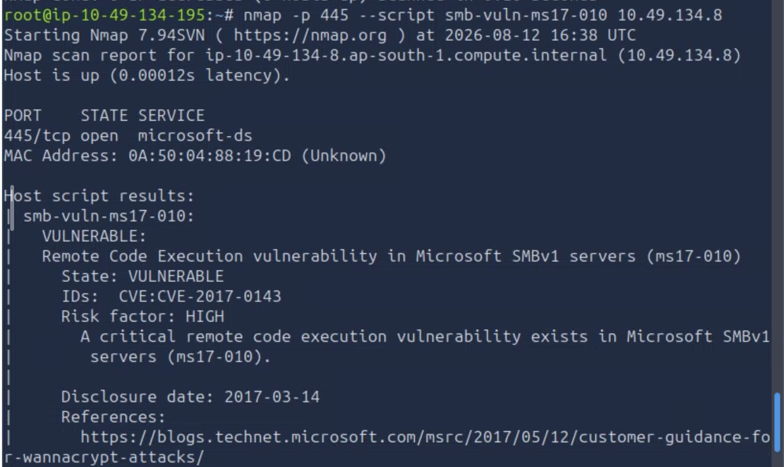
STATE : VULNERABLE!!

- EXPLOITATION
METASPLOIT - TO OPEN : MSFCONSOLE
POINTER CHANGES TO MSF

TYPE search eternalblue
Select the attack that is the main exploit

Metasploit is a penetration-testing framework that provides ready-made exploits, payloads and tools for testing vulnerable systems. Here, it is used to select and execute the EternalBlue exploit against the target.
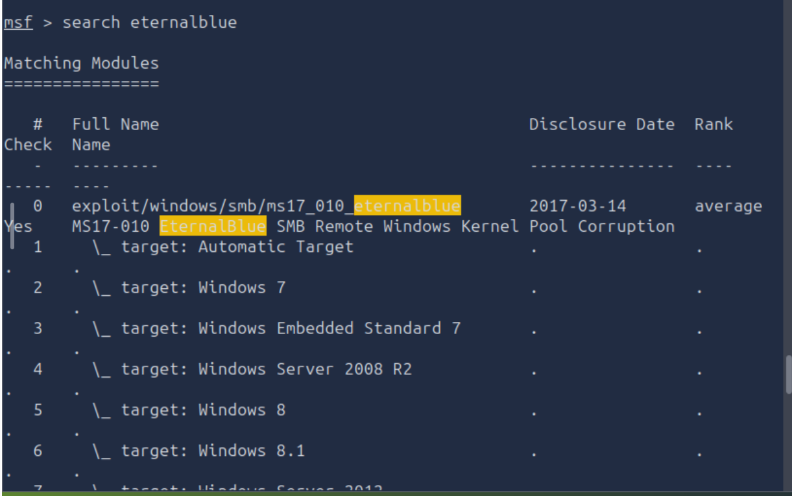
In this case, 0

Type use 0 to load that attack onto your attacker system!
Pointer changes
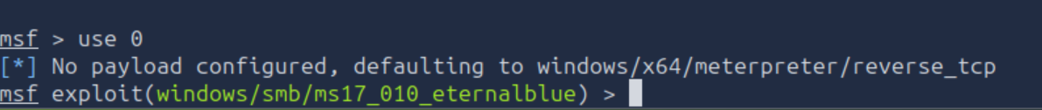

Now we have to tell system what to attack and where to send the results

What to attack:

Where to send results:

Check
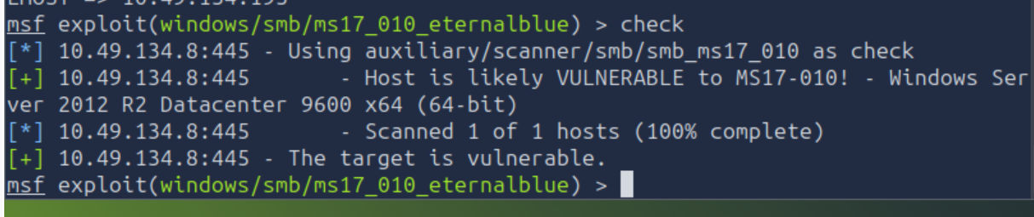
Metasploit reaches out to target, tests it and tells that THE TARGET IS VULNERABLE!!!
EXPLOIT NOW!!!!!!!!
exploit

Metasploit is sending the attack, the exploit, making the connection
METERPRETER SESSION 1 OPENED!!! - I AM INSIDE THE TARGET
Meterpreter is a Metasploit payload that provides an interactive session on a compromised machine for post-exploitation tasks. It allows commands such as getuid, ps, and access to a command shell.
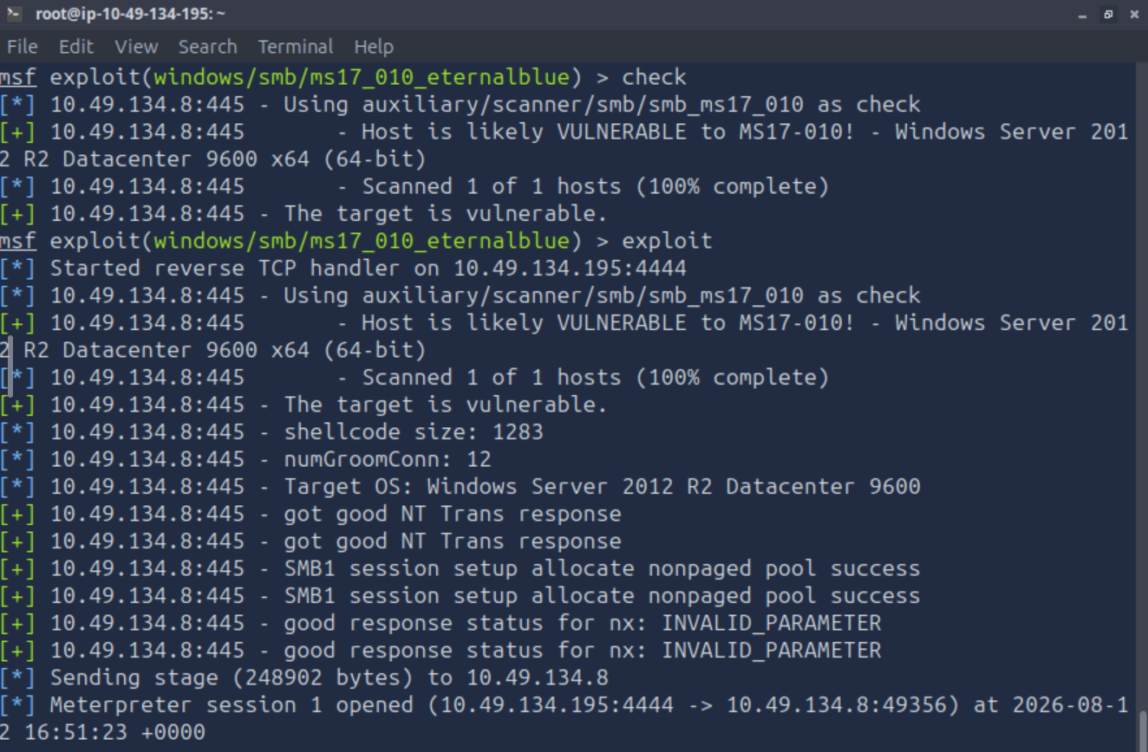

PROMPT CHANGES TO METERPRETER>
LIVE CONNECTION INTO THE COMPROMISED MACHINE!!!!

- GAINING AND MAINTAINING ACCESS
getuid
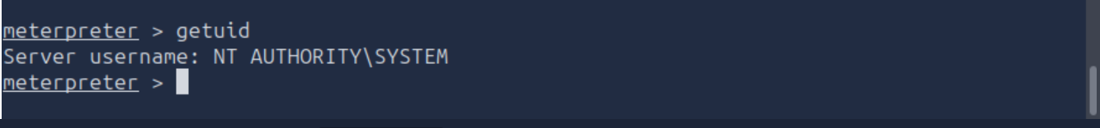
HIGH POWER! GREATER THAN USER AND ADMIN! SYSTEM is a highly privileged Windows account used by the operating system and services; it generally has greater local privileges than a normal Administrator account.

(privilege escalation skipped)

Being system is not the same as having a stable system – type ps to get an idea of stable state
Reliable one is one running on Windows Internals (like services.exe)
Having SYSTEM privileges does not guarantee a stable session; migrating to a stable process can improve session reliability.

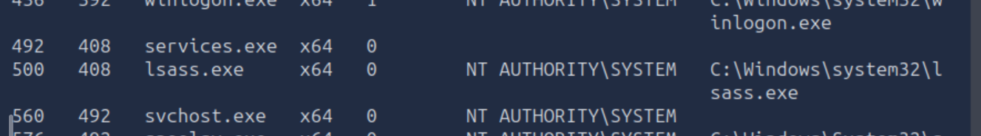
migrate moves the Meterpreter session into another running process, preferably a stable long-lived process. This can make the session more reliable if the original exploited process terminates, although migration itself does not guarantee continued SYSTEM privileges.

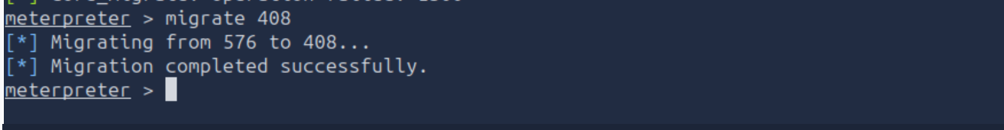

To find flags, go to shell
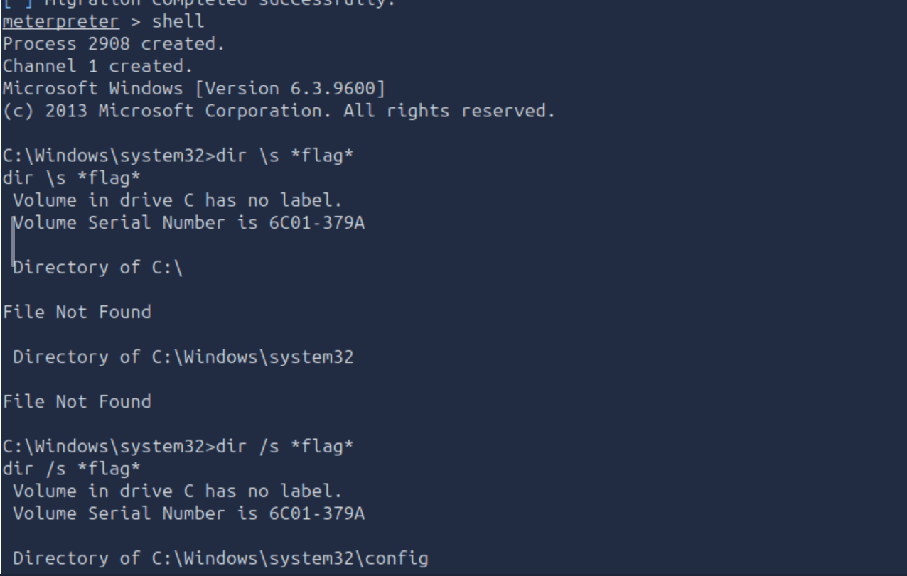

Get flag2!
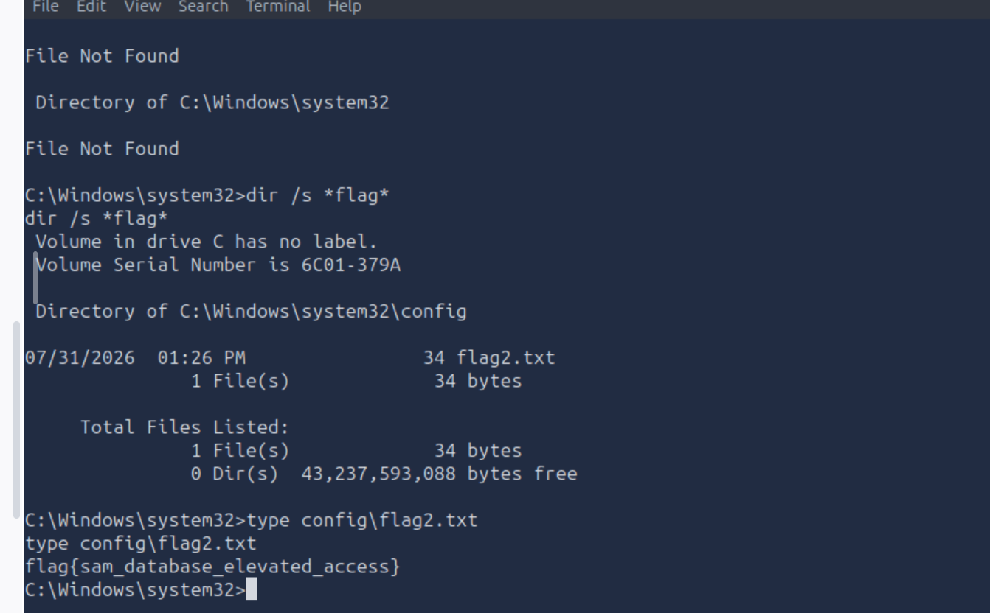

To access the flag 1 at the root:

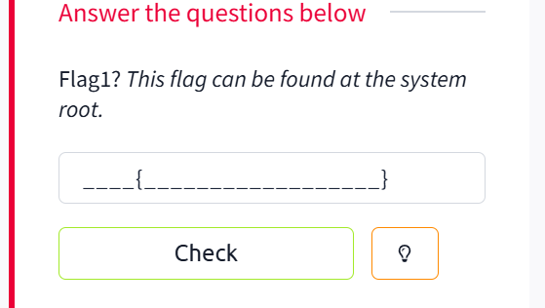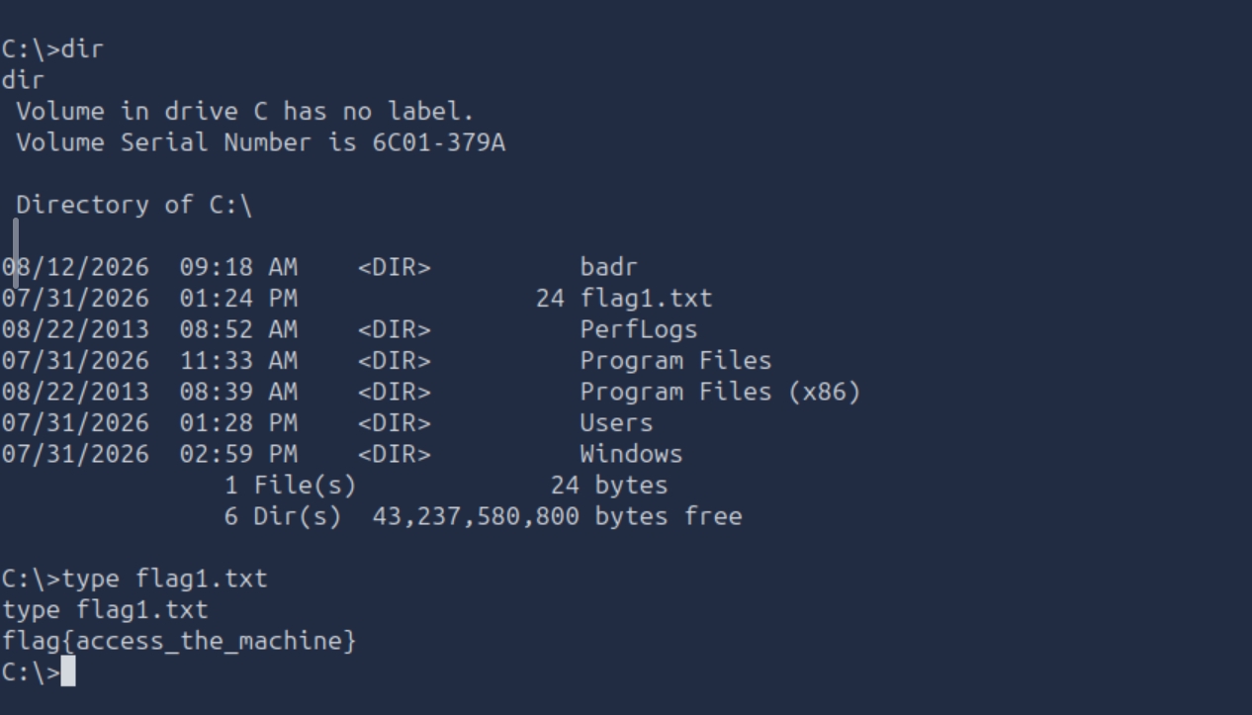

Flag3 with escalated privileges:

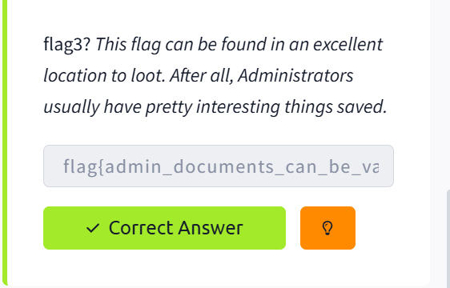
Use whoami we know that we are System,
Check if we have
dir C:\Users\Administrator

If you get Access is denied, you need elevated Command Prompt.

runas /user:Administrator cmd
It will ask for the Administrator password.
Once elevated, search the Administrator's directory for the flag:
dir C:\Users\Administrator /s /b *flag*

then use type command to read out appropriate flag
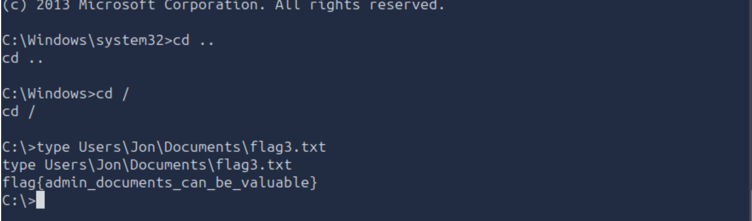

- DOCUMENTATION
Documented entire process above for Eternalblue attack using TryHackMe
Target information:
Attacker IP: 10.49.134.195
Target IP: 10.49.134.8
Attack surface identification
TCP 445 was identified as open and running SMB, making SMB the primary attack surface for further investigation.
Vulnerability identification
Nmap/SMB enumeration indicated that the target was vulnerable to MS17-010, making it a candidate for the EternalBlue exploit.
Exploitation result
Metasploit successfully exploited the vulnerable SMB service and established a Meterpreter session on the target.
Privilege verification
getuid was used to verify the privileges of the Meterpreter session; the session was running as SYSTEM.
Key takeaway
The attack demonstrates the importance of patching vulnerable SMBv1 systems and restricting unnecessary exposure of SMB services.

