访谈纪要

项目名：07 学习平台

课程名：软件需求分析原理与实践

小组：G07

成员：31901237徐过

31901239许罗阳宁

31901240余浩凯

31901238徐晟

31903093邵云飞

教师：杨枨

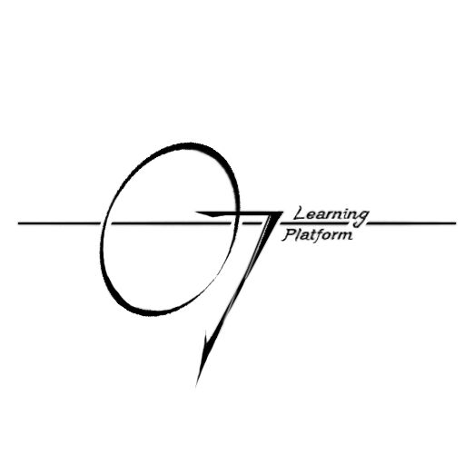

2022/2/23

|  |  |  |  |  |  |  |  |
| --- | --- | --- | --- | --- | --- | --- | --- |
| **访谈地点** | | |  | | | **访谈时间** |  |
| **访谈对象** | |  | **角色** |  | | **记录人** |  |
| **参加人员** | | |  | | | | |
| **访谈主题** | | |  | | | | |
| **访谈原因** | | |  | | | | |
|  | | | | | | | |
|  | | | | | | | |
| **访谈重点记录：** | | | | | | | |
| **访谈目的：** | | | | | | | |
| **访谈目的是否达成：** | | | | |  | | |
| **访谈感想：** | | | | | | | |
| 访谈人 |  | | | | | | |