Audacity's Digital Interface - Breakdown
Audacity is free, open-source audio editing software that I use to record and edit sound files. For this task, I chose Audacity as my advanced digital audio interface because it is widely used and offers a rich visual workspace. Below, I perform an Ontological Audit and a Gestalt Review of its interface.
- Photos of the interface:-
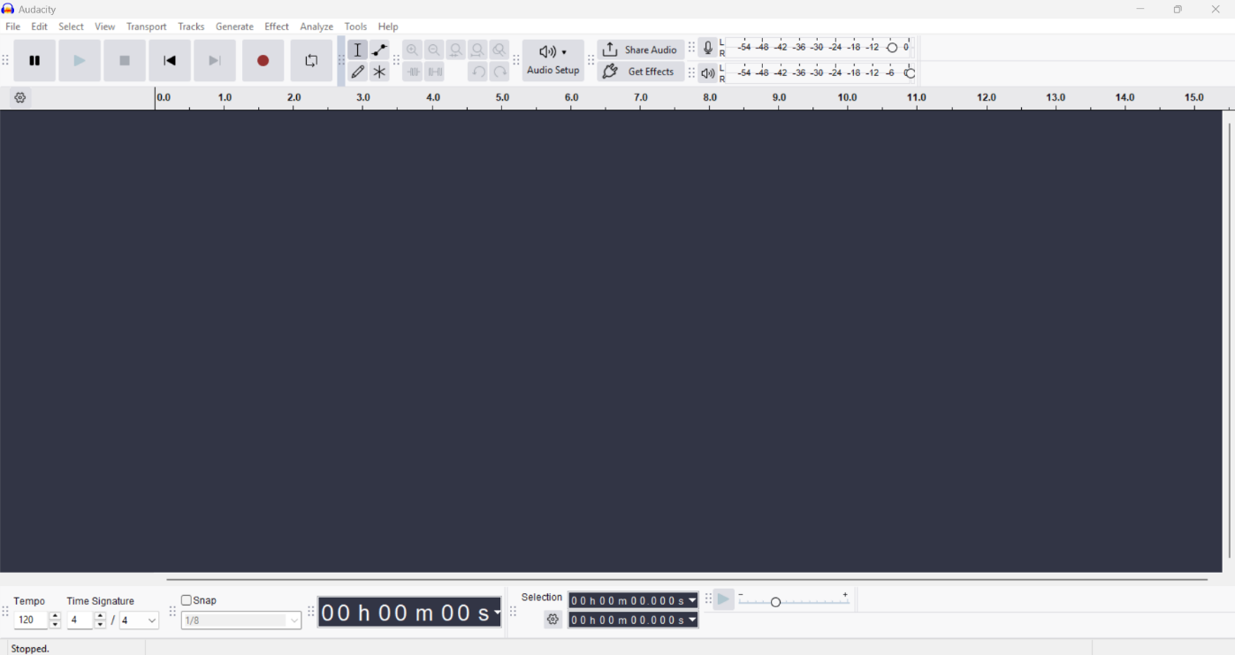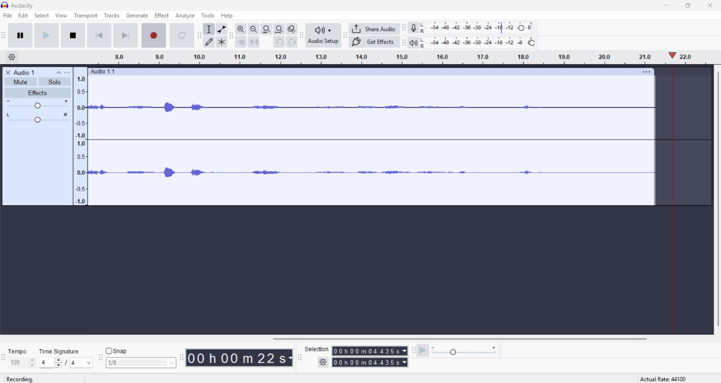
- Ontological audit:-
First, I identify three entities in the Audacity interface that the designer created but do not exist in the real world.
- The wave form:-
The most obvious virtual entity in Audacity is the audio waveform. I can clearly see blue wave-like shapes running across the track. This waveform is a visual representation of sound, which itself is invisible. No one can physically pick up or touch a waveform; it is a designer's way of making something invisible (sound) visible on screen. Without this invented visual entity, users would have no idea what their audio looks like or where the loud and quiet parts are.
- The timeline cursor:-
The red vertical line visible on the right side is the playhead. It shows the current position in the audio timeline. Time, of course, does not exist as a physical object you can see. The designer invented this red line to represent "where we are in time" during playback or recording. It is a completely abstract, virtual entity that has no physical counterpart in the real world.
- The track:-
There is a labelled container called "Audio 1" on the left side. This "track" is a conceptual container; it does not physically exist anywhere. In real life, there is no box that holds sound. The designer created the track as an ontological entity to help users organise, mute, solo, and manage individual audio layers. It is a purely digital invention that makes audio editing feel logical and manageable.
- Gestalt review:-
- Law of proximity:-
It’s used effectively. In the first screenshot, I noticed that all the playback controls (play, pause, stop, record, skip) are grouped closely together in the top toolbar, but it's a customizable part-by-part. I can drag and adjust them where I want. But I leave it how it came as default, because they are near each other, I immediately understand that they all belong to the same function group, transport controls. This is a good use of the Law of Proximity, because the closeness of the buttons tells me they are related without needing any labels.
- Law of similarity:-
I'm going to partially ignore it, because looking at the toolbar more carefully, I notice that the icons use a mix of different styles and sizes. Some buttons look like simple symbols, while others have text labels like "Audio Setup" and "Get Effects." This inconsistency means the Law of Similarity is not fully applied. If similar functions used similar visual styling, the interface would feel more unified and beginner-friendly. As someone new to Audacity, I found this slightly confusing when first looking at the toolbar.

Overall, Audacity's interface is functional but not perfectly designed for beginners. The virtual entities, like the waveform and playhead, are clever inventions that make the invisible world of sound manageable. The use of proximity in the toolbar is effective, but the inconsistent visual styling shows room for improvement. As a beginner, I think the interface prioritises functionality over beauty, which has both strengths and weaknesses.

