Traders Little Organizer™
TLO Inventory User Manual
Version v1.3 Build 361

Contents
- 1. What TLO Inventory does
- 2. Quick Start
- 3. Installation package and TLOHome layout
- 4. Pre-installation checklist
- 5. Windows installation and shortcuts
- 6. macOS, Linux, and WSL installation
- 7. Environment variables
- 8. Search paths, visible and unique volume names, and mount paths
- 9. Running the main GUI
- 10. Compliant versus non-compliant mode
- 11. Online lookup options
- 12. Tagging functions
- 13. Add Shows incremental updater
- 14. Search app
- 15. Command-line quick reference
- 16. Outputs, completion summaries, and troubleshooting
- 17. Logs deep dive
- 18. Glossary
- 19. GitHub update checks and Auto update

1. What TLO Inventory does
TLO Inventory provides full inventory, incremental Add Shows processing, audio tagging, inventory searching, and artist-database searching. The source bundle contains the application sources and build utilities. The separate distribution ZIP contains native end-user applications for Windows, macOS, and generic Linux. The generic Linux applications are also used when running under WSL; there is no separate WSL application directory or WSL build.
The full inventory function scans configured music roots, identifies core show metadata, prepares searchable setlist text, and builds the inventory output used by the included search tools.
- Full Inventory scans configured music roots and rebuilds the inventory outputs.
- Add Shows adds new content to an existing inventory without rerunning the full scan.
- Standalone Tag and inventory-time Tag in Place write audio metadata when you choose to tag files. Tag Copy and Tag Copy/Delete Original are Full Inventory modes, not standalone Tagger functions.
- The included Search app searches the completed bootlist and setlist files after the distribution is extracted into TLOHome.

2. Quick Start
Use this path for a first non-destructive inventory. The detailed installation, volume-name, and option sections follow later in the manual.
1. Extract a complete platform ZIP directly into the folder that will be TLOHome. Do not run TLO from inside the ZIP.
2. Confirm that TLOHome/TLO_DBs contains artists.sqlite and venues.txt.
3. Set the TLOHome environment variable, or launch the GUI with --TLOHome followed by the full TLOHome path.
4. Put one music root in TLOHome/toBeInventoried.txt, or enter one root in Search Path. A visible volume prefix such as [Archive]E:\Music is strongly recommended.
5. Start the Inventory GUI. For the first run, leave Tag in Place, Tag Copy, Tag Copy/Delete Original, Rename Compliantly, and Convert shn cleared.
6. Select Dry run and click Inventory. Review the proposed show names and any planned tags without changing files.
7. Clear Dry run and click Inventory again when the review is satisfactory. Confirm the settings in Review Operation and click Start.
8. After completion, open TLOHome/bootlist.csv, TLOHome/setlists, the completion summary, and View Issues. Detailed logs are under TLOHome/logs.
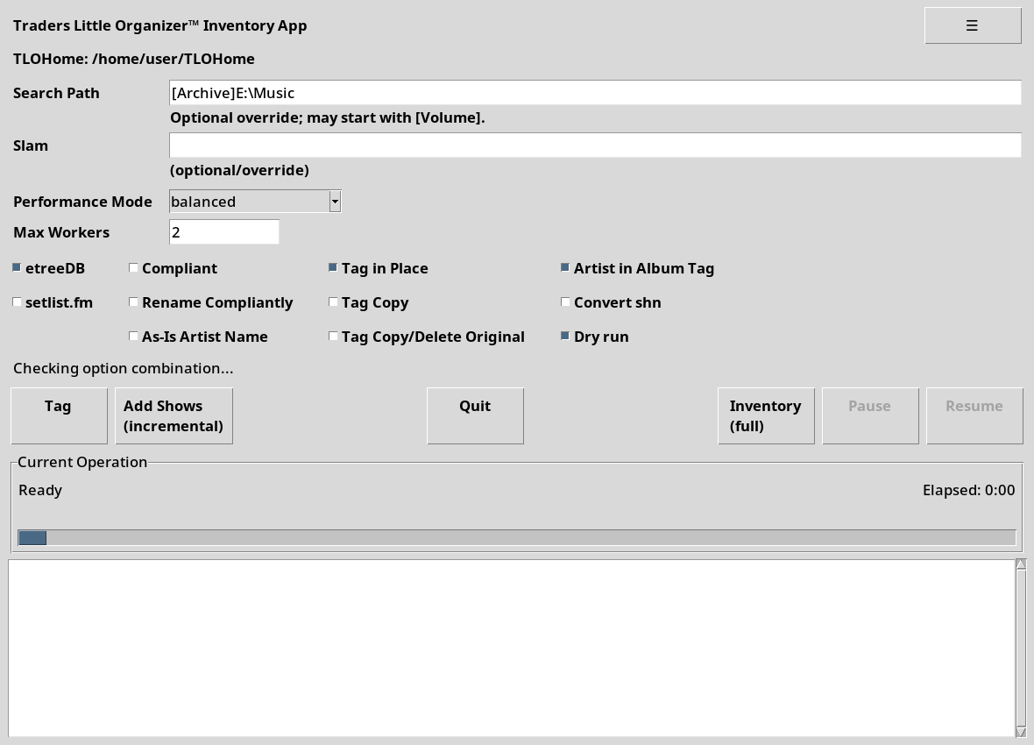
Figure 1. Main Inventory window configured for a first dry run.
First-run safety: Dry run performs metadata and tag planning but does not write tags, convert SHN files, rename folders, copy or delete content, or replace inventory output.

3. Installation package and TLOHome layout
Each release has a source bundle and eight platform distribution ZIPs: complete and update packages for Windows onefile, Windows onedir, generic Linux, and macOS. Names follow TLO_V1.3Build361_complete_<platform>.zip and TLO_V1.3Build361_update_<platform>.zip. Use a complete package for a new installation. Use the matching update package only to refresh an existing TLOHome.
The source bundle contains the current requirements DOCX, the current RTF user manual, application source, tests, and build utilities. Complete distributions include the current RTF user manual, FAQ, required databases, starter files, release information, checksums, and malware-scan receipts. Update distributions contain only the matching application payload and update metadata so they do not overwrite user data.
TLOHome/
apps/
Windows/
tlo-ggi.exe
tlo-gi.exe
tlo-tag.exe
tlo-gsi.exe
search-artist-db.exe
_internal/ Windows onedir package only
macOS/
tlo-ggi
tlo-gi
tlo-tag
tlo-gsi
search-artist-db
Linux/
tlo-ggi
tlo-gi
tlo-tag
tlo-gsi
search-artist-db
TLO_DBs/
artists.sqlite
venues.txt
debug/ dups/ logs/ readyForXfer/ setlists/ staged/
README_FIRST.txt
TLO-FAQ.txt
TLO_Inventory_User_Manual_v361.rtf
toBeInventoried.txt
Every complete distribution includes tlo-gsi, search-artist-db, TLO_DBs/artists.sqlite, and TLO_DBs/venues.txt. The generic Linux applications are also used under WSL. The Windows onedir package places all five executables directly in apps/Windows with one shared apps/Windows/_internal folder; keep that folder with the executables and replace the whole apps/Windows folder when switching between onefile and onedir layouts.
Do not run inside the ZIP: Always extract the installation ZIP first. Windows and Linux cannot reliably execute the apps while dependencies, databases, or shell scripts are still compressed.

4. Pre-installation checklist
- Choose the final TLOHome folder. Use a short absolute path such as C:\TLOHome on Windows or $HOME/TLOHome on WSL/Linux.
- Confirm that TLOHome is writable by the account that will run the apps.
- Know how attached drives will be mounted. Windows runs can use drive-letter paths such as E:\Music. WSL/Linux runs can use paths such as /mnt/e/Music after the drive is mounted and visible to that environment.
- Use visible and unique volume names for search roots. They are strongly recommended, especially with external drives, backup drives, WSL paths, or drives that may get different letters over time.
- If setlist.fm lookup will be used, obtain a setlist.fm API key and set SETLISTFM_API_KEY before enabling setlist.fm lookup.
Installation contents: The installation ZIP installs the application files and support folders under TLOHome. Pre-installation setup is limited to choosing a writable TLOHome location, preparing environment variables, and making sure mounted drives will be visible.

5. Windows installation and shortcuts

Install or refresh TLOHome
1. Create or choose the TLOHome folder, for example C:\TLOHome.
2. Extract the installation ZIP so the apps and support folders appear inside TLOHome.
3. Confirm that C:\TLOHome\apps\Windows contains tlo-ggi.exe, tlo-gi.exe, tlo-tag.exe, tlo-gsi.exe, and search-artist-db.exe.
4. Set the TLOHome environment variable and optional variables described in Section 7.
5. Open a new Windows terminal or restart any already-open TLO app so the changed environment is visible.
PowerShell example:
Expand-Archive .\TLO_V1.3Build361_complete_Windows.zip -DestinationPath C:\TLOHome
setx TLOHome "C:\TLOHome"
setx TLOCurrentStorage "Backup-1"
setx SETLISTFM_API_KEY "your-api-key-if-used"

Optional Windows shortcuts
After installation, you may pin tlo-ggi.exe or tlo-gsi.exe from TLOHome\apps\Windows to Start. Set the shortcut Start in field to TLOHome\apps\Windows. Windows, not TLO, controls shortcut hot keys and Startup-folder behavior.

6. macOS, Linux, and WSL installation

Install or refresh TLOHome
1. Create or choose the TLOHome folder.
2. Extract the matching complete package, such as TLO_V1.3Build361_complete_Linux.zip or TLO_V1.3Build361_complete_macOS.zip, directly into that folder.
3. Use apps/macOS on macOS. Use apps/Linux on generic Linux and under WSL. There is no apps/WSL directory because WSL runs the generic Linux executables. Do not substitute a Windows or macOS build.
4. Confirm that TLOHome/TLO_DBs contains artists.sqlite and venues.txt from the complete package.
5. Set TLOHome and optional variables in the startup file used by your shell.
6. Use WSLg, X/Wayland, or the native macOS graphical session when launching GUI applications.
mkdir -p "$HOME/TLOHome"
unzip TLO_V1.3Build361_complete_Linux.zip -d "$HOME/TLOHome"
cat >> ~/.profile <<'EOF'
export TLOHome="$HOME/TLOHome"
export TLOCurrentStorage="Backup-1"
# export SETLISTFM_API_KEY="your-api-key-if-used"
EOF
. ~/.profile
# macOS
chmod +x "$TLOHome/apps/macOS/"*
"$TLOHome/apps/macOS/tlo-ggi"
# Generic Linux or WSL
chmod +x "$TLOHome/apps/Linux/"*
"$TLOHome/apps/Linux/tlo-ggi"
WSL path entry: TLO accepts either Windows drive-letter paths or /mnt/<drive> paths in Search Path and toBeInventoried.txt. On WSL/Linux, a Windows path such as E: is normalized to /mnt/e for scanning when possible. If no bracketed volume prefix is supplied, TLO uses the mounted drive's operating-system volume label when it can resolve one.

7. Environment variables
The apps can be launched with explicit command-line arguments, but normal desktop use is easier when the core values are stored as environment variables.
Variable | Required? | Meaning
TLOHome | Recommended | Default home folder used when --TLOHome is not supplied.
SETLISTFM_API_KEY | Only for setlist.fm | API key used when setlist.fm lookup is enabled.
TLOCurrentStorage | Optional | Default Current Backup/Storage Drive and Volume in Add Shows.

8. Search paths, visible and unique volume names, and mount paths
Visible and unique volume names identify the physical drive being inventoried, especially with external drives, backup drives, WSL paths, or drives that may get different letters over time. A user-supplied prefix is visible text in brackets immediately before the real path. When supplied, it must match the operating-system volume label for the mounted drive so TLO can prevent accidental scans of the wrong volume.
Typed search path | Physical path used on current OS | Visible and unique volume name
[Backup-1]E: | E:\ on Windows, /mnt/e on WSL/Linux | Backup-1
[Backup-1]/mnt/e | /mnt/e on Linux/WSL, E:\ on Windows if converted | Backup-1
E: | E:\ on Windows, /mnt/e on WSL/Linux | OS volume label for that drive
/mnt/e | /mnt/e on Linux/WSL | OS volume label for that drive
[]E: | E:\ on Windows, /mnt/e on WSL/Linux | explicit blank; rejected if OS label is nonblank
Use the same bracketed volume name each time you scan the same drive. For example, use [Backup-1]E:\Music on Windows or [Backup-1]/mnt/e/Music on WSL/Linux for the same external drive. If no bracketed prefix is supplied, TLO resolves and uses the operating-system volume label when it can. The default labels New Volume and Local Disk are treated as blank rather than as useful unique volume names.
TLO tracks inventory by visible volume name plus the path below the volume. It ignores and does not store the drive letter or WSL /mnt/<drive> prefix in bootlist.csv or the top SEARCH_PATH log headers. For example, [Backup-1]/mnt/e/Music and [Backup-1]/mnt/n/Music are treated as the same stored root [Backup-1] /Music when they refer to the same labeled volume.
- If no bracketed volume name is supplied, TLO substitutes the operating-system volume label for logging and existing-volume comparison when that label can be resolved. The default Windows-style labels New Volume and Local Disk are treated as blank rather than as useful volume names.
- If an explicit bracketed volume name is supplied, it must match the mounted drive label when that label can be resolved. A mismatch raises an alert and that path is not processed.
- For a labeled drive, TLO no longer asks whether to skip or re-inventory when it sees the same volume again. It applies the path relationship automatically: same path or parent path replaces that scope; child path replaces only entries below that child path; non-overlapping paths on the same volume are added to the same volume log header and appended.
- Explicit [] means an explicit blank volume. It is rejected when the mounted drive has a nonblank, non-default operating-system volume label.
- For drives with a blank volume label, or with the default labels New Volume or Local Disk, TLO uses one append-only blank-volume log set. The log header is SEARCH_PATH: [] with no path. There is no skip or re-inventory for blank/default-label drives, so you must avoid or clean up duplicates yourself if the same blank/default-label drive content is scanned multiple times.
- When more than one path is queued, TLO schedules labeled volumes first. Paths on the same named physical drive run serially; different physical drives may run in parallel according to Performance Mode and Max Workers. After labeled work completes, all blank-label paths run serially in drive-letter order.
- A single labeled volume log can list multiple SEARCH_PATH header lines when you add non-overlapping roots from the same drive over time.
Mount aliases: TLO rejects obvious duplicate and overlapping roots after normalization, but symlinks, junctions, case-sensitive aliases, and OS-specific mount aliases can still create duplicates if they point to the same content.

Pre-run setup file: toBeInventoried.txt
For full inventory runs, TLO uses TLOHome/toBeInventoried.txt unless a Search Path override is supplied in the GUI or with --search-path on the command line. Prepare this file before the run when you are not using a one-time Search Path override. Each non-comment line is one inventory root. Blank lines and lines whose first non-whitespace character is # are ignored. Lines beginning with REM are also treated as comments.
Windows root-path examples can be entered as E:, E:\, or H:.
For WSL/Linux full inventory, Windows drive paths are translated to /mnt/<drive>/... while preserving the full subtree. Paths such as D:\B-J\D\Dudek, Les are valid; the comma in the folder name is part of the path and should not cause TLO to scan only /mnt/d.
REM examples for Windows
[External-E]E:
[External-E]E:\
[Archive-H]H:
[Backup-1]E:\Music
[Archive-F]F:\boots --$slam "Bob Dylan"
[Archive-G]G:\incoming --$copy H:\TaggedCopies
[Archive-I]I:\new --$copy-delete J:\TaggedFinished --$slam "Bill Dickens"
REM examples for WSL/Linux
[Backup-1]/mnt/e/Music
[Archive-F]/mnt/f/boots --$slam "Bob Dylan"
[Archive-G]/mnt/g/incoming --$copy /mnt/h/TaggedCopies
[Archive-I]/mnt/i/new --$copy-delete /mnt/j/TaggedFinished --$slam "Bill Dickens"
- Optional per-path directives can be added after the path. Use --$slam ARTIST_NAME to force an artist, --$copy DESTINATION to copy and tag that path's folders at the destination, or --$copy-delete DESTINATION to copy/move, verify when needed, delete the original, and tag the transferred folders. Legacy -$slam still works.
- The order of --$slam and the copy directive does not matter, but a single line cannot contain both --$copy and --$copy-delete. Destination folders must already exist and must be fully qualified paths.
- Before inventory starts, TLO checks whether each copy destination has enough free space for the source root or roots assigned to it. If a destination is short on space, TLO stops and reports the destination, the affected source path or paths, and how much additional space is needed.
- When this capacity check is needed, the console first prints a Note explaining that TLO is checking source folder sizes before it checks destination capacity. Large roots can take a while to total, similar to opening folder Properties.
Volume label behavior: If no bracketed prefix is supplied, TLO uses the operating-system volume label for comparison and logging when available. Use [Volume] only when it matches the mounted drive label. Use [] only when an explicitly blank volume is intended and the mounted drive label is blank or unavailable.

9. Running the main GUI
Start the Windows GUI with TLOHome/apps/Windows/tlo-ggi.exe, or the WSL/Linux GUI from TLOHome/apps/Linux. The GUI can also be preloaded with command-line arguments such as --TLOHome, --search-path, --compliant, --as-is-artist-name, --etree-lookup, --setlistfm-lookup, --performance-mode, and --max-workers. The main Inventory and Search windows no longer show an editable TLOHome box; the startup value is used for the whole session.
On native Windows installations, drag a folder from File Explorer and drop it onto the Search Path text box. The dropped folder replaces the Search Path value. If a file is dropped, TLO uses the containing folder.
The upper-right hamburger menu includes Donate. Donate > Venmo displays @James-Scarano-3. Donate > Check displays James Scarano, 49 Majestic Ave., Nashua, NH 03063. Venmo and Check are submenu items with chevrons. Their detail rows use normal dark menu text instead of disabled gray text.

The GUI and CLI share the same defaults through the internal option registry. setlist.fm still depends on etreeDB: command-line startup rejects --setlistfm-lookup unless --etree-lookup is also supplied, and the GUI automatically selects etreeDB when setlist.fm is selected.
When you click Inventory, the Inventory button grays out immediately, Tag and Add Shows are disabled, and the output pane reports that the request was accepted while TLO prepares the roots. Existing labeled-volume overlap is resolved automatically from the same/parent/child/non-overlap path rules; TLO does not ask a Skip/Re-inventory question.
If you click Quit while a full inventory scan is active, TLO immediately warns that it will take a moment to clean up before exiting, then stops active workers and removes active run logs.

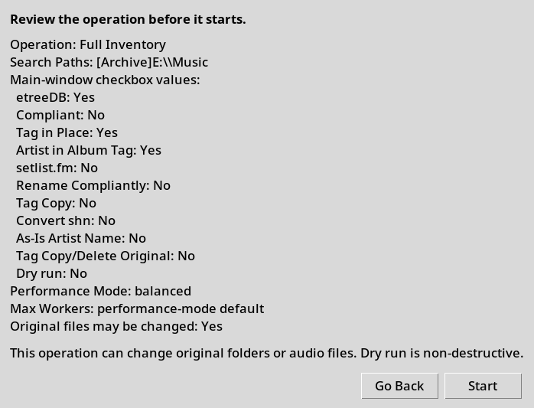
Figure 2. Review Operation reports the active settings before an action starts.

Fields and destination selection
- Tag Copy and Tag Copy/Delete Original are mutually exclusive inventory copy modes. Checking either box only selects the mode. After you click Inventory, TLO opens the same destination-entry window and requires an existing full path with readable available-space information. Tag Copy states that originals are retained. Tag Copy/Delete Original adds the warning that originals are removed after verified transfer. Before any transfer, TLO builds the show group and extracts metadata from the original source tree, including original folder and path text, selected setlist content, music filenames, and existing audio tags. It then copies or moves the identified show folder and uses the destination path for tagging and final inventory output. The transfer always applies to the complete identified folder tree: every file and every folder beneath it is included, including non-music files and empty subfolders. Tag Copy always totals the source and checks destination capacity because it always creates another tree. Copy/Delete Original performs that source-size capacity check only when the destination is on a different partition; a same-partition Copy/Delete Original operation is a directory rename or move and does not total or compare file sizes. Real copies are verified by relative file paths and sizes and by descendant folder structure before processing continues or a Copy/Delete source is removed.
- If the destination cannot hold the required source data, the GUI shows an alert naming the destination, the source path or paths, and the additional space needed.
Field | How to use it
Search Path | Optional single-root override. When filled, it overrides toBeInventoried.txt for this run. May start with [Volume]. If omitted, TLO uses the OS volume label when it can resolve one; if supplied, it must match the mounted drive label.
Slam | Optional artist override paired with Search Path. Use only when everything under that search path should use the same artist.
Performance Mode | gentle, balanced, fast, or extreme. GUI default is balanced.
Max Workers | Maximum path workers. Blank or 0 means use the selected mode default; positive values impose a cap.

Checkboxes
The main window displays the checkboxes in three rows. Row 1, left to right: etreeDB, Compliant, Tag in Place, Artist in Album Tag. Row 2: setlist.fm, Rename Compliantly, Tag Copy, Convert shn. Row 3 places As-Is Artist Name beneath the naming controls, Tag Copy/Delete Original beneath Tag in Place and Tag Copy, and Dry run at the right. Compliant and Rename Compliantly are mutually exclusive: checking either one automatically unchecks the other.
Checkbox | Effect
etreeDB | Try eTreeDB venue/location lookup after artist and yyyy-mm-dd date are known. It fills blanks and reports disagreements as observations.
Compliant | Switches metadata extraction to compliant folder-name rules. Mutually exclusive with Rename Compliantly. See Section 10.
Tag in Place | Writes audio tags in the original folders during Full Inventory and Add Shows when selected. Standalone Tag always tags the selected Tagging Path directly; this value is still reported in Review Operation.
Artist in Album Tag | Checked by default. When checked, Album tags begin with Artist followed by date, venue, location, and preserved parentheticals. This applies to Full Inventory with Tag in Place, Tag Copy, or Tag Copy/Delete Original, to Add Shows tagging, and to standalone Tag. Clear it to use the prior Album format without Artist.
setlist.fm | Last-resort venue/location lookup. In the GUI, checking it automatically checks etreeDB.
Rename Compliantly | Renames identified show folders using the resolved show name. Mutually exclusive with Compliant. By itself during non-compliant Full Inventory it renames originals in place without tagging; with Tag in Place, Tag Copy, or Tag Copy/Delete Original it applies the name to the corresponding source or destination. A broad collection or search parent containing unrelated music folders is never renamed as one show.
Tag Copy | Checking it only selects Tag Copy. After you click Inventory, TLO asks for the destination, validates the full path and available storage, totals the source size, then copies each identified music folder. TLO compares every relative file path and file size before tagging the copy. This verification is always performed, even when source and destination are on the same partition. The original material is retained.
Convert shn | Converts .shn/.shnf files to .flac during Tag, Full Inventory, or Add Shows. If no tagging mode is selected, Convert shn converts only and does not write tags.
As-Is Artist Name | Unchecked by default. When an artist or alias matches one Artist DB entry, TLO normally uses the database master name. Check this to preserve the artist name found in folder text, audio tags, or selected setlist metadata. Applies to compliant and non-compliant processing.
Tag Copy/Delete Original | Mutually exclusive with Tag in Place and Tag Copy. Checking it only selects the mode. After you click Inventory, TLO opens the shared destination window with an additional warning that the original material will be removed. If source and destination are on the same partition, TLO renames or moves the complete folder tree and does not total or compare file sizes. If they are on different partitions, TLO totals the source, checks destination capacity, recursively copies the complete folder tree, and compares every relative file path, file size, and descendant folder path before deleting the original. TLO then tags and inventories the destination.

Buttons
Control | What it does
Tag | Opens the TLO Tagger window. Uses TLOHome/readyForXfer by default, or --tag-path if supplied. The Tag window contains no duplicated main-option checkboxes or inherited-settings notice label; it reads the current main-window checkbox values when Tag is clicked and shows them in Review Operation. Disabled while inventory or Add Shows is active.
Add Shows (incremental) | Opens the incremental updater for readyForXfer, dups, and staged processing. Add Shows contains only its action-specific Check for Duplicates checkbox and no inherited-settings notice label. It reads the current main-window checkbox values when an action is clicked and shows them in Review Operation. It cannot overlap with full inventory or the tagger.
Quit | Closes the GUI. During an active inventory, it requests cancellation and exits after stopping the run.
Dry run | When checked, clicking Inventory performs the detailed non-destructive Inventory analysis. The same main-window value is inherited by Tag and Add Shows; neither child window has a separate Dry run checkbox. Inventory, Add Shows, and Tag Dry runs display resulting show names and planned actions; when tagging applies, they list each applicable audio file and the Artist, Album, Track, and Title values that would be written, including planned SHN-to-FLAC targets and files that would be skipped.
Inventory (full) | Shows Review Operation. The dialog lists every current main-window checkbox value in the same labels and order used by Tag and Add Shows. When Dry run is checked, performs the non-destructive scan; otherwise starts a full inventory using Search Path override if supplied, or toBeInventoried.txt.
Pause | Pauses full inventory between filesystem operations. Does not apply to Add Shows.
Resume | Resumes a paused full inventory. Repeated Resume clicks report only when a pause is active.

Performance modes
Search-path worker count is capped by the number of search paths queued for that run. Postprocess setlist/bootlist export uses a separate bounded worker pool after scanning finishes.
- gentle: best when using external drives, spinning disks, or Windows desktops where responsiveness matters. Uses 1 worker by default.
- balanced: moderate parallelism. GUI and CLI default performance mode. Typically uses up to 2 workers by default.
- fast: higher normal throughput, usually up to the CPU count by default.
- extreme: speed-first for inventory traversal. Search-path worker dispatch has no performance-mode worker cap unless Max Workers is set to a positive value. Postprocess still uses a bounded thread pool and honors Max Workers when set. Extreme does not skip non-compliant tag checks.

10. Compliant versus non-compliant mode

Compliant mode
Use Compliant mode when folders intentionally follow predictable naming. The main supported forms are String1 Date String2, String1 - String2, and String1 Date. For Date, TLO first looks for yyyy-mm-dd and then accepted year ranges before falling back to older date-recognition rules. In compliant mode, FLAC tags are not read or used. Compliant cannot be combined with Rename Compliantly.
- String1 Date String2: String1 is the artist text, Date is normalized, and String2 is kept as the trailing show text unless online lookup fills venue/location. By default, a matched alias is written using the Artist DB master name. Check As-Is Artist Name to preserve String1 as written.
- String1 - String2: String2 is treated as an album/show tail. A parenthetical-only tail such as (Live) is preserved.
- Every final Show Name retains all trailing parenthetical items in their original order. TLO captures them from the original folder name before cleaning the path for artist, date, venue, and location parsing, then restores them after normalization. This applies to Full Inventory, Add Shows, Dry run output, folder renames, bootlist rows, setlist names, and Album tags. For example, Danny Gatton 1994-03-13 Bottom Line NYC (set 2) becomes Danny Gatton 1994-03-13 Bottom Line New York, NY (set 2).
- String1 Date: fallback when no String2 exists; show name becomes Artist Date. Artist output follows the As-Is Artist Name checkbox.
- Standard video wrapper folders such as VIDEO_TS or BDMV can resolve from parent path components.
- The Billboard MP3 year-folder special case applies only when all inventoried music files are .mp3, the folder name is a four-digit year from 1959 through 2005, and billboard appears somewhere in the path. The exported setlist filename for this special case uses the same four-digit year.

Non-compliant mode
Use Non-compliant mode when folder names vary or contain partial or uncertain metadata. Non-compliant mode uses more evidence and tries to fill missing metadata without overwriting earlier trusted fields. As-Is Artist Name applies here too: unchecked uses an Artist DB master name for an unambiguous alias match; checked preserves the artist text from the metadata source that identified the show.
- Reads FLAC ARTIST, ALBUMARTIST, ALBUM, and DATE tags before path artist fallback. Tag values containing unknown or track are treated as blank for artist purposes.
- Searches folder and path text for artist, date, venue, and location clues, including known artist names and aliases.
- Commercial releases may use (YYYY) - Artist - Album or YYYY - Artist - Album, where YYYY is exactly one four-digit 19xx or 20xx year. TLO uses that year only to recognize the commercial-release form; it does not write the year to DATE or include it in the Show Name. Complete dates, partial dates, year ranges, two-digit years, x-filled years, and years embedded in other text do not qualify. The Show Name is Artist - Album. If the album tail already begins with the same resolved Artist followed by a dash, TLO removes that one redundant Artist component, so Rod Stewart - Rod Stewart - Camouflage becomes Rod Stewart - Camouflage.
- Aggregates related wrapper/part folders such as CD1/CD2/CD3 under one logical show only when every direct music-bearing child under the parent belongs to the same release relationship. If any direct music-bearing sibling is unrelated, TLO keeps the folders separate and never promotes the broad collection/search parent into one show. A short v-number inside a larger descriptive parenthetical, such as (WLIR-FM, rm v.2), is not treated as a volume suffix.
- Uses selected setlist header metadata for date, artist, venue, and location fallback before track names or hash/checksum sections. For stability, TLO reads at most 1 MiB while sampling ordinary text candidates, rejects full ordinary text reads above 16 MiB, and rejects DOCX document.xml content above 16 MiB uncompressed before decompression.
- Uses eTreeDB and setlist.fm only when enabled, and only to fill blanks or report observations.
Commas in unnumbered song lists do not need to be followed by spaces; TLO treats “Song A,Song B,Song C” the same as “Song A, Song B, Song C” when the item count matches the audio files.
Practical choice: When in doubt, start with non-compliant mode for mixed real-world collections. Use compliant mode when you deliberately organized the folders to match the supported naming patterns and want those names trusted.

11. Online lookup options
Online lookup is optional. It is used to fill missing venue/location fields after artist and a full yyyy-mm-dd date are known. Later sources do not overwrite nonblank metadata found earlier; non-equivalent disagreements are reported as observations in the summary log.
- etreeDB checkbox or --etree-lookup: uses eTreeDB first among online sources. When tagging is enabled, the same option can also allow a last-resort eTreeDB song-title lookup if local setlist titles are not usable.
- setlist.fm checkbox or --setlistfm-lookup: uses setlist.fm as a last resort only when etreeDB does not return usable venue/location data. On the command line, --setlistfm-lookup requires --etree-lookup. In the GUI, selecting setlist.fm automatically selects etreeDB. If the same lookup response already contains song rows, TLO may reuse those cached rows for tagging; it does not make a separate setlist.fm call just to find track titles.
- setlist.fm requires SETLISTFM_API_KEY in the environment.
- setlist.fm requests are rate-limited to one request every 600 milliseconds across local workers and capped at 1,400 calls per inventory run. Coordination state is stored under TLOHome/logs/setlistfm-state rather than the system temporary directory. If a worker cannot acquire the reservation lock within 20 seconds, TLO records the lookup failure and continues without waiting indefinitely.
- For U.S. lookup results, show names use Artist Date Venue City StateCode. Non-U.S. results use Artist Date Venue City Country.
Command-line rule: --compliant and --rename-compliantly cannot be used together; TLO reports an argument error.
Command-line examples:
tlo-gi.exe --TLOHome C:\TLOHome --etree-lookup
python3 tlo-gi.py --TLOHome "$TLOHome" --compliant --as-is-artist-name --etree-lookup --setlistfm-lookup

12. Tagging functions
The tagging window is used when you want TLO to write tags to audio files. Its window title bar reads TLO Tagger GUI v1.3 Build 361. Inside the window, the single bold heading is Traders Little Helper™ Tagger App; there is no second in-window version heading. The exact layout may vary slightly by platform, but the main choices and actions are the same.
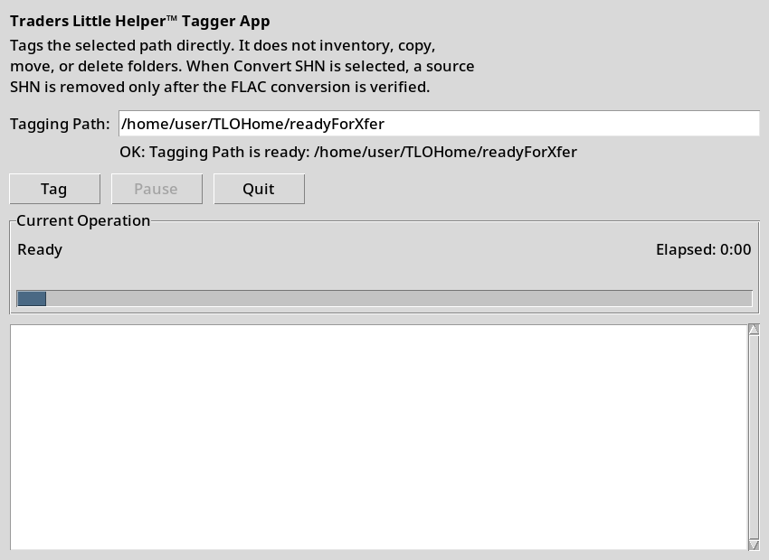
Figure 3. Tag window. Tagging options are inherited from the main window and reported in Review Operation.
The standalone and GUI Tagger write tags directly to the selected Tagging Path unless the main-window Dry run checkbox is selected. The Tag window has no option checkboxes copied from the main window and no separate inherited-settings notice. It contains the Tagging Path plus Tag, Pause or Resume, and Quit controls. When Tag is clicked, it reads the current main-window values for Compliant, etreeDB, setlist.fm, Rename Compliantly, Convert shn, Artist in Album Tag, As-Is Artist Name, and Dry run. The inventory Tag in Place, Tag Copy, and Tag Copy/Delete Original values are also reported in Review Operation, but standalone Tag always tags the selected path directly and never copies or moves folders. When Dry run is on, clicking Tag resolves the show metadata and track titles without writing tags, converting SHN, renaming, or deleting files. The output lists each applicable audio file with the exact Artist, Album, Track, and Title values that would be written, the title source, planned SHN-to-FLAC targets, and any reason a file would be skipped.
The Tagger does not copy folders and does not delete music content. The only exception is Convert shn: after a replacement FLAC is successfully created and verified, TLO deletes the source .shn or .shnf file. Failed conversions leave the source file in place.
On native Windows installations, drag a folder from File Explorer and drop it onto the Tagging Path field in the tagger window. The dropped folder replaces the Tagging Path value. If a file is dropped, TLO uses the containing folder. This tagger drag-and-drop support is not enabled for WSL, Linux, or macOS.
The tagger also creates CorruptFlacs.txt in TLOHome. If a FLAC file cannot be opened or written during tagging, TLO appends the complete file path to that file so bad FLACs can be reviewed separately from other tagging errors.

13. Add Shows incremental updater
Add Shows processes new folders already placed under TLOHome/readyForXfer and potential duplicate or upgrade folders under TLOHome/dups. Accepted folders are moved into TLOHome/staged after processing.
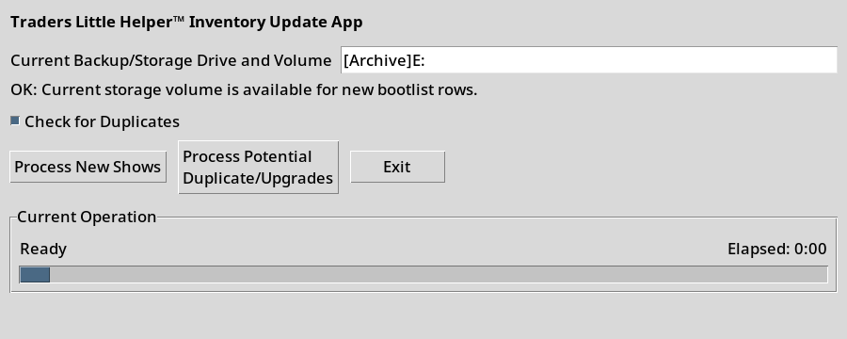
Figure 4. Add Shows window. Dry run and shared settings come from the main Inventory window.
- Enter a nonblank Current Backup/Storage Drive and Volume. The TLOCurrentStorage environment variable or --current-storage-volume can prepopulate it.
- Add Shows has no separate Preview buttons, no Dry run checkbox, and no duplicated main-option checkboxes. Check for Duplicates remains because it applies only to Process New Shows. Select Dry run on the main Inventory window, then click Process New Shows or Process Potential Duplicate/Upgrades to run the detailed non-destructive analysis. Each action reads the current main-window values when clicked and shows the same complete checkbox-value section in Review Operation before starting.
After you click Start, TLO appends the reviewed settings to TLOHome/logs/runSettings.log before the action begins. Clicking Go Back or closing Review Operation does not create a log entry. If TLO cannot write the settings log, it reports the problem and does not start the action.
- Add Shows does not keep a separate Mode display of copied main-window settings. Review Operation reports every current main-window checkbox in the same labels and order used for Full Inventory and Tag: etreeDB, Compliant, Tag in Place, Artist in Album Tag, setlist.fm, Rename Compliantly, Tag Copy, Convert shn, As-Is Artist Name, Tag Copy/Delete Original, and Dry run. Tag Copy and Tag Copy/Delete Original are reported but marked as not used by Add Shows.
- Tag in Place is honored for accepted new and duplicate-resolution folders. Tag Copy and Tag Copy/Delete Original are ignored because Add Shows already has its own readyForXfer, dups, and staged movement workflow.
- If bootlist.csv does not exist, TLO warns that Add Shows is normally used after Full Inventory and asks whether to create the first bootlist from readyForXfer.
- For potential duplicates/upgrades, review the matching existing rows and text files, then choose which old folders to keep or remove. The generated deleteBackupFolders.bat commands use the selected old bootlist paths.

14. Search app
Launch tlo-gsi from the platform application folder. The Search app uses TLOHome/bootlist.csv for normal searches and TLOHome/setlists for Deep searches.
- Use |AND| and |OR| to combine terms; parentheses and quoted phrases are supported.
- Normal search treats an empty search box as all bootlist rows. Deep search requires a nonblank term and searches setlist text.
- Select one or more results and choose View, or double-click one result. TLO derives the setlist filename directly from the Show value rather than scanning the setlists directory.
- Opening more than five setlists asks for confirmation. More than 30 setlists cannot be opened at once. Multiple text windows are cascaded down and right.
- The startup search uses --find when supplied; otherwise it uses the current clipboard/paste buffer. The main Search box remains focused.

15. Command-line quick reference
The GUI and CLI use the same option registry. The commands below show the supported user-facing command-line options.
# Full inventory
tlo-gi.exe --TLOHome C:\TLOHome --search-path "[Archive]E:\Music" --compliant
python3 tlo-gi.py --TLOHome "$TLOHome" --etree-lookup --setlistfm-lookup
# Standalone tagger
tlo-tag.exe --TLOHome C:\TLOHome --tag-path E:\ReadyToTag --convert-shn
# Search
tlo-gsi.exe --TLOHome C:\TLOHome --find "(Dylan |OR| The Band) |AND| 1974"
Option | Command | Purpose
--TLOHome DIR | Inventory, Tag | Use an explicit TLOHome. Otherwise TLO uses the TLOHome environment variable.
--debug [BOOL] | Inventory, Tag | Enable debug output. With no value it enables debug; explicit true/false forms are also accepted.
--silent | Inventory | Suppress console output while retaining files and exit status.
--search-path STRING | Inventory | Process one search root instead of toBeInventoried.txt. The value may begin with [Volume].
-$slam / --$slam STRING | Inventory | Artist override paired with --search-path. It is invalid without --search-path.
--$copy DIR | Inventory | Per-search-path Tag Copy destination. Requires --search-path and cannot be combined with --$copy-delete.
--$copy-delete DIR | Inventory | Per-search-path Tag Copy/Delete Original destination. Requires --search-path and cannot be combined with --$copy.
--compliant | Inventory, Tag | Use compliant folder-name parsing. Mutually exclusive with --rename-compliantly.
--as-is-artist-name | Inventory, Tag | Preserve the discovered artist spelling instead of substituting the Artist DB master name.
--tag-during-inventory | Inventory | Tag original folders during Full Inventory and supported Add Shows processing.
--tag-copy-during-inventory | Inventory | Copy identified folders to --tag-copy-destination and tag the copies.
--tag-copy-destination DIR | Inventory | Destination parent for Tag Copy.
--tag-copy-and-delete DIR | Inventory | Copy or move identified folders, verify cross-partition copies, and remove originals after verification.
--rename-compliantly | Inventory, Tag | Rename identified folders from resolved Show names. Mutually exclusive with --compliant.
--convert-shn | Inventory, Tag | Convert SHN/SHNF to FLAC and remove the source only after verified conversion.
--no-artist-in-album | Inventory, Tag | Omit the artist prefix from Album tags. Album tags include the artist by default.
--etree-lookup | Inventory, Tag | Enable eTreeDB metadata lookup and permitted tagging fallback.
--setlistfm-lookup | Inventory | Use setlist.fm only after eTreeDB returns no usable venue/location result. Requires --etree-lookup.
--performance-mode MODE | Inventory | Select gentle, balanced, fast, or extreme inventory scheduling.
--max-workers N | Inventory | Cap search-path worker processes. Zero uses the selected performance-mode default.
--current-storage-volume STRING | Inventory GUI | Prepopulate the Add Shows current storage volume; overrides TLOCurrentStorage.
tagPath | Tag | Optional positional fully qualified tagging path.
--tag-path DIR | Tag | Named form of the explicit tagging path override.

16. Outputs, completion summaries, and troubleshooting
- bootlist.csv: two columns, Show and [Volume] Path.
- setlists/: exported or generated setlist text named from the normalized Show metadata.
- unidentifiedShows.txt: paths that could not be identified sufficiently.
- summary.log: run totals, timing, observations, warnings, and finalization status.
- logs/runSettings.log: one append-only record of the settings for every started Inventory, Tag, or Add Shows action, including Dry runs. Each entry begins with the action, date, and time, followed by the same settings lines shown in Review Operation.
- CorruptFlacs.txt: full paths of FLAC files that could not be opened or written during tagging.
- Completion summaries show elapsed time, operation totals, warning/error counts, View Issues, Open Output when applicable, and Open Logs.
Use the completion summary and View Issues first. The tables below map common symptoms and structured reason codes to practical next steps. The detailed logs remain the authoritative record.
Symptom | Likely cause | Action
Inventory appears paused | Paths on the same physical disk are intentionally serialized, or a lookup/conversion is waiting within its timeout. | Read Current Operation and elapsed time. Check summary.log and the active token logs before cancelling.
Inventory or Tag button will not run | A required path is invalid, a first Add Shows run lacks a storage volume, or an incompatible option combination is selected. | Correct the path or option shown by validation. Compliant and Rename Compliantly cannot both be active.
Show is listed in unidentifiedShows.txt | Artist/date evidence was insufficient or conflicting. | Review metaX.log and confX.log, correct the folder/setlist metadata, then rerun the affected labeled path.
Album tags omit the artist | Artist in Album Tag was cleared, or the file was skipped before tagging. | Check runSettings.log and the Switches line in metaX.log. Review tageX.txt for skipped files.
Some song titles are Unknown | The selected title source had fewer usable titles than audio files. | Compare the setlist, filenames, and track counts. See WARN_TITLE_PARTIAL or SKIP_TITLE_COUNT in tageX.txt.
A folder was not copied or deleted | The show was unidentified, destination space was insufficient, or copy verification failed. | Review the completion Issues list and tageX.txt. Originals remain in place when verification fails.
SHN source remains | Conversion failed, timed out, or verification failed. | Review ERROR_CONVERT_SHN. TLO deletes SHN only after a valid FLAC is verified.
Search cannot open a setlist | The setlist filename derived from Show is missing or more than 30 files were selected. | Confirm the matching file under TLOHome/setlists and reduce the selection.
A broad collection root would be renamed | This was an unsafe grouping defect in older builds. Build 354 and later reject unrelated direct music siblings. | Restore the collection root name, update TLO, and rerun with Dry run before enabling Rename Compliantly.

Structured tagging and processing reason codes
Code | Meaning | Recommended response
SKIP_SETLIST_MISSING | No usable setlist candidate was found. | Check show, parent, info, setlist, and data folders; enable eTreeDB only when desired.
SKIP_SETLIST_UNREADABLE | A candidate setlist could not be safely read. | Replace or repair the file; oversized, malformed, and binary-like inputs are rejected.
SKIP_TITLE_PARSE | No usable numbered, unnumbered, comma-separated, filename, or tag title sequence was found. | Review setlist formatting and filenames.
SKIP_TITLE_COUNT | Usable title count did not match the audio-file count. | Check missing tracks, disc boundaries, and extra non-music files.
WARN_TITLE_FALLBACK | TLO used a lower-priority title source. | Review results if exact setlist titles matter.
WARN_TITLE_PARTIAL | Some files received titles and unmatched files received Unknown. | Compare the listed titles with the ordered audio files.
ERROR_AUDIO_FILE | An audio file could not be opened or written. | Check corruption, permissions, read-only media, and antivirus history.
ERROR_CONVERT_SHN | SHN conversion or verification failed. | Keep the original SHN and review converter output.
SKIP_METADATA | The show could not be identified sufficiently for the requested operation. | Correct artist/date/venue evidence and rerun.
SKIP_NO_AUDIO | No supported audio files were present at the working path. | Check grouping and whether a prior rename moved the expected path.
SKIP_CANCELLED | The operation was cancelled before the item completed. | Rerun the affected scope when ready.
ERROR_TAGGING / WARN_TAGGING | Tagging failed or completed with warnings. | Review tageX.txt and CorruptFlacs.txt for file-specific details.

17. Logs deep dive
runSettings.log is a single shared, append-only history of run configuration. The first line of each entry identifies the action and local date/time. The remaining lines mirror Review Operation, including the selected path, every main-window checkbox, action-specific values, destinations or performance settings when applicable, and whether original files may be changed. Command-line Full Inventory and Tag runs write the same format.
Log | Use
summary.log | Consolidated run totals, elapsed time, observations, warnings, and finalization status.
runSettings.log | Append-only action/date/time and the exact accepted Review Operation settings for Inventory, Tag, Add Shows, and Dry runs.
groupsX.log | Logical groups, wrapper/volume aggregation decisions, music directories, and sample files for one path token.
metaX.log | Resolved show metadata, evidence, observations, and the Switches line for each show.
compX.log | Compact representative path/music records used by later processing.
confX.log | Unresolved metadata conflicts and paths that could not become shows.
deadX.log | Rejected or dead-end traversal records.
dupsX.log | Duplicate-related records.
tagsX.txt | Successful inventory-time tagging and progress information for path token X.
tageX.txt | Inventory-time tagging warnings, skips, conversion failures, and file errors for path token X.
tagsT.txt | Standalone Tagger success and progress log.
tageT.txt | Standalone Tagger warnings, skips, and errors.
CorruptFlacs.txt | Append-only full paths of FLAC files that could not be opened or written.
Log tokens are assigned per active search path. Labeled-volume reruns replace or prune the affected scope according to path relationships. Blank-label runs append to the shared blank-volume log set and can create duplicates if the same content is scanned again.

18. Glossary
Term | Meaning
Add Shows | Incremental workflow for content in readyForXfer and potential duplicates/upgrades in dups.
bootlist | The two-column bootlist.csv inventory containing Show and [Volume] Path.
Compliant | Simplified parsing that relies on recognized folder-name patterns and does not use the full non-compliant evidence process.
Non-compliant | Default evidence-based parsing using paths, selected setlists, tags, databases, and optional online lookup.
Parenthetical | A trailing item in parentheses retained at the end of a show name, such as (set 2) or (24-bit).
Show group | One logical inventory entry and its associated music directories, setlists, and metadata.
Slam | An artist override paired with one Search Path.
String1 / String2 | Folder-name portions before and after a recognized date or dash separator in compliant/non-compliant parsing rules.
Token | The letter/number suffix assigned to one active search path log set, such as meta5.log or tageA.txt.
Wrapper folder | A parent or part folder such as CD1/CD2 or Disc 1/Disc 2 that may belong to one logical show when all direct music-bearing children are related.
readyForXfer | TLOHome folder containing new material for Add Shows or the default Tag path.
dups | TLOHome folder containing potential duplicate or upgrade material for Add Shows review.
staged | TLOHome folder receiving accepted Add Shows content after processing.
Tag in Place | Write tags to original music files.
Tag Copy | Full Inventory mode that copies identified music folders and tags the copies.
Tag Copy/Delete Original | Full Inventory mode that copies or moves identified folders, verifies cross-partition copies, and removes originals only after verification.
Dry run | Non-destructive metadata and tag planning selected on the main Inventory window and inherited by Inventory, Tag, and Add Shows.

19. GitHub update checks and Auto update
- Check for updates compares the installed build with the latest public GitHub release and downloads the best matching ZIP to Downloads. TLO does not install or extract the update automatically.
- Auto update is a download-only startup check. Its setting is stored in TLOHome/update-settings.json, and automatic checks are limited to at most once per day.
- Current releases contain eight assets: complete and update ZIPs for Windows onefile, Windows onedir, Linux, and macOS.
- Complete packages include the platform applications, required TLO_DBs files, manual, FAQ, starter files, work folders, manifests, checksums, and scan receipt. Update packages intentionally omit databases and all user-data/output areas.
- Do not overlay a Windows onefile apps/Windows folder with a Windows onedir folder or vice versa. Replace apps/Windows as a unit when switching layouts; onedir executables require the shared _internal folder.
- Close all TLO applications before applying an update.

